***Java 17 Masterclass Notes***

## Section 1 – Introduction

### What is Java LTS?

* Oracle owners of Java release Java updates a few times per year – special ones are designated “Long-Term Support”, or LTS
* Regular releases are only supported for six months
* LTS versions, on the other hand, receive extended security updates, bug fixes, and patches for years
* As a results, LTS releases are your rock-solid choice, especially for production environments and when learning Java

### Why use a Java LTS version?

* Stability: Companies need stable systems. LTS versions minimize surprises with bugs, and security issues are already ironed out.
* Support: if something goes wrong with an LTS version, you’ve got a longer window where official support and updates are guaranteed. This is vital for businesses.
* Ecosystem: Libraries, tools, and frameworks often focus their support on LTS versions. That means a much smoother experience for you.
* Regular versions: while they have cool new features, they lack long-term support. Neat stuff eventually gets rolled into the next LTS version, making it the smarter choice for most production work.

### JDK 17 vs. JDK 21: Does it matter?

* You might see a course like this one using JDK 17 and wonder, “Isn’t JDK 21 the latest and greatest?” True, but…
* Java LTS versions are designed for long-term use.
  + Companies don’t instantly jump to the newest JDK
  + Why? They prioritize testing, ensuring compatibility with existing systems, and just letting the LTS mature a bit.

### Key Takeaways

* For serious projects, learning an LTS like JDK 17 is the way to go.

You’ll master core Java skills relevant across all versions

* When a new LTS comes out, companies steadily migrate.

There’s no need to chase every JDK update, especially as cool non-LTS features get merged into the next LTS anyway

* For those eager to try JDK 21, a section on that will be added to this course soon

### JShell

* JShell became a standard component of the Java Developers Kit in Java 9
* It is what is known as a Read-Eval-Print-Loop interactive program (or REPL for short) which means it does pretty much just that:
  + It reads the command or code segment we type in
  + It evaluates and executes the code, and often allows short cuts to be used
  + It prints out the results of the evaluation or execution, without making the developer write code to output the results
  + Lastly, it loops right back for more input (more code segments and commands)
* JShell runs in a terminal (or command line for Windows) and is useful for quickly trying out new ideas
* JShell is a kind of sandbox or playground that lets us experiment with code in a simple, safe, and fun way. It does this with instant feedback, which, for brand new developers, is very rewarding
* Note that although JShell, because it is a REPL environment, is interactive, and that is not the same thing as an integrated development environment, it does not replace the need for an IDE. It’s just a handy tool to quickly get started with Java.

Link to documentation is [here](https://docs.oracle.com/en/java/javase/17/jshell/introduction-jshell.html).

To launch JShell, simply type “jshell” into the command prompt:

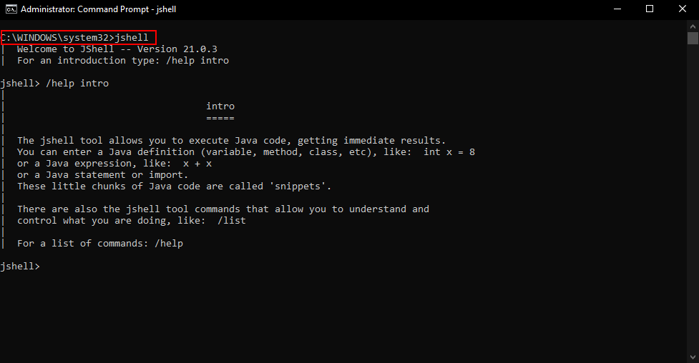

Typing in /help will give you a list of all the JShell commands you can use:

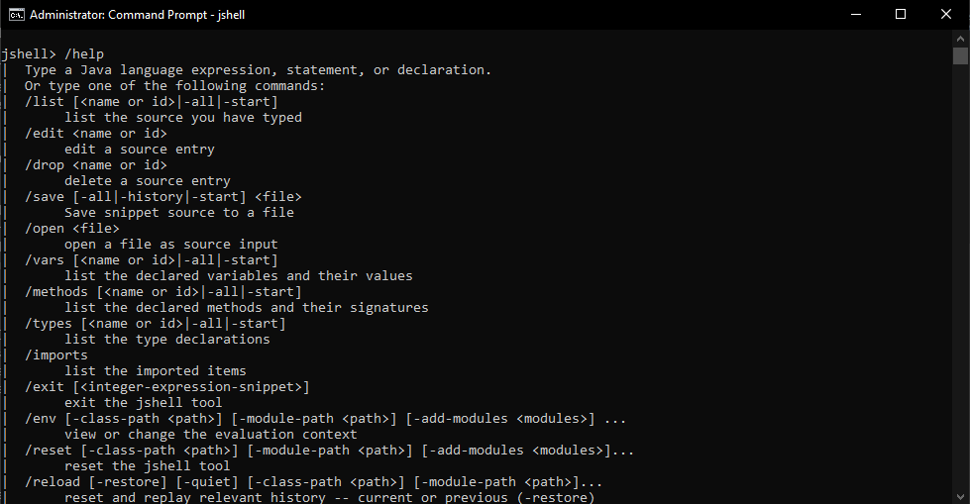

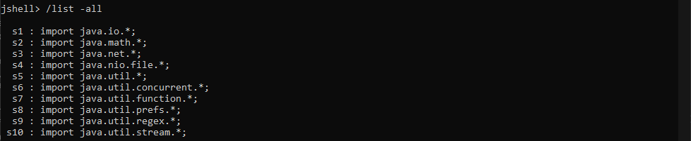

A list of all the libraries that JShell keeps in its environment

You can enter multiple lines of code using JShell by using curly braces {…}

Putting letters or words between double quotes creates an object called a “string literal”.

Using single quotes are used for character literals, or single characters.

These are a few examples of errors that might occur when you’re coding in JShell. Let me encourage you to play with this line of code (System.out.println(“Hello, World!”);) in JShell, in as many ways as you can think of to see what kind of errors you might get, or what kind of output is produced.

This is the whole point of JShell – to provide you with a safe place to test code segments.

Remember that the key combination “ctrl+c” on Windows, or “ctrl+d” on a Mac or a Linux machine, should cancel what you are in the middle of, and get you back to the JShell prompt.

Typing forward-slash and the word “exit”, or forward-slash with the shortcut text “ex” will end your JShell session if you get stuck. (i.e. “/exit” or “/ex”)

## Section 3 – First Steps

### Keywords

A keyword is any one of a number of reserved words that have a predefined meaning in the Java language.

In Java syntax, all code is case-sensitive, and this includes keywords. As we’ll soon see, an int, all lowercase, is not the same as Int, with a capital I. Here, an int, (all in lowercase) is a keyword in Java.

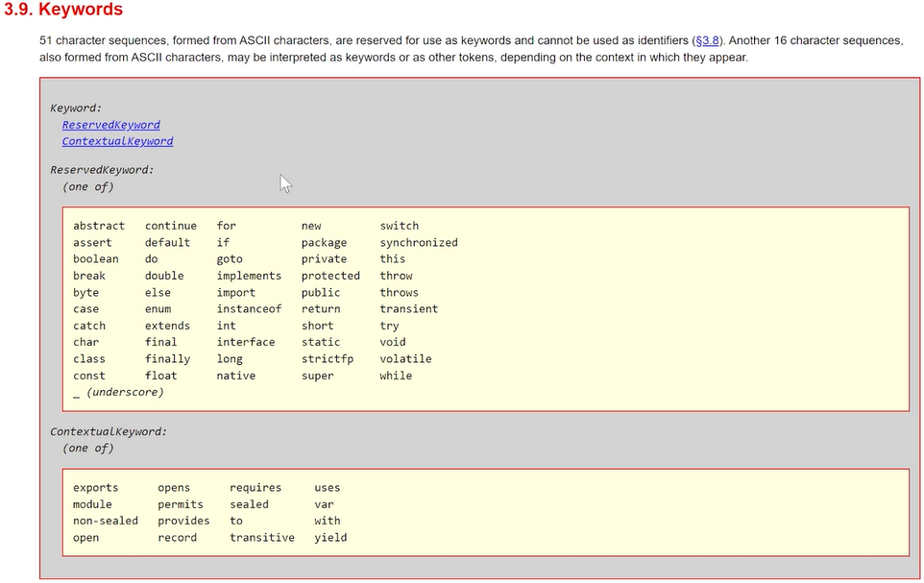

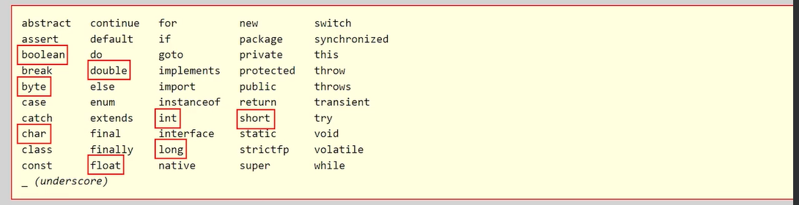

### Primitive Data Types

Variables

* Variables are a way to store information in your computer
* Variables that we define in a program can be accessed by a name we give them, and the computer does the hard work of figuring out where they get stored in the computer’s random-access memory, or RAM.

Data Type

* There are a lot of different types of data that we can define for our variables, some of which were shown in the keyword list above.
* Collectively, these are known as *data types*.
* Some data types are keywords in Java. When we get to the Object-Oriented features of Java, you will see that we have a lot of flexibility for creating our own data types, but in the next few videos, we’ll explore primitive data types, which are built into the Java language.

Declaration Statement – a *declaration statement* is used to define a variable by indicating the data type and the name, then optionally to set the variable to a specific value.

Expressions – an expression is a coding construct that evaluates to a single value

Operators – Java operators perform an operation (hence the term) on a variable or value. Addition, Subtraction, Division, and Multiplication are the four most common ones, but there are a lot more operators available in Java.

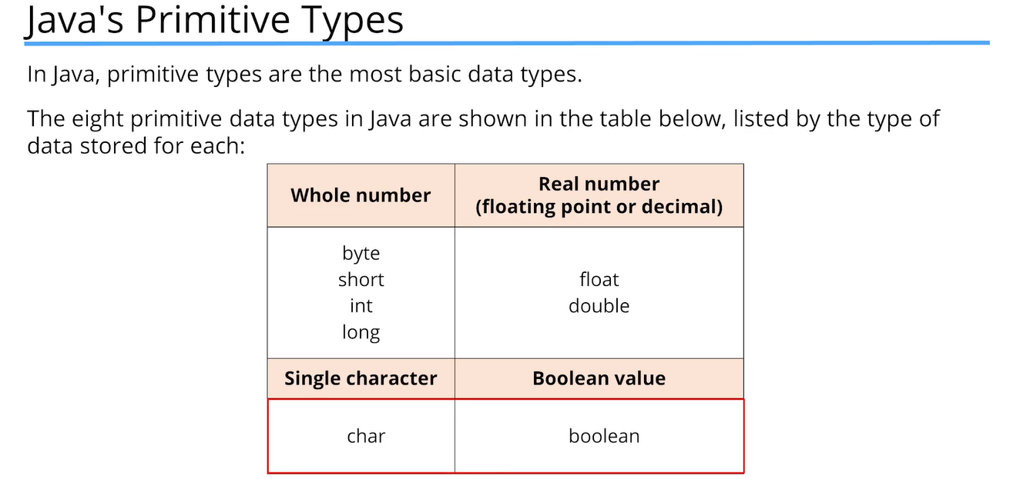

Integer – an integer is a whole number, meaning it doesn’t contain a fractional element or a decimal. There is a specified range of values allowed for the int, which is true for most data types. What this means is that the range of values for int is not infinite. There’s a defined minimum and maximum value for each numeric type, meaning you can’t assign a number larger or smaller outside of that range.

The plus sign, +, when used in System.out.print will print different data types together as a single line of text.

Example: System.out.print(“Integer Minimum Value = “ + myMinIntValue);

We want to print a label before a numeric integer value.

Whatever follows the plus sign in System.out.print here, is converted to a String by Java and concatenated to the String that comes before it.

This is perfectly valid syntax in Java.

A class is a building block for object-oriented programming and allows us to build custom data types.

Java uses the concept of a Wrapper Class for all of its eight primitive data types. A wrapper class provides simple operations as well as some basic information about the primitive data type which cannot be stored in the primitive type itself.

We saw that MIN_VALUE and MAX_VALUE are elements of basic information for the int data type that are stored within the Integer wrapper class.

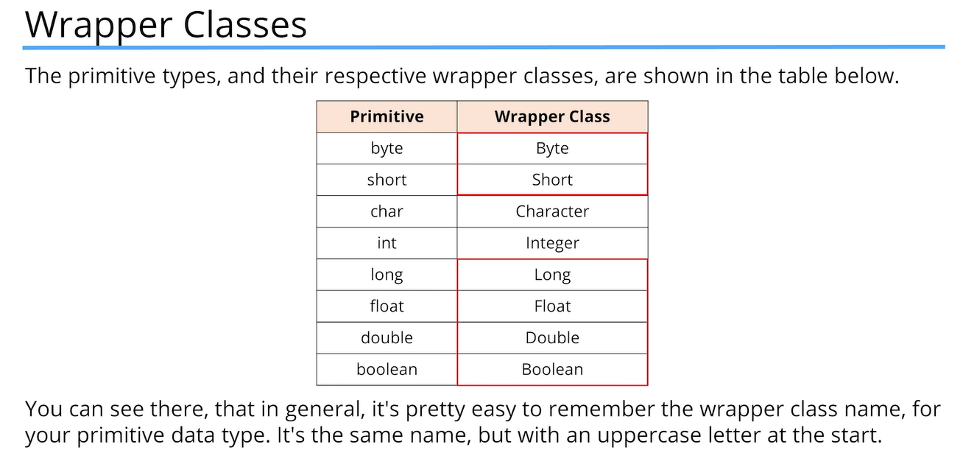

The wrapper classes for char and int, Character and Integer respectively, are the only two that differ in name from their primitive types.



Trying to add a number to the maximum value of an integer caused the value to “overflow”. The computer tried to put a number larger than Integer.MAX_VALUE instead of throwing an error, and it caused the value to overflow and cycle around to the lowest value. If it does the same thing with the smallest number, an “underflow” will occur.

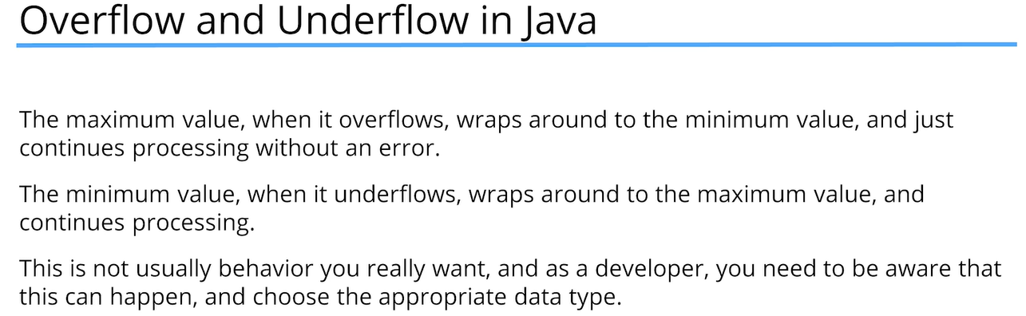

As programmers, it’s our responsibility to use the appropriate data type in all situations.

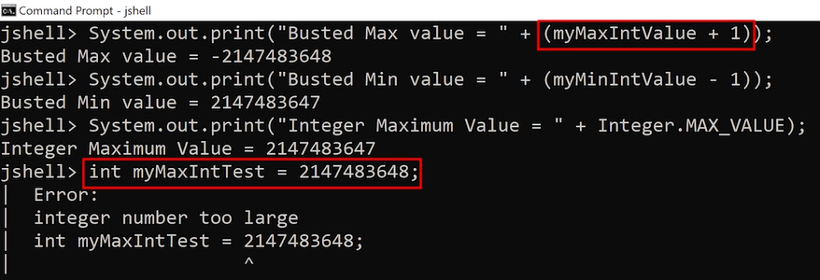

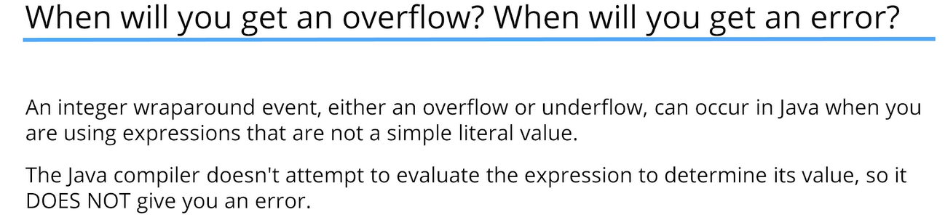

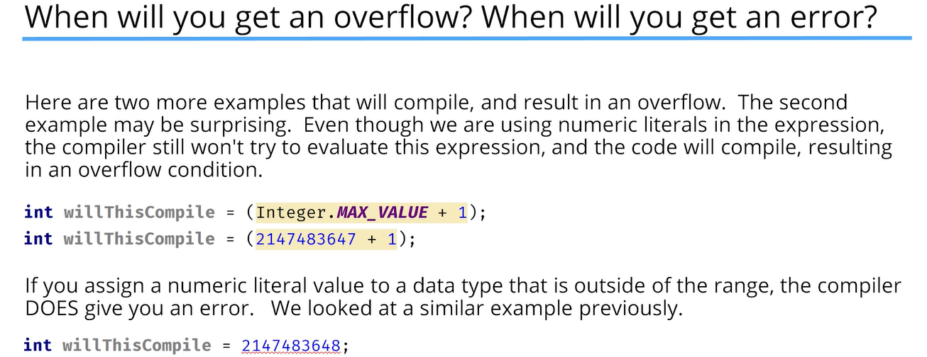

For large numbers in Java, you cannot put commas in numeric literals. For example, the following is not valid syntax:

int myMaxIntTest = 2,147,483,647;

Instead of a comma, Java allows the use of an underscore anywhere you might want to use a comma, but you can’t use an underscore at the start or end of a numeric literal.

int myMaxIntTest = 2_147_483_647;

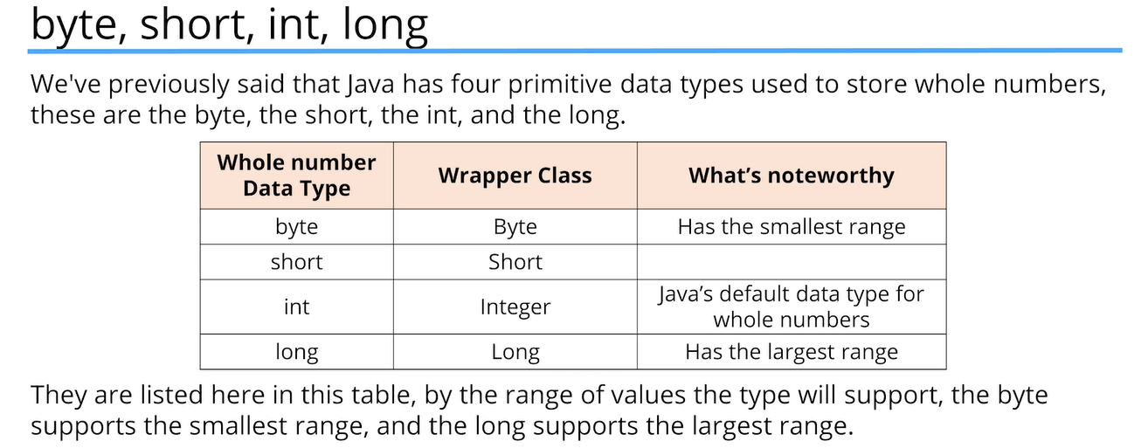

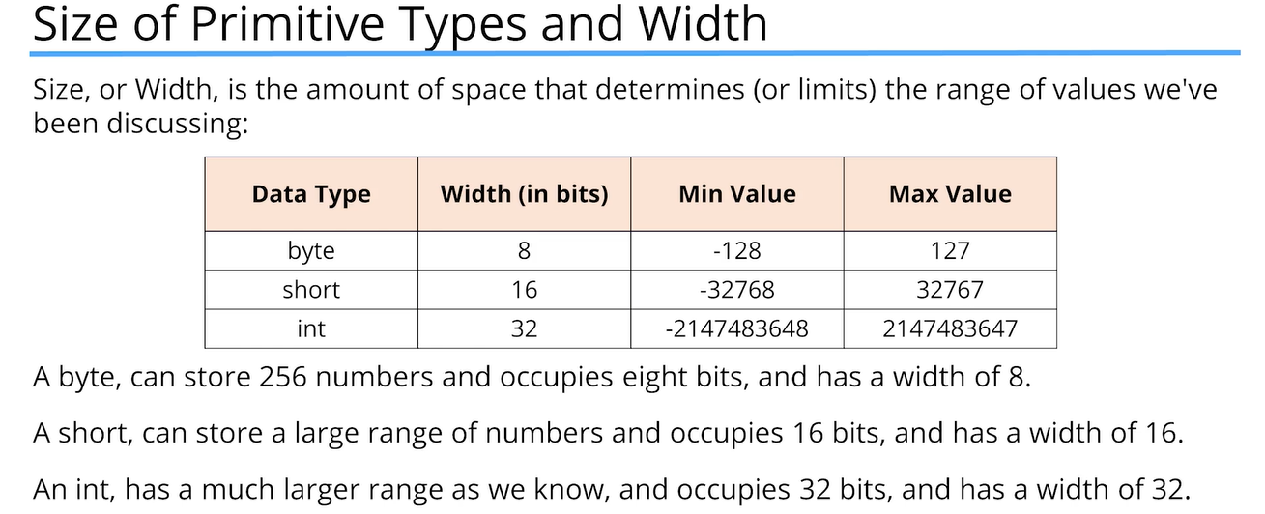

long myLongValue = 100; 🡨 this syntax is misleading

The number 100 by default is an int. Java allows certain numeric literals to have a suffix appended to the value to force it to be a different data type from the default type.

The ‘long’ is one of these types and its suffix is an ‘L’.

This is one of the few instances when Java is not case sensitive. A lowercase ‘l’ or an uppercase ‘L’ at the end of a whole number mean the same thing – the number is a long.

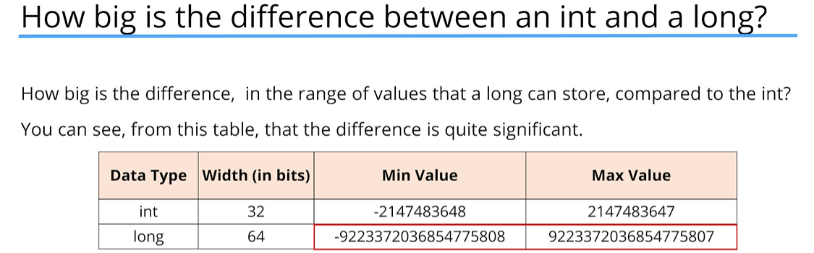

A numeric literal that exceeds Integer.MAX_VALUE must use the L suffix.

We cannot create a numeric literal in Java that exceeds Integer.MAX_VALUE without using the ‘L’ suffix, otherwise we will always get the error ‘integer number too large’.

### Rules for declaring multiple variables in one statement:

* You cannot declare variables with different data types in a single statement
* If you declare multiple variables of the same data type in a single statement, you must specify the data type only once before any variable names

### Assigning expressions to variables with data types that don’t match:

* The Java compiler does not attempt to evaluate the value in a variable when it’s used in a calculation, so it doesn’t know if the value fits and it throws an error:

byte myNewByteValue = (myMinByteValue / 2);

| Error:

| incompatible types: possible lossy conversion from int to byte

| byte myNewByteValue = (myMinByteValue / 2);

| ^----------------^

* If your calculation uses literal values, Java can figure out the end result at compile time and whether it fits into the variable, then it won’t throw an error if it does.

byte myNewByteValue = (-128 / 2);

### Casting in Java

* Casting means to treat or convert a number from one type to another. We put the type we want the number to be in parentheses like this:

(byte) (myMinByteValue / 2);

* Other languages have casting too, this is not just a Java thing

***IMPORTANT***

The double data type is Java’s default data type for Real Numbers.

* For example, any number with a decimal is a double – so 10.5 is a double by default in Java
* The double data type can be specified as a numeric literal with a suffix of either lowercase ‘d’ or uppercase ‘D’, but because doubles are the default in Java, the use of the suffix is optional
* The float data type can be specified as a numeric literal with a suffix of lowercase ‘f’ or uppercase ‘F’. This suffix is required if you are assigning a real number to a variable that was declared with a float type.

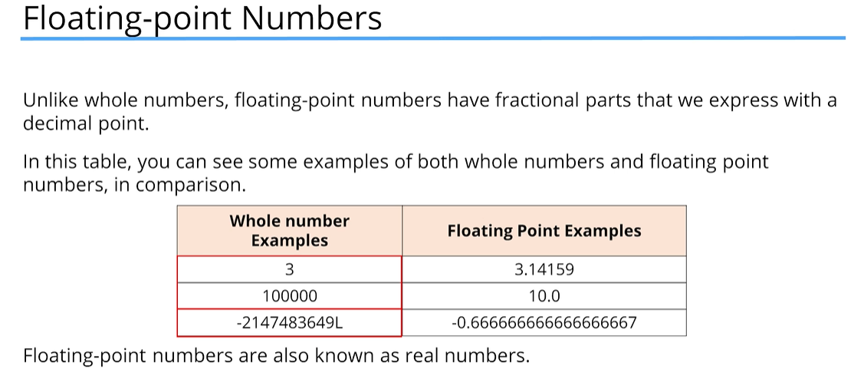

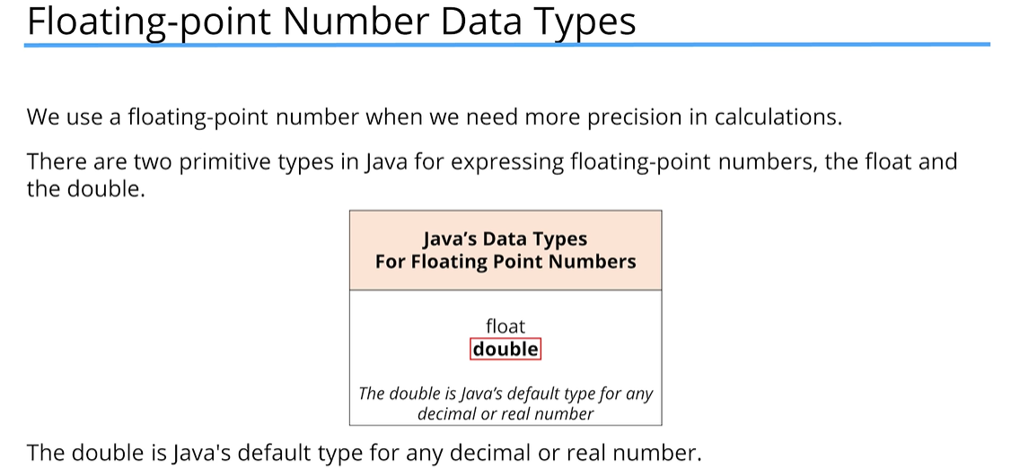

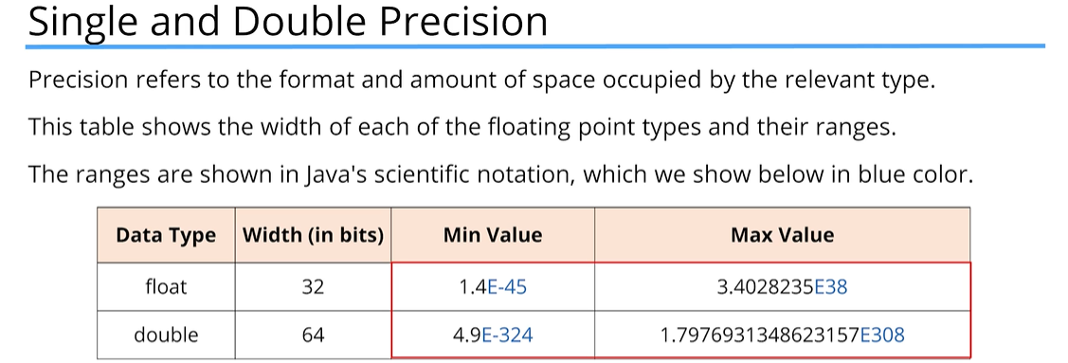

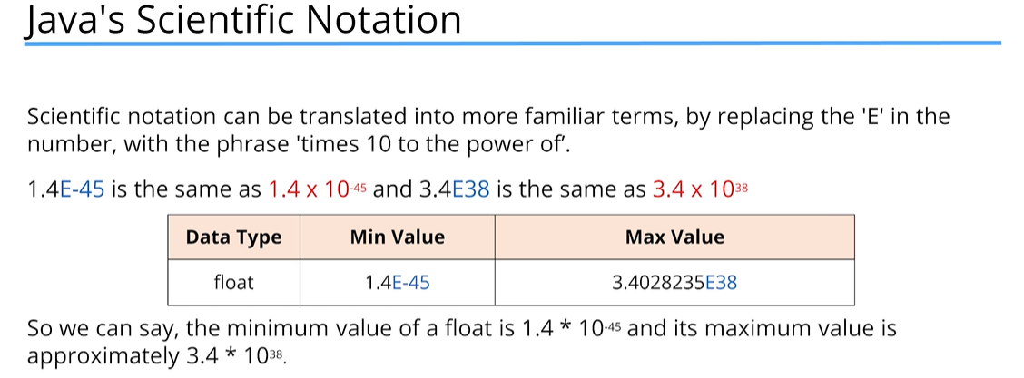

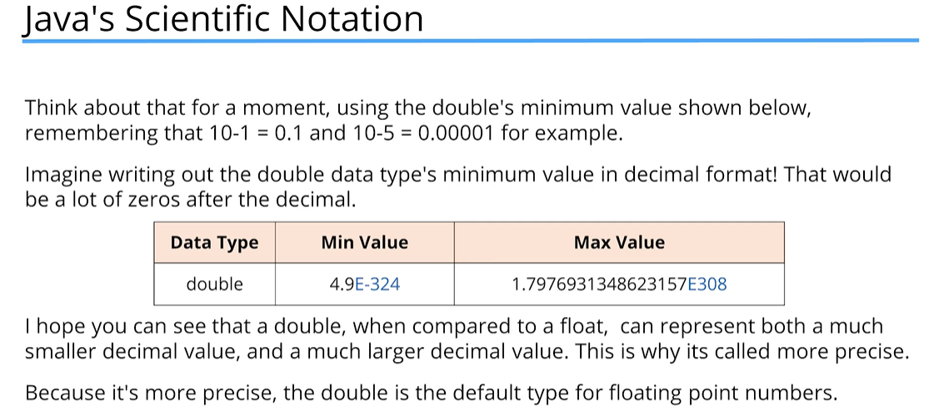

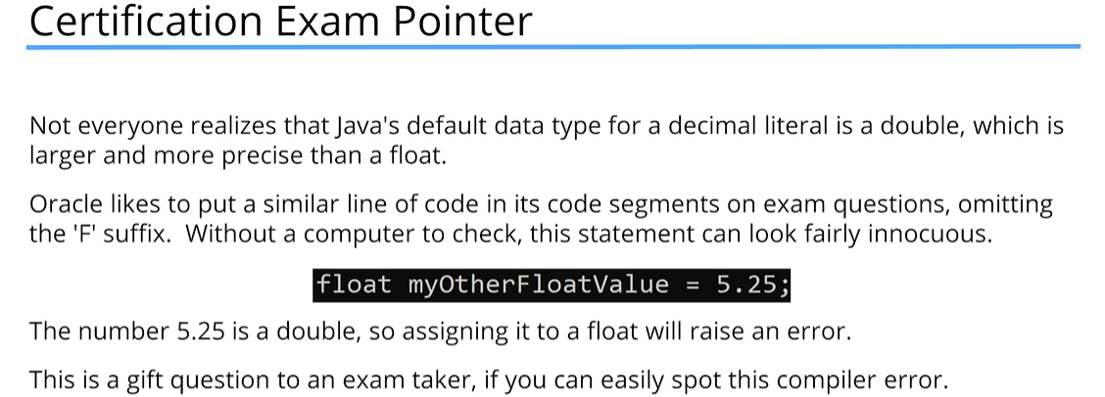

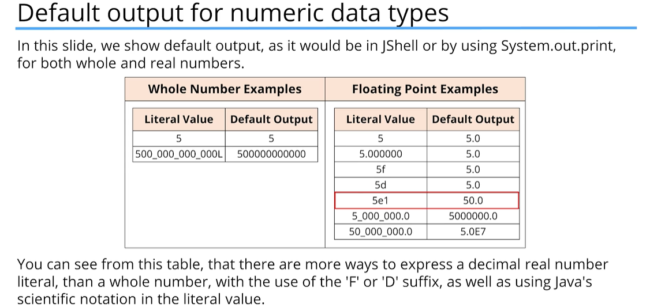

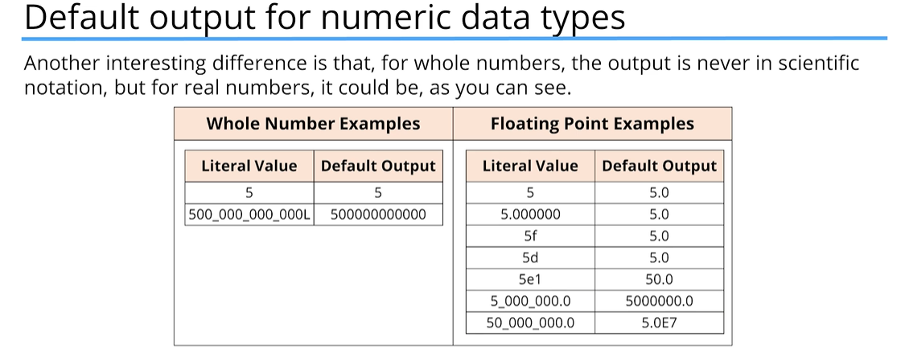

Why is the double a better choice in most circumstances?

* The double is faster to process on many modern computers because, at the chip level, computers have the functionality to actually deal with these double numbers faster than the equivalent float
* The Java libraries such as math functions and others are often written to process doubles and not floats, and to return the result as a double
* The creators of Java selected the double because it’s more precise, and it can handle a larger range of numbers

### Char Data Type

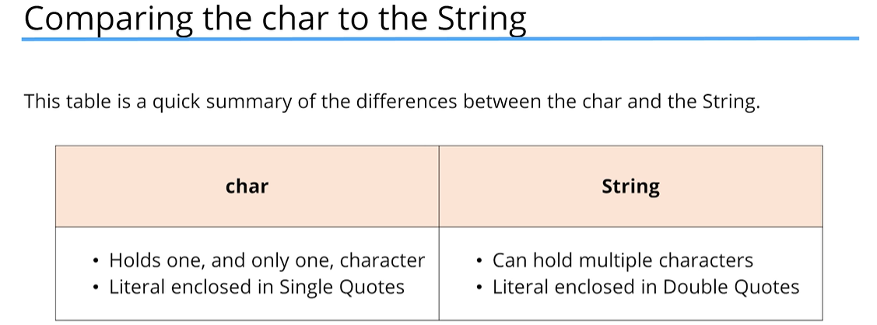

Is there a good use for the char data type in today’s computing world?

* Why would you want to use a variable that only allows you to store one character?
* One example might be to store the last key pressed by a user in a game
* Another example might be to loop programmatically through the letters in an alphabet

char Data Type

* A char occupies two bytes of memory, or 16 bits, and thus has a width of 16
* The reason it’s not just a single byte is that a char is stored as a 2-byte number, similar to the short.
* This number gets mapped to a single character by Java
  + When you print a char, you will see the mapped character and not the representative number
  + You can use single-quotes and a character literal to assign a value to a char, which is much simpler than looking up the representative number

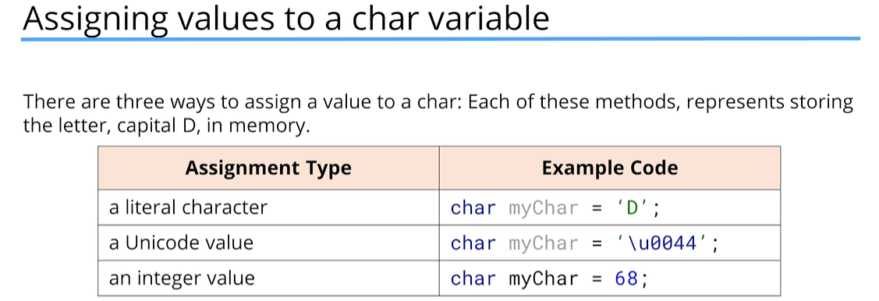

### Boolean Primitive Type

* A Boolean value allows for two opposite choices, true or false, yes or no, one or zero
* In Java terms, we’ve got a boolean primitive type, and it can be set to two values only – either true or false
* The wrapper class for boolean is Boolean with a capital B.
* Developers often use the word ‘is’ as a prefix for a boolean variable name
* This creates a name that seems to ask a question, which makes reading the code more intuitive.
* Other prefixes can be just as valid

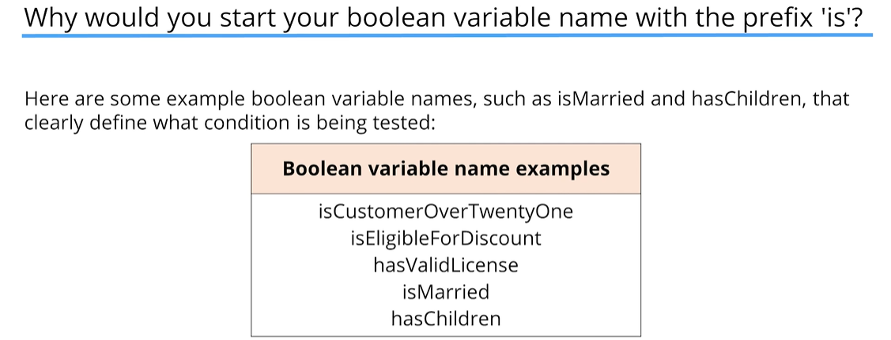

### Handling Data in Java

* Most Java programs use some combination of the data types shown below:
  + Java’s Primitives – boolean, byte, char, double, float, int, long, short
  + Java’s Built-in Classes – Wrappers (Boolean, Byte, Character, etc.), BigDecimal, **String**
  + Your Classes
  + Somebody Else’s Classes

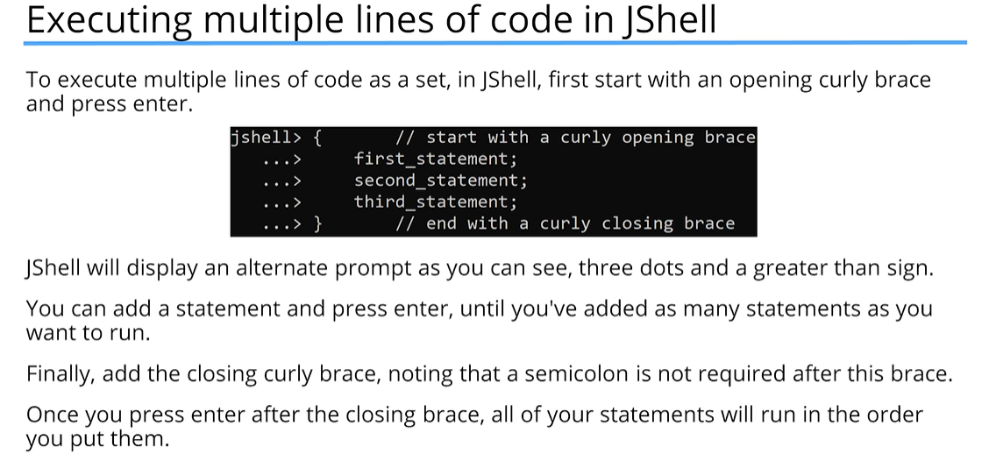

### String Concatenation

* In Java, the ‘+’ symbol is an operator which can mean addition if used for numbers, but it also means concatenation when applied to a String.
* A String + anything else gives us a String as a result, concatenating anything after the String as text to the initial String.

### Strings are Immutable

* Immutable means that you can’t change a String after it’s created.
* So, in the case of the code we’ve written, the value of 120.47 is technically not appended to the current contents of **lastString**.
* Instead, a new String is created automatically by Java. The new String consists of the previous value of **lastString**, plus a textual representation of the double value 120.47.
* The net result is that our variable, **lastString**, has the concatenated value. However, Java created a new String in the process, and the old one will get discarded from memory automatically.

### String vs StringBuilder

* The String class is immutable but can be used much like a primitive data type.
* The StringBuilder class is mutable, meaning that it can be changed, but does not share the Strings special features, such as being able to assign it a String literal or use the plus operator on it.
* Both are classes, but the String class is in a special category in the Java language.

### Operators

* Operators in Java are special symbols that perform specific operations on one, two, or three operands and then return a result.
* In our previous examples, we used the addition operator as well as the multiplication operator, but there are many other operators in Java.

### Operands

* An operand is a term used to describe any object that is manipulated by an operator.

int myVar = 15 + 12;

* In the example above, the plus sign is the operator, and 15 & 12 are the operands. Variables that are used instead of literals can also be operands.

**Expression** – *an* ***expression*** *is formed by combining variables, literals, method return values, and operators. They are a way of forming and combining those values to produce a result.*

* In the example above under Operands, [15 + 12] is the expression. If variables are used, something like [byteValue + shortValue + intValue] is the expression

**Comment** – ***comments*** *are ignored by the computer and are added to the program to help describe something. Comments are there for humans to read. We use two forward slashes in front of any code or blank line. Anything that comes after the two forward slashes, right through to the end of the line, is ignored by the computer.*

//this is a comment

* Aside from describing something about a program, comments can also be used to temporarily disable code

**Block Comment** – ***block comments*** *are the same as comments but are multi-line comments and are marked by starting with a forward slash and an asterisk, then closed out with an asterisk followed by a forward slash –*

/*

this is

a block comment

*/

If you have two char variables and try to add them together, chars treat the ‘+’ operator differently. Instead of concatenating, it will add the decimal value of the characters

char firstChar = ‘A’; char secondChar = ‘B’;

System.out.print(firstChar + secondChar);

131 //’A’ decimal value = 65, ‘B’ decimal value = 66 -> thus, 65 + 66 = 131

Multiplication operator is represented by the asterisk symbol: *

Division operator is represented by the forward slash: /

### The Remainder Operator

* The remainder operator is represented in Java by the % sign and goes by several other names: modulus, modulo, or just plain mod for short.
* The remainder operator returns the remaining value from a division operation. If there is no remaining value, the result is 0.

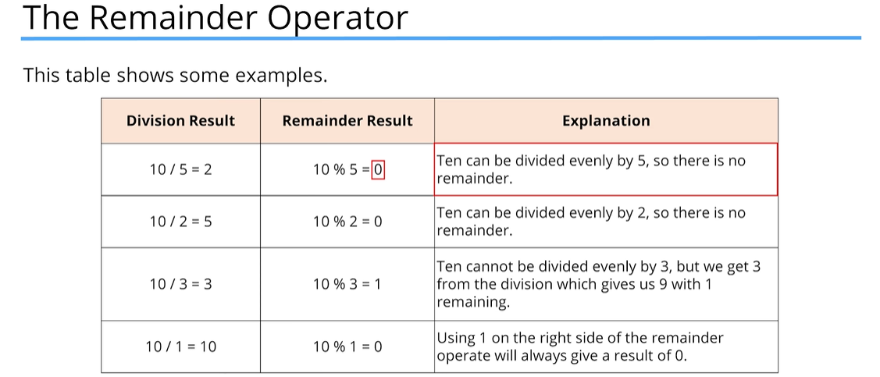

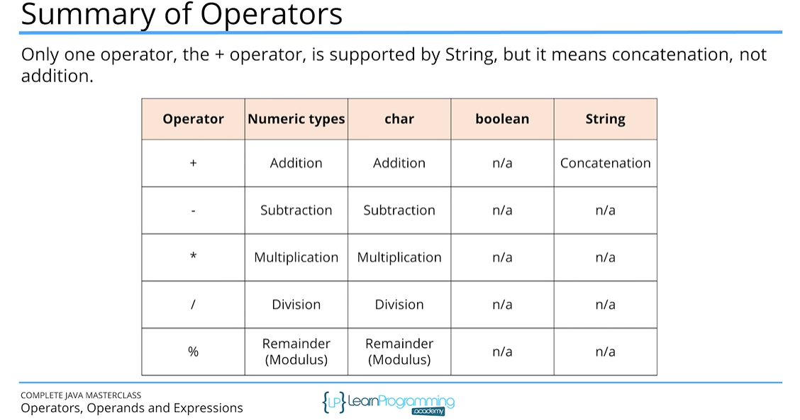

Why do we use multiple statements in curly braces {}?

* It’s a way to group statements together before executing them.
* It allows us to put statements on multiple lines which is more natural and readable.
* We can execute the group of statements as a whole, which more closely resembles running code in Java.

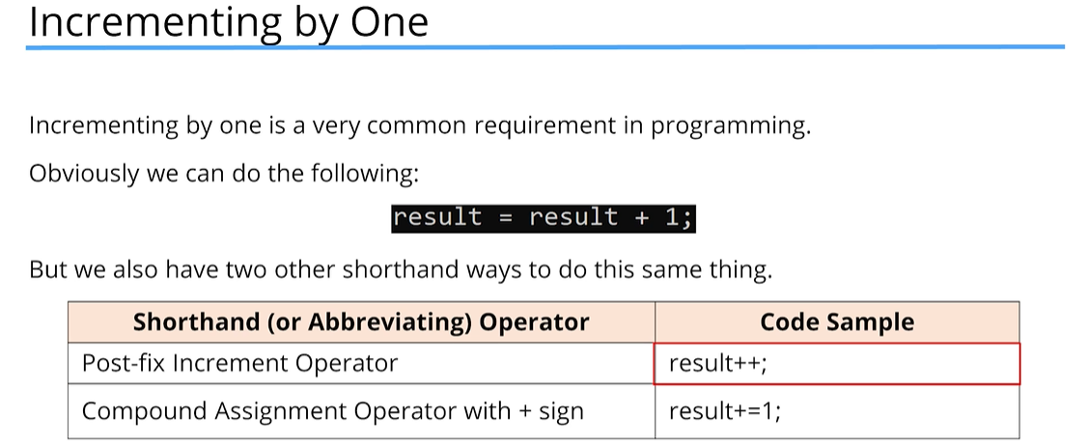

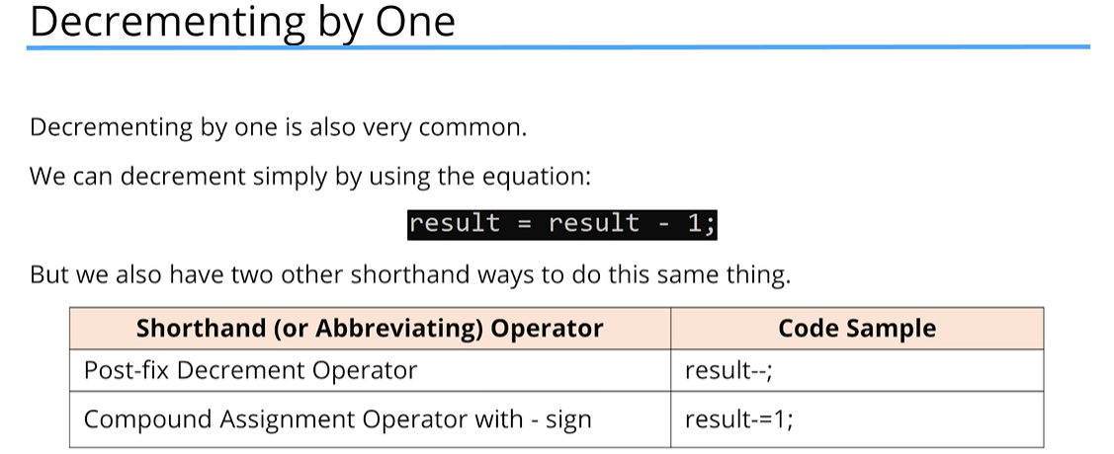

### Compound Operator Assignment

When **result** is an **int**, the compound operator assignment: result -= 5.5; gives us a different result from what we expect, which was result = result – 5.5;

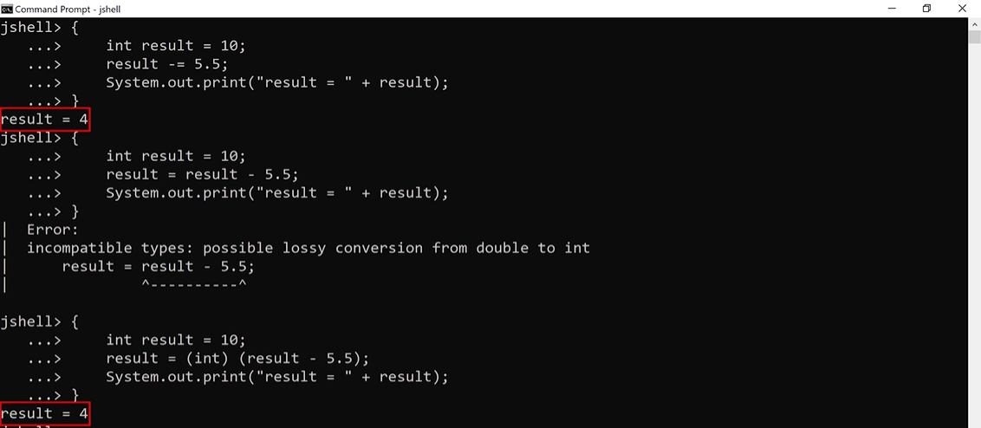

x -= y

Is really

x = (data type of x) (x – y)

An implicit cast is done when using this operator, so no error occurs, but unexpected results happen, as we have seen.

So, summarizing for our own sample of code:

result -= 5.5;

is really

result = (int) (result – 5.5);

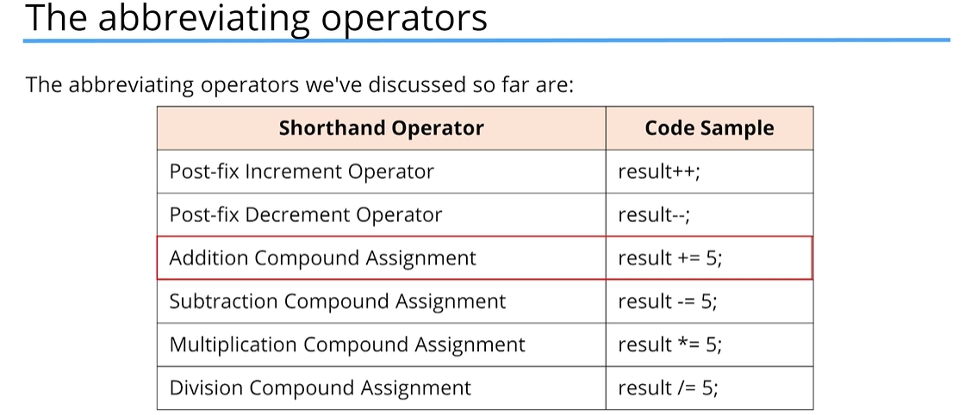

## Section 4 – IntelliJ Introduction

### Why do we need an Integrated Development Environment (IDE)?

An IDE is the easiest, least error-prone way to develop, manage and deploy Java classes. It provides many benefits to developers including:

* increased productivity,
* code completion,
* refactoring of code,
* debugging tools,
* version control,
* and team development, just to name a few

The main feature is a text editor that we type our code into, but an IDE also compiles and runs our programs for us. It also warns us about errors in our code before we run it.

### What is IntelliJ?

* IntelliJ IDEA is one of several IDE’s available for Java.
* It’s also written in Java, developed by JetBrains, and simply known as IntelliJ.
* JetBrains offers a free and open-source community edition.

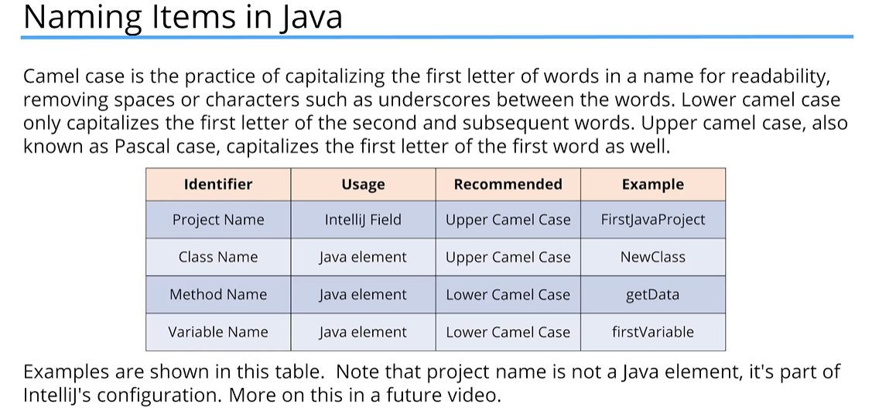

The **public** Java keyword is what’s called an **access modifier**. An access modifier allows us to define which parts of our code, or even someone else’s code, can access a particular element.

public static class FirstClass {

public static void main(String[] args) {

System.out.print(“Hello World!”);

}

}

The **class** keyword is used to define a class. The class name will be the text following the keyword, so in our first example above, **FirstClass** is the name.

Notice that the **left and right curly braces** are used to define the class code block or class body.

What is a Method?

A **method** is a collection of statements, one or more, that perform an operation.

Java looks for the Main method when running a program. The Main method is the entry point for any Java code, and Java looks for this method to start and run the program.

System.out.println() method adds a blank line after the line that it prints out

The **if-then** statement is the most basic of all the control flow statements. It tells your program to execute a certain section of code, only if a particular test evaluates to **true**. This is known as **conditional logic**.

**Conditional logic** uses specific statements in Java to allow us to check a condition, and execute certain code based on whether that condition (that expression) is **true** or **false**.

Without a **code-block**, only the first line immediately following the if-clause will be executed:

boolean isAlien = false;

if(!isAlien)

System.out.println(“It is not an alien!”); //only this line will be printed

Always use code-blocks for if-then statements

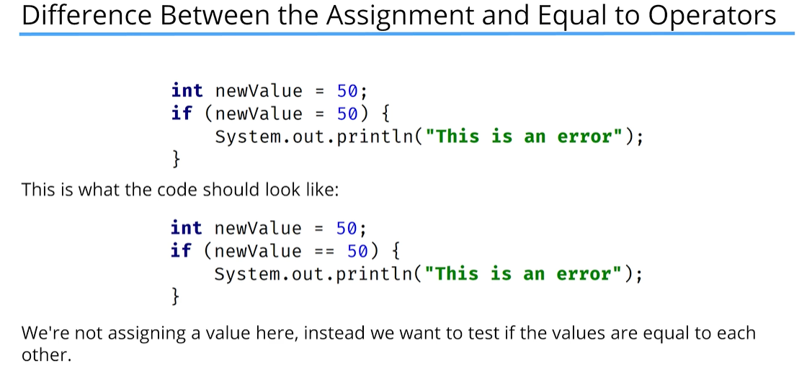

The exclamation mark (!), or **NOT** operator, is also known as the Logical Complement Operator. It can be used with a boolean variable to test for the opposite value.

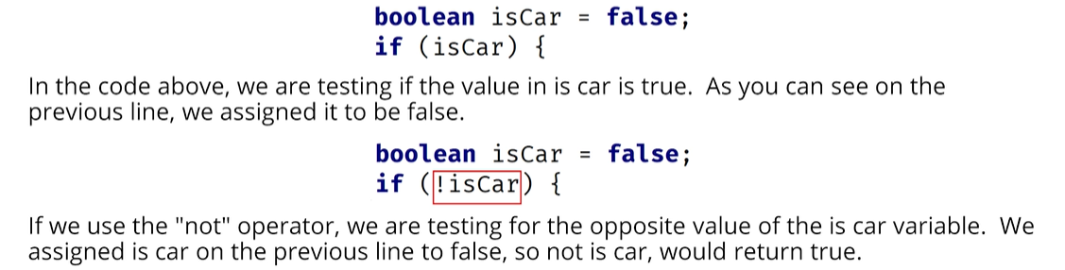

It’s recommended using the abbreviated form if your variables are booleans for two reasons:

* It’s much harder to identify the error if you accidentally use an assignment operator. IntelliJ won’t flag this as an error when you’re testing a boolean variable, so the only way you’ll know you made this common mistake is by discovering that your program or output isn’t what you expected.
* Secondly, the code is more concise, and more concise code can often be more readable code.

### Ternary Operator (Condition?:Operator)

The ternary operator has three operands. The only operator currently in Java that has three. Officially, Java calls it the conditional operator.

The structure of this operator is:

**operand1 ? operand 2 : operand3**

The **ternary** operator is a shortcut to assigning one of two values to a variable, depending on a given condition, or in other words, it’s a shortcut of the if-then-else statement.

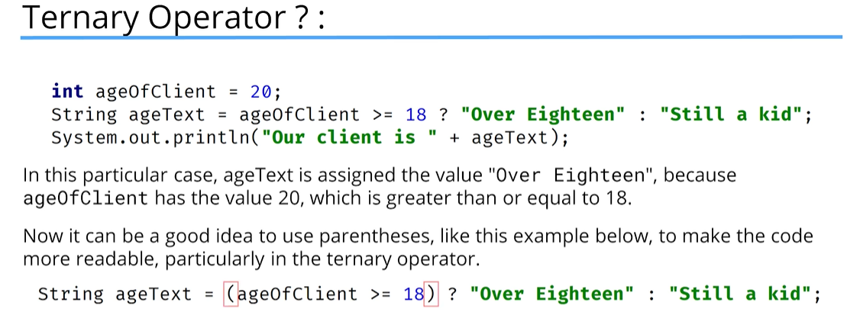

## Section 5 – Expressions, Statements, and More

Writing code is similar to writing a document. It consists of special hierarchical units which, together, form a whole. These are:

The **Expression** – *an expression computes a single value.*

The **Statement** – *statements are stand alone unites of work.*

**Code Blocks** – *a code block is a set of zero, one or more statements, usually grouped together in some way to achieve a single goal*

int myVariable = 50;

In the example above, ‘myVariable = 50’ is the expression, and the entire line ‘int myVariable = 50;’ with the semi-colon at the end is a statement.

With IntelliJ – go to Code -> Reformat Code

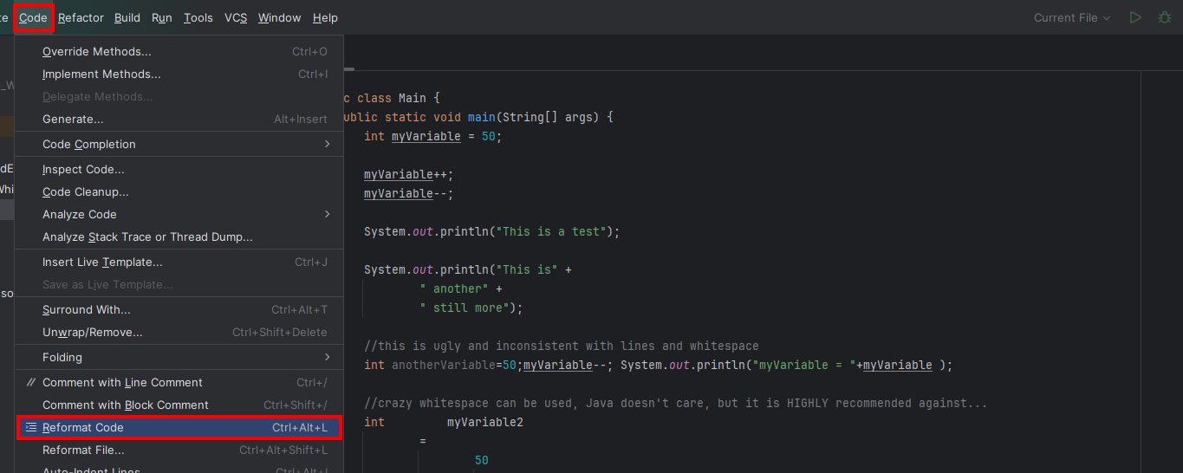

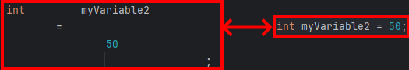

Whitespace Coding Conventions

Code conventions for whitespace do exist, which you can refer to for more detail.

The Google Java Style Guide, which was seen previously in this course, has a section on whitespace, so refer to that for more information. Link to document is [here](https://google.github.io/styleguide/javaguide.html#s4.6-whitespace).

If with an Else block

if(condition) {

// Code in block will execute only if

// condition is true

} else {

// Code in block will execute only if

// condition is false

}

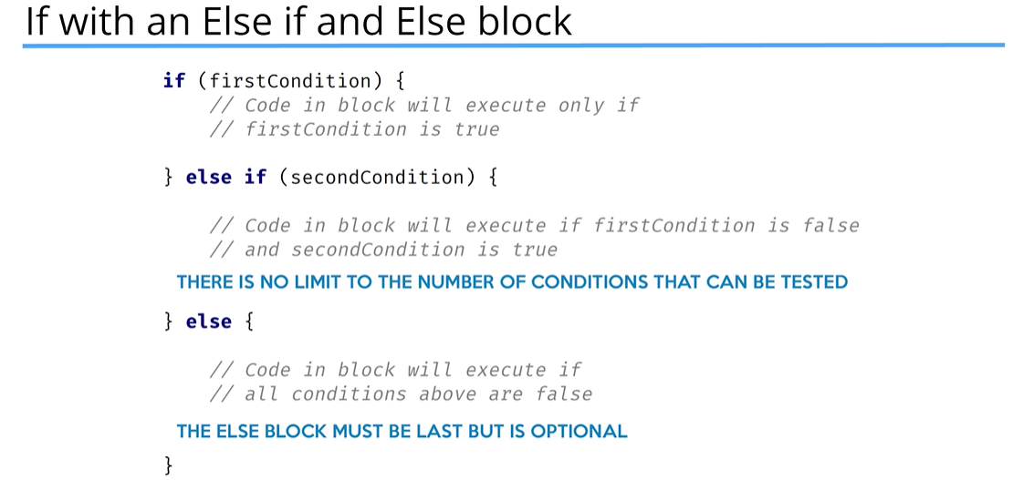

### The Method

Java’s description of the method is: a method declares executable code that can be invoked, passing a fixed number of values as arguments.

The Benefits of the Method

* A method is a way of reducing code duplication.
* A method can be executed many times with potentially different results, by passing data to the method in the form of arguments.

One of the simplest ways to declare a method is shown below:

This method has a name, but takes no data in, and returns no data from the method (which is what the special word ***void*** means in its declaration):

public static void methodName() {

//Method statements form the method body

}

To execute a method, we can write a statement in code, which we say is calling, or invoking, the method. For a simple method like calculateScore, we just use the name of the method where we want it to be executed followed by parentheses and a semi-colon to complete the statement.

calculateScore();

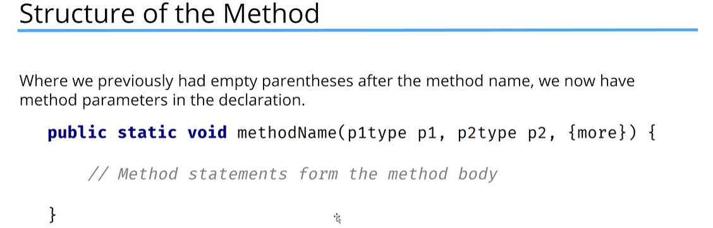

### Parameters or Arguments?

Parameters and arguments are terms that are often used interchangeably by developers.

But technically, a parameter is the definition as shown in the method declaration, and the argument will be the value that’s passed to the method when we call it.

To execute a method that’s defined with parameters, you have to pass variables, values, or expressions that match the type, order, and number of the parameters declared.

Similar to declaring a variable with a data type, we can declare a method to have a type.

This declared type is placed just before the method name.

In addition, a return statement is required in the code block which returns the result from the method:

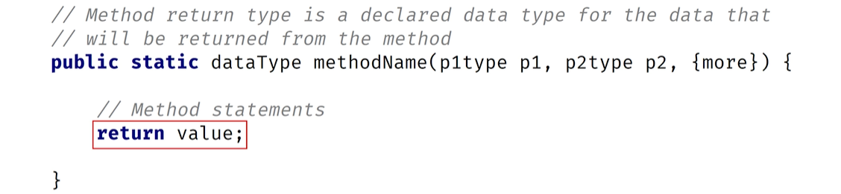

### The return Statement

Java states that a **return** statement returns control to the invoker of a method. The most common usage of the return statement is to return a value back from a method.

In a method that doesn’t return anything, in other words, a method declared with void as the return type, a return statement is not required. It is assumed and execution is returned after the last line of code in the method is executed. But in methods that ***DO*** return data, a return statement with a value is required.

What are functions and procedures?

* Some programming languages will call a method that returns a value a function, and a method that doesn’t return a value a procedure.
* You’ll often hear function and method used interchangeably in Java.
* The term procedure is somewhat less common when applied to Java methods, but you may still hear a method with a void return type called a procedure.

### Declaring a method

There are quite a few declarations that need to occur for a method to be created.

This consists of:

* Declaring Modifiers – these are keywords in Java with special meanings. We’ve seen public and static as examples, but there are others.
* Declaring the return type:
  + **void** is a Java keyword meaning no data is returned from a method.
  + Alternatively, the return type can be any primitive data type or class.
  + If a return type is defined, the code block must use at least one return statement, returning a value of the declared type or comparable type.
* Declaring the method name – lower camel case is recommended for method names.
* Declaring the method parameters in parentheses – a method is not required to have parameters, so a set of empty parentheses would be declared in the case that there are none.
* Declaring the method block with opening and closing curly brackets {}. This is also called the method body

**Declaring the Parameters**

* Parameters are declared as a list of comma-separated specifiers, each of which has a parameter type and a parameter name (or identifier).
* Parameter order is important when calling the method.
* The calling code must pass arguments to the method with the same or comparable type, and in the same order as the declaration.
* The calling code must pass the same number of arguments as the number of parameters declared.

**Declaring the Return Type**

When declaring a return type:

* **void** is a valid return type and means no data is returned.
* Any other return type requires a return statement in the method code block.
* If a method declares a return type, meaning it’s not void, then a return type is required at any exit point from the method block.
* In the case of using a return statement in nested code blocks in a method, all possible code segments must result in a value being returned.
* One common practice is to declare a default return value at the start of a method, and only have a single return statement from a method, returning that variable as shown below:

public static boolean isTooYoung(int age) {

boolean result = false;

if(age < 21) {

result = true;

}

return result;

}

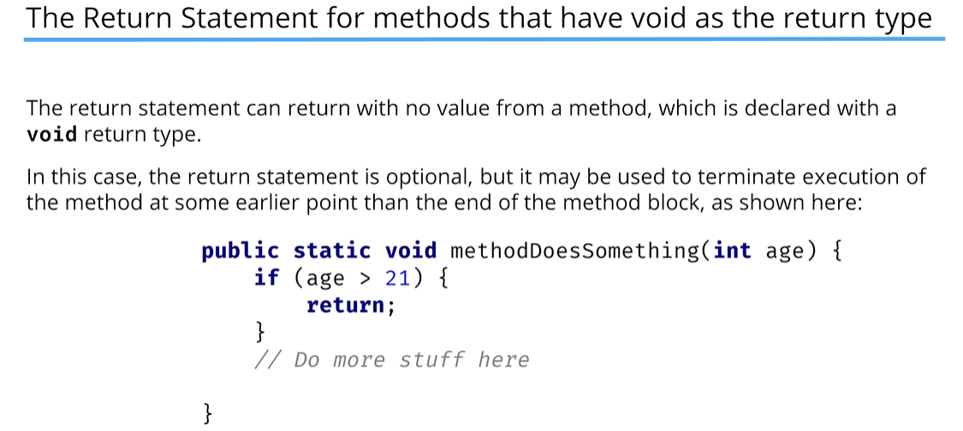

The Method Signature

* A method is uniquely defined in a class by its name and by the number and type of parameters that are declared for it. This is called the method ***signature***.
* You can have multiple methods with the same method name, as long as the method signature (meaning the parameters declared) are different.
* A method signature consists of the name of the method and the uniqueness of the declaration of its parameters
* In other words, a signature is unique, not just by the method name, but in combination with the number of parameters, their types, and the order in which they are declared.
* A method’s return type is not part of the signature.
* A parameter name is also not part of the signature.

In many languages, methods can be defined with default values, and you can omit passing values for these when calling the method. However, Java doesn’t support default values for parameters.

There are workarounds for this limitation.

### Method Overloading

Method overloading occurs when a class has multiple methods with the same name, but the methods are declared with different parameters.

So, you can execute multiple methods with the same name, but call it with different arguments.

Java can resolve which method it needs to execute based on the arguments being passed when the method is invoked.

The type, order, and number of parameters, in conjunction with the name, make a method signature unique.

A unique method signature is the key for the Java compiler to determine if a method is overloaded correctly.

The name of the parameter is not part of the signature, and therefore it doesn’t matter what we call our parameters, from Java’s point of view.

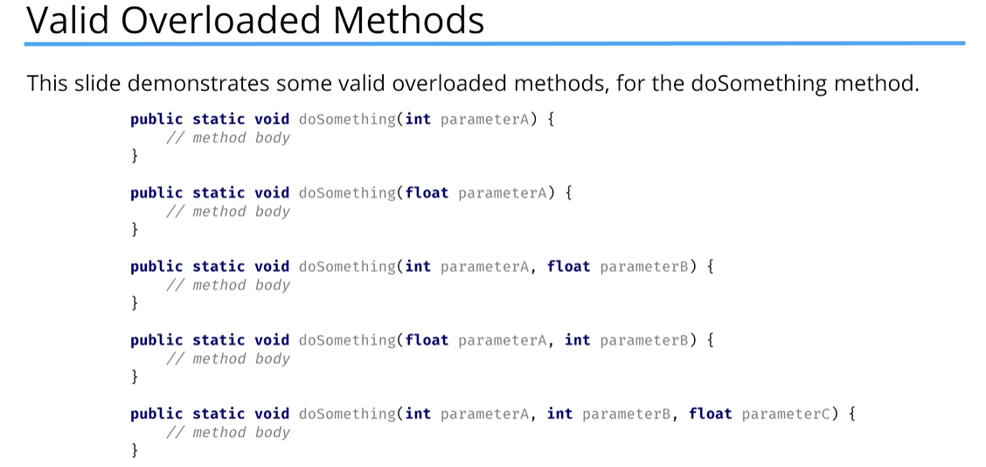

In the following examples, the first two methods have different parameter names, but the same type, so it will cause a compiler error. The first and the third method also have the same type and name for their parameters and only the return type is different, however, the return type is not included in the method signature. So, this will also cause a compiler error.

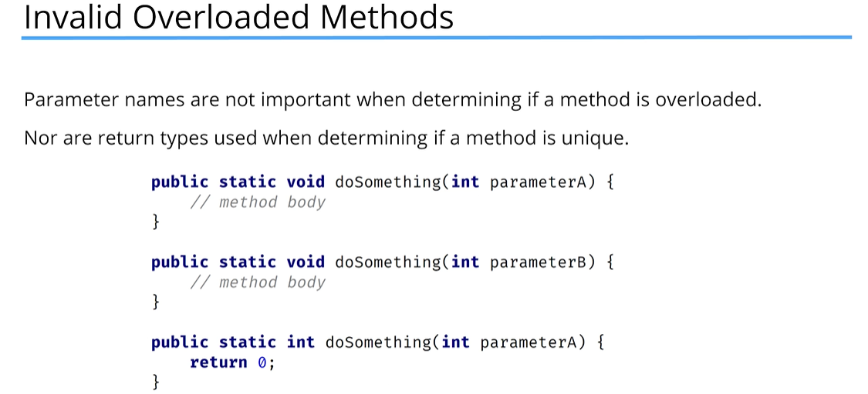

## Section 6 – Control Flow Statements

### Introduction

In this section we’re dealing with control flow statements. These are essential for programming to determine the flow of your program. In other words, what should be executed and under what conditions.

In this section, we’ll be learning about the **switch** statement, which like the if-then-else statement, allows you to execute different code blocks based on different conditions.

We’ll also be looking at three additional statements. The for statement, the while statement, and the do-while statement, which are used to repeat segments based on conditions you set.

### The switch statement:

switch(value) {

case x :

// code for value == x

break;

case y : case z : (you can add additional cases if the code will be the same for multiple values)

// code for value == y and value == z

break;

default :

// code for any value not equal to x or y

break;

}

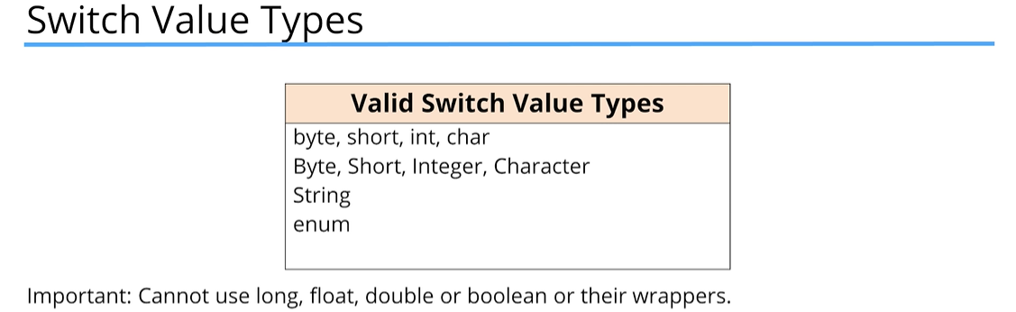

Fall through within a switch statement:

* Once a switch case label matches the switch variable, no more cases are checked.
* Any code after the case label where there was a match found will be executed, until a break statement or the end of the switch statement occurs.
* Without a break statement, execution will continue to fall through any case labels declared below the matching one and execute each case’s code.

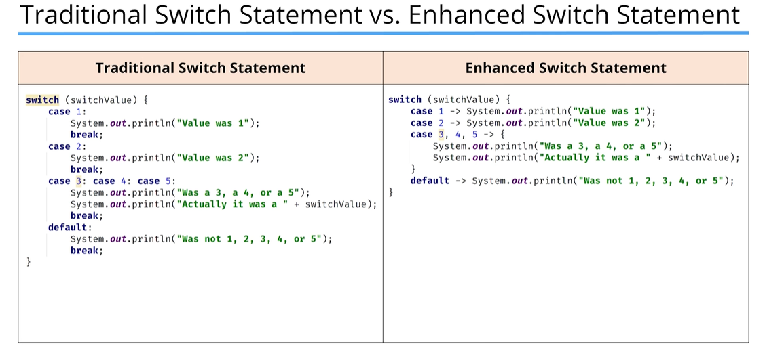

With the enhanced switch statement, there is no fall through, as the break statement is omitted.

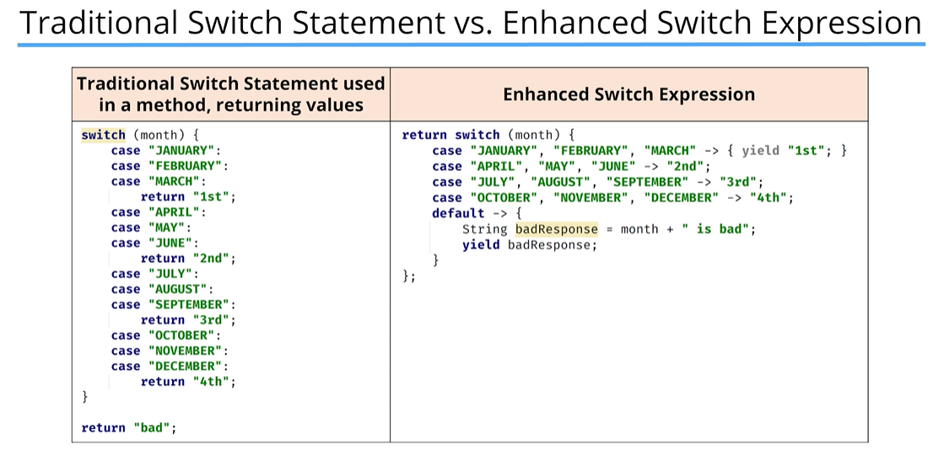

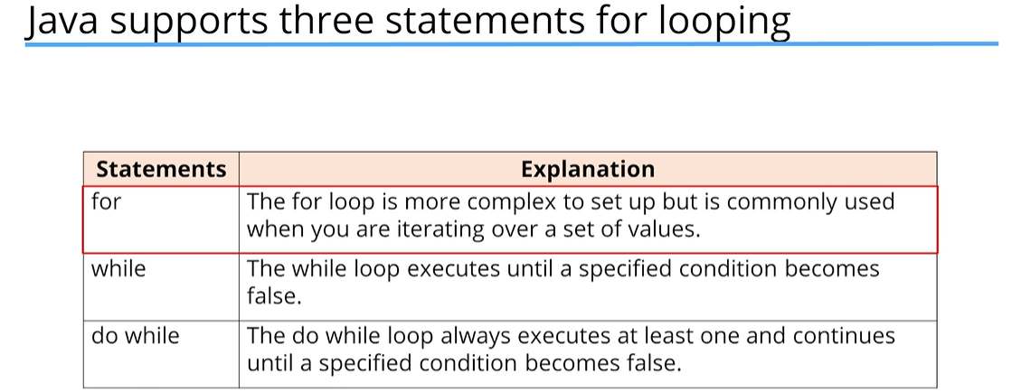

### The for statement

The for-statement is often referred to as the for-loop. It repeatedly loops something until a condition is satisfied.

The break statement

A break statement transfers control out of an enclosing statement.

We’ve seen the break statement in the switch statement, but it can also be used in a for loop.

**The continue statement**

The continue statement, in its simplest form, will stop executing the current iteration of a block of code in a loop and start a new iteration.

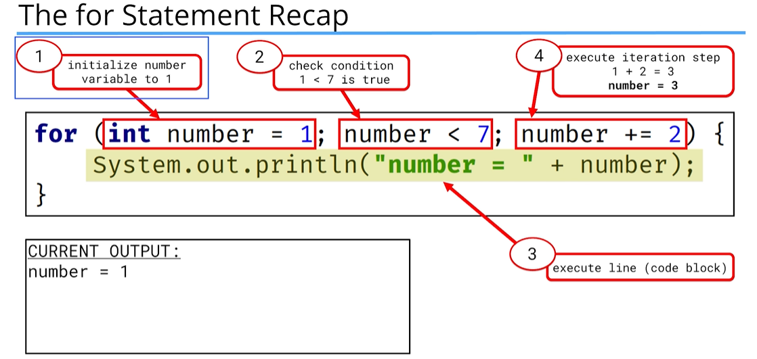

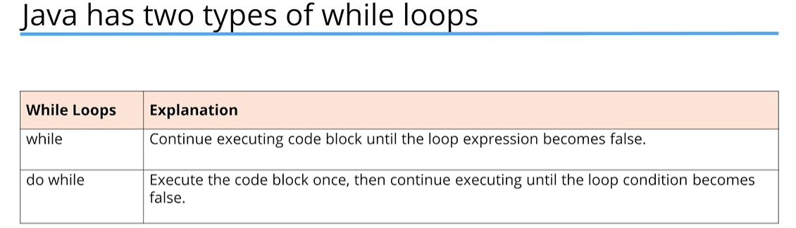

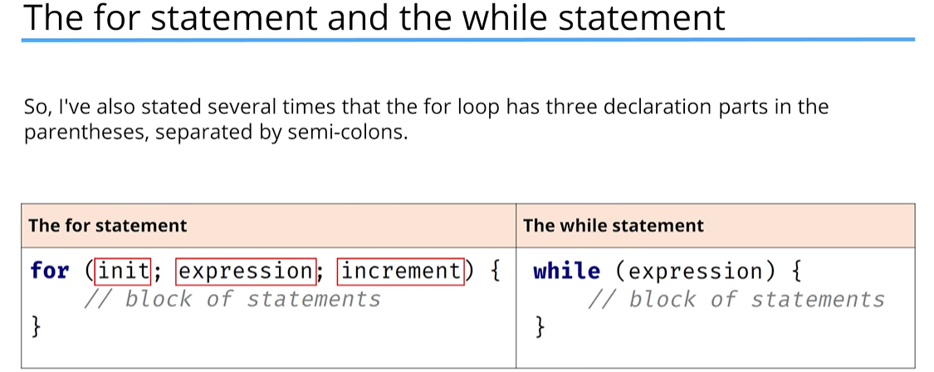

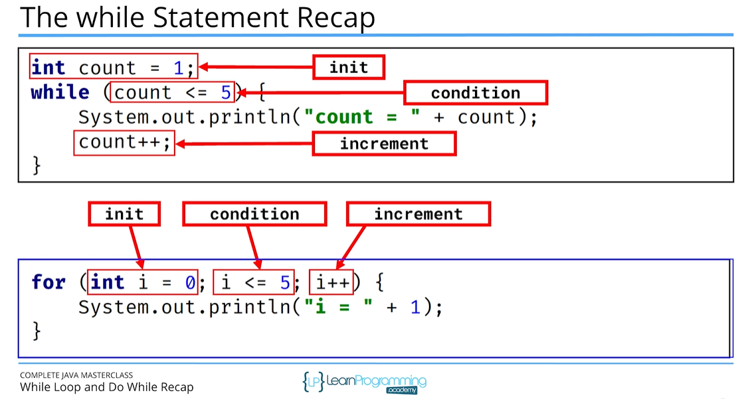

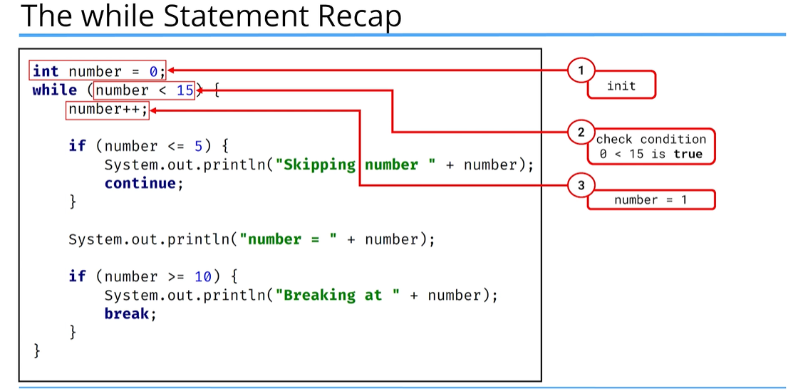

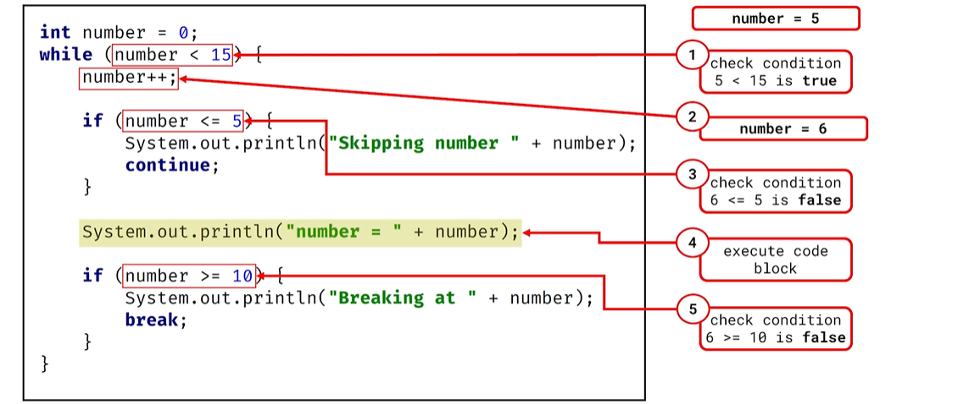

### Continue and Break

* The continue and break statements both interrupt normal loop processing.
* The continue statement starts a new iteration but continues to iterate through the loop.
* The break statement exits the loop at the point it’s executed and no longer completes any code in the loop, and the loop will no longer continue iterating.

### Local Variables

A local variable is called local because it is available for use by the code block in which it was declared. It is also available to code blocks that are contained by the declaring block.

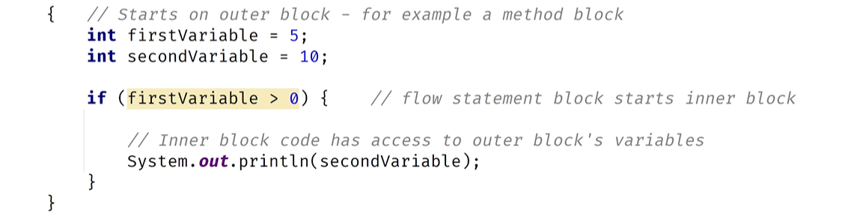

### Scope

Scope describes the availability of a variable.

* “In scope” means the variable can be used by an executing block or any nested blocks.
* “Out of scope” means the variable is no longer available and cannot be used.

Local variables are always in scope in the block they are declared. They are also in scope for any nested blocks or blocks contained within the other block.

Local variables are always out of scope for outer blocks or the containing blocks they are declared in.

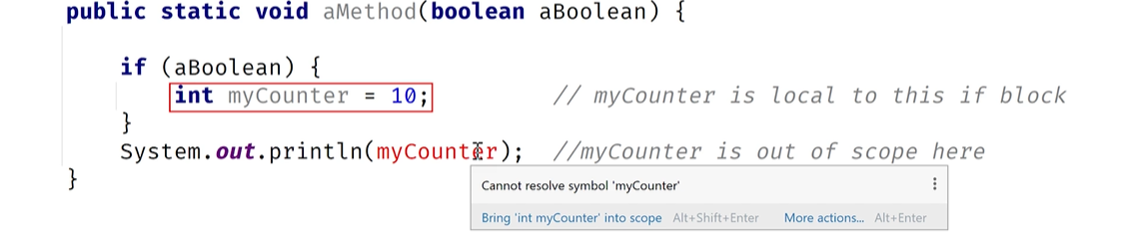

It is considered best practice:

* To declare and initialize variables in the same place, if possible
* And to declare variables in the narrowest scope possible. This simply means, if your variable is only used in a nested block, declare it there.

### Local Variables and the For Statement

In a **for** statement, as part of the declaration, there is an initialization part where a variable is declared. That variable is not accessible outside of the for loop.

This is because any variables declared in the init section are local to the loop, meaning they exist and are accessible in memory only while the loop is executing, thus, only in the loop code block.

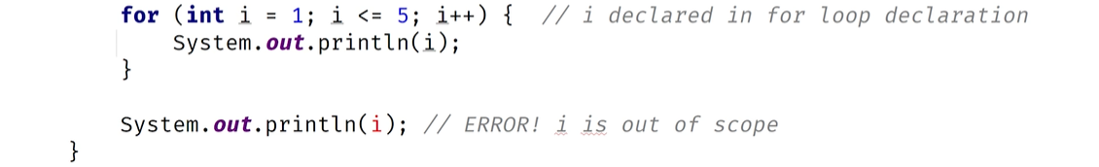

This is also true for the **if** statement. Local variables declared in an if statement block are not accessible outside of that block. This also includes other parts of the if-statement, like the else-if block or the else block.

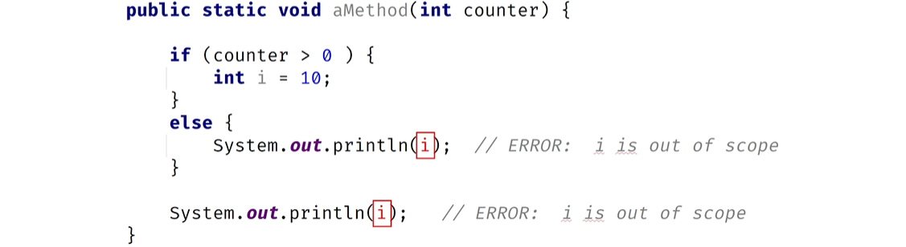

The **switch** statement is different from the if-then-else statement blocks. If a variable is declared in a case statement and it comes before the other case statements within the switch statement, that variable can be accessed by the other case statements. However, once the case statement finishes, the variable is no longer in scope.

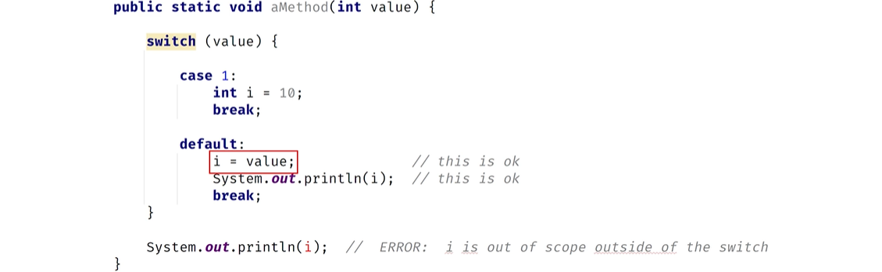

Local variables are a way to store and manipulate temporary data. In addition to local variables, we can set up data to be defined and used as part of a class or an object.

* First, attributes on classes are another way to store data
* Second, static methods on wrapper classes, which are classes we haven’t looked at yet, can be used as well. These methods will help pass strings into numeric values.
* Finally, there is a special class for reading input to create an interactive program

### Classes and Objects

A **class** can be described as:

* A custom data type
* A special code block that contains methods

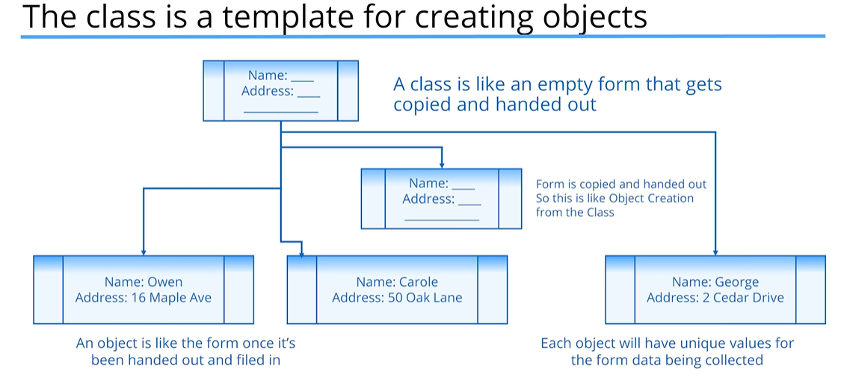

An **object** is called an instance of a particular class

* We call the creation of an object instantiation or instantiating a class
* We can use the term object or instance of a class interchangeably
* There is no limit to the number of objects or instances you can create from a class

A class is sometimes described as a cookie cutter and the cookies are your objects. A template is another word use when trying to describe a class’s relationship to an object.

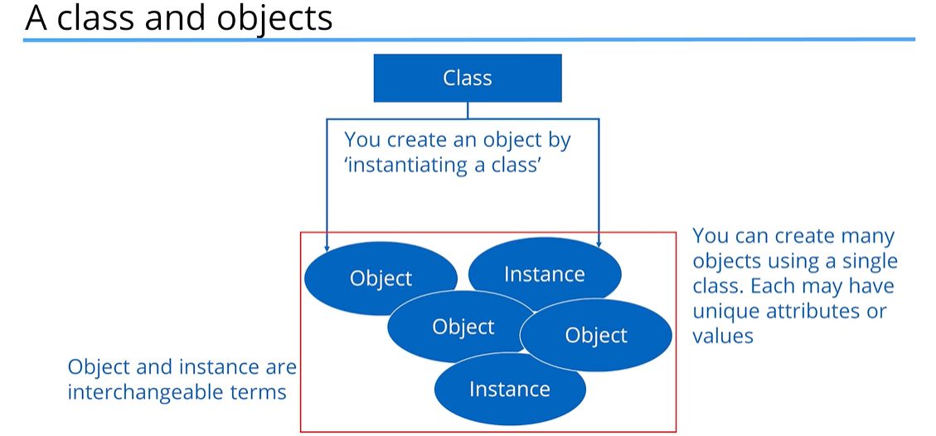

**Declaring and Instantiating a New Object From a Class**

* The most common way to create an object is to use the ‘new’ keyword
* The ‘new’ keyword creates an instance of a class, and you can optionally pass data when creating that instance to set up data on that object
* Looking at the String, it’s actually a class. However, it holds a special place in the Java language because we can create a String just by using a literal which we have seen:
  + String s = “Hello”;

But we could’ve used:

* + String s = new String(“Hello”);

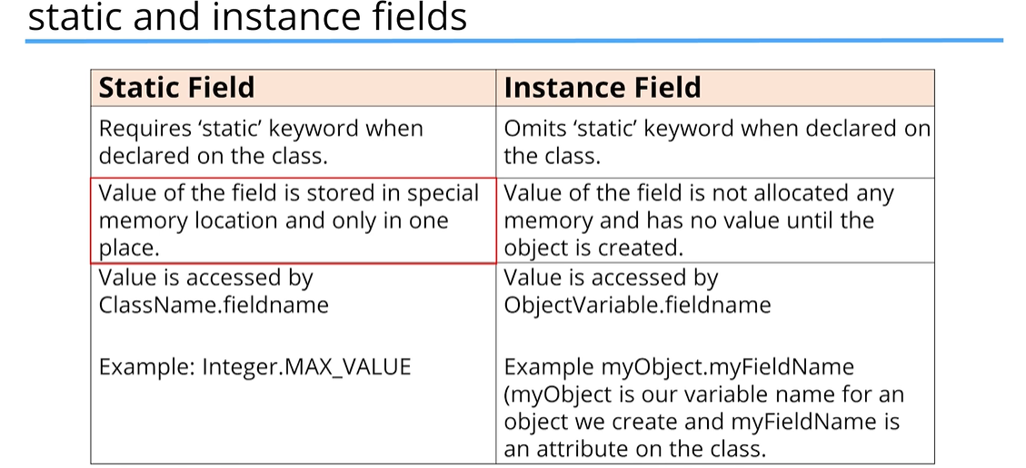

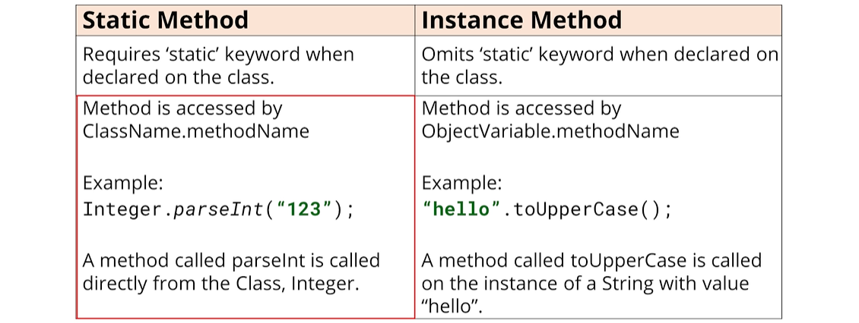

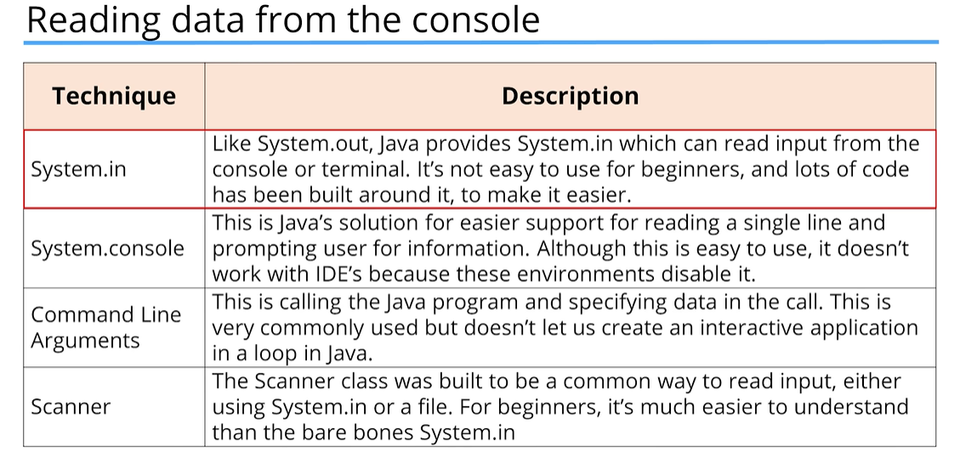

### Exceptions

What’s an Exception?

* An exception is an error that happens in code.
* Some types of errors can be predicted and named.

Catching an Exception

* An exception is caught first by creating a code block around the code that gets the error.
* This is done with the try statement code block.

The try statement

* The try statement actually has two code blocks.
* The first is declared directly after the try keyword, and this code block ends and is followed by the declaration of the catch keyword. The catch keyword includes the declaration of variables in parentheses and has its own code block:



### The Scanner class

* The Scanner class is described as a simple text scanner which can parse primitive types and strings.
* To use the Scanner class, we have to import the class from the java.util package and create an instance of Scanner.
* This means we’re creating an object of type Scanner.
* We’ll use the keyword ‘new’ to do it.

New keyword

* The ‘new’ keyword is used in what Java calls a Class Instance Creation Expression.
* In its simplest form, it’s the word ‘new’ followed by the classname and empty parentheses.

ClassName variableName = new ClassName();

* We can optionally pass arguments to those parentheses, as we saw with methods:

ClassName variableName = new ClassName(argument1, argument2);

* We saw that we could do this with the String class, passing the text in parentheses.

Instantiating Scanner

* For reading input from the console or terminal, we instantiate a scanner object using new, followed by the Scanner class name, and passing System.in as an argument in the parentheses.

Scanner sc = new Scanner(System.in);

* For reading input from a file, we instantiate a scanner object using new, again with the Scanner class name, but pass a file object as an argument within the parentheses.

Scanner sc = new Scanner(new File(“nameOfFileOnFileSystem”));

Using the import statement – this allows us to use other people’s code. In this code, Java provides a library of code which includes the Scanner class in a library called java.util.

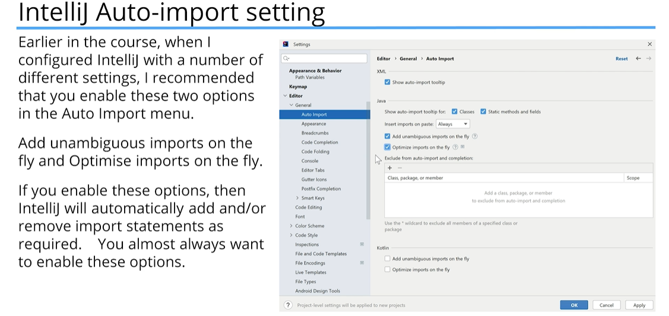

## Section 7 – OOP Part 1 – Inheritance

### What is Object-Oriented Programming?

Object-Oriented Programming is a way to model real-world objects as software objects which contain both data and code.

OOP is a common acronym for Object-Oriented Programming. OOP is sometimes called class-based programming.

Class-based programming starts with classes which become the blueprints for objects. But, what does this really mean? To start, we need to understand what objects really are. They’re really the key to understanding this object-oriented terminology.

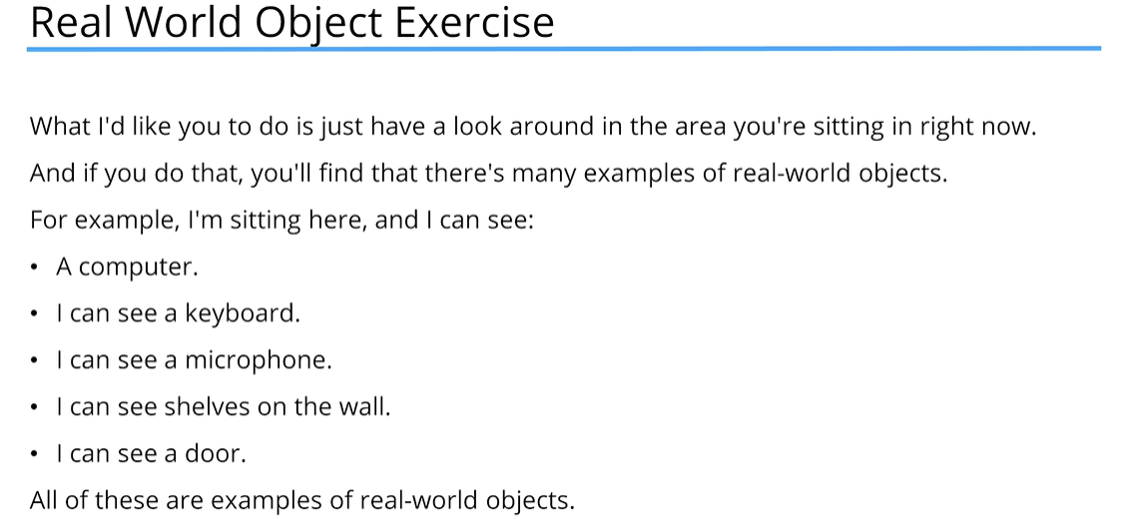

### State and Behavior

Real-world objects have two major components:

* State
* Behavior

State (Computer)

State, in terms of a computer object, might be:

* The amount of RAM it has.
* The operating system it’s running.
* The hard drive size.
* The size of the monitor.

These are characteristics about the item that can describe it.

State (ant)

We could also describe animate objects like people, animals, or even insects like an ant.

For an ant, the state might be:

* The age.
* The number of legs.
* The conscious state.
* Whether the ant is sleeping or awake.

Behavior (computer)

In addition to state, objects may also have behavior or actions that can be performed by the object, or upon the object.

Behavior, for a computer, might be things like:

* Booting up.
* Shutting down.
* Beeping or outputting some form of sound.
* Drawing something on the screen, and so on.

All of these could be described as behaviors for a computer.

Behavior (ant)

For an ant, behavior might be:

* Eating.
* Drinking.
* Fighting.
* Carrying food, etc.

Modeling real-world objects as software objects is a fundamental part of Object-Oriented Programming. A software object stores its state in fields, which can also be called variables or attributes. Objects expose their behavior with methods, which we’ve talked about before.

Think of a class as a template or a blueprint for creating objects.

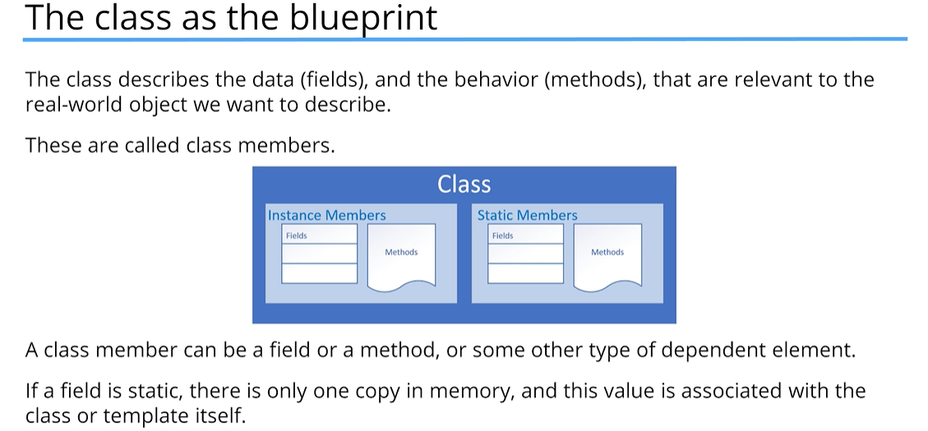

* If a field is not static, it’s called an instance field, and each object may have a different value for this field.
* A static method can’t be dependent on any one object’s state, so it can’t reference any instance members.
* In other words, any method that operates on instance fields needs to be non-static.

### Organizing Classes

* Classes can be organized into logical groupings which are called packages.
* You declare a package name in the class using the package statement.
* If you don’t declare a package, the class implicitly belongs to the default package.

Access Modifiers for the Class

* A class is said to be a top-level class if it is defined in the source code file and not enclosed in the code block of another class, type, or method.
* A top-level class has only two valid access modifier options: public or none:

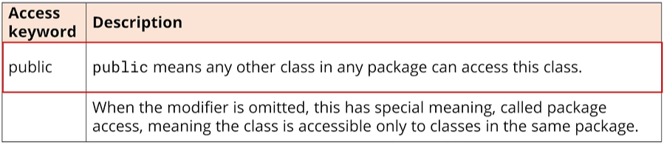

Access Modifiers for Class Members

* An access modifier at the member level allows granular control over class members.
* The valid access modifiers are shown in this table from the least restrictive to the most restrictive.

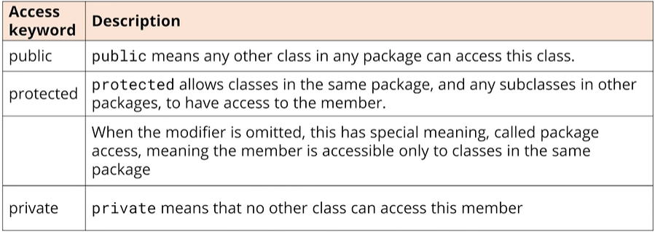

As a general rule, all fields in a class should be private. This practice is known as Encapsulation, and it’s a key, fundamental rule of object-oriented programming.

### Encapsulation

Encapsulation in Object-Oriented Programming usually has two meanings:

* One is the bundling of behavior and attributes on a single object.
* The other is the practice of hiding fields and some methods from public access.

What is null?

* null is a special keyword in Java, meaning, the variable or attribute has a type but no reference to an object.
* This means that no instance or object is assigned to the variable or field.
* Fields with primitive data types are never null.

Default values for fields on classes

* Fields on classes are assigned default values automatically by Java, if you don’t assign values yourself.

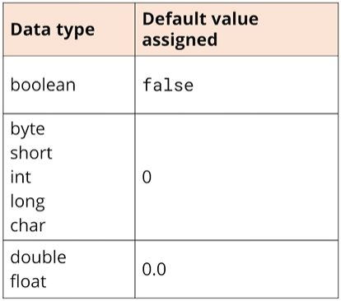

What Are Getters and Setters? Why Should We Use Them?

* What are getters and setters?
* A getter is a method on a class that retrieves the value of a private field and returns it.
* A setter is a method on a class that sets the value of a private field.
* The purpose of these methods is to control and protect access to private fields.
* Another important aspect is that the getter and setter methods’ signatures are part of the class’s public interface, but the field names and types are not.
* This means that things can be changed internally, like the name or type of a field, but as long as the same getter and setter methods are used, the changes should have no effect on external code that uses the class. The internal changes are hidden from the users.

A getter method usually just returns the value of a private field. It’s usual to name a getter with the ‘get’ prefix, followed by the field name in lower camel case, but this is not required. (i.e. getColor)

You can have getter methods that are not really declared on the class, but are derived in some way.

A setter method may simply just assign an argument/value passed to the method to a field, but it may also have additional code to validate data, check additional security requirements, ensure immutability of the field value, or any other code required to protect and validate an object’s state.

It’s usual to name a setter method with the ‘set’ prefix followed by the field name in lower camel case.

### This

this is a special keyword in Java.

What it really refers to is the instance that was created when the object was instantiated. So, this is a special reference name for the object or instance, which it can use to describe itself.

We can use ‘this’ to access fields on the class.

### Constructor

A **constructor** is used in the creation of an object. It is a special type of code block that has a specific name and parameters, much like a method. It has the same name as the class itself., and it doesn’t return any values.

You never include a return type from a constructor, not even void. You can, and should, specify an appropriate access modifier to control who should be able to create new instances of the class using this constructor.

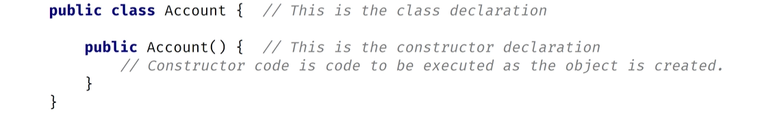

What you can do with a constructor is essentially set the values of the fields in the instance of your class. In addition, you can add other initialization code you want to perform in the constructor.

It turns out that a constructor is created for us implicitly by Java in the byte code, generated during the compilation process. When you declare a new instantiation of a class using the keyword ‘new’, then the class with parentheses after, it is actually calling the implicit constructor. (BankAccount account1 = new BankAccount();)

This is called the *default constructor*.

The default constructor:

* If a class contains no constructor declarations, then a default constructor is implicitly declared.
* This constructor has no parameters and is often called the no-args (no arguments) constructor.
* If a class contains any other constructor declarations, then a default constructor is NOT implicitly declared.

**Constructor Overloading**

Constructor overloading is the same as method overloading – it is declaring multiple constructors with different parameters. The number of parameters can be different between constructors, or, if the number of parameters is the same between constructors, their types or order of the types/parameters must be different.

**Constructor Chaining**

Constructor chaining is when one constructor explicitly calls another overloaded constructor. You can only use constructor chaining within constructors.

You must use the special statement this() to execute another constructor, passing it arguments, if required. And this() must be the first executable statement if it’s used from another constructor.

**References vs Objects vs Instances vs Classes**

By now we have used the words reference, object, instance, and class frequently. These new concepts may well be confusing at first.

We will be going through all of these terms and showing exactly what each of these words mean in the context of Java programming.

Using the analogy of building a house to understand classes – a class is basically a blueprint for the house. Using the blueprint, we can build as many houses as we like based on those plans.

Each house we build (in other words, going back to programming terms, each house we instantiate using the new operator) is an object.

This object can also be known as an instance. Often, we’ll say it’s an instance of the class. So, we would have an instance of house in this example.

Getting back to the physical world – each house we build has an address (it’s built at a physical location). In other words, if we want to tell someone where we live, we give them our address (perhaps written on a piece of paper). This is known as a reference.

We can copy that reference as many times as we like, but there is still just one house that we are referring to. In other words, we’re copying the paper that has the address on it, not the house itself.

Again, back to programming terms – we can pass references as parameters to constructors and methods.

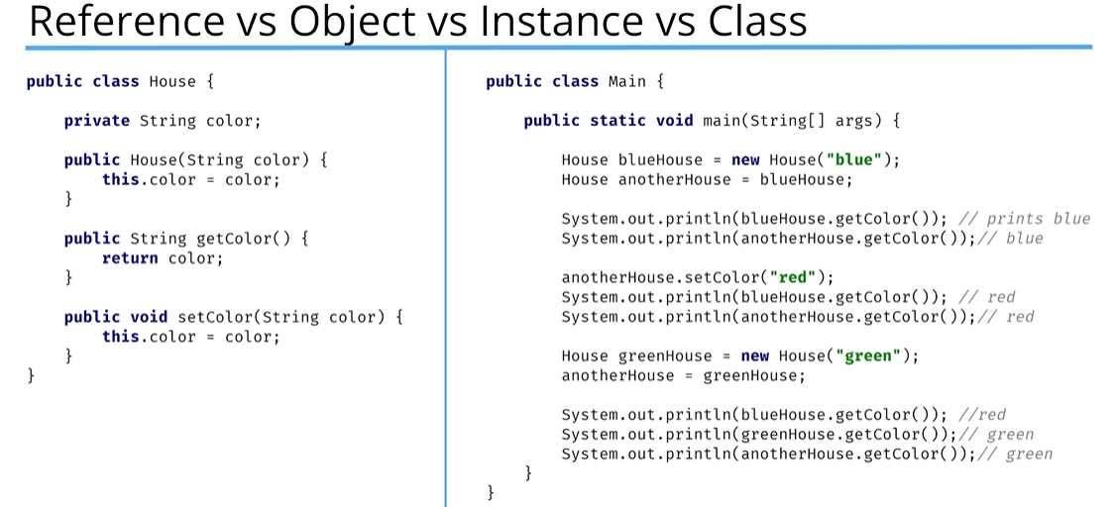

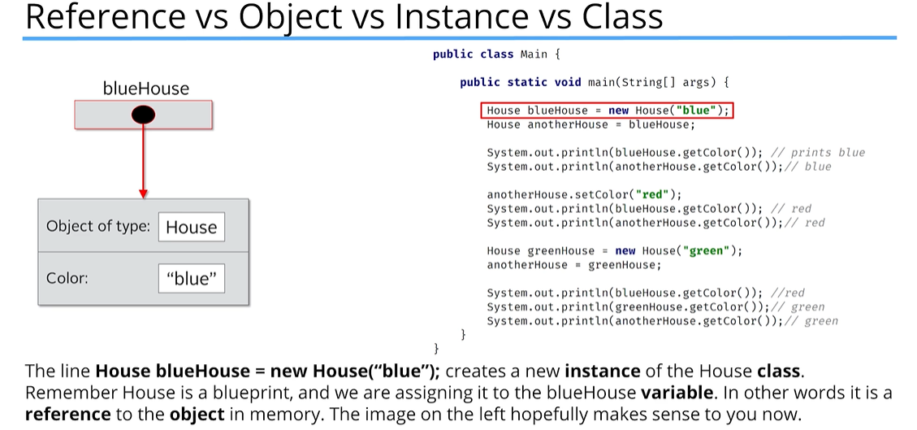

The next line **House anotherHouse = blueHouse;** creates another **reference** to the same object in memory. Here we have two **references** pointing to the same object in memory. There is still one house, but two **references** to that one object. In other words, we have two pieces of paper with the physical address of where the house is built (going back to our real world example).

Next, we have two println statements that print the blueHouse color and anotherHouse color. Both will print “blue” since we have two **references** to the same **object**.

The next line calls the method setColor and sets the color to yellow. To the left you can see that both blueHouse and anotherHouse are pointing down to show that they both have the same color now. Why? Remember, we have two **references** that point to the same **object** in memory. Once we change the color of one, **both references** still point to the same **object**. In our real-world example, there is still just one physical house at that one address, even though we have written the address on two pieces of paper. If that one house is painted a new color, both addresses will still refer to the same house with the new color.

Below the setColor() call, we have two println statements that are printing the color. Both now print “yellow” since we still have two **references** that point to the same **object** in memory.

Next we are creating another new instance of the House class with the color set to “green”. Now we have two **objects** in memory, but we have three **references**, which are blueHouse, anotherHouse, and greenHouse. The variable (**reference**) greenHouse points to a different **object** in memory, but blueHouse and anotherHouse point to the same object in memory.

On the next line, we assign greenHouse to anotherHouse. In other words, we are dereferencing anotherHouse. It will now point to a different **object** in memory. Before it was pointing to a house that had the “yellow” color, but now it points to the house with the “green” color. In this scenario, we still have three **references** and two **objects** in memory, but blueHouse points to one **object** while anotherHouse and greenHouse now point to the same **object** in memory.

Finally, we have three println statements. The first will print “yellow” since the blue **variable(reference)** points to the **object** in memory that has the “yellow” color, while the next two lines will print “green” since both anotherHouse and greenHouse point to the same **object** in memory.

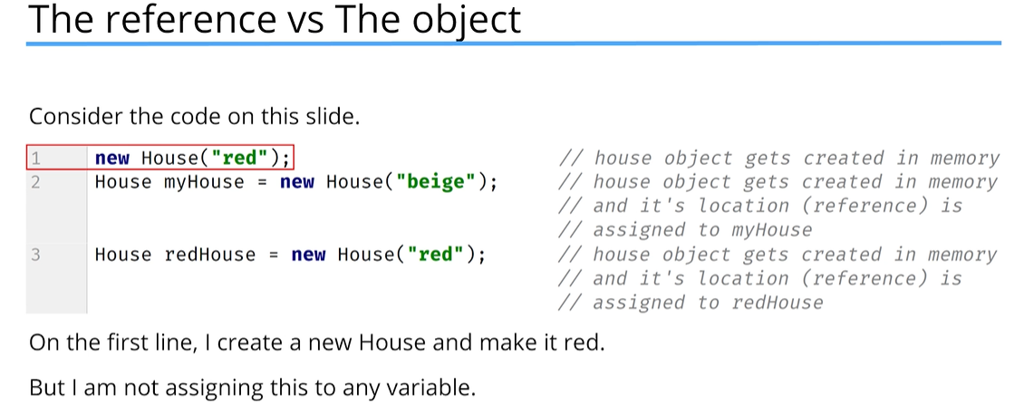

This compiles fine and you can do this – the object is created in memory, but after the statement completes, the code has no way to access it because there is no reference to it.

On the second line, there is a reference to the new House object (myHouse), which grants access to the “beige” house, as long as the variable stays in scope. Or, until it gets reassigned to reference a different object.

The third line is creating another brand new red house object that has no relation to the the red house that was created on the first line, and is assigning a reference to it called “redHouse”.

This code has three **instances** of House, but only two **references**. That first object will stay in memory with no reference to it until Java’s automatic process, appropriately called Garbage Collection, figures out there is no running code with a reference to that object and deletes it. That first object is said to be eligible for garbage collection immediately after that first statement. It’s useless to the code because it’s no longer accessible.

There are times we might want to instantiate an object and immediately call a method on it, and not assign the object to a variable reference. However, 99% of the time we’ll want to reference the objects we create.

### Static vs Instance Variables

#### Static Variables

* Declared by using the keyword “static”.
* Static variables are also known as static member variables.
* Every instance of the class shares the same static variable(s).
* If changes are made to that variable, all other instance of that class will see the effect of that change.

It is considered best practice to use the Class name and not a reference variable to access a static variable:

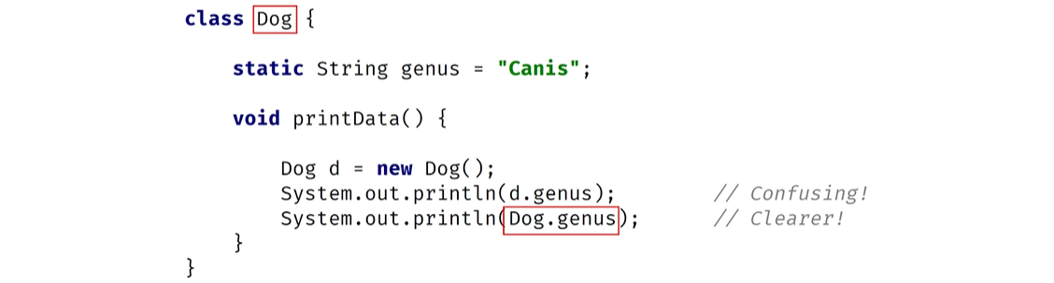

An instance isn’t required to exist to access the value of a static variable.

Static variables aren’t used very often but can sometimes be very useful. They can be used for:

* Storing counters
* Generating unique IDs
* Storing a constant value that doesn’t change, like PI, for example
* Creating and controlling access to a shared resource (log file, a database, or some other type of I/O stream)

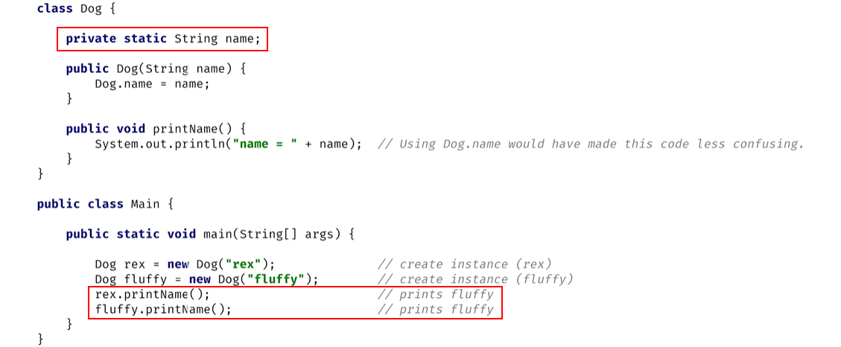

This is a scenario in which using a static variable probably isn’t the best idea

#### Instance Variables

Instance variables don’t use the “static” keyword and are also known as ‘fields’ or ‘member variables’. **Instance variables** belong to a specific instance of a class.

* Each instance has its own copy of an instance variable.
* Every instance can have a different value.
* Instance variables represent the state of a specific instance of a class.

#### Static Methods

Static methods are declared using a static modifier.

Static methods can’t access instance methods and instance variables directly.

They’re usually used for operations that don’t require any data from an instance of the class (from ‘**this**’). Inside a static method, we cannot use the ‘**this**’ keyword. Whenever you see a method that doesn’t use instance variables, that method should probably be declared as a static method.

For example, main is a static method and it’s called by the Java virtual machine when it starts the Java application.

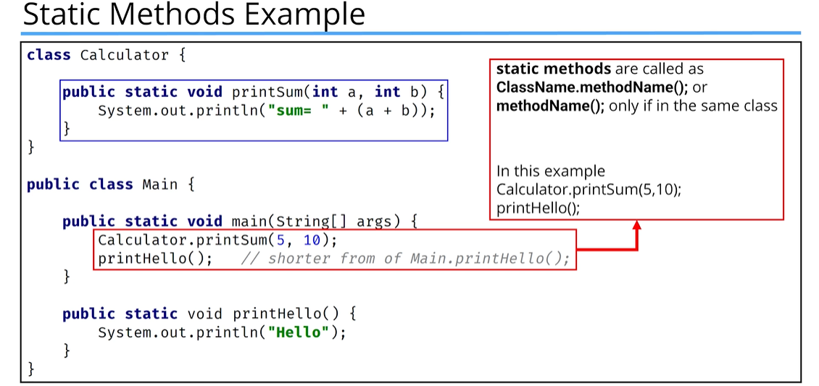

printHello(); is being called within the Main class because the static method for printHello() is in the same class.

#### Instance Methods

Instance methods belong to an instance of a class.

To use an instance method, we have to instantiate the class first, usually by using the **new** keyword.

* Instance methods can access instance methods and instance variables directly.
* Instance methods can also access static methods and static variables directly.

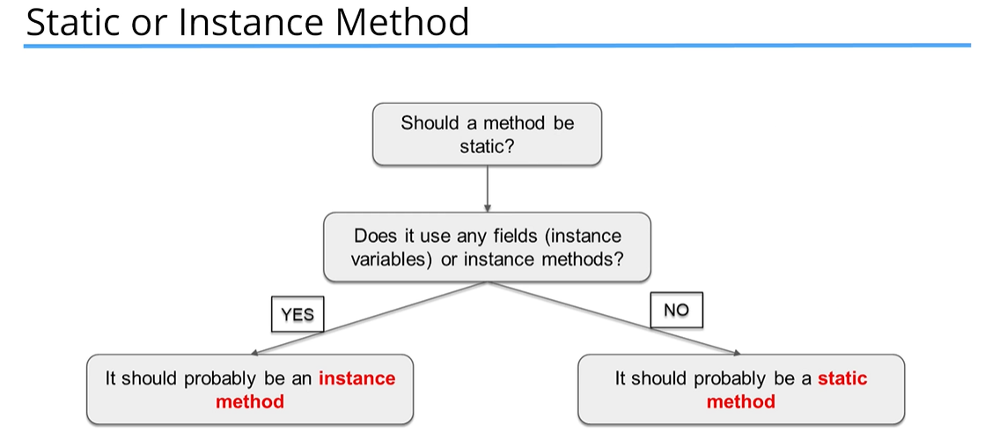

### Plain Old Java Object (POJO)

A plain old Java object (whose acronym is **POJO**) is a class that generally only has instance fields. It’s used to house data and pass data between functional classes. It usually has no other, or very few methods, other than getters and setters, for the instance fields.

Many database frameworks use POJO’s to read data from, or to write data to, databases, files, or streams.

A POJO also might be called a bean or a JavaBean. A JavaBean is just a POJO with some extra rules applied to it.

A POJO is sometimes called an Entity because it mirrors database entities. Another acronym is DTO for Data Transfer Object. It’s a description of an object that can be modeled as just data.

**Support for POJO Creation**

There are many generation tools that will turn a data model into generated POJO’s or JavaBeans. You’ve seen an example of similar code generation in IntelliJ, which allowed us to generate getters, setters, and constructors in a uniform way, based on the class’s fields.

Record Project:

* The Entity – The Student Table
  + Student: Id, Name, DateOfBirth, ClassList

### Annotation

Annotations are a type of *metadata*

* Metadata is a way to formally describe additional information about our code.
* Annotations are more structured and have more meaning than comments.
* This is because they can be used by the compiler or other types of pre-processing functions to get information about the code.
* Metadata doesn’t affect how the code runs, so this code will still run with or without the annotation.

### Overridden Method

An *overridden* method is not the same thing as an overloaded method.

An overridden method is a special method in Java that other classes can implement if they use a specified method signature.

Every object when passed to the println() method will have the toString() method implicitly executed if you’ve created that method on your class.

Getters and setters – setting, retrieving, and updating. This kind of code has a name: boilerplate code. This is code that is repetitive and follows a pattern, which is why code generation tools can create it for us.

However, it is still a lot of code to look at, so wouldn’t it be nice if there was a type that did all of this work for us and we didn’t have to put all this code in our class? Well, we do – Java introduced a new type called the record which officially became part of Java in JDK 16.

### POJO vs The Record

The plain old Java object comes with a lot of boilerplate code that is repetitive and follows certain rules. Once created, this code is rarely looked at or modified. In fact, there are tools that’ll just regenerate all of this code if your underlying data or domain model changes.

The **record** was introduced in JDK 14 and became officially part of Java in JDK 16. It’s purpose is to replace the boilerplate code of the POJO, but to be more restrictive. Java calls them “plain data carriers”. The word carrier is an important term, because it means the record has more rules built in than a POJO would.

### The Record Type

The record is a special class that contains data that’s not meant to be altered. In other words, it seeks to achieve immutability for the data of its members. It contains only the most fundamental methods, such as constructors and accessors.

Implicit or Generated Code that Java Provides

What does Java tell us about what is implicitly created when we declare a record as we did in this code?

public record LPAStudent(String id, String name, String dateOfBirth, String classList) {}

First, it’s important to understand that the part that’s in parentheses is called the record header. The record header consists of record components, a comma-delimited list of components.

For each component in the header, Java generates:

* A field with the same name and declared type as the record component.
* The fields are declared private and final.
* The fields are sometimes referred to as a component field.
* Java generates a toString() method that prints out each attribute in a formatted String.
* In addition to creating a private final field for each component, Java creates a public accessor method for each component.
* This method has the same name and type of the component. It doesn’t have any kind of special prefix like “get” or “is”. For example, the accessor method for id is simply id()

Why have an immutable record?

* Why is the record built to be immutable?
* There are more use cases for immutable data transfer objects and keeping them well encapsulated.
* You want to protect the data from unintended mutations.

POGO vs Record

If you want to modify data on your class, you won’t be using the record.

You can use the code generation options for the POJO as was shown earlier. However, if you’re reading a whole lot of records from a database or file source and simply passing data around, then the record is a big improvement.

We’ll be revisiting the record type when we discuss the final keyword and the immutability of data, as well as when we get into the Database and I/O sections of the course.

### Inheritance

What is Inheritance, and why is it so powerful?

We can look at Inheritance as a form of code reuse. It’s a way to organize classes into a parent-child hierarchy, which lets the child inherit (reuse) fields and methods from its parent.

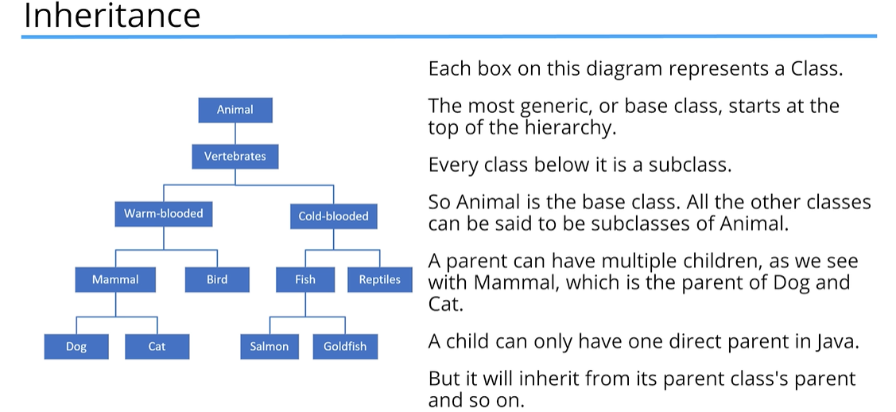

The Animal Class (class diagram):

* Animal
  + type: String
  + size: String
  + weight: double
  + Methods: move(String speed); makeNoise()

A class diagram allows us to design our classes before we build them. This diagram shows the Animal class with the attributes we think that every kind of animal has. Below the fields are the behaviors (methods) that all animals have in common: move and makeNoise.

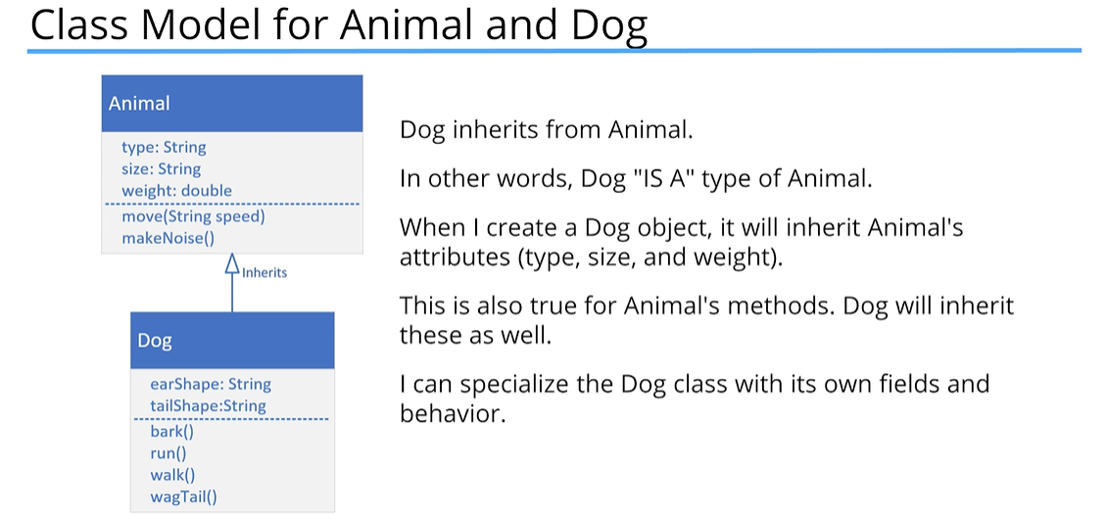

**extends**

Using extends specifies the superclass (or the parent class) of the class we are declaring. We can say Dog is a subclass or child class of Animal, and we can also say that Animal is a parent or superclass of Dog.

A class can specify one and only one class in its extends clause.

**super()**

super() is a lot like this(). It’s a way to call a constructor on the super class directly from the sub class’s constructor. Like this(), it has to be the first statement of the constructor. Because of that rule, this() and super() can never be called from the same constructor.

If you don’t make a call to super(), then Java makes it for you using super’s default constructor. If your superclass doesn’t have a default constructor, then you must explicitly call super() in all of your constructors, passing the right arguments to that constructor.

**Code Re-use**

All subclasses can execute methods even though the code is declared on the parent class. The code doesn’t have to be duplicated in each subclass. We can use code from the parent class or we can change that code for the subclass.

**Overriding a Method**

Overriding a method is when you create a method on a subclass, which has the same signature as a method on a superclass. You override the parent class method when you want the child class to show different behavior for that method.

The overridden method can do one of three things:

* It can implement completely different behavior, overriding the behavior of the parent.
* It can simply call the parent class’s method, which is somewhat redundant to do (this is the default behavior)
* Or the method can call the parent class’s method and include other code to run so it can extend the functionality of the method for the child class

### Polymorphism

Polymorphism simply means “many forms”.

Some advantages of Polymorphism are:

* It makes code simpler.
* It encourages code extensibility

In Java, we’ve been using Inheritance all along, without even knowing it. This is because every class we create in Java actually extends a special Java class. That class is named Object, and it is in the java.lang package.

According to the Java Application Programming Interface (API), Class **Object** is the root of the class hierarchy. Every class has **Object** as a superclass. All objects, including arrays, implement the methods of this class.

Methods from the Object class include:

* clone() – creates and returns a copy of this object
* equals(Object obj) – indicates whether some other object is “equal to” this one
* getClass() – returns runtime class of this Object
* toString() – Returns a string representation of the object.

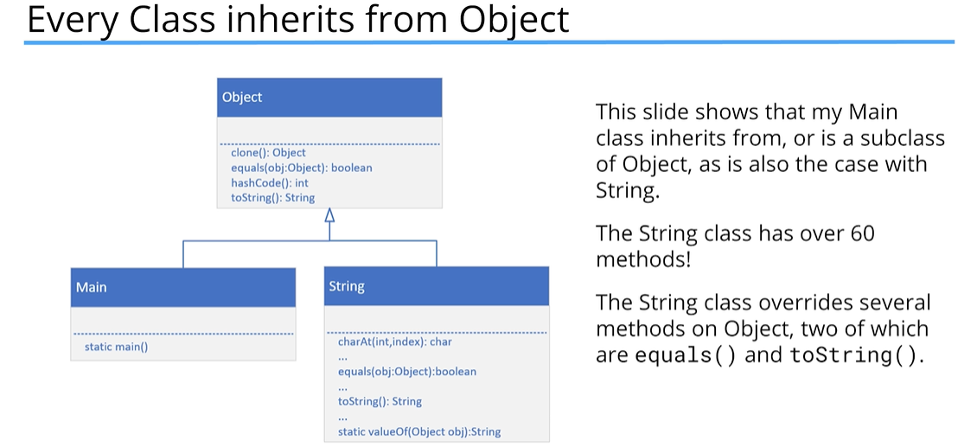

Difference between this and super keywords as well as the this() and super() method calls

* The keyword **super** is used to access or call the parent class members (both variables and methods).
* The keyword **this** is used to call the current class members (both variables and methods).
* **this** is required when we have a parameter with the same name as an instance variable or field
* NOTE: we can use either of these two keywords anywhere in a class, except for static elements, such as a static method. Any attempt to do so will result in compile time errors.
* The keyword **this** is commonly used within constructors and setters, and is optionally used within getters
* The keyword **super** is commonly used with method overriding when we call a method with the same name from the parent class.

In Java, we’ve got the this() and super() calls. These are known as calls since they look like regular method calls, although we are calling certain constructors. Use this() to call a constructor from another overloaded constructor in the same class. The call to this() can only be used in a constructor, and it must be the first statement in a constructor. It’s used in constructor chaining, in other words when one constructor calls another constructor, and helps to reduce duplicated code. The only way to call a parent constructor is by calling super(), which calls the parent constructor().

The Java compiler puts a default call to super() if we don’t add it, and it’s always a call to the no argument constructor, which is inserted by the compiler. The call to super() must also be the first statement in each constructor. Thus, a constructor can have a call to super() or this(), but never both.

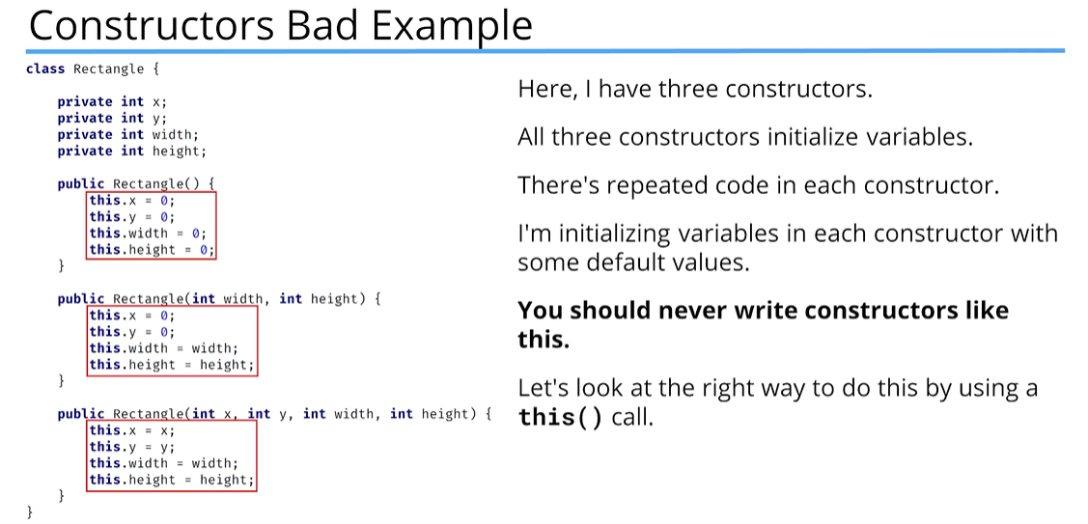

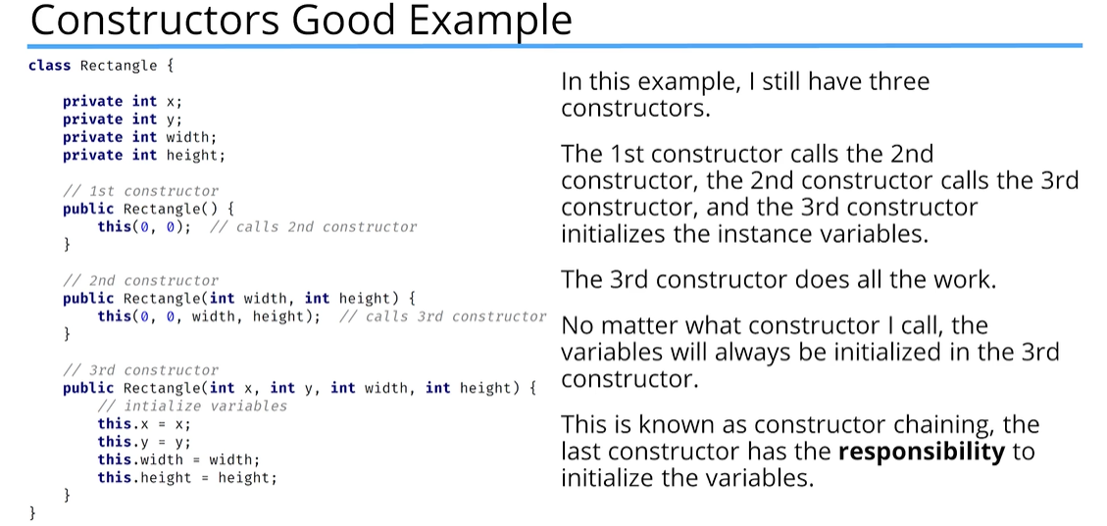

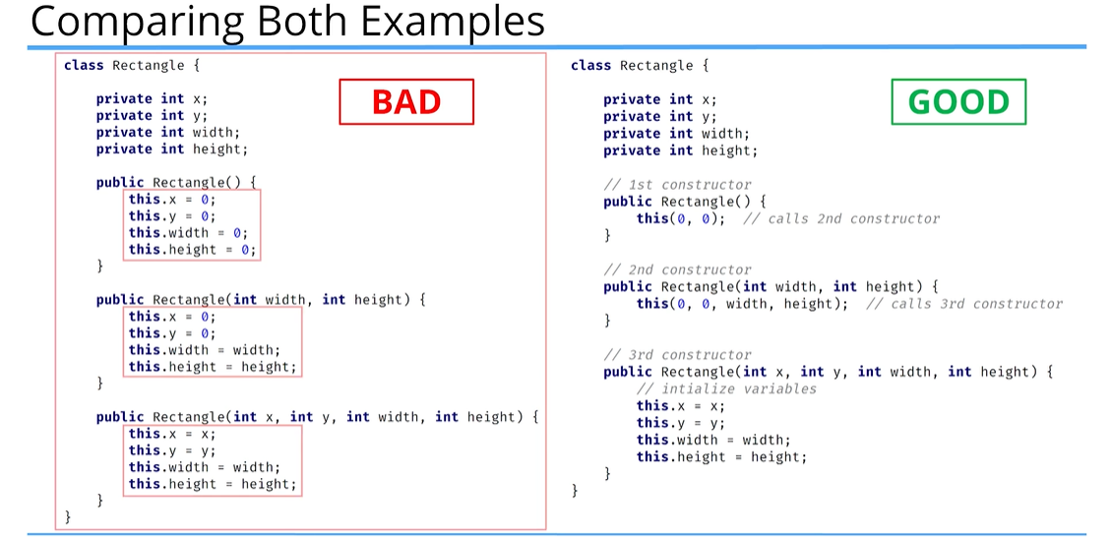

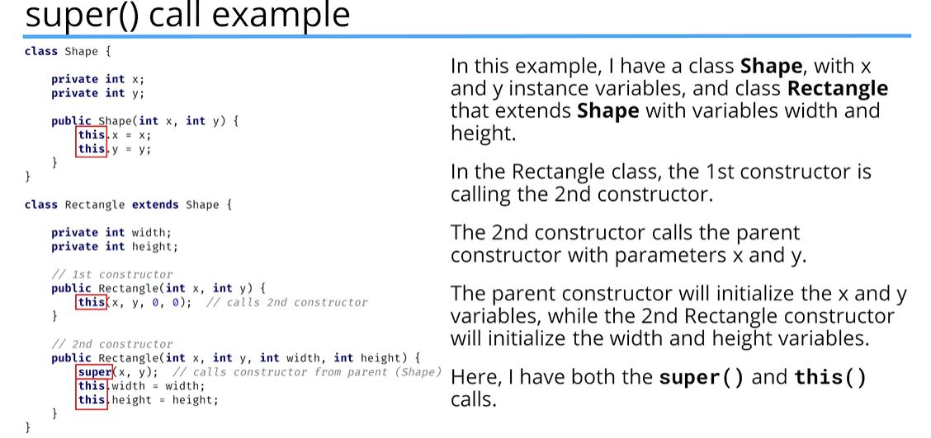

### Method Overloading

**Method overloading** means providing two or more separate methods in a class with the same name but different parameters. Method return types may or may not be different, and that allows us to reuse the method name.

**Overloading** is very handy, as it reduces duplicated code and we don’t have to remember multiple method names. We can overload static or instance methods.

To the code calling an overloaded method, it looks like a single method can be called with different sets of arguments. In actuality, each call that’s made with a different set of arguments is calling a separate method.

Java developers refer to method overloading as *compile-time polymorphism*. This means the compiler is determining the right method to call based on the method name and argument list.

Usually **overloading** happens within a single class, but methods can also be overloaded in subclasses. That’s because a subclass inherits one version of the method from the parent class, and then the subclass can have another overloaded version of that method.

Methods will be considered overloaded if both methods follow the following rules:

* Methods must have the same method name
* Methods must have different parameters

If methods follow the rules above:

* They may or may not have different return types
* They may or may not have different access modifiers
* They may or may not throw different checked or unchecked exceptions

### Method Overriding

Method overriding means defining a method in a child class that already exists in the parent class, with the same signature (in other words, with the same name and same parameters).

By extending the parent class, the child class gets all the methods defined in the parent class. Those methods are also known as derived methods.

**Method Overriding** is also known as **Runtime Polymorphism** or **Dynamic Method Dispatch** because the method that is going to be called is decided at runtime by the Java virtual machine.

When we **override** a method, it’s recommended to put **@Override** immediately above the method definition. The @Override statement is not required, but it’s a way to get the compiler to flag an error if you don’t actually properly override a method. We’ll get an error if we don’t follow the overriding rules correctly. As mentioned previously, this is called an annotation (@Override).

We cannot override static methods, only instance methods can be overridden.

A method will be considered overridden if we follow these rules:

* It must have the same name and same arguments.
* The return type can be a subclass of the return type in the parent class.
* It can’t have a lower access modifier. In other words, it can’t have more restrictive access privileges.
* For example, if the parent’s method is protected, then using private in the child’s overridden method is not allowed. However, using public for the child’s method would be allowed.

Important points about method overriding to keep in mind:

* Only **inherited methods** can be overridden, in other words, methods can be overridden only in child classes
* Constructors and private methods cannot be overridden
* Methods that are final cannot be overridden.
* A subclass can use super.methodName() to call the superclass version of an overridden method.

**Covariant Return Type**

The return type of an overridden method can be the same type as the parent method’s declaration. But, it can also be a subclass. The term, covariant return type, is more appropriate, as the return type could include types such as interfaces and generic types.

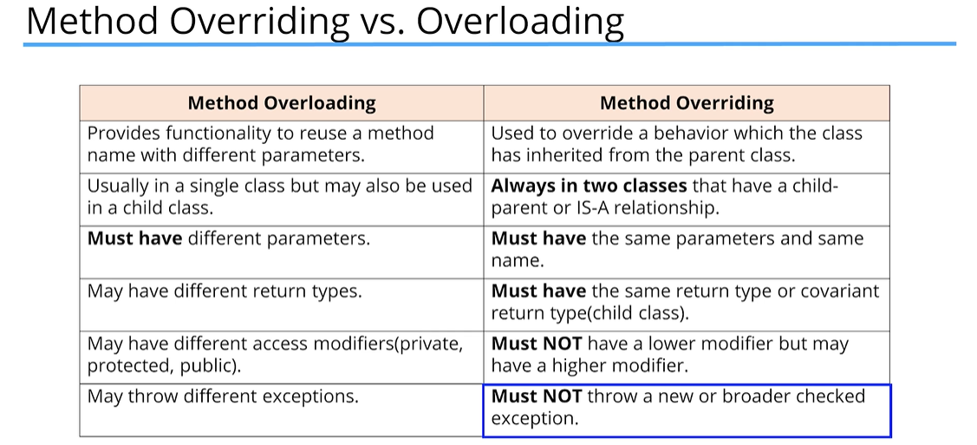

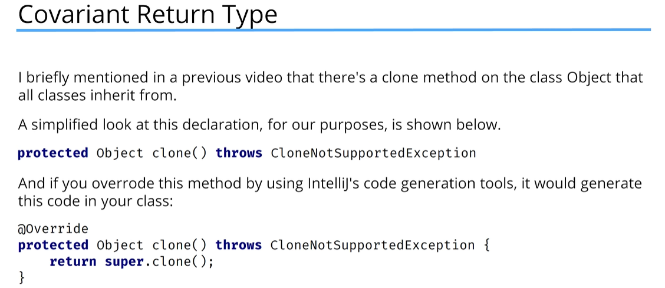

In general, when you’re cloning an object, you’re going to want to return an Object that is the same type as the Object that you’re cloning.

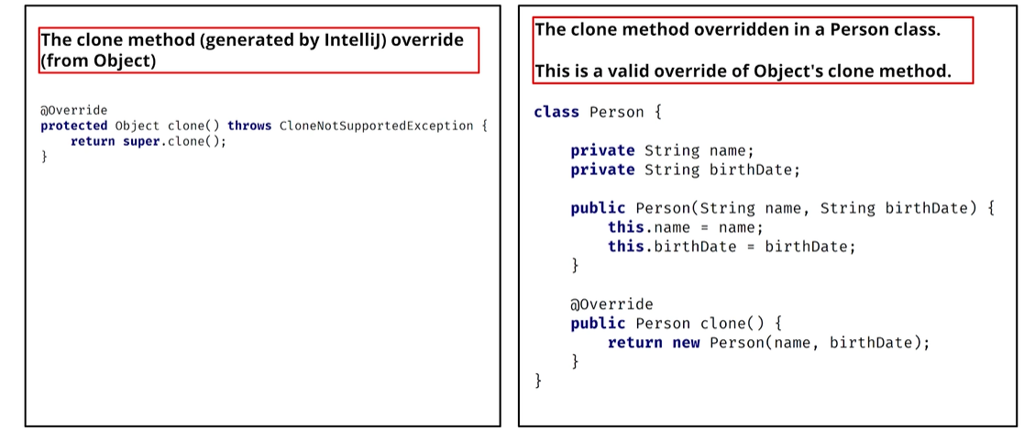

What’s a Text Block?

A Text Block is just a ne special format for multi-line String literals. It’s simply a String with a new representation in the source code. It became part of the official language as of JDK 15.

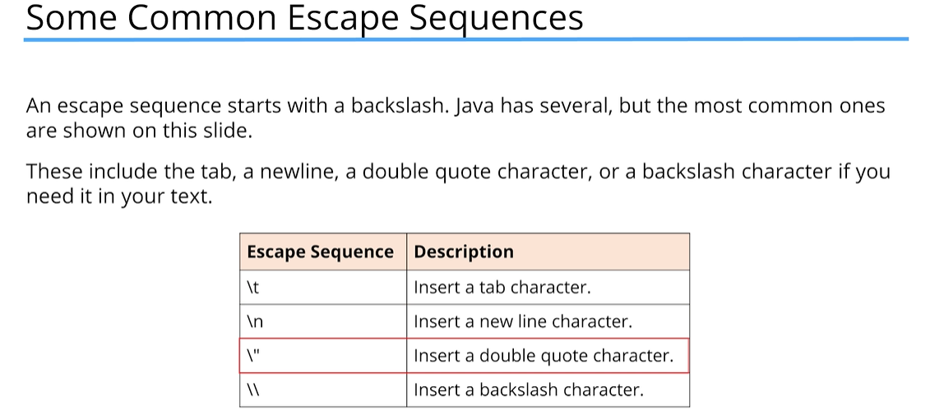

Format Specifiers

At their most complex, format specifiers take the form shown here:

%[argument_index$][flags][width][.precision]conversion

They start with a percent sign and end with a conversion symbol and have lots of options in between. The one that we just looked at was %d – or conversion type d, which is the symbol used for decimal integer values.

Link to Java class Formatter: <https://docs.oracle.com/en/java/javase/17/docs/api/java.base/java/util/Formatter.html>

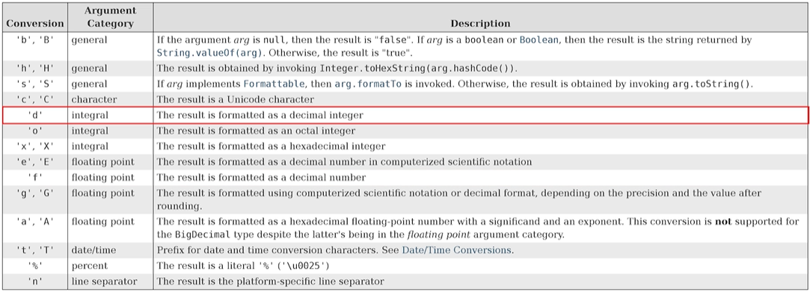

System.*out*.printf("Your age is %.2f%n", (float)age); //adding the .2 in front of the f (%.2f) tells Java to print with 2 decimal places)

The String

The String has over 60 methods available.

The String is a sequence of characters, meaning its characters are ordered and indexed. The index starts at 0 and not 1.

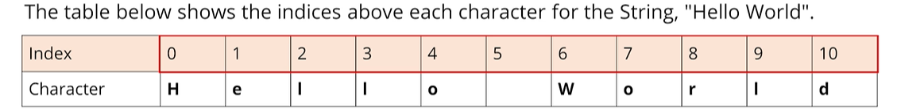

We can say the character ‘H’ is at index 0, and ‘W’ is at index 6. The length of this String is 11, but the last index is 10.

We can split String’s methods up into three basic categories:

* String Inspection Methods (length, isEmpty, isBlank)
* Methods for Comparing String Values.
* String manipulation methods.

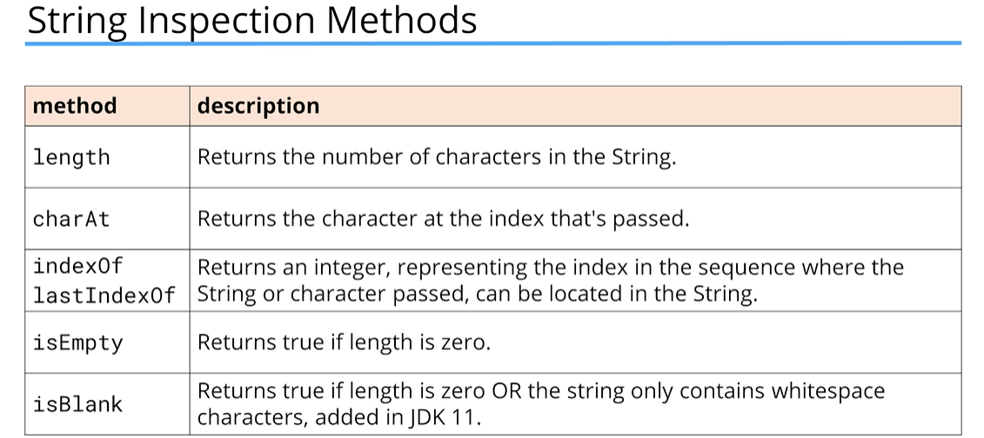

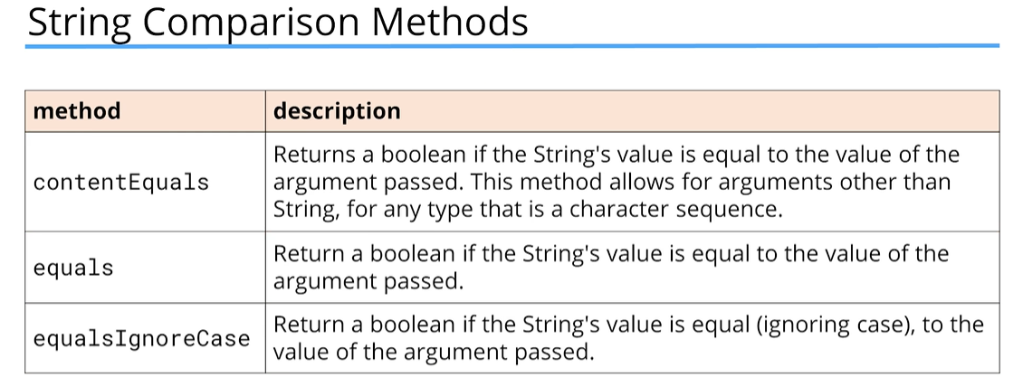

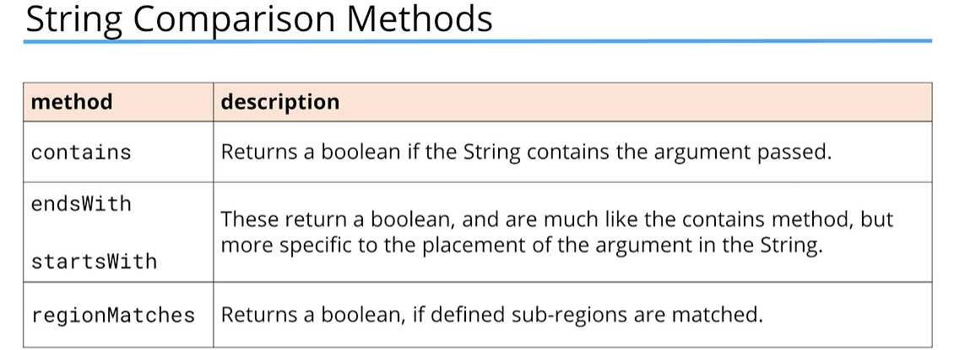

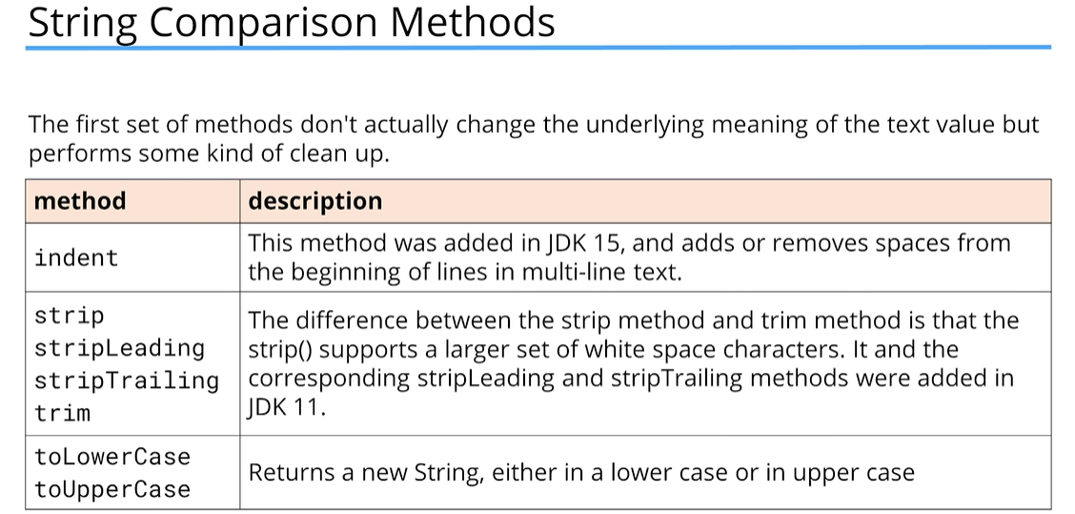

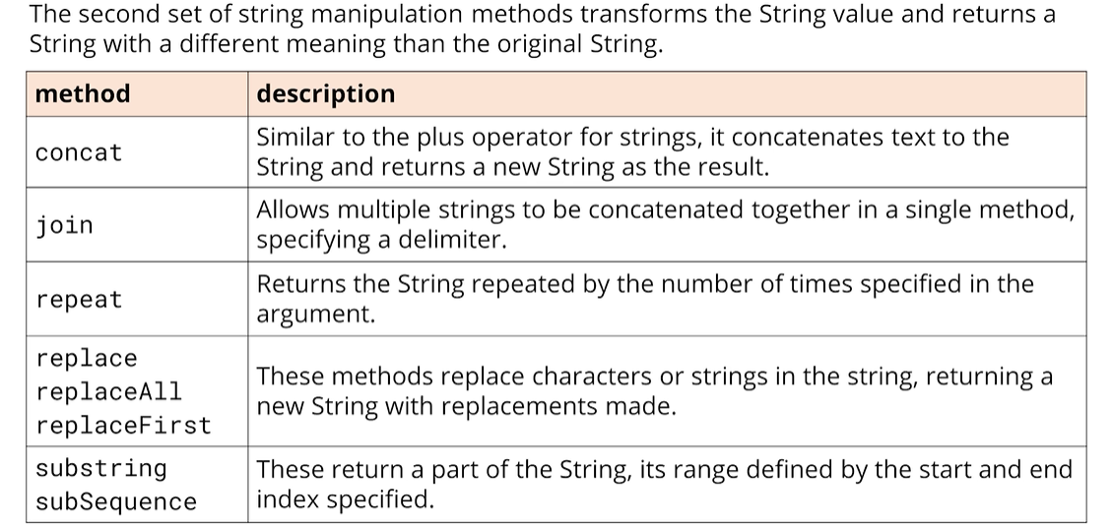

### String vs StringBuilder

Java provides a mutable class that lets us change its text value or character sequence. This is called the **StringBuilder** class.

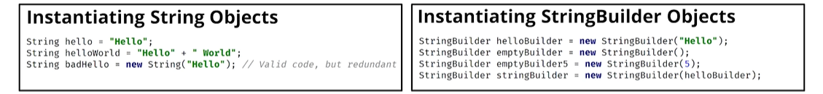

There are four ways to create a new StringBuilder object using the new keyword:

* Pass a String
* Pass no arguments at all
* Pass an integer value
* Pass some other type of character sequence (like StringBuilder)

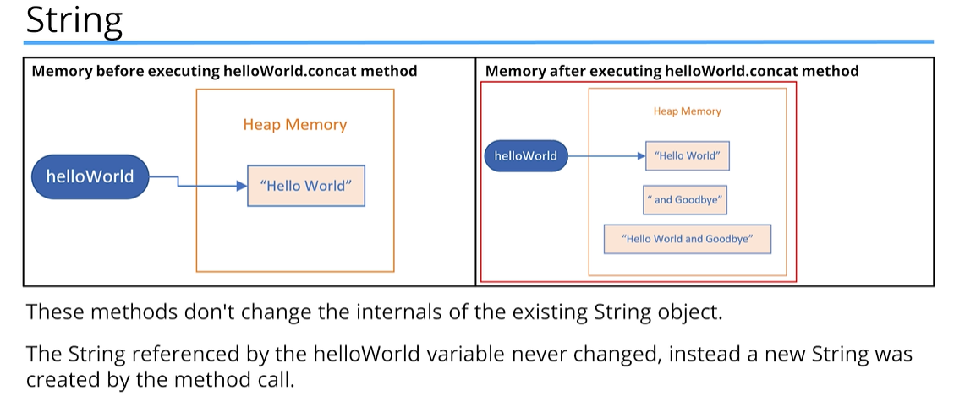

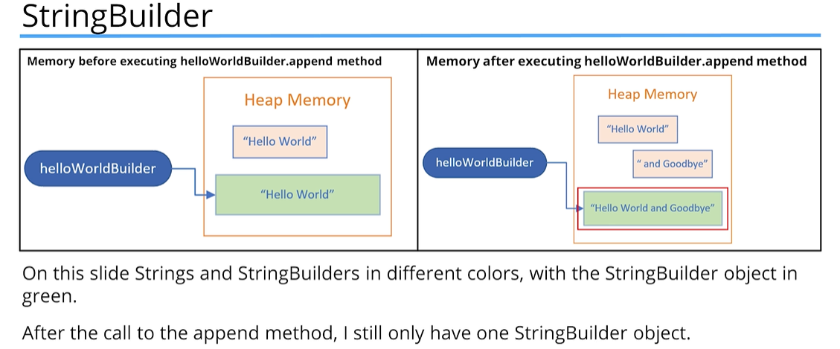 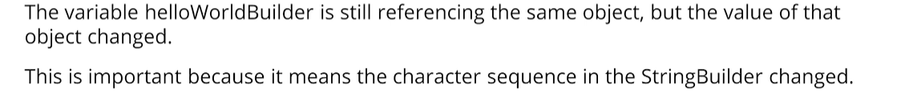

String Methods vs StringBuilder Methods

String methods create a new object in memory and return a reference to this new object.

StringBuilder methods return a StringBuilder reference, but it’s really a self-reference.

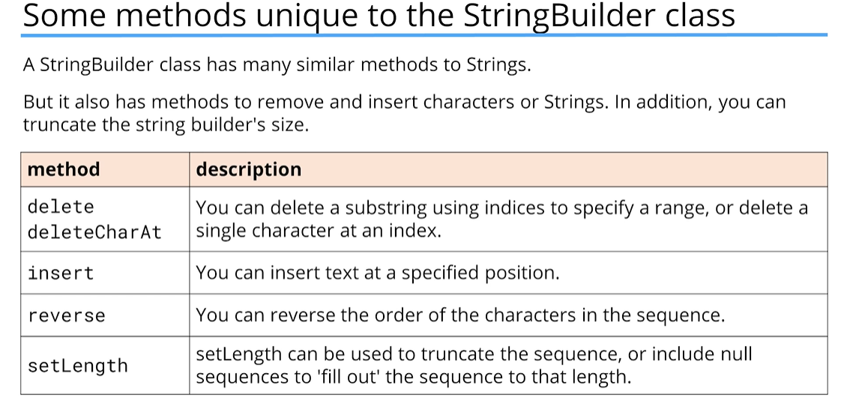

## Section 8 – OOP Part 2 – Composition, Encapsulation, and Polymorphism

It’s now time to look at the remaining 3 major components of Object-Oriented Programming:

* Composition
* Encapsulation
* Polymorphism

### Composition

Composition is another component of object-oriented programming.

Before we get into Composition, we will review one last example of Inheritance:

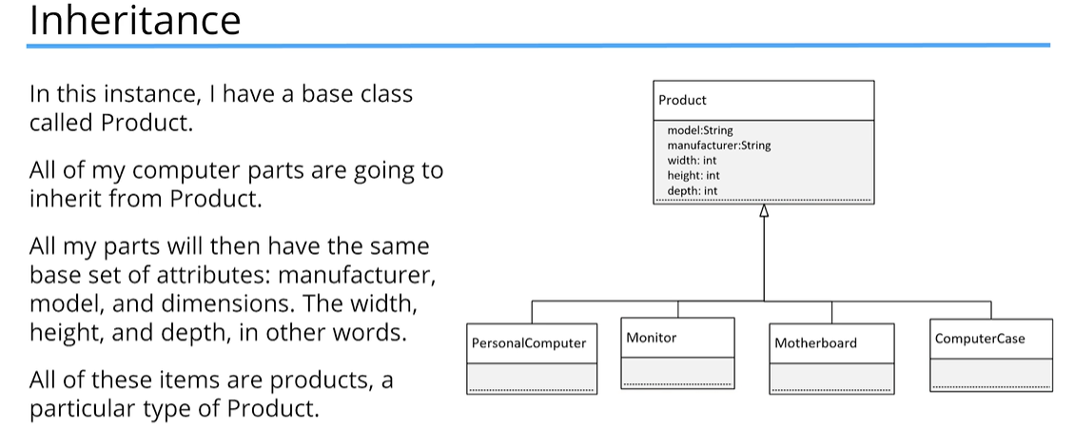

### Inheritance vs Composition

* Inheritance defines an “IS A” relationship
* Composition defines a “HAS A” relationship

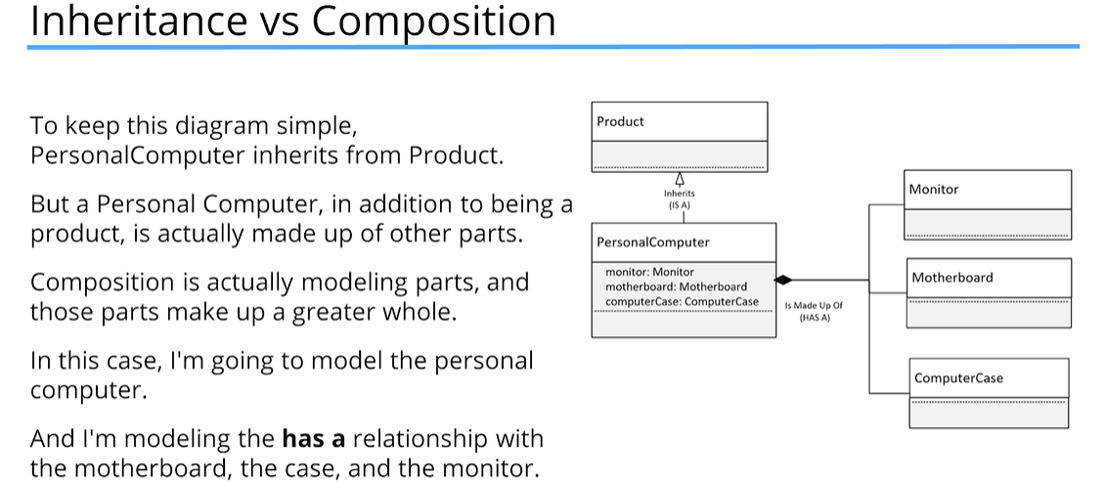

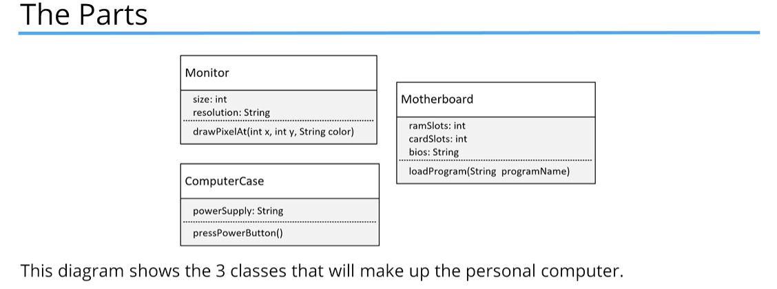

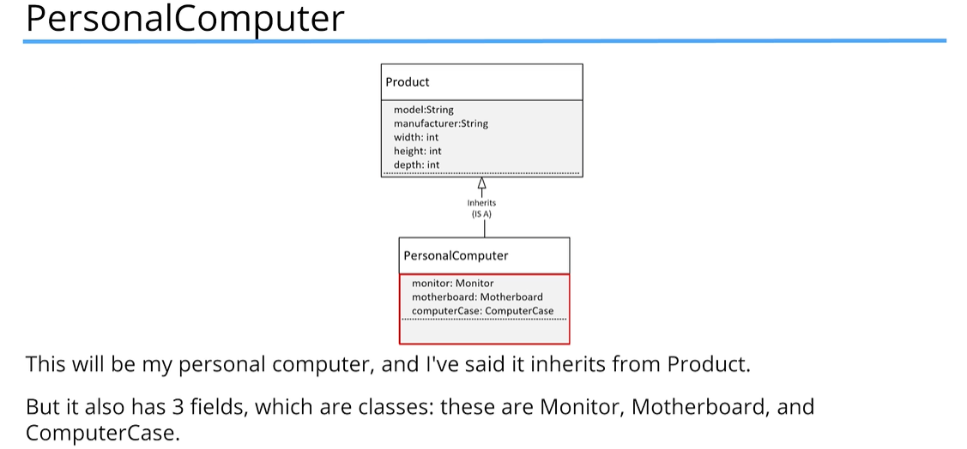

Inheritance is a way to reuse functionality and attributes, while **composition** is a way to make the combination of classes act like a single coherent object.

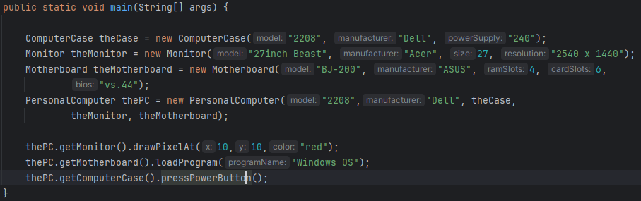

Here, we are creating a PersonalComputer object, and calling methods by accessing the Monitor, Motherboard, and ComputerCase objects that are part of the PersonalComputer object.

Next, we will hide the functionality further by not allowing the program to access the objects/parts directly. To do this, comment out the getter methods, and create new methods on the PersonalComputer object class itself, rather than trying to access the other object classes directly.

As a general rule, when you’re designing your programs in Java, you probably want to look at Composition first. Most experts will tell you that as a rule, look at using composition before implementing inheritance.

In the PersonalComputer example, we actually used both. All of the products were able to inherit a set of attributes, like the manufacturer and model. The calling code didn’t have to know anything about these parts to get PersonalComputer to do something.

The reason Composition is preferred over Inheritance:

* Composition is more flexible. You can add parts or remove them, and these changes are less likely to have downstream effects.
* Composition provides functional reuse outside of the class hierarchy, meaning classes can share attributes & behavior by having similar components, instead of inheriting functionality from a parent or base class.
* Java’s inheritance breaks encapsulation because subclasses may need direct access to a parent’s state or behavior.

Why is Inheritance Less Flexible?

* Adding a class or removing a class from a class hierarchy may impact all subclasses from that point
* In addition, a new subclass may not need all the functionality or attributes of its parent class

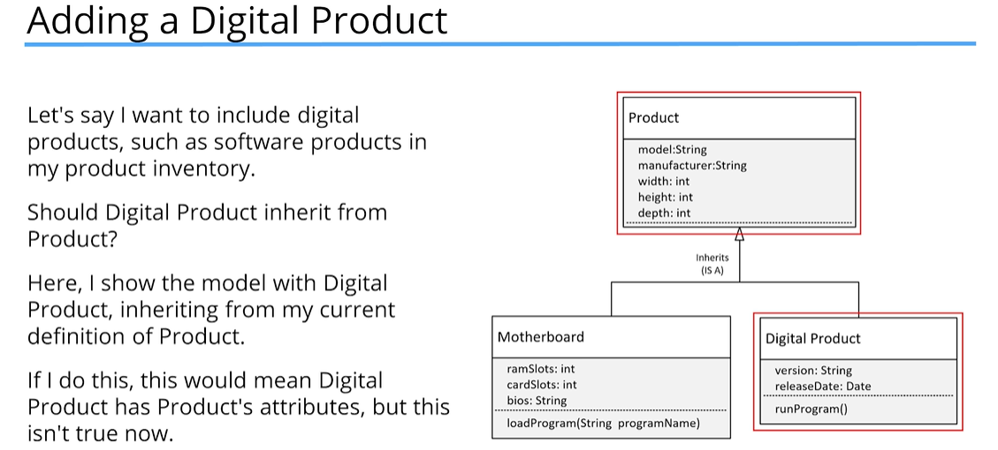

A digital product wouldn’t really have width, height, and depth, so this model isn’t a good representation of what we want to build. It would be better if we didn’t have those three attributes on Product, but instead used Composition to include them on certain products and not all products.

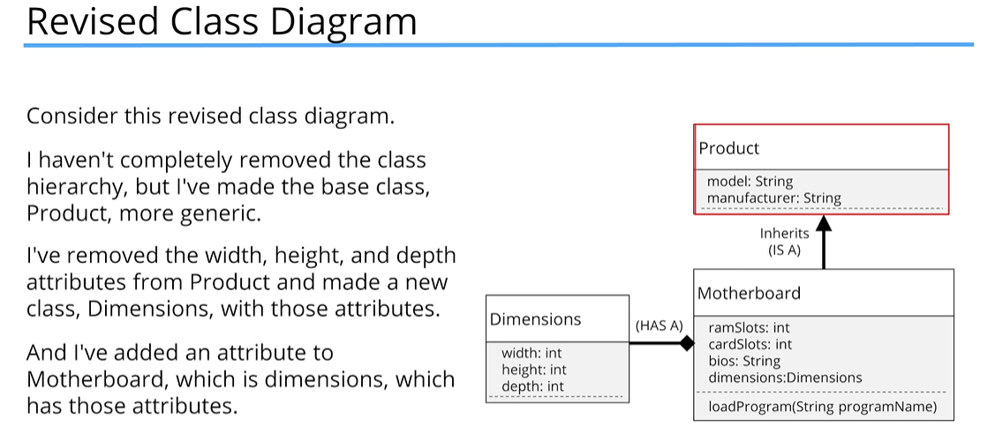

This design allows for future enhancements to be made, like the addition of the subclass Digital Product, without causing problems for existing code that may already be extending Product.

### Encapsulation

What does ***Encapsulation*** mean? In Java, **encapsulation** means hiding things by making them private or inaccessible.

Why would we want to hide things in Java?

* To make the interface simpler, we may want to hide unnecessary details.
* To protect the integrity of data on an object, we may hide or restrict access to some of the data and operations.
* To decouple the published interface from the internal details of the class, we may hide actual names and types of class members.

What do we mean by *interface* here?

* When we talk about a class’s *public* or *published* *interface*, we’re really talking about the class members that are exposed to or can be accessed by the calling code.
* Everything else in the class is internal or private to it.
* An application programming interface, or API, is the public contract that tells others how to use the class.

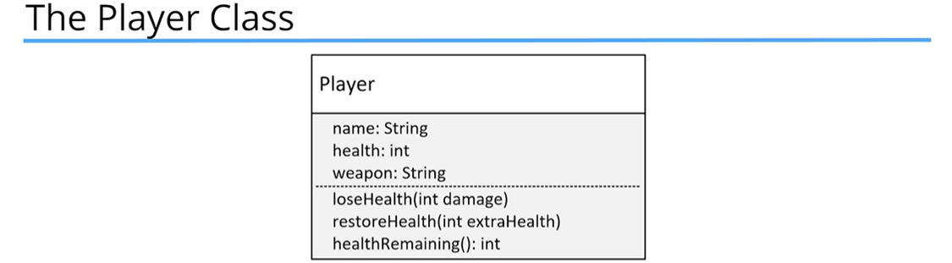

Problem Two:

Allowing direct access to fields means calling code would need to change when you edit any of the fields in your classes.

Problem Three:

Omitting a constructor that would accept initialization data means the calling code is responsible for setting up this data on the new object.

Benefits of Encapsulation

* When using encapsulation, you’re able to make changes without affecting any other code.
* It’s sort of like a black box in many ways.
* Classes have more control over their data.

Staying in control – this is why we want to use encapsulation. We protect the members of the class and some methods from external access. This prevents calling code from bypassing the rules and constraints we’ve built into the class.

By doing this, we ensure that when we create a new instance of a class, it’s initialized with valid data. But likewise, we’re also making sure that there’s no direct access to the fields for data manipulation.

Encapsulation Principles

To create an encapsulated class, you want to:

* Create constructors for object initialization, which enforces that only objects with valid data will get created.
* Use the private access modifier for your fields.
* Use getter and setter methods sparingly, and only when needed.
* Only use access modifiers that aren’t private for the methods that the calling code needs to use.

### Polymorphism

Simply stated, polymorphism means many forms – but how does this apply to code?

Polymorphism lets us write code to call a method, but at run time, this method’s behavior can be different for different objects. This means the behavior that occurs while the program is executing depends on the runtime type of the object. And, the runtime type might be different than the declared type in the code. The declared type has to have some kind of relationship to the runtime type, and inheritance is one way to establish this relationship.

Polymorphism in action:

* The ability to execute different behavior for different types, which are determined at runtime.
* We were able to do it in the Main method using Movie.getMovie(type, title); and movie.watchMovie();
* Polymorphism enables you to write generic code, based on the base class, or a parent class.

Our code in the main method is extendable, meaning it doesn’t have to change, as new subclasses become available. It can handle any instances that are a Move, or a subclass of Movie, that are returned from the factory method.

What is ***var***?

var is a special contextual keyword in Java that lets our code take advantage of Local Variable Type Inference. By using var as the type, we are telling Java to figure out the compile-time type for us.

**Local Variable Type Inference (LVTI)**

Local Variable Type Inference was introduced in Java 10. One of the benefits is to help with the readability of the code and to reduce boilerplate code.

It’s called Local Variable Type Inference because:

* It can’t be used in field declarations on a class.
* It can’t be used in method signatures, either as a parameter type or return type.
* It can’t be used without an assignment because the type can’t be inferred in that case.
* It can’t be assigned a null literal, again, because a type can’t be inferred in that case.

Difference between Run Time vs Compile Time Typing

* You can think of the compile time type as the declared type – this type is declared either as a variable reference, a method return type, or a method parameter. In case of LVTI, we don’t declare a type for the compiled reference type – it gets inferred, but the byte code is the same, as if we had declared it.
* In many cases, the compile time type is the declared type to the left of the assignment operator.
* What is returned on the right side of the assignment operator from whatever expression or method is executed can sometimes only be determined at runtime, when the code is executing conditionally through the statements in the code.
* You can only assign a runtime instance to a different compile time type if certain rules are followed.

Up until now, we have only looked at examples with Inheritance. We can assign an instance to a variable of the same type, or a parent type, or a parent’s parent type, including java.lang.Object, the ultimate base class.

Why Are Runtime Types Different Than Compile Time Types?

* Because of Polymorphism
* Polymorphism lets us write code once, in a more generic fashion that can execute behavior differently and uniquely to different classes.

Evaluating What the Runtime Type Is

How do we test what the runtime type of a variable really is at runtime, if the declared type is something else?

* We can test in several different ways
* The first way is using an if statement to test looking at an object named unknownObject, checking its class, then creating a new Comedy object by casting the unknown object to Comedy.

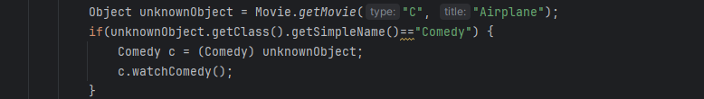

* We can also check for an instanceof, then call a method directly on a casting:



instanceof operator

The instanceof operator lets you test the type of an object or instance.

The reference variable you are testing is the left operand and the type you are testing for is the right operand:

[reference variable] unknownObject instanceof Adventure [type]

It’s important to see that *Adventure* is not in quotes, meaning we’re testing the actual type, not the type name. This operator returns *true* if unknownObject is an instance of Adventure.

Pattern Matching for the instanceof Operator

If the JVM can identify that the object matches the type, it can extract data from the object without casting. For this operator, the object can be assigned to a binding operator, which here is called syfy



The variable syfy (if the instanceof method returns true) is already typed as a ScienceFiction variable.

### Organizing Java Classes

Up until this point in the class we haven’t created a lot of classes, so we haven’t had to think about organizing those classes. As the course progresses, we’re going to be using more and more of Java’s libraries, and our applications are going to get more complex.

This feels like a good time to talk about the package and import statements in more detail.

We’ve talked briefly about import statements when we used the Scanner class and when we mentioned packages when we talked about access modifiers.

Right now, we’ll focus on what a package is, why we’ll be switching to using it from this point forward, and how to access classes in different packages.

### Package

As per the Oracle Java Documentation:

* A package is a namespace that organizes a set of related types.
* In general, a package corresponds to a folder, or directory, on the operating system, but this isn’t a requirement.
* When using an IDE, like IntelliJ, we don’t have to worry about how packages and classes are stored on the file system.
* The package structure is hierarchical, meaning you group types in a tree fashion.
* You can use any legal Java identifier for your package names, but common practice has package names as all lower case.
* The period separates the hierarchical level of the package.

By now we’re familiar with two of Java’s packages: java.lang and java.util.

A few of the classes we’ve used from these packages are:

* java.lang – StringBuilder, String, Integer, Double
* java.util – Random, Scanner

Java.lang has an implied import statement, so those classes are accessible at any time, while all other classes require the respective packages to be imported.

If we remember when we used the Scanner class or the Random class, we were required to use the import statement. The import statement had to be declared before any class or type declarations, but after any package statement. If there is no package statement, the import statements should be the first statements in the code.

There is no limit for how many import statements you can have.

Alternatively, you can use a wild card (asterisk * character) with the import statement on a package to import all classes within the package:

import java.util.*; //this will import all classes within the java.util package

What is the Purpose of a Package?

* Packages let us reuse common class names across different libraries or applications, and they provide a way to identify the correct class, either with an import statement or a qualifying name. For example, you might have a packge for utility classes that can provide common functionality for all of your classes to access.
* Packages let us organize our classes by functionality or relationships.
* Packages also allow us to encapsulate our classes from other classes in other packages. So, you might have a package of tightly coupled classes that should only be accessed by each other, but not by the outside world.

What would a package name look like?

* Most built-in Java packages begin their names with java.[package name], but it is common practice to use a reverse domain name to start your own package naming conventions.
* If your company has a domain that is abccompany.com for example, your package prefixes would be com.abccompany.
* The package name hierarchy is separated by periods.

Using the Package Statement

* The package statement needs to be the first statement in the code with the exception of comments.
* The package statement comes before any import statements.
* There can be only one package statement, because a class or type can only be in a single package.

The Fully Qualified Class Name (FQCN)

* A class’s fully qualified class name (FQCN) consists of the package name and the class name.
* As an example, the Scanner class FQCN is java.util.Scanner.
* It is possible to use the FQCN instead of using the import statement, however, that could become rather tedious if you need to use the class numerous times in the code.
* Later in the course, we will learn about using a combination of the import statement and the fully qualified class name to resolve conflicts.

If you do not create a package to store classes when you create them, they will be implicitly placed into the default or unnamed package. Main disadvantage from doing this are:

* You can’t import types from the default package into other classes, outside of the default package.
* In other words, you can’t qualify the name, if it’s in the default package, and you can’t import classes from the default package

## Section 9 – Arrays

In the last two sections, we learned about different ways to create classes, which can have any number and type of data elements.

What we haven’t discussed though, is a way to have multiple values, all of the same type. Java provides us with many types of containers to store multiple values of the same type. These start with the most basic, which is the array, and that’s what this section will cover.

Let’s look at ways to store and manipulate multiple values of the same type. The most common way to do this in Java is with an array.

An ***array*** is a data structure that allows you to store a sequence of values, all of the same data type. You can have arrays for any primitive type, like ints, doubles, booleans, or any of the other 8 primitives we’ve learned about. You can also have arrays for any class.

Elements in an array are indexed, starting at 0.

### Declaring an Array:

* When you declare an array, you first specify the type of the elements you want to store in the array.
* Then you include square brackets in the declaration, which is the key for Java to identify the variable is an array.
* The square brackets can follow the type or they can follow the name of the variable:

int[] integerArray;

String[] nameList;

* It is much more common to declare them using the first method (int[] integerList;)
* You don’t specify size in the array declaratin itself.

One way to instantiate the array is with the ‘new’ keyword, similar to most other classes, with the exception of String.

When declaring and instantiating an array, the square brackets are used, and when the new keyword is used, the size of the array should be specified as well to signify how many elements there will be in the array:

int[] integerArray = new int[15]; //creates new integer array of size 15

An array instantiation does not have a set of parentheses, meaning we can’t pass data to a constructor for an array.

int[] integerArray = new int[15](); //this will result in a compile error

***IMPORTANT*** An Array is NOT Resizeable ***IMPORTANT***

The size of an array, once created, is fixed. You can’t change the size of an array after the array is instantiated. We can’t add or delete elements, we can only assign values to one of the elements in the array.

### The Array Initializer

An array initializer makes the job of instantiating and initializing a small array much easier.

int[] firstFivePositives = new int[]{1,2,3,4,};

In this example, we can see that we still use the ‘new’ keyword and have int with the square brackets, but instead of specifying the size of the array, we instead specify the values we want the array to be initialized to in a comma delimited list within curly brackets.

Because these values are specified, the length of the array can be determined, thus, we don’t have to specify the size of the array inside the square brackets.

Actually, Java provides an even simpler way to do this:

Java allows us to drop *new int[]* from the expression, so it can be declared and initialized as follows:

int[] firstFivePositives = {1,2,3,4,};

This is known as an anonymous array. An anonymous array initializer can only be used in a declaration statement.

An array is a special class in Java, but like all other classes, it ultimately inherites from java.lang.Object.

When you don’t use an array initializer statement, all array elements get initialized to the default value for that type. For primitive types, this is zero (0) for any kind of numeric primitive, like int, double, or short. For booleans, the default value will be false. For any class type, the elements will be initialized to null.

### Enhanced For Loop

This loop was designed to walk through elements in an array, or some other type of collection. It processes one element at a time, from the first element to the last.

The syntax is as follows:

for (declaration : collection) {

// block of statements

}

The enhanced for loop only has two components defined in the parentheses after the for keyword, compared to a regular for loop which has three.

It’s important to notice that to separate a character between components, a colon is used in the enhanced for-loop, rather than the semi-colon that is used in a regular for-loop.

The first part on the left side in the parentheses is a declaration expression, which includes the type and a variable name. This is usually a local variable with the same type as the elements in the array. The second component is the array, or some other collection variable.

### java.util.Arrays

Java’s array type is very basic, and it comes with very little built-in functionality. It has a single property or field named length, and it inherits java.util.Object’s functionality.

Java provides a helper class name java.util.Arrays, providing common functionality you’d want for many array operations. These are static methods on Arrays, so they’re class methods, not instance methods.

Printing Elements In an Array Using Arrays.toString()

The toString() method on this helper class prints out all the array elements, comma delimited, and contained in square brackets.

String arrayElementsInAString = Arrays.toString(newArray);

The output fromt his method is shown below conceptually:

[ e[0], e[1], e[2], e[3], … ]

It prints the element at index 0 first, followed by a comma, then element at index 1 followed by a comma, then element at index 2, another comma, and so on, until all elements are printed.

### Why use arrays?

We use arrays to manage many items of the same type.

Some common behavior for arrays would be sorting, initializing values, copying the array, and finding an element.

For an array, this behavior isn’t on the array instance itself, but it’s provided on a helper class called java.util.Arrays.

**Finding a Match – Searching in an Array**

Searching Sequentially

You can hopefully imagine if you were going to start writing code to do this, you might start looping through from start to finish and check each element, to see if it equals what you are looking for. If you find a match, you’d stop loopiong and return that a match was found, either with the position you found the element at or just a boolean value (true if it was found and false if it was not).

This is called a **linear search** or **sequential**, because you’re stepping through the elements, one after another.

If your elements are sorted, though, using this type of linear search is unnecessarily inefficient.

**Using Intervals to Search**

One more efficient way to search is to split each section up, testing the values at the boundaries, and based on that, split the values again into smaller sections, narrowing the number of elements to test each time.

This type of searching is called ***interval searching***.

Within two categories, sequential and interval, there are numerous existing algorithms in each for searching within arrays. One of the most common interval searches is the ***binary search***, which is why Java provides this search on so many of its collection classes.

In this search, intervals are continuously split into two, hence the word ‘binary’.

If you’re a software engineer at heart, you’ll have some fun researching these different algorithms to understand how they differ and studying the code behind their implementations.

### Arrays.binarySearch

The static method, binarySearch, is on the Arrays class.

We can use this method to test if a value is already in our array, but there are some important things to remember.

* First, the array has to be sorted.
* Second, if there are duplicate values in the array, there’s no guarantee which one it’ll match on.
* Finally, elements must be comparable. Trying to compare instances of different types may lead to errors and invalid results.

This method returns:

* The position of a match if found.
* It returns -1 when no match was found.
* It’s important to remember that a positive number may not be the position of the first match.
* If your array has duplicate values, and you need to find the first element, other methods should be used.

Array Challenge

Create a program using arrays that sorts a list of integers in descending order. Descending order means from the highest value to the lowest value.

In other words, if the array has the values 50, 25, 80, 5, and 15, your program should return an array with the values in the descending order: 80, 50, 25, 15, and 5.

First, create an array of randomly generated integers.

Print the array before you sort it and print it again after you sort it.

Arrays Recap:

* An array is a data structure that allows us to store multiple values of the same type in a single variable.
* The default values of numeric array elements are always set to zero.
* Arrays are zero indexed, so an array with n elements is indexed from 0 to n-1. For example, an array with 10 elements would have an index range from 0 through 9.
* If we try to access an index that is out of range, Java will throw an **ArrayIndexOutOfBoundsException**, which indicates that the index is out of the range for that array, in other words, out of bounds.
* To access array elements, we use square braces with the element index address within the square braces. This is also known as the array access operator.

int[] array = new int[5]; //example of creating a new array

* This array contains the elements from array[0] through array[4].
* It has five elements and an index range from 0 to 4.
* The ‘new’ operator or keyword is used to create the array, and initialize the array elements to their default values.
* In this example, all the elements default to zero because it is an int array.
* For boolean arrays, elements would be initialized to false, and for Strings or other objects they would be null.

We can also initialize an array inline using an array initializer block. We define the values for the array in curly braces in the order we want them assigned with each value separated by a comma. This way of initializing array elements is also known as an anonymous array.

Use the enhanced for-loop if you’re looping through elements from first to last and want to process them one at a time, and you’re not setting or assigning values to the elements.

**Reference Types vs Value Types**

When you assign an object to a variable, the variable becomes a reference to that object.

This is true of arrays, but the array has yet another level of indirection if it’s an array of objects. This means every array element is also a reference.

### Arrays As Method Parameters

public static void main(String[] args) {

}

Notice here that the parameter to the main method is an array of String. This means we can pass an array of Strings to this method when it’s called. Or, if we use this method as the entry point to our application, we can pass data on the command line to the method.

### Variable Arguments (varargs)

This signature can actually be written in a slightly different way. We can replace the brackets after the String type, which we know tells us this method will take an array of type String, and we can instead replace it with three periods.

public static void main(String… args){

}

This is a special designation for Java that means Java will take zero, one, or many Strings as arguments to this method and create an array with which to process them in the method. The array will be called args and be of type String.

So what’s the difference then?

The difference is minor within the method body, but significant to the code that calls the method.

**When Can You Use Variable Arguments (varargs)?**

* There can be only one variable argument in a method.
* The variable argument must be the last argument.

### Java’s Nested Arrays

An array element can actually be an array. It’s known as a nested array, or an array assigned to an outer array’s element. This is how Java supports two and three dimensional arrays of varying dimensions.

A two-dimensional array can be thought of as a table or matrix of values with rows and columns. You can use an array initializer for this. Using this type of declaration tells Java we want a two dimensional array of integers.

A 2-dimensional array doesn’t have to be a uniform matrix, though. This means the nested arrays can be different sizes/lengths.

int[][] array = {

{ 1, 2 },

{ 11, 12, 13 },

{ 21, 22, 23, 24, 25 }

};

Here, we have an array with 3 elements. Each element is an array of integers (a nested array). Each nested array is a different length.

You can initialize a two-dimensional array and define the size of the nested arrays in the following format:

int[][] array = new int[3][3];

This statement says we have an array of 3 nested arrays, and each nested array will have 3 ints. The result of the initialization is shown in the table below:

|  |  |  |  |
| --- | --- | --- | --- |
|  | 0 | 1 | 2 |
| 0 | 0 | 0 | 0 |
| 1 | 0 | 0 | 0 |
| 2 | 0 | 0 | 0 |

Java knows we want a 3x3 matrix of ints, and defaults the values of the nested arrays to zeros, as it would for any array.

You can also initialize a two-dimensional array without specifying the size of the nested arrays.

int[][] array = new int[3][];

Here, we’re specifying only the outer array size, by specifying the length only in the first set of square brackets. We have let the second set of square brackets empty. The result of this initialization is an array of three null elements. We are limited to assigning integer arrays to these elements, but they can be any length.

There are multiple ways to declare a two-dimensional array. The most common, and clearest way, to declare a two-dimensional array is to stack the square brackets as we’ve shown so far.

One additonal way is by splitting up the square brackets as shown below:

int[] array[] = new int[3][];

Accessing elements in multi-dimensional arrays – this table shows the indices which are used to access elements in a two-dimensional array.

|  |  |  |  |
| --- | --- | --- | --- |
|  | j = 0 | j = 1 | j = 2 |
| i = 0 | [0][0] | [0][1] | [0][2] |
| i = 1 | [1][0] | [1][1] | [1][2] |
| i = 2 | [2][0] | [2][1] | [2][2] |

When we loop through the inner loop, we’re accessing each cell in the array. A cell in this matrix can be any type.

We cannot use an anonymous array when assigning values to a multi-dimensional array element.

## Section 10 – Lists, ArrayLists, LinkedList, Iterator, Autoboxing

Arrays were a massive improvement if we needed to store items of the same type, but as we’ve seen, Arrays have some limitations. Not being able to change the number of elements in an Array is a big one.

Fortunately, Java also includes an entire library for Java containers, which they call Collections. They take the arrays we’ve worked with to the next level. They allow you to change the number of elements defined in an array for one, but there are many other improvements as well.

In this section we’ll be talking about lists, which are Java containers, and explain what they are and how to use them. Two of the most common classes for lists are ArrayList and LinkedList.

We will also be covering important topics related to these topics, such as Big O Notation, Iterators, Autoboxing and Unboxing, and the enum type.

### Java Array vs Java List

An array is mutable and we could set or change values in the array, but we could not resize it.

Java gives us several classes that let us add and remove items and resize a sequence of elements.

These classes are said to implement a List’s behavior.

List is a special type in Java called an Interface. We will cover Interfaces in the next section of the course. For now, we’ll say that the List Interface describes a set of method signatures that all List classes are expected to have.

### The ArrayList

The ArrayList is a class that really maintains an array in memory that’s actually bigger than what we need in most cases. It keeps track of the capacity, which is the actual size of the array in memory. But, it also keeps track of the elements that’ve been assigned or set, which is the size of the ArrayList.

As elements are added to an ArrayList, its capacity may need to grow. This all happens automatically, behind the scenes. This is why the ArrayList is resizeable.

ArrayLists do not support primitive types. ArrayList supports primitive wrappers.

ArrayList elements are accessed using .get() and .set() methods.

There are times when you’ll want to switch between an Array and an ArrayList, and we find support for this on both the Arrays class and the ArrayList class.

ArrayList<String> stringLists = new ArrayList<>(List.of(“Jan”,”Feb”,”Mar”));

String[] stringArray = stringLists.toArray(new String[0]);

This shows the most common method to create an array from an ArrayList using the method .toArray(). This method takes one argument, which should be an instance of a typed array, and returns an array of that same type.

If the length of the array you pass has more elements that the list, the extra elements will be filled with the default values for that type. If the length of the array you pass has less elements than the list, the method will still return an array with the same number of elements in it as in the list.

In the example above, the string array is passed in with a size of 0, but the array returned will have the three elements, which is the number of elements in the list.

Array of primitive values:

When an array of primitive typtes is allocated, space is allocated for all of its elemets contiguously. You can see from the table below that we have an array of *seven integers*. The index position is in the left column, and that’s the number we use to access the specific value array value. So, when we use index 0 to access the first element in the array, this will retrieve the value 34. When we use index position 1, it gets the value of 18, and so on.

|  |  |  |
| --- | --- | --- |
| **Index** | **Value** | **Address** |
| 0 | 34 | 100 |
| 1 | 18 | 104 |
| 2 | 91 | 108 |
| 3 | 57 | 112 |
| 4 | 453 | 116 |
| 5 | 68 | 120 |
| 6 | 7 | 124 |

The addresses shown in the table are memory addresses represented by the numbers. If 100 is the address of an integer and we know that an integer is 4-bytes, then the address of the next integer, if it’s contiguous, would be 104, as is shown in the table.

Java can use simple math using the index and the address of the initial element in the array to get the address, and retrieve the value of the element.

### Arrays and ArrayLists of Reference Types

For reference types (meaning anything that’s not a primitive type), like a String or any other object, the array elements aren’t the values, but the addresses of the referenced object or String.

We’ve learned that ArrayLists are really implemented with arrays under the covers. This means that objects aren’t stored contiguously in memory, but their addresses are, in the array behind the ArrayList. And again, the addresses can be easily retrieved with a bit of math if we know the index of the element.

This is a **cheap** lookup and doesn’t change no matter wha the size of the ArrayList is. However, to remove an element, the referenced addresses have to be re-indexed, or shifted, to remove an empty space.

When adding an element, the array that backs the ArrayList might be too small and my need to be re-allocated. Either of these operations can be an **expensive** process if the number of elements is large.

If elements are added to an ArrayList and the capacity is reached, Java needs to reallocate memory to fit more elements into the array behind it. This can be a costly operation, especially if your ArrayList contains a lot of elements.

If our code simply calls add on an ArrayList that is at capacity, the next operation is going to have to create a new array with more elements and copy the 10 existing elements over. We can imagine that this add operation costs a lot more in both time and memory than the previous add methods did.

When Java re-allocates new memory for the ArrayList, it automatically sets the capacity to a greater capacity. But, the Java language doesn’t really specify exactly how it determines the capacity, or promise that it will continue to increase the capacity in the same way in future versions. We can’t get this capacity size from the ArrayList.

From their own documentation, Java states that, “The details of the growth policy are not specified beyond the fact that adding an element has constant amortized time cost.”

What is constant amortized time?

Let’s start with how to determine cost, which in this case, is generally considered in terms of time, but may include memory usage and processing costs, etc.

### Big O Notation

There are a couple of concepts regarding Big O Notatoin that are fairly easy to grasp that will help us understand how **cheap** or **expensive** an operation is in terms of time and memory usage as the operation scales. This means, it’s a way to express how well the operation performs when applied to more and more elements.

Big O approximates the cost of an operation for a certain number of elements called n. Cost is usually determined by the time it takes but it can include memory usage and complexity, for example.

As n (the number of elements) gets bigger, an operation’s cost can stay the same. But, more often than not, the cost grows as the number of elements grows.

Cost can grow linearly, meaning the cost stays in step with the magnitude of the number of elements, or cost can grow exponentially or by some other non-linear fashion.

In a perfect world, an operation’s time and complexity would never change. This ideal world in Big O Notation is depicted as O(1) (oh-one), sometimes called constant time.

In many situations, an operations cost is in direct correlation to the number of elements, n. In Big O Notation, this is O(n) (oh-N), sometimes called linear time.

So, if we have 10 elements, the cost is 10 times what it would be for 1 element, because the operation may have to execute some functions up to 10 times vs. just once, and 100 times for 100 elements.

O(n) is generally our worst case scenario for List operations, but there are Big O Notations for worse performers.

Another scenario is the one that the Java documentation declared for the growth of the ArrayList, which is adding an element has *constant amortized time cost*. In our case, we’ll designate this constance amortized time as O(1)*.

This means that in the majority of cases, the cost is close to O(1) but at certain intervals, the cost is O(n).

If we add an element to an ArrayList where the capacity of the List is already allocated and space is available, the cost is the same each time, regardless of how many elements we add. But, as soon as we reach the capacity and all the elements (all n elements) need to be copied in memory, this single add would have a maximum cost of O(n). After this operation that forced reallocation, any additional add operations go back to O(1) until the capacity is reached again.

As the expensive intervals decrease, the cost gets closer to O(1), so we give it the notation O(1)*.

|  |  |  |
| --- | --- | --- |
| **Operation** | **Worst Case** | **Best Case** |
| add(E element) | O(1)* |  |
| add(int index, E element) | O(n) | O(1)* |
| contains(E element) | O(n) | O(1)* |
| get(int index) | O(1) |  |
| indexOf(E Element) | O(n) | O(1) |
| remove(int index) | O(n) | O(1) |
| remove(E element) | O(n) |  |
| set(int index, E element) | O(1) |  |

Big O Values for Most Common ArrayList Operations:

One example, the contains method, which loos for a matching element and needs to traverse through the ArrayList to find a match, could find a match at the very first index.

This is the best case scenario and would be O(1). But, it might not find a match until the last index, which is the worst case scenario, and would be O(n).

In general, the cost will be something in between for the contains method, because the element will most likely be found somewhere between the first and nth (or last) element.

The indexed methods are usually O(1), because finding an element by its index is a simple calculation. It only gets costly with indexed add or remove methods if the ArrayList needs to be re-indexed or re-sized.

### Linked Lists

The LinkedList is not indexed at all. There is no array storing the addresses in a neat, ordered way like with the ArrayList.

Instead, each element that’s added to a linked list forms a chain, and the chain has links to the previous element and the next element.

This architecture is called a doubly-linked list, meaning an element is linked to the next element, and it’s also linked to the previous element in the chain of elements.

The beginning of the chain is called the head of the list and the end is called the tail. This can also be considered a queue, in this case, a double-ended queue, because we can traverse forwards and backwards through the elements.



Getting an element from the list, or setting a value of element, isn't just simple math anymore with the LinkedList type.

To find an element, we'd need to start at the head or tail and check if the element matches, or keep track of the number of elements traversed if we are matching by an index, because the index isn't stored as part of the list. For example, even if we want to find the 5th element, we still have to traverse the chain this way to get that fifth element.

This type of retrieval is considered expensive in computer currency, which is processing time and memory usage. On the other hand, inserting and removing an element is much simpler for this type of collection.

In contrast, inserting or removing an item in a LinkedList is just a matter of breaking two links in the chain, and re-establishing two different links.

No new array needs to be created, and elements don’t need to be shifted into different positions. A reallocation of memory to accommodate all existing elements is never required.

So, for a LinkedList, inserting and removing elements is generally considered **cheap** in computer currency compared to doing these functions in an ArrayList.

All that being said, there is a lot of debate about whether a LinkedList is ever really a preferred solution over the ArrayList, especially as the Java language improves in performance and computer hardward itself continues to improve.

**LinkedList vs ArrayList Operations Big O Comparisons**

|  |  |  |  |  |
| --- | --- | --- | --- | --- |
|  | **Linked List** | | **ArrayList** | |
| **Operation** | **Worst Case** | **Best Case** | **Worst Case** | **Best Case** |
| add(E element) | O(1) |  | O(1)* |  |
| add(int index, E element) | O(n) | O(1) | O(n) | O(1)* |
| contains(E element) | O(n) | O(1) | O(n) | O(1)* |
| get(int index) | O(n) | O(1) | O(1) |  |
| indexOf(E Element) | O(n) | O(1) | O(n) | O(1) |
| remove(int index) | O(n) | O(1) | O(n) | O(1) |
| remove(E element) | O(n) | O(1) | O(n) |  |
| set(int index, E element) | O(n) | O(1) | O(1) |  |

This table shows the Big O values for the most common shared list operations or methods for both the Linked List and the ArrayList.

For a LinkedList, adding elements to start or end of the list will almost always be more efficient than an ArrayList.

When removing elements, a LinkedList will always be more efficient, because it doesn’t require re-indexing, but the element needs to be found using the traversal mechanism, which is why it is O(n) as the worst case.

Removing elements from the start or end of the list will be more efficient for a LinkedList.

**Things to Remember When Considering Whether to Use an ArrayList vs LinkedList**

* The ArrayList is usually the better default choice for a List, especially if the List is used predominantly for storing and reading data.
* If you know the maximum number of possible items, then it's probably better to use an ArrayList, but set it's capacity.
* This code demonstrates how to set the capacity of your ArrayList to 500,000.



* An ArrayList's index is an int type, so an ArrayList's capacity is limited to the maximum number of elements an int can hold. (Integer.MAX_VALUE = 2,147,483,647)
* You may want to consider using a LinkedList if you're adding and processing or manipulating a large amount of elements and the maximum number of elements isn't known, but may be great. Or if your number of elements may exceed Integer.MAX_VALUE.
* A LinkedList can be more efficient when items are being processed predominantly from either the head or tail of the list.

We’ve just learned about how the LinkedList and the ArrayList are different under the covers. An ArrayList is implemented on top of an array, but a LinkedList is a doubly-linked list. Both implement all of List’s methods, but the LinkedList also implements the Queue and Stack methods as well.

**A Queue is a First-In, First-Out (FIFO) Data Collection**

When you think of a queue, you might think of standing in line. When you get in a line or a queue, you expect that you’ll be processes in relation to the first person in line.

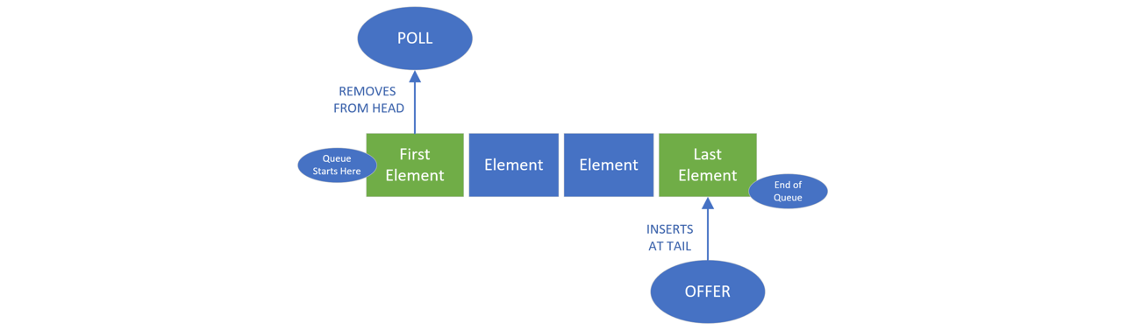

If you want to remove an item, you poll the queue, getting the first element or person in the line. If you want to add an item, you offer it onto the queue, sending it to the back of the line. Single ended queues always process elements from the start of the queue.

A double-ended queue allows access to both the start and end of the queue.

A LinkedList can be used as a double-ended queue.

**A Stack is a Last-In, First-Out (LIFO) Data Collection**

When you think of a stack, you can think of a vertical pile of elements, one on top of another, as is shown below.

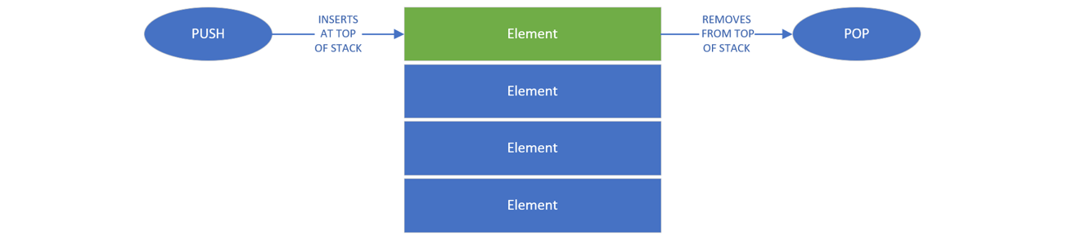

When you add an item, you push it onto the stack. If you want to get an item, you’ll take the top item and pop it from the stack.

A LinkedList can be used as a stack as well.

### Iterators

So far, we’ve mainly used for loops to traverse or step through elements in an array or list. We can use the traditional for-loop and an index to index into a list.

We can use the enhanced for-loop and a collection to step through the elements one at a time. But, Java provaides other means to traverse lists. Two alternatives are the Iterator and the ListIterator.

How Does an Iterator Work?

If you’re familiar with databases, you might be familiar with a database cursor, which is a mechanism that enables traversal over records in a database.

An *iterator* can be thought of as similar to a database cursor. The kind of cursor we’re referring to here can be described as an object that allows traversal over records in a collection.

How Does an Iterator Work?

The iterator is pretty simple. When you get an instance of an interator, you can call the *next()* method to get the next element in the list. You can us the *hasNext()* method to check if any elements remain to be processed.

In the code, you can see a while loop which uses the iterator’s **hasNext** method to determine if it should continue looping. Inside the loop, the next() method is called, its value is assigned to a local variable, and the local variable is printed out.

This would just print each element in a list, but do it through the iterator object.

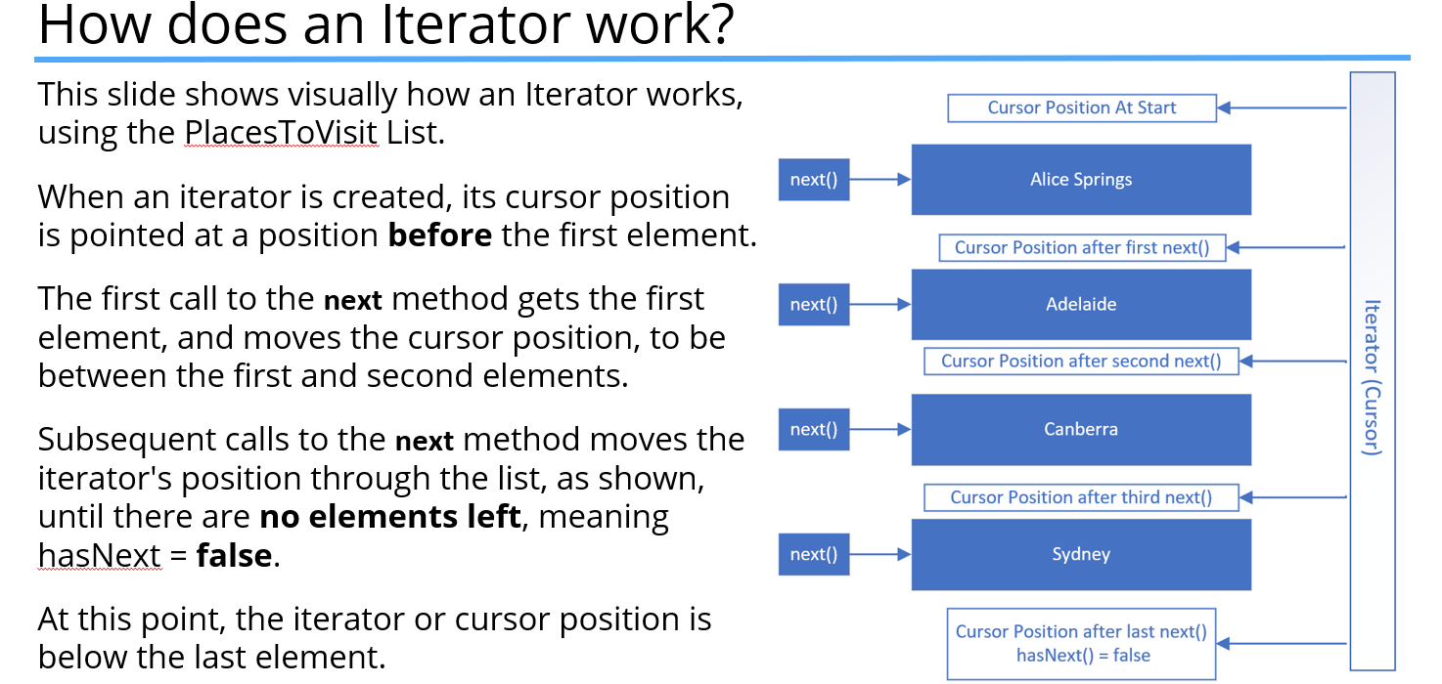

**Iterator vs ListIterator**

An Iterator is forwards only, and only supports the **remove** method.

A ListIterator can be used to go both forwards and backwards, and in addition to the **remove** method, it also supports the **add** and **set** methods.

**Iterator Positions vs. Element Positions**

It’s really important to understand that the iterator’s cursor positions are between the elements.

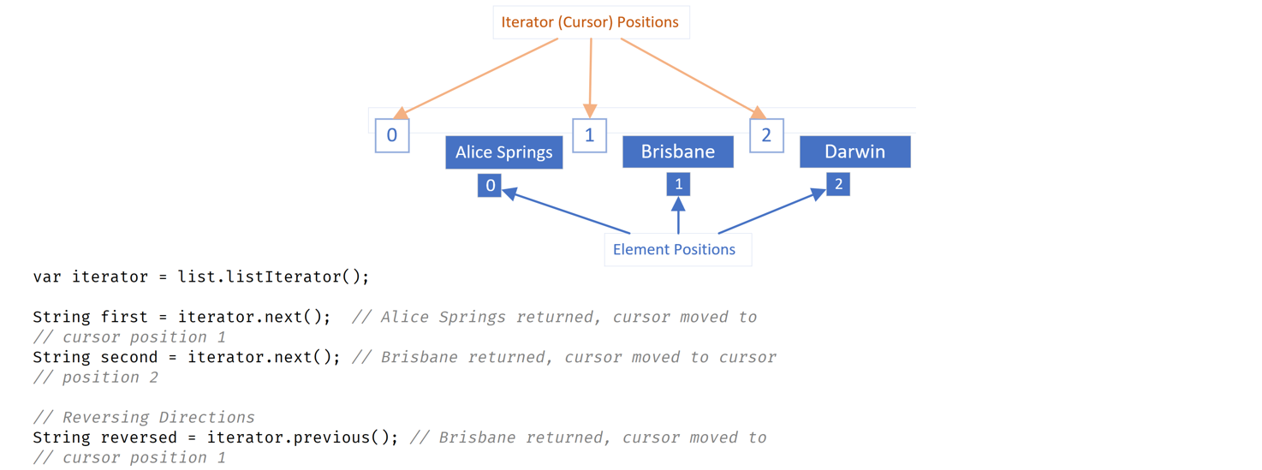

**Why Does Java Have Primitive Data Types?**

Some object-oriented languages don’t support any primitive data types at all, meaning everything is an object. But, most of the more popular object-oriented languages of the day support both primitive types and objects, just like Java.

Primitive types generally represent the way data is stored on an operating system. Primitives have some advantages over objects, especially as the magnitude or number of elements increase. Objects take up additional memory and may require a bit more processing power.

We know we can create objects with primitive data types as field types, for example, and we can also return primitive types from methods.

But, when we look at classes like the ArrayList or the LinkedList which we’ve reviewed in a lot of detail in this section, these classes don’t support primitive data types as the collection type.

In other words, we can’t do the following, creating a LinkedList using the int primitive data type:

LinkedList<int> myIntegers = new LinkedList<>();

This code won’t compile. This means we can’t use all the great functions that Lists provide with primitive values.

More importantly, we can’t easily use primitives in some of the features we’ll be learning about in the future, like generics.

But, Java, as we know, gives us wrapper classes for each primitive type. We can go from a primitive to a wrapper, which is called unboxing, or a wrapper to a primitive which is called unboxing, with relative ease in Java.

### What is Boxing?

A primitive is boxed, or wrapped, in a containing class whose main data is the primitive value. Each primitive data type has a wrapper class, and each wrapper type boxes a specific primitive value.

**How Do We Box?**

Each wrapper has a static overloaded factory method, valueOf(), which takes a primitive and returns an instance of the wrapper class.

The following code ***manually boxes*** a primitive integer of 15 to the boxedInt variable and returns an instance of the java.lang.Integer class:

Integer boxedInt = Integer.valueOf(15);

Another manual way of boxing that can be seen in older code is by creating a new instance of the wrapper class, using the ‘new’ keyword and passing the primitive value to the constructor.

Integer boxedInt = new Integer(15);

If we try the above method in IntelliJ with any JDK of version JDK-9 or higher, IntelliJ will inform us that it is deprecated code.

Java’s own documentation states the following:

* It is rarely appropriate to use this constructor.
* The static factory of valueOf(int) is generally a better choice, as it is likely to yield significantly better space and time performance.

This deprecation applies to all the constructors of the wrapper classes, not just the Integer class. In truth, we rarely have to manually box primitives, because Java supports something called ***autoboxing***.

We can simply assign a primitive value to a wrapper variable:

Integer boxedInt = 15;

Java allows this code, and it’s actually preferred, as opposed to manual boxing. Underneath the covers, Java is doing the boxing. In other words, an instance of Integer is created, and its value is set to 15. Allowing Java to autobox is preferred to any other method, because Java will provide the best mechanism to do it.

Every wrapper class also supports a method to return the primitive value it contains. This is called unboxing. To perform a manual unboxing on an Integer variable, we can use the intValue() method. However, similar to boxing, Java will do the unboxing automatically for us.

We can assign an instance of a wrapper class directly to a primitive variable.

### Enumeration

The enum type is Java’s type to support enumeration. Wikipedia defines enumeration as, “A complete ordered listing of ***all the items*** in a collection.”

Java describes the enum type as: A special data type that contains predefined constants. A constant is a variable whose value can’t be changed once its value had been assigned.

So, an enum is a little like an array except its elements are known, not changeable, and each element can be referred to by a constant name instead of an index position.

An enum in its simplest form is described/defined like a class, but the word ‘enum’ replaces the keyword ‘class’:

public enum DayOfTheWeek { SUNDAY, MONDAY, TUESDAY,

WEDNESDAY, THURSDAY, FRIDAY, SATURDAY }

We can name the enum with any valid identifier, but like a class, Upper Camel Case is the preferred style. Within the enum body, we declare a list of constant identifiers separated by commas. By convention, these are all uppercase labels.

An enum is ordered by the way you declare the constants. This means that in the DayOfTheWeek example above, SUNDAY is considered the first day of the week, and SATURDAY is the last day of the week.

The enum type is used to declare a limited set of constants and sometimes there is a natural order to the listing such as with the days of the week.

Other examples of possible enum declarations might be:

* The months in a year: JANUARY, FEBRUARY, MARCH, etc.
* The directions on a compass: EAST, NORTH, WEST, SOUTH
* A set of sizes: EXTRA_SMALL, SMALL, MEDIUM, LARGE, EXTRA_LARGE

Underneath the covers, the enum type is a special type of class, which contains fields to support the constants, but we'll get into that, in a later discussion. You don't have to understand all the internals of an enum, to derive the benefits of using this type.

Once you get used to how this type works, you may find many places to use an enum. They simplify your code and make it more readable in many ways.

## Section 11 – Abstraction in Java

In this section we’ll be talking about abstraction and generalization. These concepts in action reduce the amount of code we have to write and encourage extensible and flexible code.

When we say code is extensible, we mean it can support future enhancements and changes with little or no effort. An extensible application is designed with change in mind.

In this section, we’ll be looking at Java’s support for these two concepts.

We use the terms ***Abstraction*** and ***Generalization*** when we start trying to model real world things in software. Before we launch into interface types and abstract classes, we need to talk about what these concepts mean.

### Generalization

When you start modeling objects for your application, you start by identifying what features or behavior your objects have in common. We generalize when we create a class hierarchy.

A base class is the most general class, the most basic building block which everything can be said to have in common.

### Abstraction

Part of generalizing is using ***abstraction***. You can generalize a set of characters and behaviors into an abstract type.

If we consider an octopus, a dog, and a penguin, we would probably say they’re all animals. An animal is really an abstract concept.

An animal doesn’t really exist, except as a way to describe a set of more specific things. If you can’t draw it on a piece of paper, it’s probably abstract. An animal would be hard to draw, for example, if you weren’t given more information about what type of animal to draw.

Abstraction simplifies the view of a set of items’ traits and behavior so we can talk about them as a group, as well as generalize their functionality.

**Java’s Support for Abstraction**

Java supports abstraction in several ways:

* Java allows us to create a class hierarchy where the top of the hierarchy, the base class, is usually an abstract concept, whether it’s an abstract class or not.
* Java let’s us create abstract classes.
* Java gives us a way to create interfaces.

#### Abstract Methods

An abstract method has a method signature and a return type but doesn’t have a method body. Because of this, we say an abstract method is ***unimplemented***.

Its purpose is to describe behavior, which any object of that type will always have. Conceptually, we can understand behaviors like move or eat on an Animal, so we might include those as abstract methods on an abstract type.

We can think of an abstract method as a contract. This contract promises that all subtypes will provide the promised functionality, with the agreed upon names and arguments.

#### Concrete Method

A concrete method has a method body, usually with at least one statement. This means it has operational code that gets executed under the right conditions.

A concrete method is said to ***implement*** an abstract method if it overrides one. Abstract classes and interfaces can have a mix of abstract and concrete methods.

#### Method Modifiers

In addition to access modifiers, methods have other modifiers that are listed below as a high-level introduction:

|  |  |
| --- | --- |
| **Modifier** | **Purpose** |
| abstract | When you declare a method abstract, a method body is always omitted. An abstract method can only be declared on an abstract class or an interface. |
| static | Sometimes called a class method, rather than an instance method, because it's called directly on the Class instance. |
| final | A method that is final cannot be overridden by subclasses. |
| default | This modifier is only applicable to an interface, and we'll talk about it in our interface videos. |
| native | This is another method with no body, but it's very different from the abstract modifier. The method body will be implemented in platform-dependent code, typically written in another programming language such as C. This is an advanced topic and not generally commonly used, and we won't be covering it in this course. |
| synchronized | This modifier manages how multiple threads will access the code in this method. We'll cover this in a later section on multi-threaded code. |

**What is ‘it’?**

Consider these sentences:

* We adopted a new pet this weekend.
* I ordered something I really wanted from the store.
* I bought a ticket and won a price.

If we said these things to a friend or a coworker, it might be frustrating for them. We haven’t given them enough information in any of these cases. In other words, they can’t paint a picture in their head because they lack details.

New pet, something ordered, and a ticket are too general when talking about one item.

On the other hand, when we talk about ***groups of things***, we don’t usually need too many specifics.

Consider these sentences:

* I need to get home to feed the animals.
* I’m waiting for my box of stuff from an online store to be delivered.

So here, ‘animals’ and ‘stuff’ are probably enough information to fully describe the situation.

The abstract class is declared using the ***abstract*** modifier. Below, we are declaring an abstract class called Animal:

Abstract class Animal {} // An abstract class is declared with the abstract

// modifier.

An **abstract** class is a class that’s **incomplete**. For that reason, we can’t create an instance of an abstract class. But, an abstract class can still have a constructor which will be called by its subclasses during their construction.

Animal a = new Animal(); // INVALID, an abstract class never gets instantiated.

An abstract class’s purpose is to define the behavior its subclasses are required to have, so it always participates in ***inheritance***. Classes extend abstract classes and can be concrete.

The example below inherits from the abstract class Animal:

class Dog extends Animal {}; // Animal is abstract, Dog is not.

A class that extends an abstract class can also be abstract itself, as shown below:

abstract class Mammal extends Animal {} // Animal is abstract, Mammal is also

//abstract.

Finally, an abstract class can extend a concrete class. Below we have BestOfBreed, and abstract class, extending Dog, which is concrete:

abstract class BestOfBreed extends Dog {} // Dog is not abstract, but

//BestOfBreed is.

#### What’s An Abstract Method?

An abstract method is declared with the modifier ***abstract***.

Below, we declare an abstract method called move with a void return type. It simply ends with a semi-colon:

abstract class Animal {

public abstract void move();

}

It doesn’t have a body, not even curly braces. Abstract methods can only be declared on an abstract class or interface.

**What Good Is An Abstract Method If It Doesn’t Have Any Code In It?**

An abstract method tells the outside world that all members of this class can perform this method. In the example above, it says that all Animals will move. Thus, any subtype of Animal knows it can call the move method, and the subtype will implement this method with this signature.

This is also true for a concrete class and a concrete method that is being overridden.

In the videos on **inheritance**, we created a very basic Animal class, and then we extended it to create a Dog.

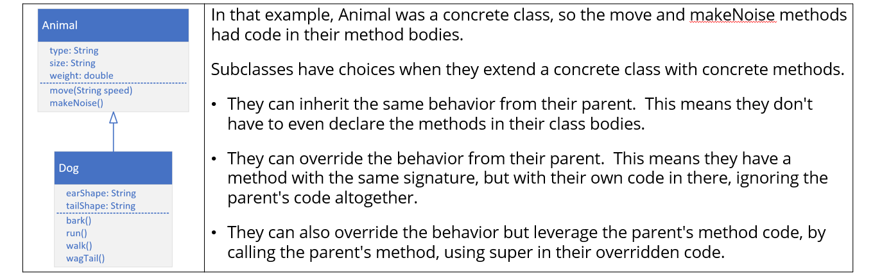

But what happens if Animal is declared as abstract, and the move and makeNoise methods are also abstract?

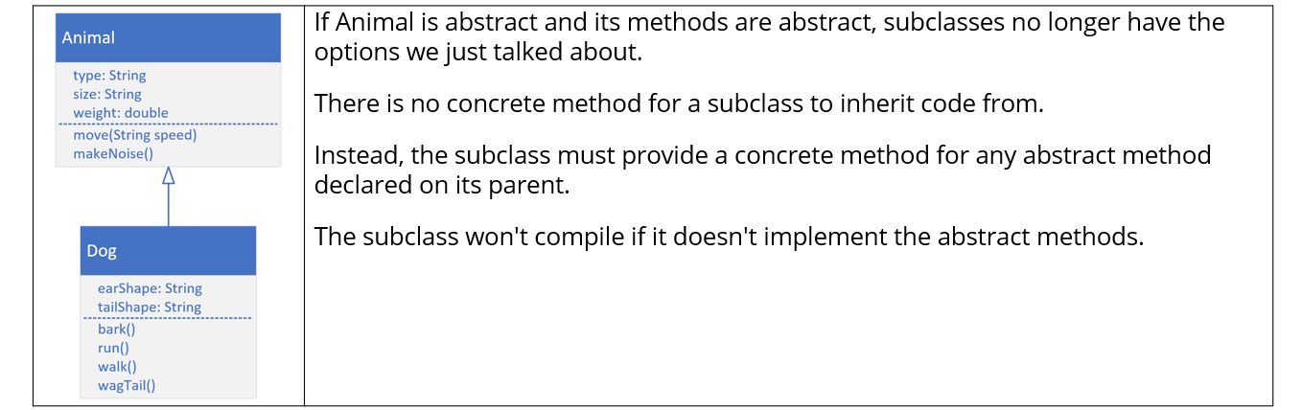

**An Abstract Class Doesn’t Have to Implement Abstract Methods**

An abstract class that extends another abstract class has some flexibility.

* It can implement *all* of the parent’s abstract methods.
* It can implement *some* of them.
* Or it can implement *none* of them.
* It can also implement additional abstract methods which will force subclasses to implement both Animal’s abstract methods as well as Mammal’s.

**Why Use An Abstract Class?**

In truth, you may never need to use an abstract class in your design, but there are some good arguments for using them.

An abstract class in your hierarchy forces the designers of subclasses to think about and create unique and targeted implementations for the abstracted methods.

It may not always make sense to provide a default, or inherited implementation, of a particular method. An abstract class can’t be instantiated, so if you’re using abstract classes to design a framework for implementation, this is definitely an advantage.

In our example, we don’t really want people creating instances of Animals or Mammals. We used those classes to abstract behavior at different classification levels. All Animals have to implement the move and makeNoise methods, but only Mammals needed to implement shedHair, as we demonstrated.

Course design solution for challenge:

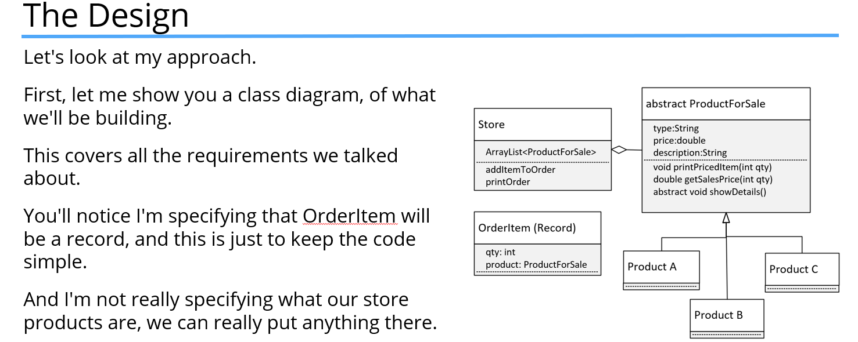

### Interface vs Abstract Class

We saw that an abstract class requires its subclasses to implement its abstract methods. An ***interface*** is similar to an abstract class, although it isn’t a class at all.

It’s a **special** type that’s more like a **contract** between the class and the client clone that the compiler enforces.

By declaring it’s using an interface, your class must implement all the abstract methods on the interface. A class agrees to this because it wants to be **known by that type,** by the outside world, or by the client code. An **interface** lets **classes that might have little less else in common** be recognized as a special reference type.

Declaring an interface is similar to declaring a class, using the keyword ***interface*** where you would use ‘class’.

public interface FlightEnabled {}

An interface is usually named according to the set of behaviors it describes. Many interfaces will end in ‘able’, like Comparable, and ‘Iterable’, again, meaning something is capable or can-do a given set of behaviors.

A class is associated to an interface by using the ***implements*** clause in the class declaration. In the example below, the class Bird implements the FlightEnabled interface:

public class Bird implements FlightEnabled {

}

Because of this declaration, we can use FlightEnabled as the reference type, and assign it an instance of bird. In the following example, we create a new Bird object, but we assign it to the FlightEnabled variable named flier:

FlightEnabled flier = new Bird();

A class can only **extend** a **single class**, which is why Java is called single inheritance. But, a class can **implement many interfaces.** This give us **plug and play functionality**, which is what makes them so powerful. A class can **both extend** another class and **implement** one or more interfaces.

public class Bird extends Animal implements FlightEnabled, Trackable {}

Here, the Bird class extends/inherits from Animal, but it’s implementing both a FlightEnabled & Trackable interface.

**The Abstract Modifier is Implied On an Interface**

We don’t have to declare the interface type as abstract, because this modifier is implicitly declared for all interfaces. Likewise, we don’t have to declare any method within an interface as abstract.

In fact, any method declared without a body is really **implicitly declared both public and abstract**.

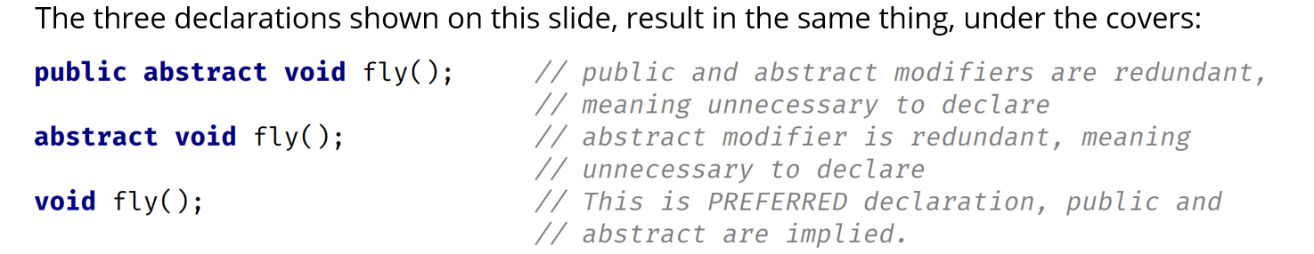

**All Members On an Interface Are Implicitly Public**

If we omit an access modifier on a *class member*, it’s implicitly package private. However, if we omit an access modifier on an *interface member*, it’s implicitly public. This is an important difference and one we need to remember.

Changing the access modifier of a method to protected on an interface is a compiler error, whether the method is concrete or abstract. Only a concrete method can have private access.

### The Bird Class

An interface lets us treat an instance of a single class as many different types. The Bird Class inherits behavior and attributes from Animal, because we used the ‘extends’ keyword in the declaration of Bird,

Because the move method was abstract on Animal, Bird was required to implement it. The Bird Class as implements the FlightEnabled interface which required us to implement the takeOff, fly, and land methods, the abstract methods on FlightEnabled, on the Bird Class.

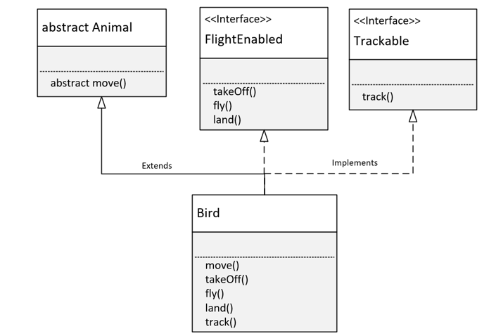

The Bird Class also implements the Trackable interface. This required the Bird Class to implement the track method, which was the abstract method declared in trackable.

Because of these declarations, any instance of the Bird Class can be treated as a Bird. This means it has access to all of Bird’s methods, including those from Animal, FlightEnabled, and Trackable. An instance of Bird can be treated like, or declared as, an Animal with access to the Animal functionality described in that class, but customized to Bird.

It can be used as a FlightEnabled type with just the methods a FlightEnabled type needs, but again customized for the Bird. Or, it can take the form of a Trackable object and be tracked with specifics for the Bird class.

Interfaces let us take objects that may have almost nothing in common and write reusable code so we can process them all in a like manner.

Three very different entities like Jet, Bird, and Dragonfly can implement FlightEnabled, and we can treat them as the same type, as something that flies, and ignore the differences in the classes.

Interfaces allow us to type our objects differently, **by behavior only**.

Any fields declared on an interface are not really instance fields. They are implicitly public, static, and final, which means, they are really constants.

### The final Modifier in Java

***When we use the final modifier, we prevent any further modifications to that component***.

* a final method means it can’t be overridden by a subclass.
* a final field means an object’s field can’t be reassigned or given a different value after its initialization.
* a final static field is a class field that can’t be reassigned or given a different value after the class’s initialization process.
* a final class can’t be overridden, meaning no class can use it in the extends clause.
* a final variable in a block of code means that once it’s assigned a value, any remaining code in the block can’t change it.
* a final method parameter means we can’t assign a different value to that parameter within the method code block.

The final static field is what we’re really creating when we declare a variable field/instance on an interface.

**Constants in Java**

A ***constant*** in Java is a variable that can’t be changed.

A *constant variable* is a final variable of primitive type or type String that is initialized with a constant expression. Constants in Java are usually named with all uppercase letters, and with an underscore in between the words.

example: HOURS_IN_A_DAY = 24;

A static constant means we access it via the type name. We saw this with the Integer.MAX_VALUE and the Integer.MIN_VALUE fields.

A filed declared on an Interface is always public, static, and final, so we can declare them with any combination of these modifiers, or none at all, with the same result. Java let’s us specify these like an ordinary field on an interface, which might be kind of confusing and misleading to a new Java programmer.

double MILES_TO_KM = 1.60934;

final double MILES_TO_KM = 1.60934;

public final double MILES_TO_KM = 1.60934;

public static final double MILES_TO_KM = 1.60934;

### Extending Interfaces

Interfaces can be extended, similar to classes, using the ‘extends’ keyword. Below, we show that OrbitEarth is an interface that extends the FlightEnabled interface:

interface OrbitEarth extends FlightEnabled {}

This interface requires all classes to implement both the OrbitEarth and the FlightEnabled abstract methods. Unlike a class, an interface can use the extends expression with multiple interfaces:

interface OrbitEarth extends FlightEnabled, Trackable {}

**Implements Is Invalid On An Interface**

An interface doesn’t implement another interface, so the code on this slide won’t compile. In other words, implements is an invalid clause in an interface declaration. (they are the same type, so they will extend each other)

interface OrbitEarth implements FlightEnabled {} // INVALID, implements is

// invalid clause for interfaces

**Abstracted Types – Coding to an Interface**

Both interfaces and abstract classes are **abstracted reference types**. Reference types can be used in code as variable types, method parameters, and return types, list types, and so on. When you use an abstracted reference type, this is referred to as ***coding to an interface***.

This means your code doesn’t use specific types but more generalized ones, usually an interface type. **This technique is preferred** because it allows many runtime instances of various classes to be processed uniformly by the same code. It also allows for substitutions of some other class or object that still implements the same interface without forcing a major refactor of your code.

Using interface types as a reference type is considered a best practice.

### Coding to an Interface

Coding to an interface scales well to support new subtypes, and it helps when refactoring code. The downside, though, is that alterations to the interface may wreak havoc on the client code.

Imagine that you have 50 classes using your interface and you want to add an extra abstract method to support new functionality.

As soon as you add a new abstract method, all 50 classes won’t compile because your code isn’t backwards compatible with this kind of change to an interface.

Interfaces haven’t been easily extensible in the past, but Java has made several changes to the Interface type over time to try and address this problem.

**What’s Happened to the Interface Type Since JDK-8**

Before JDK-8, the interface type could only have public abstract methods. JDK-8 introduced the **default** method and the public **static** methods, and then JDK-9 introduced **private** methods, both static and non-static.

All of these method types (on the interface) are concrete methods.

Java came to the rescue with the introduction of the ***extension method***.

**The Interface Extension Method – The Default Method (as of JDK-8)**

An extension method is identified by the modifier **default**, so it’s more commonly known as the default method. This method is a concrete method, meaning it has a code block and we can add statements to it. In fact, it has to have a method body. Even just an empty set of curly braces. It’s a lot like a method on a superclass because we can override it.

Adding a default method doesn’t break any classes currently implementing the interface.

### Overriding a default Method

So, like overriding a method on a class, you have three choices when you override a default method on an interface.

* You can choose not to override it at all.
* You can override the method and write code for it so that the interface method isn’t executed.
* Or, you can write your own code and invoke the method on the interface as part of your implementation.

**Support for public static methods On An Interface (as of JDK-8)**

Another enhancement that Java included in JDK-8 was support for public static methods on the Interface. Before JDK-8, an interface would often come with a helper class that would contain the static methods.

Static methods don’t need to specify a public access modifier because it’s implied. When you call a public static method on an interface, you must use the interface name as a qualifier.

### Private Methods (JDK-9)

JDK-9 gave us private methods, both static and not static. This enhancement primarily addresses the problem of the re-use of code within concrete methods on an interface.

A private static method can be accessed by either a public static method, a default method, or a private non-static method. A private non-static method is used to support default methods and other private methods.

### Abstract Class

* Abstract classes are very similar to interfaces. You can’t instantiate either of them. Both types contain a mix of methods declared with or without a method block. Remember, when a method has a method block, it’s a ***concrete method*** and we can say it’s implemented or provides an implementation for that method.
* With abstract classes, you can declare fields that aren’t static and final – in other words, instance fields.
* Also, with abstract classes, you can use any of the four access modifiers for its concrete methods (public, private, protected or the default package)
* You can also use all but the private access modifier for its abstract methods.
* An abstract class can extend only one parent class, but it can implement multiple interfaces.
* When an abstract class is subclassed, the subclass usually provides implementations for all of the abstract methods in its parent class. However, if it doesn’t, then the subclass must also be declared abstract.

**Use an Abstract Class When…**

You want to use an abstract class when you want to share code among several closely related classes (Animal for example, with fields name, age, etc.)

You expect class that extend your abstract class to have many common methods or fields, or require access modifiers other than public.

You want to declare non-static or non-final fields (for example, name, age, etc.), so this enables you to define methods that can access and modify the state of an object (getName, setName, etc.).

Also, you may want to use an abstract class when you have a requirement for your base class to provide a default implementation of certain methods, but other methods should be open to being overridden by child classes.

**In Summary: An abstract class provides a common definition, as a base class, that multiple, derived classes can share.**

### Interface

* An interface is just the declaration of methods which you want some classes to have, it’s not the implementation.
* In an interface, we define what kind of operation an object can perform. These operations are defined by the classes that implement the interface.
* Interfaces form a contract between the class and the outside world, and this contract is enforced at build time by the Java compiler.
* You can’t instantiate interfaces, but they may contain a mix of methods declared with or without an implementation.
* All methods on interfaces declared without a method body are automatically public and abstract.
* An interface can extend another interface.
* Interfaces are more flexible and can deal with a lot more stress on the design of your program because they aren’t part of the class hierarchy.
* A best practice way of coding is commonly called Coding to an Interface.
* By introducing Interfaces into your program, you’re really introducing points of variation, at which you can plug different implementations for that interface.

**In summary: The interface decouples the “what” from the “how” and is used to make different types behave in similar ways.**

Since Java 8, interfaces can now contain default methods, so in other words, methods with implementation. The keyword ‘default’ is used mostly for backwards compatibility. Public static methods were also introduced in Java 8.

Since Java 9, an interface can also contain private methods, commonly used when default methods share common code.

**Use An Interface When…**

You want to use an interface when you expect that unrelated classes will implement your interface. For example, two of Java’s own interfaces, Comparable and Cloneable, can be implemented by many unrelated classes.

You want to specify the behavior of a particular data type, but you’re not concerned about who implements its behavior.

You want to separate different behavior.

**Interfaces Are Used In Many of Java’s Own Features**

We have briefly discussed some interfaces, like List and Queue, and their implementations ArrayList and LinkedList. These are part of what Java calls its **Collections Framework**.

Interfaces are also the basis for many of the features that are coming up, such as ***lambda expressions***, which were introduced in JDK-8.

Another example is **Java’s database connectivity support, or JDBC**, built almost entirely with interfaces. The concrete implementation of methods is different for each database vendor and comes in the form of JDBC drivers. This enables you to write all database code without being concerned about the details of the database you’re connected to.

We’ve said that interfaces and abstract classes are both abstracted types and that abstracted types are used as reference types in code. The table below gives a summary of the similarities and differences:

|  |  |  |
| --- | --- | --- |
|  | **Abstract Class** | **Interface** |
| An instance can be created from it | No | No |
| Has a constructor | Yes | No |
| Implemented as part of the Class Hierarchy. Uses Inheritance | Yes (in extends clause) | No (in implements clause) |
| records and enums can extend or implement? | No | Yes |
| Inherits from java.lang.Object | Yes | No |
| Can have both abstract methods and concrete methods | Yes | Yes (as of JDK 8) |
| Abstract methods must include abstract modifier | Yes | No (Implicit) |
| Supports default modifier for it's methods | No | Yes (as of JDK 8) |
| Can have instance fields (non-static instance fields) | Yes | No |
| Can have static fields (class fields) | Yes | Yes - (implicitly **public static final**) |

Interface Challenge Class Diagram

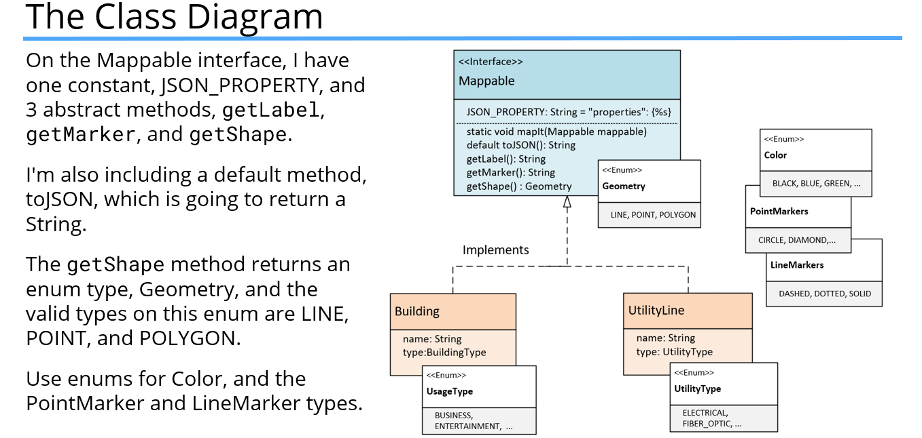

Two business classes to be mapped, Building and UtilityLine. For building, use an enum to describe the building type. For the UtilityLine, use the enum to describe the type of utility it is.

## Section 12 – Generics

This section is on another important topic in Java – Generics. If you’ve been doing this course in order, you’re familiar with generalizing, conceptually, your own class design.

You pull out what things your classes have in common so that you can think about them generally. Generics allow us to create classes, to design them in a general way, without really worrying about the specific details of the elements they may contain.

Java’s ArrayLists are an example of a generic class. We can use an ArrayList for any type of object because many methods on that class can be applied to any type.

### What Are Generics?

Java supports generic types such as classes, records, and interfaces. It also supports generic methods.

Below is a regular class declaration next to a generic class. The thing to notice with the generic class is that the class declaration has angle brackets with a T in them directly after the class name.

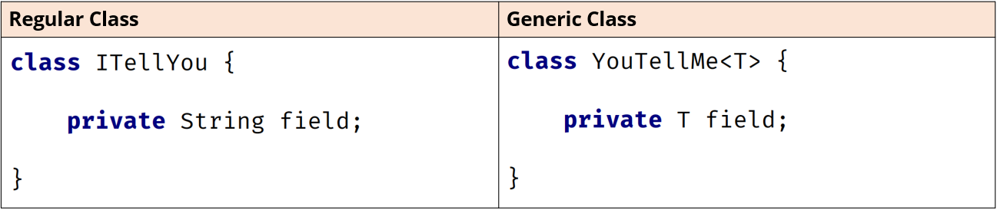

T is the placeholder for a type that will be specified later. This is called a type identifier, and it can be any letter or word, but T, which is short for Type, is most commonly used.

**Declaring a Class vs Declaring a Generic Class**

For the generic class, the field’s type is that placeholder, just T, and this means it can be any type at all. The T in the angle brackets means it’s the same type as the T specified as the type of the field.

**Using a Generic Class As a Reference Type**

Below is a variable declaration of the generic ArrayList. In the declaration of a reference type that uses generics, the type parameter is declared in angle brackets.

The reference type is ArrayList, the type parameter (or parameterized type) is String, which is declared in angle brackets, and listOfString is the variable name.

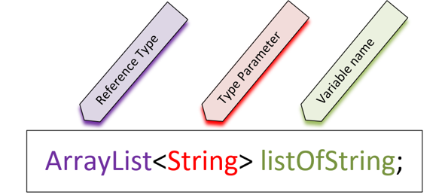

Many of Java’s libraries are written using generic classes and interfaces, so we’ll be using them a lot moving forward. But, it’s still a good idea to learn to write your own generic class to help you understand the concept.

It’s best practice to use the Interface type as the reference variable on the left side when declaring variables, so for an ArrayList of Strings, declare it as List<String> on the left side (reference side), then on the ride when it’s instantiated, it will be ArrayList<String>().

### Generics Examples

We created a class for BaseballTeam with BaseballPlayers and now we want to create a class for FootballTeam. One solution would be to copy and paste the BaseballTeam code and rename everything to FootballTeam, then create a FootballPlayer, as shown below:

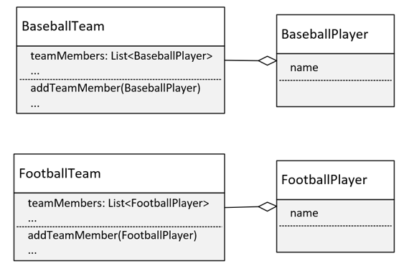

This would mean that we’d have to make sure any changes we made to one team or player that made sense for the other team or player had to be made in both sets of code. This is rarely a recommended approach unless team operations are significantly different.

**Solution 2: Use a Player Interface or Abstract Class to Support Different Types of Players**

We could change BaseballTeam to simply Team and use an interface type (or abstract base class) for Player. This is shown below:

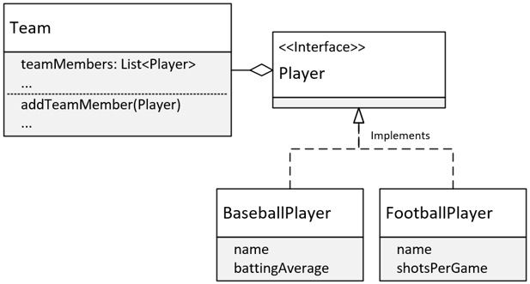

Above we have a Team class with a List of Players. Player is an interface, then BaseballPlayer and FootballPlayer implement that interface. This is a better design than the previous one, but it’s still got problems.

### Generic Type Parameters

We’ve already seen that one way to declare a generic class is to include a type parameter which is shown below in angle brackets:

public class Team<T> {}

Now, using T is just a convention, short for whatever type you want to use this Team class for. But you can but anything you want there.

We can have more than one type parameter, so we could do T1, T2, T3 if we wanted to:

public class Team<T1, T2, T3> {}

But, convention says instead of using type parameters like this, it’s easier to read the code with alternate letter selections:

public class Team<T, S, U> {}

These are usually S, U, and V, in that order. If we had three types, we’d probably want to declare this class as shown above with T, S, and U.

A few letters are reserved for special use cases.

The most commonly used type parameter identifiers are:

* E for Element (used extensively by the Java Collections Framework).
* K for Key (used for mapped types).
* N for Number.
* T for Type.
* V for Value.
* S, U, V etc. for 2nd, 3rd, 4th, etc. types.

### Raw Usage of Generic Classes

When you use generic classes, either referencing them or instantiating them, it’s definitely recommended that you include a type parameter. But, you can still use them without specifying one. This is called the ***Raw Use*** of the reference type.

The raw use of these classes is still available for backwards compatibility, but it’s discouraged for several reasons.

* Generics allow the compiler to do compile-time type checking when adding and processing elements in the list.
* Generics simplify code, because we don’t have to do our own type checking and casting as we would if the type of our elements was Object.

public class Team<T extends Player> {}

The code above is using the extends keyword, but this extends keyword doesn’t have the same meaning as extends when it’s used in a class declaration. This isn’t saying that the type T extends Player, although it could. Instead, it is saying that type T has to either be a Player or a **subtype** of Player.

Now, Player in this case could have been either a class or an interface. The syntax would be the same.

This declaration establishes what is called an ***upper bound***, on the types that are allowed to be used with this class.

**Why Specify an Upper Bound?**

An upper bound permits access to the bounded type’s functionality. An upper bound limits the kind of type parameters you can use when using a generic class. It tells the system the type must be equal to or a subtype of the bounded type.

**Interfaces Used For Sorting**

Now that we’ve covered interfaces and generic classes, we will go into more detail over interfaces that were covered in previous lectures.

The first is Comparable.

For an array, we can simply call Arrays.sort() and pass it an array. But, as was previously mentioned, the elements in the array need to implement Comparable.

Types like String, or primitive wrapper classes like Integer or Character, are sortable. This is because they implement this interface.

**Comparable Interface**

The interface declaration in Java:

public interface Comparable<T> {

int compareTo(T o);

}

It’s a generic type, meaning it’s parameterized. Any class that implements this interface needs to implement the compareTo() method. This method takes one object as an argument, shown above as the letter ‘o’, and compares it to the current instance (this).

The table below shows what the results of the compareTo() method should mean when implemented:

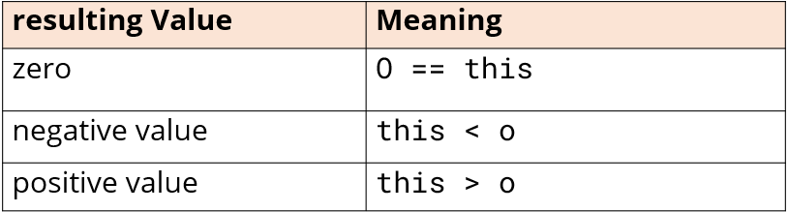

### The Comparator Interface

The Comparator Interface is similar to the Comparable interface, and the two can often be confused with each other. Its declaration and primary abstract method are shown below in comparison to Comparable:

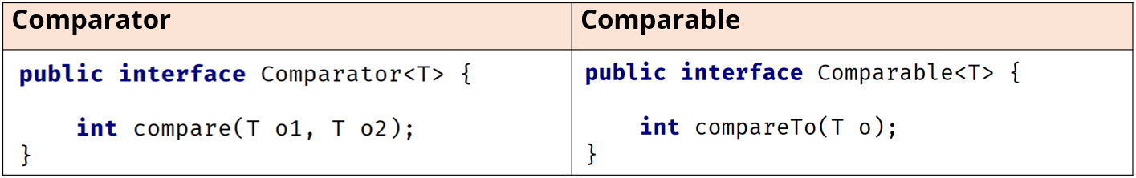

Notice that the method names are different: compare vs compareTo. The compare method takes two arguments vs one for compareTo, meaning that it will compare the two arguments to one another, and not one object to the instance itself.

It’s common practice to include a Comparator as a nested class.

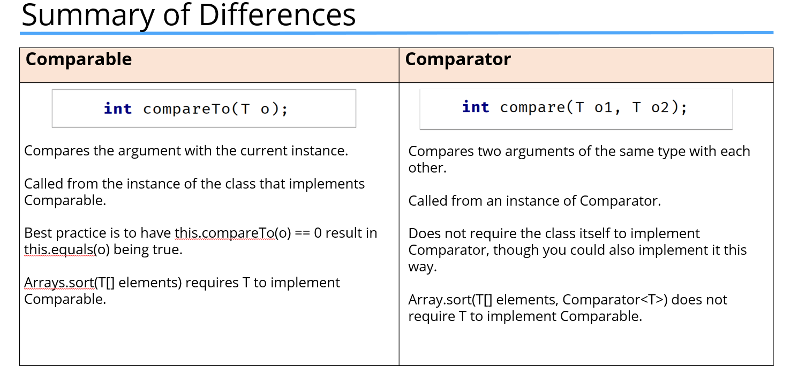

**What’s Left to Know About Generics?**

In the next few videos, we will cover the following topics:

* Using generic references that use type arguments declared in method parameters and local variables.
* Creating generic methods apart from generic classes.
* Using wild cards in the type argument.
* Understanding static methods with generic types.
* Using multiple upper bounds.

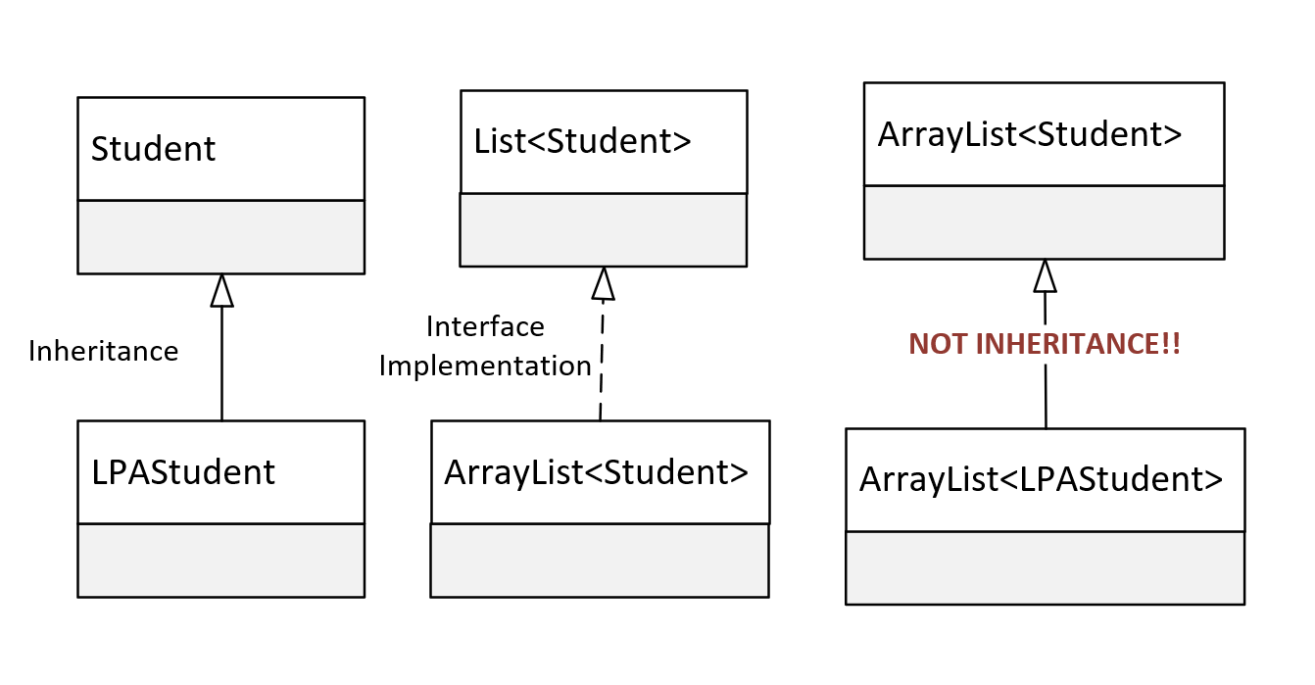

Trying to pass an ArrayList of LPAStudent objects to a method defined to receive an ArrayList of Students will always fail, even if LPAStudent is a subclass of Student. This has nothing to do with inheritance.

We know LPAStudent inherits from Student, and we can pass an instance of LPA Student to any method, or assign it to any reference type, declared with the type Student. We also know that ArrayList implements List, and we can pass an ArrayList to a method or assign it to a reference of the List type.

Why can't we pass an ArrayList of LPA Student, to the method parameter that's declared as a List of Student?

Surely, if an LPAStudent is a Student, a List of LPAStudent is ultimately a List of Student. It's very natural to assume that a method that takes a List with Students should accept a List with LPAStudents, because LPAStudent is a Student after all.

But that's not how it works.

When used as reference types, a container of one type has no relationship to the same container of another type, even if the contained types do have a relationship.

**Limitation of Reference of Generic Class with an Argument List**

When we declare a variable or a method parameter with: List<Student>

Only List subtypes with Student elements can be assigned to this variable or method argument. We CANNOT assign a list of Student subtypes to this.

Setting up a generic method:

public void <T> void myMethod(T [parameterName]) {

return input.toString();

}

For a method, type parameters are placed after any modifiers and before the method’s return type. The type parameter can be referenced in the method parameter, as the method return type, or in the method code block, much as we saw a class’s type parameter can be used.

A generic method can be used for collections with type arguments, as we just saw, to allow for variability of the elements in the collection, without using a raw version of the collection.

A generic method can be used for static methods on a generic class because static methods can’t use class type parameters.

A generic method can be used on a non-generic class to enforce type rules on a specific method. The generic method type parameter is separate from a generic class type parameter.

In fact, if you’ve used T for both, the T declared on the method means a different type than the T for the class.

Another option is passing in a parameter type, but including a wild card:

public static void printMoreLists(List<? Extends Student> students) {

for(Student s : students) {

System.out.println(s.getYearStarted() + “: “ + s);

}

System.out.println();

}

### Type Parameters, Type Arguments and Using a Wildcard

A **type parameter** is a generic class, or generic method’s declaration of the type. In both of the examples below, T is said to be the type parameter. You can bind a type parameter with the use of the **extends** keyword to specify an **upper bound**.

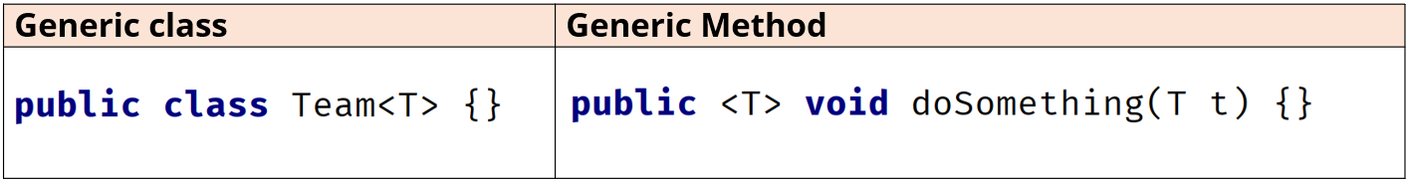

A **type argument** declares the type to be used, and is specified in a type reference, such as a local variable reference, method parameter declaration, or field declaration.

In the example below, BaseballPlayer is the type argument for the Team class:



A **wildcard** can only be used in a **type argument**, not in the type parameter declaration.

A wildcard is represented with the **?** character.

A wildcard means the type is unknown.

For this reason, a wildcard limits what you can do when you specify a type this way.

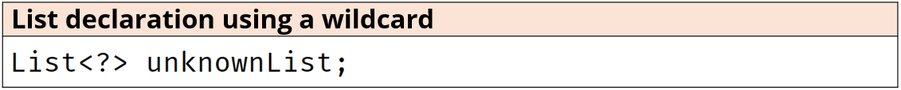

A wildcard can’t be used in an instantiation of a generic class. The code below is invalid:



A wildcard can be unbounded or, alternatively, you can specify either an upper bound or lower bound. You CANNOT specify both an upper and a lower bound, in the same declaration.

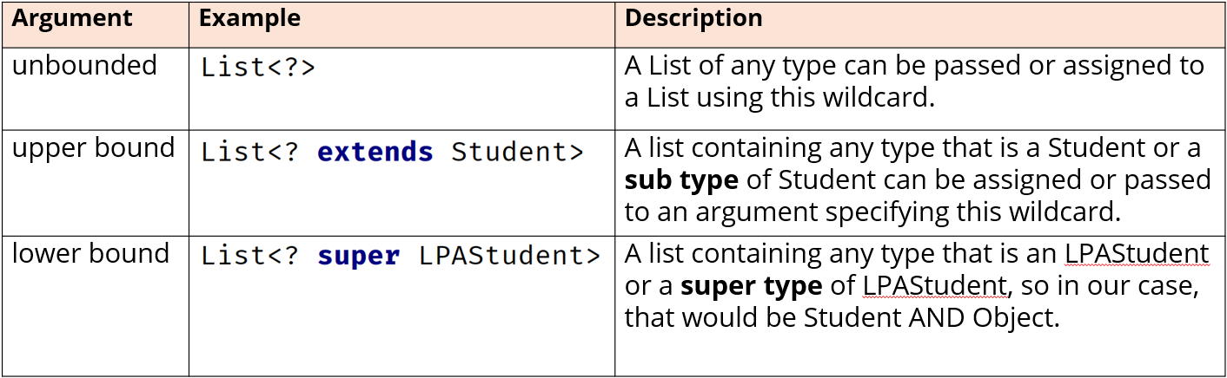

### Type Erasure

Generics exist to enforce tighter type checks at compile time. The compiler transforms a generic class into a typed class, meaning the byte code, or class file, contains no parameters.

Everywhere a type parameter is used in a class it gets replaced with either the type Object, if no upper bound was specified, or the upper bound type itself.

This transformation process is called type erasure because the T parameter (or S, U, V), is erased and replaced with a true type.

Why is this important? – for the most part, this isn’t something you really need to worry about, but it’s important to understand for overloaded methods.

To declare a generic class that extends (inherits) from another class and implements an interface, it is written as:

//Student is the inherited class and QueryItem is the interface

public class QueryList <T extends Student & QueryItem > {

…

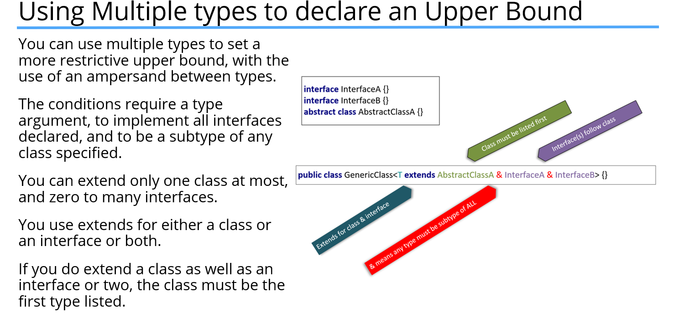

## ­Section 13 – Nested Classes and Types

### Nesting Classes (or Types) Within Another Class

A class can contain other types within the class body, such as other classes, interfaces, enums, and records. These are called nested types, or nested classes.

You might want to use nested classes when your classes are tightly coupled, meaning their functionality is interwoven.

The four different types of nested classes we can use in Java are: the static nested class, the inner class, and the local and anonymous classes.

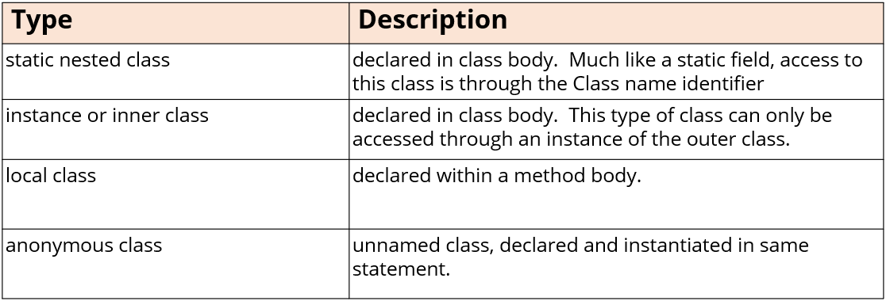

Before JDK-16, only static nested classes were allowed to have static methods. As of JDK-16, all four types of nested classes can have static members of any type, including static methods.

#### Static Nested Class

The static nested class is a class enclosed in the structure of another class declared as static. This means the class requires the outer class name as part of the qualifying name, if accessed externally.

This class has the advantage of being able to access private attributes on the outer class.

The enclosing class can access any attributes on the static nested class, also including private attributes.

#### Inner Classes

Inner classes are non-static classes declared on an enclosing class at the member level. They can have any of the four valid access modifiers, meaning they can be public, protected, private, or package-private (have no modifier).

An inner class has access to instance members including private members of the enclosing class.

As of JDK-16, static members of all types are supported on inner classes.

Instantiating an inner class from external code can be a bit tricky.

To create an instance of an inner class, you must first have an instance of the enclosing class. From that instance, you call .new followed by the inner class name and the parentheses, taking any constructor arguments.

This definitely looks strange the first time you see it.



#### Local Classes

Local classes are inner classes, but declared directly in a code block, usually a method body.

Because of that, **they don’t have access modifiers** and are only accessible to that method body while it’s executing. Like an inner class, they have access to all fields and methods on the enclosing class. They can also access local variables and method arguments that are final or effectively final.

##### Local Class’s ‘Captured Variables’

When you create an instance of a local class, referenced variables used in the class from the enclosing code are “captured”. This means a copy is made of them and the copy is stored with the instance. This is done because the instance is stored in a different memory area than the local variables in the method.

For this reason, if a local class uses local variables or method arguments from the enclosing code, these must be final or effectively final.

#### Final Variables and Effectively Final

The sample below shows:

* A method parameter called methodArgument in the doThis method declared as final.
* A local variable in the method block Field30 also declared with the keyword ‘final’

class ShowFinal {

private void doThis(final int methodArgument) {

final int Field30 = 30;

}

}

#### Effectively Final

In addition to explicitly final variables, you can also use ***effectively final*** variables in your local class. A local variable or a method argument are effectively final if a value is assigned to them and then never changed after that.

Effectively final variables can be used in a local class.

#### Additional Local Types

As of JDK-16, you can also create a local record, interface, and enum type in your method block. These are all implicitly static types and therefore aren’t inner classes or types, but static nested types.

The record was introduced in JDK-16. Prior to that release, there was no support for a local interface or enum in a method block either.

### Anonymous Class

An anonymous class is a local class that doesn’t have a name. All the nested classes we’ve looked at so far have been created with a class declaration. The anonymous class is never created with a class declaration, but it’s always instantiated as part of an expression.

Anonymous classes are used a lot less since the introduction of lambda expressions in JDK-8. However, there are still some use cases where an anonymous class might be a good solution.

An anonymous class is instantiated and assigned in a single statement. The new keyword is used followed by any type. This is NOT the type of the class being instantiated. It’s the super class of the anonymous class, or it’s the interface this anonymous class will implement as shown below:

var c4 = new Comparator<StoreEmployee>() {};

In the first example, the anonymous unnamed class will implement the Comparator interface. The second example below shows an anonymous class extends the Employee class, meaning it’s a subclass of Employee:

var e1 = new Employee {};

In both cases, it’s important to remember the semi-colon after the closing bracket because this is an expression, not a declaration.

## Section 14 – Lambda Expressions, Functional Interfaces, and Method References

Many methods that support Lambda Expressions have been introduced to Java’s interfaces and classes since JDK-8. Lambda expressions let you pass around snippets of custom code, giving you so much more functionality than you might otherwise be able to achieve, and with very little effort.

It’s sometimes confusing to understand these expressions, or how much power is in their punch, and sometimes with just a single statement.

A lambda expression can be thought of as implicit code for an anonymous class, using a special kind of interface as the mechanics to do this. The method reference goes even further and is a short cut for the lambda expression syntax for existing methods.

### The Lambda Expression

The syntax of this lambda expression is on the left below. This was passed directly as a method argument for a parameter type that was a Comparator.

The Comparator’s abstract method, compare is shown on the right side.

|  |  |
| --- | --- |
| **The generated Lambda Expression** | **Comparator’s Abstract Method** |
| (o1, o2) -> o1.lastName().compareTo(o2.lastName()) | int compare(T o1, T o2) |

The lambda expression parameters are determined by the associated interface’s method, the functional method. In the case of a Comparator and its compare() method, there are two arguments.

This is why we get o1 and o2 in parentheses in the generated lambda expression. These arguments can be used in the expression, which is on the right of the arrow token.

A lambda expression consists of a formal parameter list, usually but not always declared in parentheses, the arrow token, and either an expression or a code block after the arrow token.

(parameter1, parameter2, … ) -> expression;

Because Lambda expressions are usually simple expressions, it’s more common to see them written as shown above.

The expression should return a value if the associated interface’s method returns a value. In the case of our generated expression, it returns an int, which is the result of the compare() method on Comparator.

**Comparing the Anonymous Class and the Lambda Expression**

Where is the link between the compare method and this lambda expression?

It’s obvious in the anonymous class, because we override the compare method and return the result of that expression.

|  |  |
| --- | --- |
| **Anonymous Class** | **Lambda Expression** |
| new Comparator<Person>() {  @Override  public int compare(Person o1, Person o2) {  return o1.lastName().compareTo(o2.lastName());  }  } | (o1, o2) -> o1.lastName().compareTo(o2.lastName()) |

We can see the two parameters and their types, and what the return value should be in the anonymous class.

The lambda expression has no reference to an enclosing method as far as we can see from this code. For a lambda expression, the method is inferred by Java.

### How Can Java Infer the Method?

Java takes its clue from the reference type, in the context of the lambda expression usage. Below, we show a simplified view of the sort method on a List:

void sort(Comparator c)

…and here is the call to that method passing the lambda expression:

people.sort((o1, o2) -> o1.lastName().compareTo(o2.lastName()));

From this, Java can infer that this lambda expression resolves to a comparator type because of the method declaration for sort(). This means that the lambda expression passed should represent code for a specific method on the Comparator interface.

But which method?

Well, there is only one the lambda expression cares about, and that’s the **abstract method** on Comparator. (compareTo)

Java requires types which support lambda expressions to be something called a functional interface.

### What’s a Functional Interface?

A ***functional interface*** is an interface that has **one, and only one**, abstract method. This is how Java can infer the method to derive the parameters and return type for the lambda expression.

You may also hear/see this referred to as SAM, which is short for ***Single Abstract Method***, also known as the functional method. A functional interface is the **target type for a lambda expression**.

Adding @FunctionalInterface above an interface in IntelliJ will give you notice whether or not it truly is a functional interface or not. If it is not, IntelliJ will give an error, and provide explanations why.

#### The Lambda Expression

The functional interface is the framework that last a lambda expression be used. Lambda expressions are also called lambdas for short.

Many of Java’s classes use functional interfaces in their method signatures, which allows us to pass lambdas as arguments to them. We’ll soon discover that lambdas will reduce the amount of code we write.

In an upcoming video, we will cover many of Java’s build-in functional interfaces, but for now, we will cover just one – the Consumer interface.

#### The Consumer Interface

The Consumer interface is in the java.util.function package. It has one abstract method that takes a single argument and doesn’t return anything:

void accept(T t)

This doesn’t seem like a very interesting interface at first, but let’s see what this means in practice as far as the lambda expressions we can use with it.

#### Lambda Expression Variations For a Single Parameter

Below are the different ways to declare a single parameter in a lambda expression.

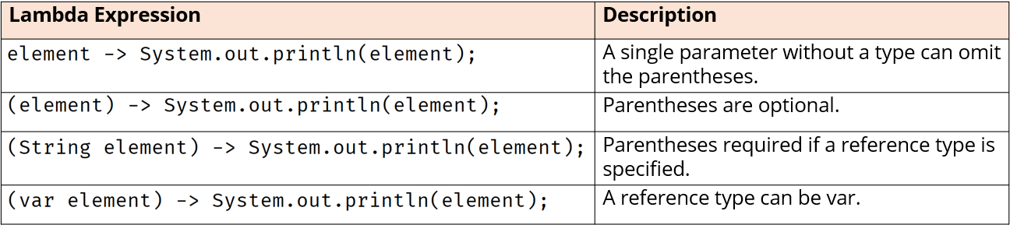

#### The Lambda Body

The lambda body can be a single expression or can contain a lambda body in opening and closing curly brackets:

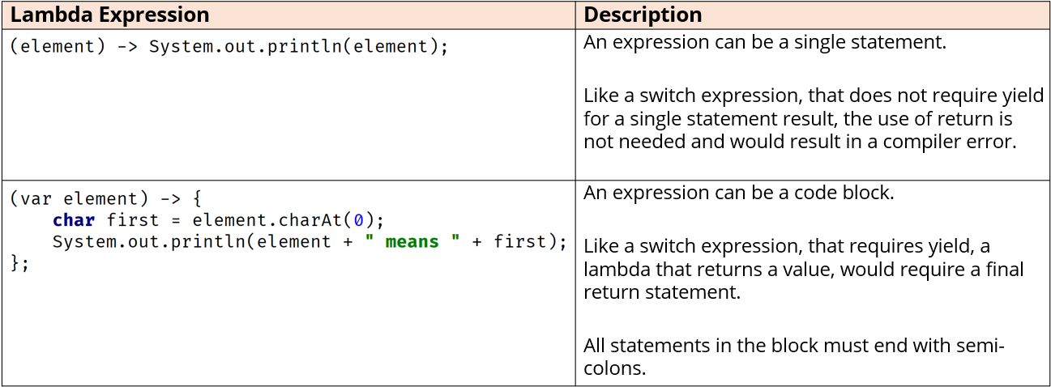

### Functional Programming

Lambdas are Java’s first step into functional programming, a programming paradigm that focuses on computing and returning results.

And just for more information about functional programming, there's a good wikipedia article here.

<https://en.wikipedia.org/wiki/Functional_programming>

Check that out to find out a bit more about functional programming.

### Streams

Another feature of Java that we will cover in more detail later on that makes extensive use of lambda expressions, and that’s streams. Streams are exciting because they create a pipeline of work that can be formed into a chain.

Many of the stream operations take functional interfaces as parameters, meaning we can code them with lambda expressions.

### Lambda Expressions with Multiple Parameters

The rules for multiple parameters used in a lambda expression are shown below:

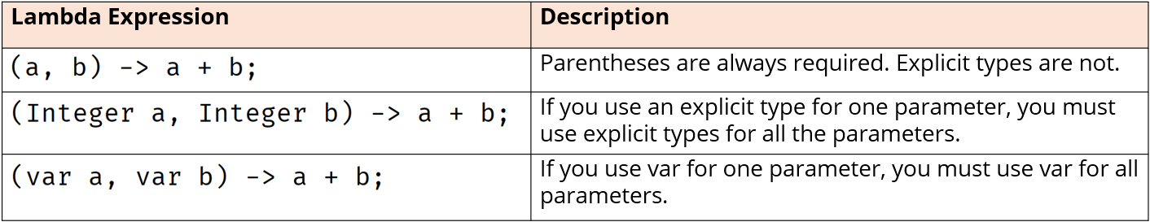

### Lambda Expressions that Return Values

The two rules for returning values from a lambda expression are below:

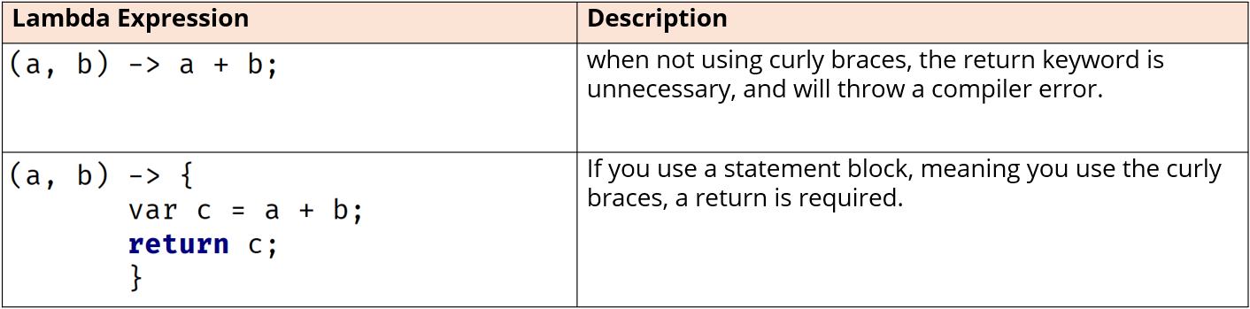

Java provides a library of functional interfaces in the java.util.function package. We looked at the forEach() method that was from the Consumer package. Next we will be looking at another interface called the BinaryOperator.

### The Four Basic Categories of Functional Interfaces in java.util.function Package

It’s a good idea to know the four basic types of functional interfaces in the java.util.function package. There are over forty interfaces in the package. The four basic ones can be categorized as one of the following:

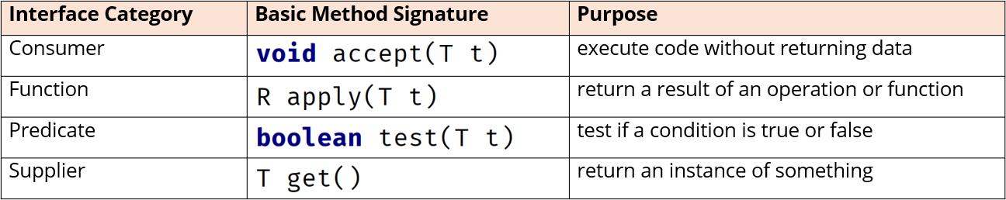

Consumer interfaces are used to execute statements but don’t pass any data back. They take one or two arguments of various types but return no value.

Function interfaces are used to perform an operation and return a result. These take one or two arguments of various types and return the result of some formula or calculation, much like the operation calculation we created before.

Predicate interfaces are used to test a condition and take one or two arguments, again of various types, and always returns a boolean result.

Supplier interfaces are different because they take no arguments but return an object which can be various types. Supplier interfaces are used to return an instance of something, a factory method might be a good lambda expression for this type of interface.

Below are the two most common Consumer interfaces and the functional method on each. The Consumer interface takes one argument of any type. The BiConsumer interface takes two arguments of two different types:

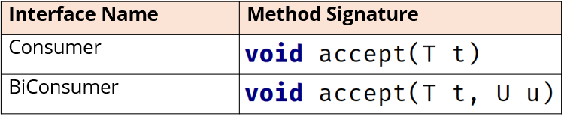

Below is an example of a consumer lambda expression. It takes one argument and executes a single statement. No result is returned.

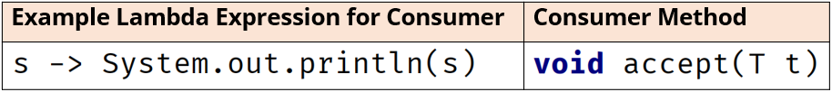

### The Predicate Interface

The predicate interfaces take one or two arguments and always return a boolean value. They are used to test a condition, and if the condition is true, some operation will be performed.

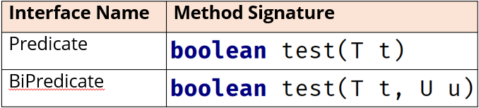

In the following example, the expression takes a String and tests if it’s equal to the literal text (“Hello” in this instance), ignoring the case, then it returns either true or false:

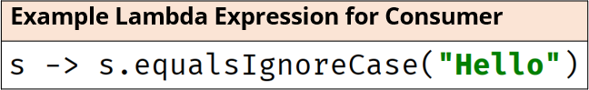

Another method from the interface called removeIf takes a predicate type as an argument.

### The Function Interface

Four of the most common interfaces in this category are Function, BiFunction, UnaryOperator, and BinaryOperator. Each has a return type shown below as either T or R (which stands for Result – meaning a result is expected for any of these).

In addition to Function and BiFunction, there is also a UnaryOperator and BinaryOperator. We can think of the UnaryOperator as a Function Interface, but where the argument type is the same as the result type.

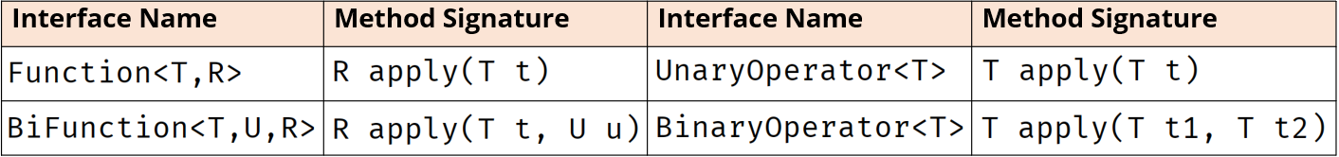

The BinaryOperator is a BiFunction interface where both arguments have the same type as does the result, which is why the result is shown as T, not as R. This reminds us that the result will be the same as type as the arguments to the methods.

Also, it’s good to notice that the result for a Function or BiFunction is declared as the last type argument.

For UnaryOperator and BinaryOperator, there is only one type argument declared because the types of the arguments and results will be the same.

#### A Function Interface Lambda Expression Example

Below is an example of a lambda expression which targets a Function interface. This lambda expression takes a String, s, and splits that String on commas, returning an array of type String.



In this case, the argument type, T, is a String and the result, R, is an array of type String.

To demonstrate how to declare a variable of this type, there is also an example of a variable declaration for this specific example.

The replaceAll() method on list (defined in our code as an ArrayList<>(List.of(Strings))) takes a unary operator as an argument. The unary operator takes one argument and returns a result, which has the same type as the argument. By executing this type of method, we’re guaranteed to get back the same type we passed to it. So, we can pass it an array element and get a transformed array element back, which replaces the current value in the specified array position.

### The Supplier Interface

The supplier interface takes no arguments but returns an instance of some type, T.

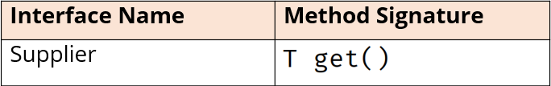

We can think of this as kind of like a factory method code. It will produce an instance of some object. However, it doesn’t have to be a new or distinct result returned.

In the example below, the Random class is being used to generate a random integer. The method takes no argument, but lambda expressions can use final or effectively final variables in their expressions. The variable random is an example of a variable from the enclosing code:

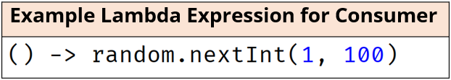

**Valid Lambda Declarations for Different Number of Arguments**

The table below shows many varieties of declaring a parameter type in a lambda expression. Parentheses are required in all but the one case where the functional method has a single argument, and you don’t specify the type or use var.

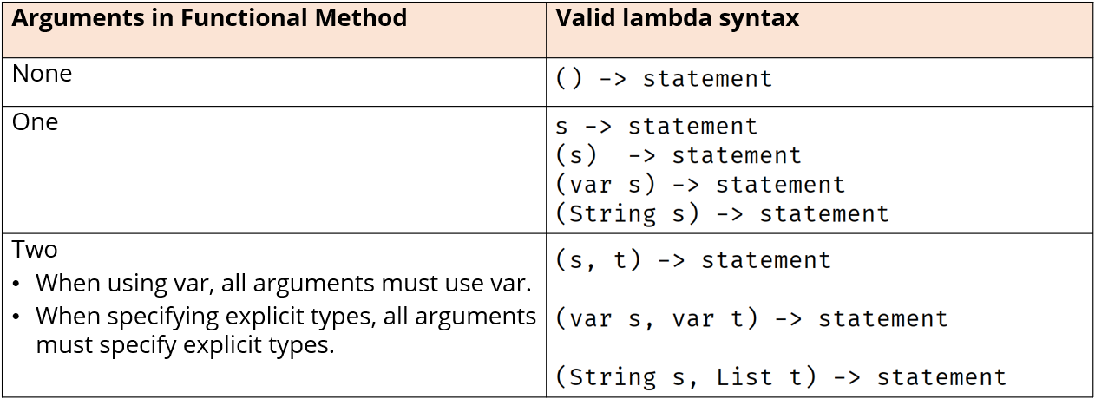

When using var as the type, every argument must use var. When specifying explicit types, every argument must include a specific type.

**Lambda Expressions, What We Need To Understand**

1. Declare lambda variables or pass lambdas directly to methods that are targets. Two examples are shown below:



1. Create methods that can be targets for lambda expressions

### Method References

Java gives us an alternative syntax to use for a second kind of lambda that uses named references. These are called method references.

These provide a more compact, easier-to-read lambda expression for methods that are already defined on a class.

For the last few videos, we have been ignoring all of IntelliJ’s warnings and hints whenever we’ve used System.out.println() in a lambda expression. IntelliJ has been trying to tell us that it can be replaced with a method reference.

nameList.forEach(System.out::println);

**Why Are These Statements Equal?**

At first glance, it’s not really obvious why a method reference has this syntax.

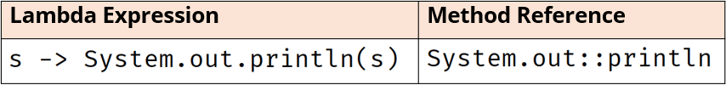

A method reference abstracts the lambda expression even further, eliminating the need to declare formal parameters. We also don’t have to pass arguments to the method in question, in this case, println.

A method reference has double colons, ::, between the qualifying type, or object, and the method name. In the above example of a Consumer interface, not only is the method inferred, but the parameters are as well.

**What Methods Can Be Used In Method References?**

Methods which can be used are based on the context of the lambda expression. This means the method reference is again dependent on the targeted interface’s method.

You can reference a static method on a class. You can reference an instance method from either an instance external to the expression, or an instance passed as one of the arguments. Or you can reference a constructer by using new as the method.

Method references can be used to increase the readability of your code.

#### Deferred Method Invocation

When you create variables that are lambda expressions or method references, it’s important to remember that the code isn’t invoked at that point. The statement or code block gets invoked at the point in the code that the targeted functional method is called.

#### Additional Terminology For Method References

***Type Reference*** – refers to a class name, an interface name, an enum name, or a record name. Remember that static methods are usually called using type references but can also be called by instances in the code. However, this is NOT true for method references.

***Static Methods*** – must invoked using a reference type only in method references and lambda expressions.

There are *two ways* to call an instance method:

The first is when you refer to the method with an instance derived from the enclosing code. The instance is declared outside of the method reference. The System.out::println method is an example. Some websites call this instance a bounded receiver, while others prefer the terminology as a differentiator.

A Bounded Receiver is an instance derived from the enclosing code used in the lambda expression on which the method will be invoked.

The second way is where the confusion starts. The instance used to invoke the method will be the first argument passed to the lambda expression or method reference when executed. The is known in some places as the ***Unbounded Receiver***. It gets dynamically bound to the first argument, which is passed to the lambda expression when the method is executed.

Unfortunately, this looks an awful lot like a static method reference using a reference type, which means there are two method references that resemble each other but have ***two very different meanings***.

The first actually does call a static method and uses a reference type to do it. We saw this earlier when we used the sum method on the Integer wrapper class:

Integer::sum

This is a Type Reference (Integer is the type), which will invoke a static method. This is easier to understand.

But there is another, which we’ll see when we start working with String method references in particular. Below, we show a method reference for the concat method on String:

String::concat

Now, we know that the concat method is not a static method on String, so why is this method reference even valid? We could never call concat from the String class directly, because it needs to be called on a specific instance.

Even though normally instance methods can’t be called using Reference Types, the example shown above is a special syntax, when it’s declared in the right context, meaning when it’s associated to the right type of interface.

This is valid when we use a method reference in the context of an unbounded receiver.

***Remember, the unbounded receiver means the first argument becomes the instance used on which the method gets invoked***.

Any method reference that uses String::concat must be in the context of a two parameter functional method. The first parameter is the String instance on which the concat method gets invoked, and the second argument is the String argument passed to the concat method.

#### Four Types of Method References

The following chart shows the four different types of method references with method reference examples and a corresponding lambda expression.

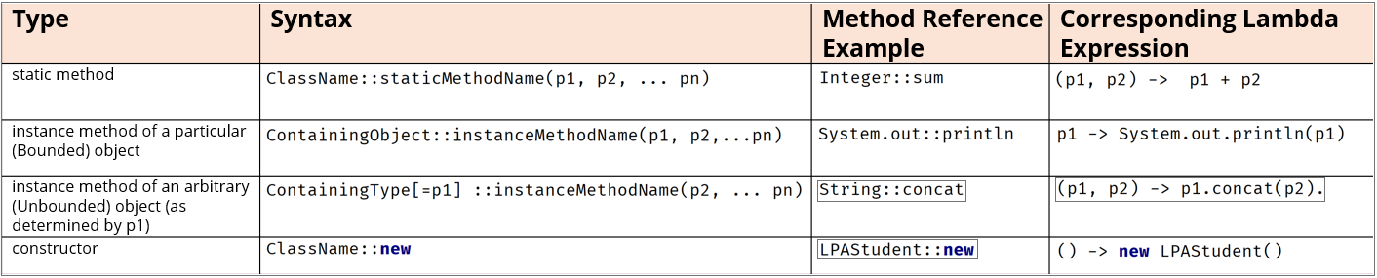

#### Method Reference Examples (No Arguments and One Argument)

The chart below shows some of the valid ways to use method references when assigned to different interface types. These interface types have no arguments in the case of a Supplier, and one argument for the other interfaces.

If a cell is empty, it’s not because it’s not valid, but there are many possibilities. n/a means not applicable, so a Supplier or an interface method that has no arguments can never be a target for the unbounded receiver type of method reference.

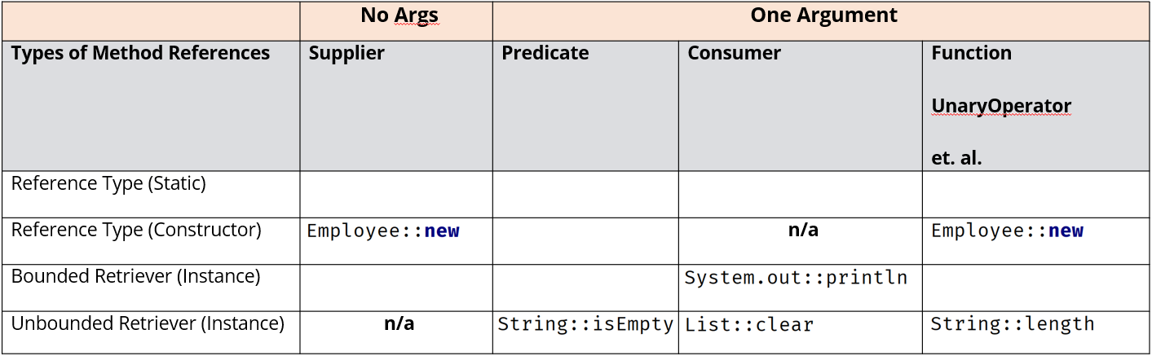

#### Method Reference Examples (Two Arguments)

This chart shows some of the valid ways to use method references when assigned to different interface types. These interface types have two arguments, and therefore it’s more common to see the unbounded retriever method references used for these.

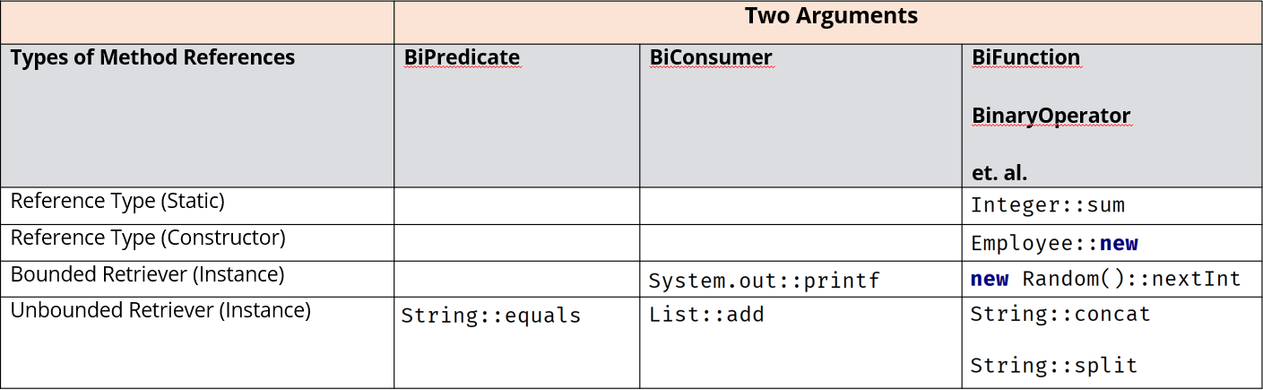

### Convenience Methods

Convenience methods are default methods on some of the functional interfaces we’ve been covering in the last few videos. The Consumer, Predicate, and Function interfaces all come with these methods, as does the Comparator, which will also be included here.

The Function interface has two default methods. The first one is .andThen() method, which lets us chain functions, one to another. If you have two methods that transform objects, such as Strings, you can chain them together using andThen() to have them be performed concurrently to the object.

See the example for strings below:

String name = "George";  
Function<String,String> uCase = String::toUpperCase;  
System.*out*.println(uCase.apply(name));  
  
Function<String,String> lastName = s -> s.concat(" Kittle");  
Function<String,String> uCaseLastName = uCase.andThen(lastName);

What this does is execute uCase, and then executes lastName using the result of uCase as input.

In addition to the andThen() method, this interface also has a compose() method. This is similar to the andThen() method, but instead, the method reference that is passed as an argument to compose is executed first, then the method to the left of the period (.) is executed.

In our example below, lastName is executed first, and then uCase is executed on lastName:

uCaseLastName = uCase.compose(lastName);

The andThen method is also available on the BiFunction and BinaryOperator, but not for any interfaces that have a primitive argument, like IntFunction, DoubleFunction, or LongFunction. The Consumer and BiConsumer interfaces, as well as the primitive versions of Consumer, also have an andThen method.

Remember a consumer doesn’t return any data, so whatever the input is at the start of the chain, will remain the input for any following chained expressions.

Convenience methods on Predicates – these are completely different, because Predicate returns a boolean value.

**Convenience Methods on Functional Interfaces in java.util.function Package Summary**

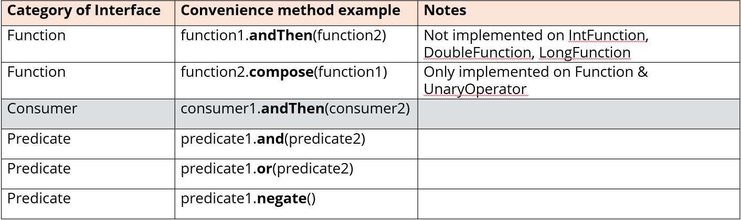

Interim Functions are not required to have the same type arguments for the andThen and compose methods for the Function Interface category.

Instead, one function's output becomes the next function's input, and the next function's output is not constrained to any specific type, except the last function executed.

The Consumer's andThen method is different, because it never returns a result, so you use this when you're chaining methods independent of one another.

The Predicate methods always return a boolean, which will combine the output of the two expressions, to obtain a final boolean result.

**Comparator’s Additional Helper Methods**

There is a comparing static method, an overloaded default method named thenComparing, and finally a default reversed method.

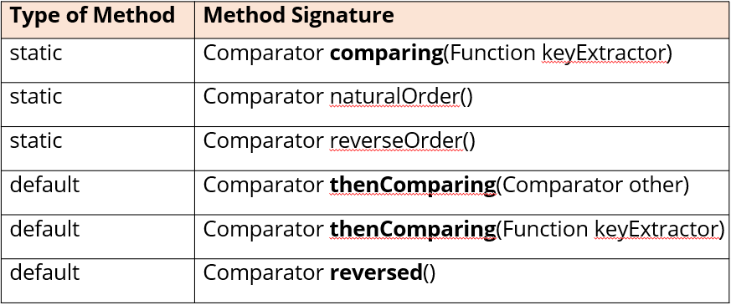

## Section 15 – Java Collections

This section will cover the Collections Framework in Java. The List and Iterator interfaces, and the ArrayList and LinkedList classes belong to this framework.

We will revisit these types a little bit to demonstrate how they fit into the big picture of this series of interfaces and classes, but also cover some other very important types of collection objects, such as sets and maps.

By the end of the section, we’ll have a few more classes in our toolbox for groups of many objects.

A ***collection*** is just an object that represents a group of objects. In general, the group of objects have some relationship to each other. Computer Science has common names and an expected set of behavior for different types of collection objects.

Collection objects in various languages include arrays, lists, vectors, sets, queues, tables, dictionaries, and maps. These are differentiated by the way they store the objects in memory, how objects are retrieved and ordered, and whether nulls and duplicate entries are permitted.

Oracle’s Java documentation describes its collections framework as:

“A unified architecture for representing and manipulating collections, enabling collections to be manipulated independently of implementation details.”

Link to overview documentation can be found [here](https://docs.oracle.com/javase/8/docs/technotes/guides/collections/overview.html).

**What’s in the Framework, What’s Not?**

Strictly speaking, arrays and the array utilities in the java.util.Arrays class are not considered part of this framework. All collection objects implement the Collection interface, with the exception of maps, and we will cover why in this section.

### The Collection Interface

The Collection interface is the root of the collection hierarchy. Like most roots in software hierarchies, it’s an abstract representation of the behavior you’d need for managing a group of objects. This type is typically used to pass collections around and manipulate them where *maximum generality* is desired.

Remember, the interface let’s us describe objects by what they can do, rather than what they really look like or how they’re ultimately constructed. If we look at the methods on the interface below, we can see the basic operations a collection of any shape, or type, would need to support:

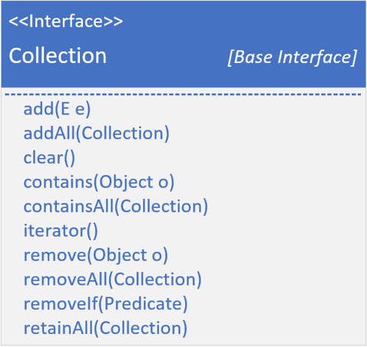

We’ve already looked at every one of these operations in our study of ArrayLists and LinkedLists. When managing a group, we’ll be adding and removing elements, checking if an element is in the group and iterating through the elements. There are some others, but these are the ones that describe nearly everything you’d want to do to manage a group.

Java uses the term **Element** for a member of the group being managed.

For different types of lists and sets, we can define them using either the List interface or the even more abstract Collection interface. However, the Collection interface does not have a sort() method on it.

The images below show how the List interface extends the Collection interface. It only shows additional methods that are specifically declared on the List interface:

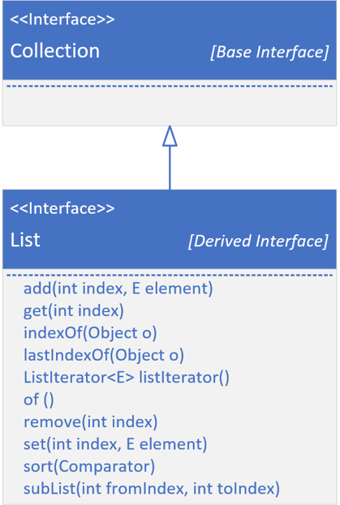

We have covered most of these methods, but this shows that most of these are dealing with an index. A list can be either indexed, as an ArrayList, or not, like a LinkedList, but a LinkedList is implemented to support all of these methods as well.

Derived interfaces may have specific ways to add, remove, get, and sort elements for their specific type of collection, in addition to those defined on the Collection Interface itself.

Now let’s look at the big picture of interfaces and some specific implementations. Below shows the interface hierarchy. It’s also showing the implementations, or concrete classes, that implement these interfaces in yellow font.

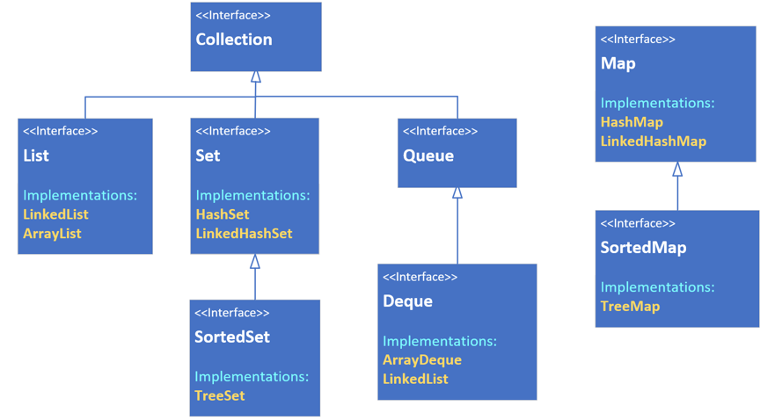

***NOTE*** - Notice that Map does not extend Collection, although it is still part of this framework. Maps are uniquely different.

***NOTE*** - We can also see that LinkedList implements both List and Deque (double sided queue)

#### The List

A ***List*** is an ordered collection, also known as a sequence. These can be sequenced in memory like an ArrayList, or maintain links to the next and previous values like a LinkedList.

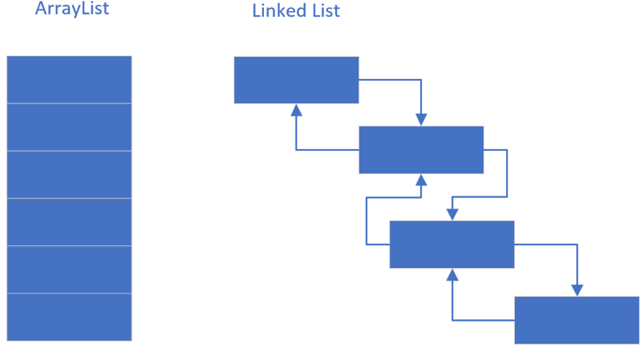

#### The Queue

A ***Queue*** is a collection designed for holding elements prior to processing, in other words, the processing order matters, so the first and last positions, or the head and tail, are prioritized.

Most often these may be implemented as First In, First Out (FIFO), but can also be implemented like Stack, as Last In, First Out (LIFO).

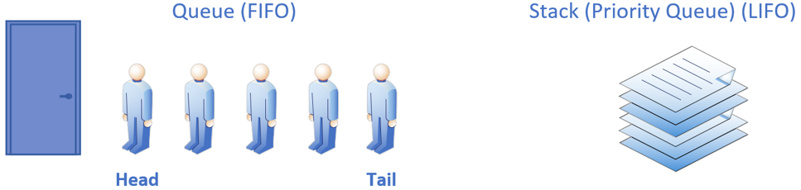

***NOTE*** - Remember a Deque supports both

#### The Set

A ***Set*** is a collection conceptually based off of a mathematical set. Importantly, it contains no duplicate elements, and isn’t naturally sequenced or ordered.

We can think of a set as a kind of penned in chaotic grouping of objects.

Java has three implementations which we’ll be reviewing in detail this section: the HashSet, the TreeSet, and the LinkedHashSet. These are distinguished by the underlying way they store the elements in the set.

A Sorted Set is a set that provides a total ordering of the elements.

#### The Map

A ***Map*** is a collection that stores key and value pairs. The keys are a set, and the values are a separate collection, where the key keeps a reference to the value. Keys need to be unique, but values don’t.

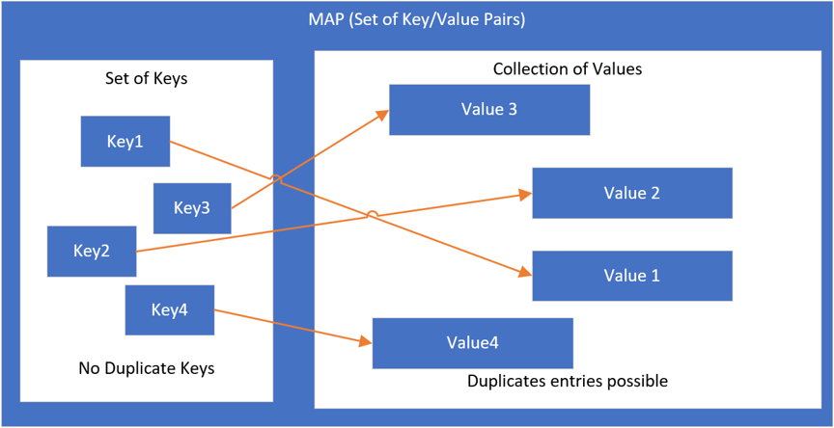

Elements in a tree are stored in a key value Node, also called an entry.

### What’s A Polymorphic Algorithm?

Oracle’s documentation describes a polymorphic algorithm as a piece of reusable functionality.

At one time, most of these methods were provided to us as static methods on a class called java.util.Collections. Since JDK-8 and the advent of multiple interface enhancements, some of these methods are now on the interfaces themselves, as default or static methods.

But not all, so we’ll be discussing this class and what it has to offer, in comparison to what’s available on each collection class. It’s also important to understand that legacy code will be using this class for some operations that can now be done from the class itself.

### What’s a Collections Class?

It’s important to understand that the Collections class is not the same as the Collections Framework. The framework contains many interfaces and implemented classes, as well as helper classes, which this Collections class is just one example.

At one time, Java had interfaces, but no support for static or default methods on them, so useful methods were packaged in these helper classes. Some of these methods have since been implemented on the interfaces themselves, but there’s still some functionality on the Collections class that might be useful.

We’ll examine some of these in code and compare them to the methods on the interfaces now available.

### Understanding the Importance of the Hash Code

HashSet and HashMap are based on the hash codes of objects. This can be a confusing topic for new programmers, so we will spend a little extra time on it.

Since sets are unique because they don’t support duplicates, adding an element always incurs the cost of first checking for a match. If your set is large or very large, this becomes a costly operation, O(n), or linear time, if we remember BigO notations that were covered previously.

A mechanism to reduce this cost is introduced by something call hashing. If we created two buckets of elements, and the element could consistently identify which bucket it was stored in, then the lookup could be reduced by half. If we created four buckets, we could reduce the cost by a quarter.

A hashed collection will optimally create a limited set of buckets to provide an even distribution of the objects across the buckets in a full set.

A hash code can be any valid integer, so it could be one of 4.2 billion valid numbers. If your collection only contains 100,000 elements, you don’t want to back it with a storage mechanism of 4 billion possible placeholders. And you don’t want to have to iterate through 100,000 elements one at a time to find a match or a duplicate.

A hashing mechanism will take an integer hash code and a capacity declaration which specifies the number of buckets to distribute the objects over. It then translates the range of hash codes into a range of bucket identifiers.

Hashed implementations use a combination of the hash code and other means to provide the most efficient bucketing system to achieve this desired uniform distribution of the objects.

To understand hashing in Java, it helps to first understand the equality of objects. There are two methods on java.util.Object that all objects inherit. These are equals(Object obj) and hashCode():



The implementation of equals on Object is shown below. It simply returns this == obj:

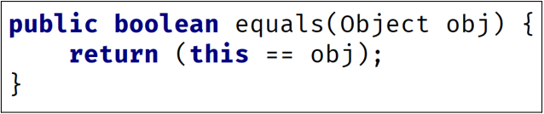

**Do You Remember What == Means for Objects?**

It means two variables have the same reference to a single object in memory. Because both references are pointing to the same object, then this is obviously a good equality test.

#### Equality of Objects

Objects can be considered equal in other instances as well if their attribute values are equal for example. The String class overrides this method, so that it compares all the characters in each String to confirm that two Strings are equal.

Our code set up five String reference variables, but two of these referenced the same string object in memory, as shown below with aText and bText pointing to the same string instance. When we passed our list of five strings to the HashSet, it added only unique instances to its collection.

It locates elements to match, by first deriving which bucket to look through based on the hash code. It then compares those elements to the next elements to be added with other elements in that bucket using the equals method.

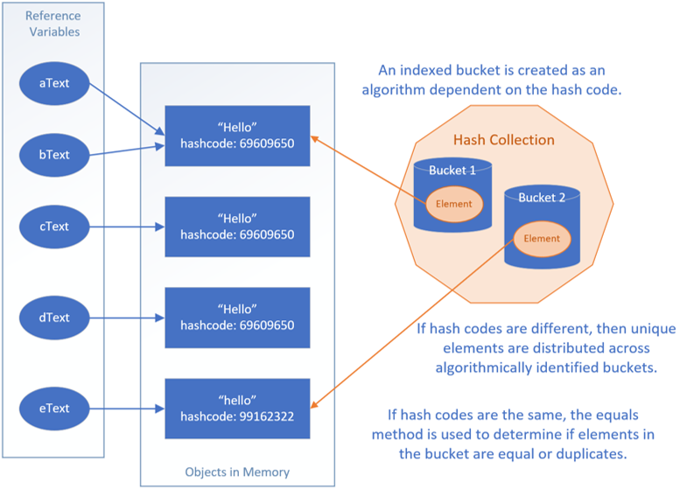

#### Creating the hashCode Method

You don’t have to use the generated algorithm provided by IntelliJ for the methods. You can always create your own, but the code should stick to the following rules:

1. It should be fast to compute.
2. It should produce a consistent result each time it’s called. For example, we wouldn’t want to use a random number generator or a date-time based algorithm that would return a different value each time the method is called.
3. Objects that are considered equal should produce the same hashCode.
4. Values used in the calculation should not be mutable.

It is common practice to include a small prime number as a multiplicative factor (although some non-prime numbers also provide good distributions). This helps ensure a more even distribution for the bucket identifier algorithm, especially if your data might exhibit clustering in some way.

IntelliJ and other code generation tools use 31, but other good options could be 29, 33 (not prime, but shown to have good results), 37, 43, and so on. You want to avoid the single digit primes because more numbers will be divisible by those and may not produce the even distribution that will lend itself to improved performance.

It is encouraged to do research on the topic to understand how things really work. Remember, if we are using our own classes in hashed collections, we’ll want to override both the equals and the hashCode methods.

#### Java’s Hashed Collection Types

Java supports four hashed collections implementation. These are the HashSet, LinkedHashSet, the HashMap, and LinkedHashMap. In addition, there’s one legacy implementation, the HashTable, which we won’t be covering since there are more efficient implementations that have replaced this legacy class.

**The Setup (Phone and Email Contacts Code) Challenge**

For this example, we’ll be using HashSets as fields, and we’ll be using the Scanner class, always passing System.in to the constructor. We’ll be using Scanner with just a String passed to the constructor.

### The Contact Class

This last constructor should do the following:

* Add the email argument to the emails set, if email is not null
* Transform the fone argument, a long, (if it’s not zero), to a string in the format (123) 456-7890, for example
* Add the transformed phone to the phones set

Finally include a method called mergeContactData that takes a contact and returns a new Contact instance, which merges the current instance with the Contact passed.

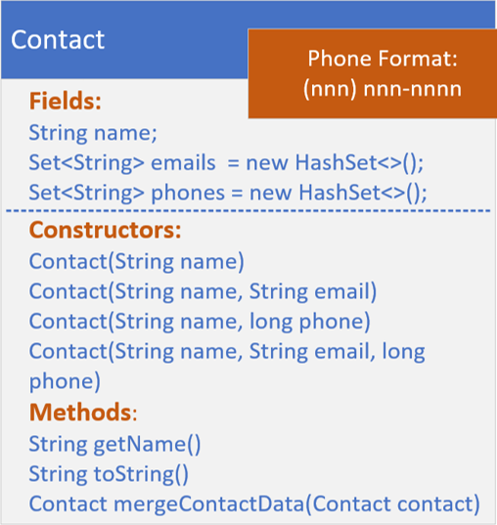

### The ContactData Class

The ContactData Class is going to emulate getting data from an external source, but instead of an external source, just set the data up with two different text blocks in the format shown below:

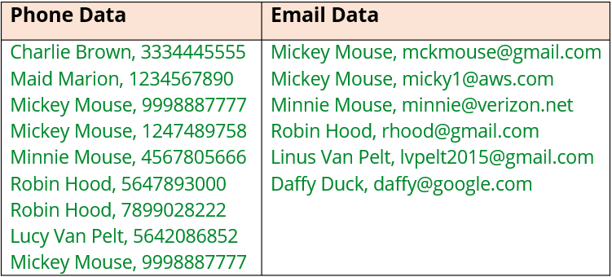

Create a method called getData that takes a String type (either phone or email) and returns a List of Contact. Use the Scanner class to parse the data in the text blocks.

### The Set

A Set is not implicitly ordered. A Set contains no duplicates. A Set may contain a single null element. Sets can be useful because operations on them are very fast.

The set interface defines the basic methods add, remove, and clear to maintain the items in the set. We can also check if a specific item is in the set using the contains method. Interestingly enough, there’s no way to retrieve an item from a set. You can check if something exists using *contains*, and you can iterate over all the elements in the set, but attempting to get the 10th element, for example, from a set isn’t possible with a single method.

The best-performing implementation of the Set interface is the HashSet class. This class uses hashing mechanisms to store the items.

Oracle describes this class as offering constant time performance for the basic operations (add, remove, contains, and size). This assumes the hash function disperses the elements properly among the buckets. Constant time has the Big O notation O(1).

Although we haven’t covered the Map and HashMap types yet, the HashSet actually uses a HashMap in its own implementation, as of JDK-8.

#### Set Operations

In this section we will be looking a little bit at Set Math, or Set Operations, what they are, and why we’d want to use them. When trying to understand data in multiple sets, we might want to get the data that’s in all the sets, that’s in every set, or the data where there’s no overlap.

The collection interface’s bulk operations (addAll, retainAll, removeAll, and containAll) can be used to perform these set operations.

Sets are often represented as circles or ovals with elements inside, on what is known as a Venn Diagram. Below, we are showing two sets that have no elements in common. The Venn Diagram shows some of the cartoon characters of the Peanuts and Mickey Mouse cartoons.

Because the characters are distinct for each set, the circles representing the sets don’t overlap or intersect:

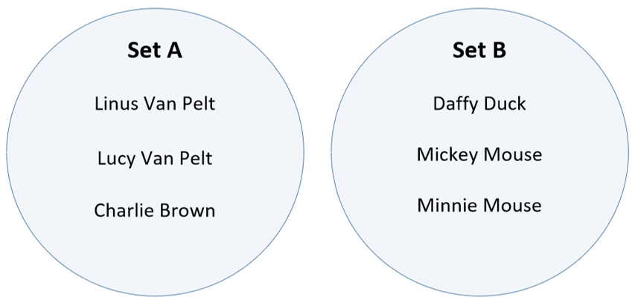

The next diagram shows two sets of characters that do overlap. Let’s say that Goofy and Snoopy have guest appearances in the other’s holiday special show. The intersection of these sets is represented by the area where the two circles (sets) overlap and contains the elements that are shared by both sets.

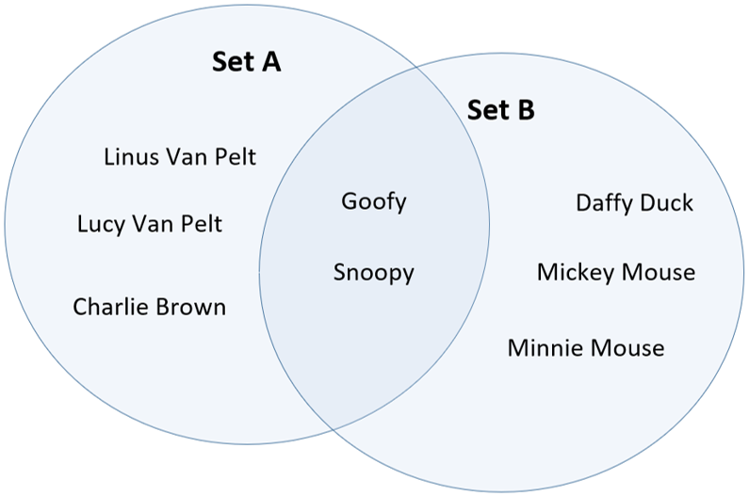

Goofy and Snoopy are both in Set A and Set B, in other words. Venn Diagrams are an easy way to quickly see how elements in multiple sets relate to each other.

##### Set Operations – Union A ∪ B

The Union of two or more sets will return elements that are in any or all of the sets, removing any duplicates. Here we are showing two sets, names on an email list, and names on a phone numbers list. The overlap are names that are on both lists.

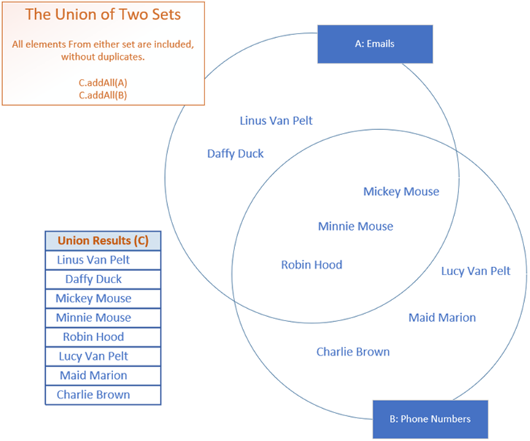

In the example shown below, all names on the email list and phone list will be included in a union of the two sets, but Minnie, Mickie and Robin Hood, which are the only elements included in both sets, are included in the resulting set only once.

Java doesn't have a union method on Collections, but the addAll bulk function, when used on a Set, can be used to create a union of multiple sets.

The intersection of two or more sets, will return only the elements the sets have in common. These are shown in the overlapping area of the sets on this slide, the intersect, shown in green, and includes Mickey and Minnie Mouse, and Robin Hood.

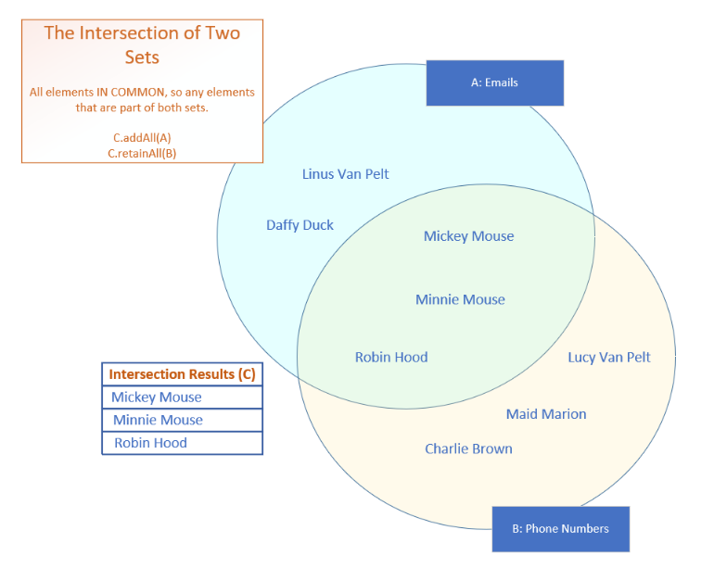

##### Set Operations – Symmetric Operations

The ability to evaluate sets, A interest B and get the same result as B interest A, means that the intersect operation is a symmetric set operation. Union is also a symmetric operation.

It doesn’t matter if you do A Union B or B union A, the final set of elements will be the always be the same set of names.

##### Set Operations – Asymmetric Differences

A difference subtracts elements in common from one set and another, leaving only the distinct elements from the first set as the result.

This is an asymmetric operation because if we take Set A subtract Set B from it, we’ll end up with a different set of elements that if we take Set B and subtract Set A.

The sets from these two operations won’t result in the same elements.

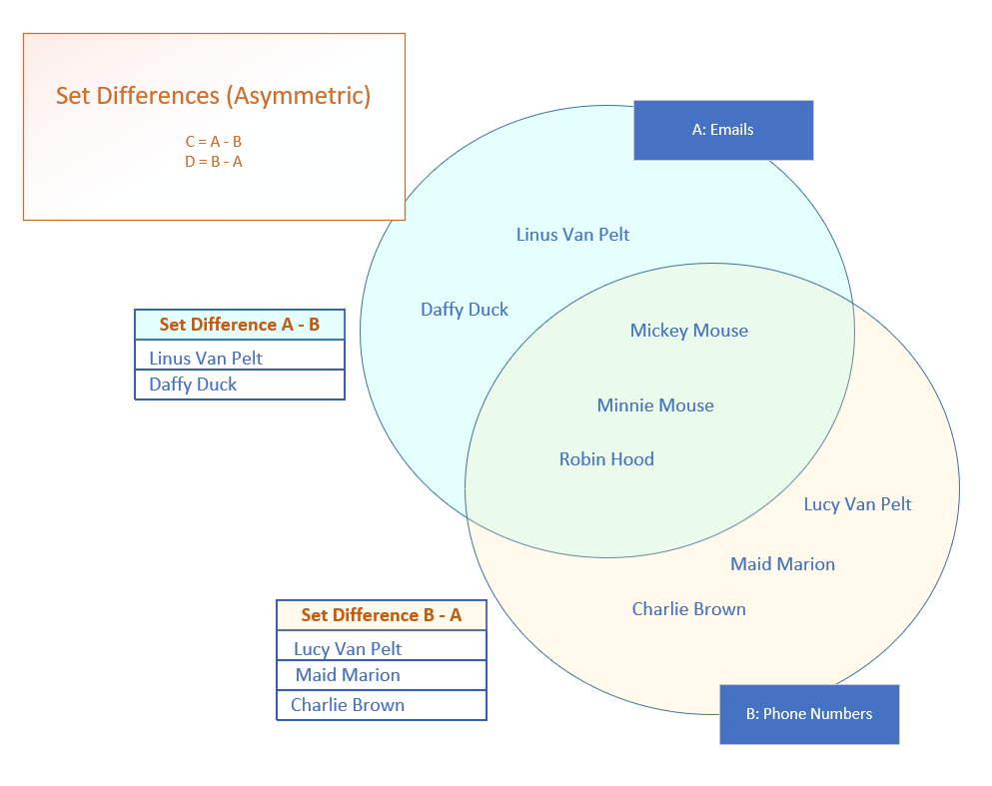

##### Set Operations – Symmetric Differences

You can think of the set symmetric differences as the elements from all sets that don’t intersect. Below, these are the elements that are represented in the ***paler*** yellow areas:

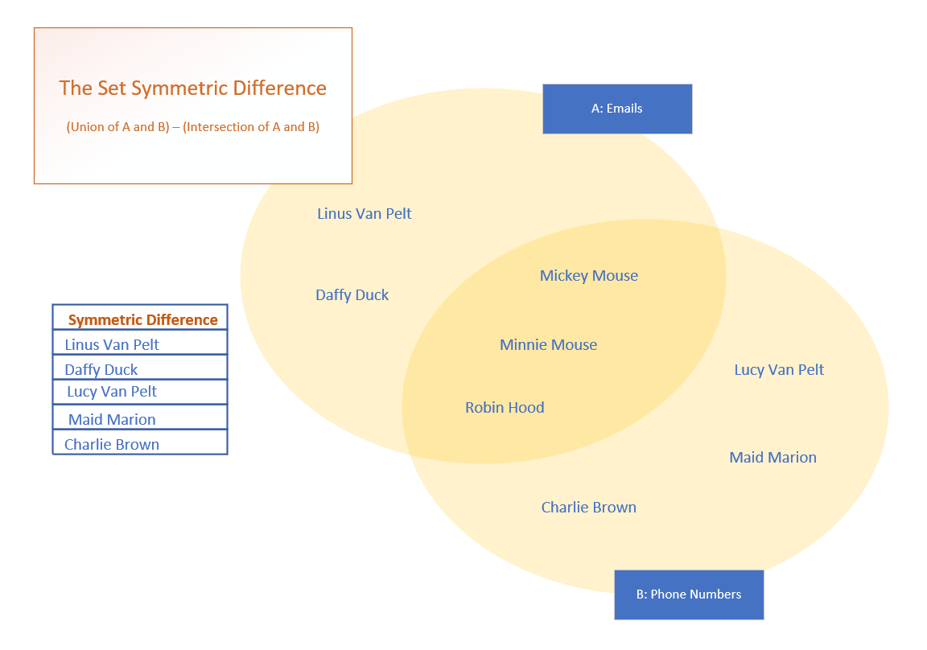

### Ordered Sets

If you need an ordered set, you’ll want to consider either the LinkedHashSet or the TreeSet. A LinkedHashSet maintains the insertion order of the elements. The TreeSet is a sorted collection sorted by the natural order of the elements or by specifying the sort during the creation of the set.

**The LinkedHashSet**

The LinkedHashSet extends the HashSet class.

It maintains relationships between elements with the use of a doubly linked list between entries. The iteration order is therefore the same as the insertion order of the elements, meaning the order is predictable.

All the methods for the LinkedHashSet are the same as those for the HashSet. Like HashSet, it provides constant-time performance O(1), for the add, contains, and remove operations.

### TreeSet

A TreeSet’s class uses a data structure that’s a derivative of what’s called a binary search tree, or BTree for short, which is based on the concept and efficiencies of the binary search.

We’ve discussed the binarySearch method on the List, as well as on the java.util.Collections class and shown that this type of search is very fast, especially if the elements are sorted. This search iteratively tests the mid-range of a group of elements to be searched to quickly find its element in a collection.

As elements are added to a TreeSet, they’re organized in the form of a tree, where the top of the tree represents that mid-point of the elements. The image below shows a conceptual example using some of the character contacts from our last samples of code:

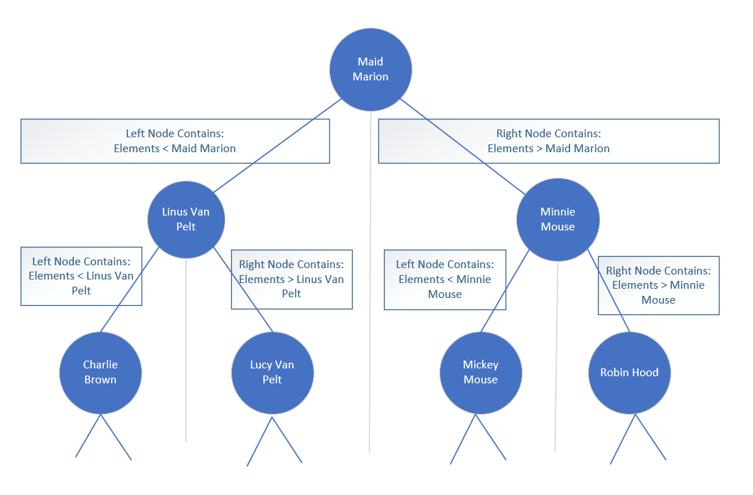

Further binary divisions become nodes under that. The **left** node and its children are elements that are **less than** the parent node. The **right** node and its children are elements that are **greater than** the parent node.

Instead of looking through all the elements of the collection to locate a match, this allows the tree to be quickly traversed, each node a simple decision point. The main point is the tree remains balanced as elements are added.

#### TreeSet O Notation

Remember that O(1) is constant time, meaning the time or cost of an operation doesn’t change, regardless of how many elements are processed. O(n) is linear time, meaning it grows in line with the way the collection grows.

Another notation is O(log(n)) which means the cost falls somewhere in between constant and linear time. The TreeSet promises O(log(n)) for the add, remove, and contains operations, compared to the HashSet, which has constant time O(1) for those same operations.

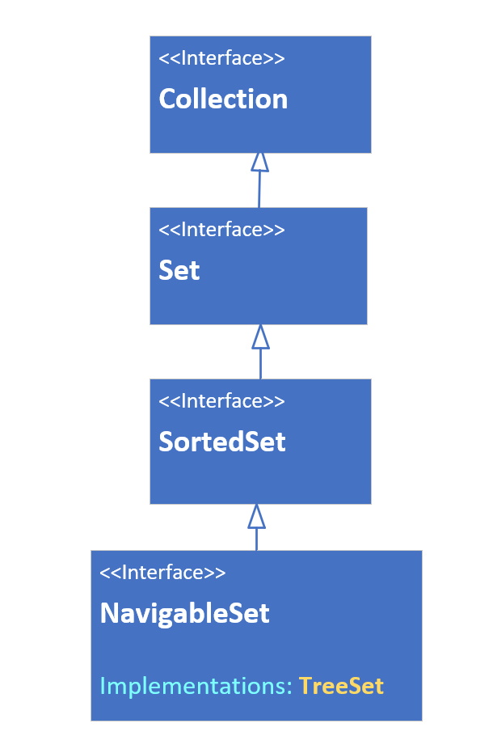

#### The TreeSet Interface Hierarchy

A TreeSet can be declared or passed to arguments typed with any of the interfaces shown below. This class is sorted and implements the SortedSet interface, which has such methods as first, last, headSet and tailSet, and comparator. This set also implements the NavigableSet Interface, so it has methods such as ceiling, floor, higher, lower, descendingSet, and others.

#### The TreeSet Relies on Comparable or Comparator Methods

Elements which implement Comparable (said to have a natural order sort, like Strings and numbers) can be elements of a TreeSet.

If your elements don’t implement Comparable, you must pass a Comparator to the Constructor.

**NavigableSet Methods to Get Closest Matches**

All the methods shown below take an element as an argument and return an element in the set, the closest match to the element passed.

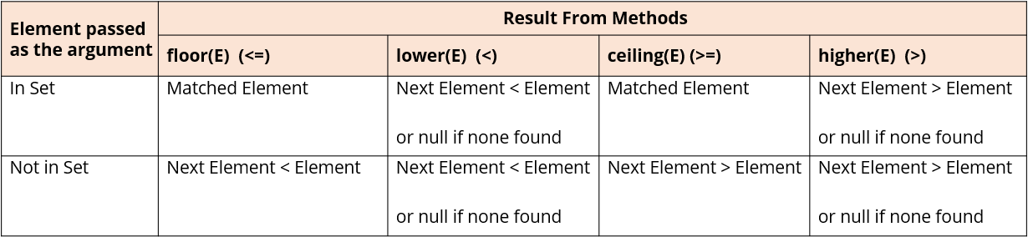

**Getting Subsets from a TreeSet**

All three methods, headSet, tailSet, and subset, return a subset of elements backed by the original set.

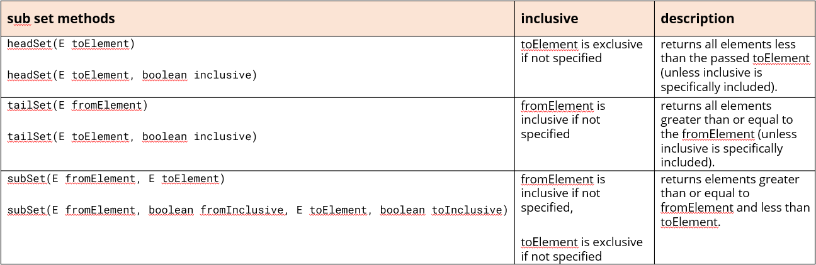

**When Would You Use TreeSet?**

The TreeSet offers many advantages, in terms of built-in functionality over the other two Set implementations, but it does come at a higher cost.

If the number of elements is not large, or you want a collection that’s sorted and continuously re-sorted as you add and remove elements, and that shouldn’t contain any duplicate elements, the TreeSet is a good alternative to the ArrayList.

**The Map Interface – Why is it Different?**

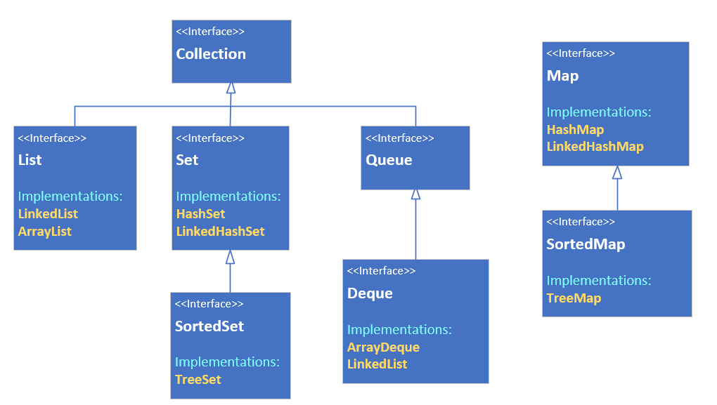

From the diagram above, we can obviously see the Map is out to the right on its own.

A Map in the Collections framework is another data structure. Although it’s still a grouping of elements, it’s different because elements are stored with keyed references. This means a Map requires two type arguments, as shown below where the Collection is compared to the Map interface:



The Map has K for its key type and V for its value type. As with any generic classes, the only restriction on these types is, they must be reference types and not primitives.

**Map Characteristics**

A Java Map can’t contain duplicate keys.

Each key can only map to a single value.

**Map Implementations (The Classes that Implement Map)**

In the next few lectures, we’ll be looking at 3 of the Java classes that implement the map interface – the HashMap, the LinkedHashMap, and the TreeMap.

The HashMap is unordered, the LinkedHashMap is ordered by insertion order, and the TreeMap is a sorted Map.

### What’s a View?

The view, or view collection as Java calls it, doesn’t store elements, but depends on a backing collection that stores the data elements.

We saw this with the headSet, tailSet, and subset methods on Sets. We’re also very familiar now with a list backed by an array, a view we get back when we use the Arrays.asList method to get an array in the form of a list. Remember, when we make changes to that list, the changes are reflected in the underlying array and vice versa.

The functionality available to us on the list is limited to features supported by the backing storage, so for a list backed by an array, we can’t add or remove elements as an example.

**The Purpose of View Collections**

We might be familiar with database views which hide the details of the underlying data structures to make it easier for clients to use the data. These view collections serve a similar purpose.

They let us manipulate the collections, without really having to know exact details, about the storage of the data. In other words, we don’t have to keep learning new methods to manipulate data.

**The HashMap’s Implementation**

Below is a high-level overview of the structure of the HashMap class. First, it’s important to know that there’s a static nested interface on the Map interface, and it’s name is Entry.

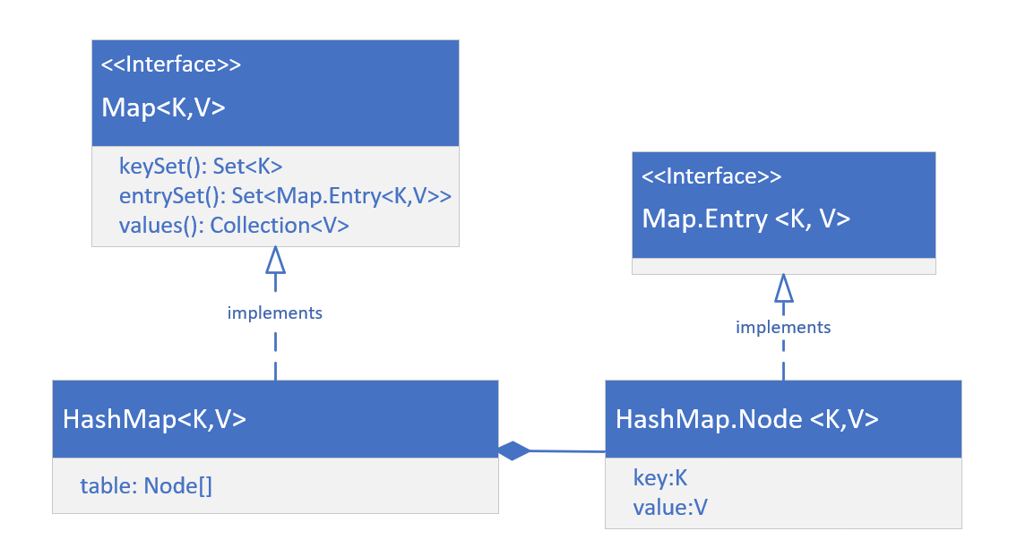Concrete classes implement both the Map interface and the Map.Entry interface.

The HashMap implements Map and has a static nested class, Node, that implements the Map.Entry interface.

The HashMap maintains an array of these Nodes in a field called table, whose size is managed by Java, and whose indices are determined by hashing functions.

For this reason, a HashMap is not ordered.

**The Map’s View Collections**

We are going to now focus on the three view collections we can get from the map, which are the key set, the entry set, and the values.

We know a map has keys and these can’t contain duplicates. These keys can be retrieved as a Set view by calling the keyset method on any map object.

Each key value pair is stored as an instance of an Entry, and the combination of the key and value will be unique because the key is unique.

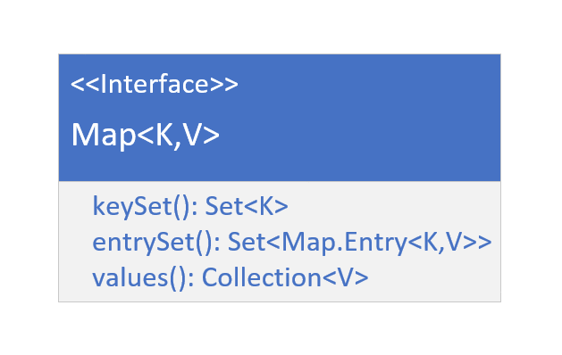

A Set view of these entries, or nodes in the case of the HashMap, can be retrieved from the method entrySet.

Finally, values are stored and referenced by the key, and values can have duplicates, meaning multiple keys could reference a single value.

You can get a Collection view of these, from the values method, on a map instance.

**Functionality Available to Set Returned From keySet()**

The set returned from keySet method is backed by the Map. This means changes to the Map are reflected in the set, and vice-versa.

The set supports element removal, which removes the corresponding mapping from the map. You can use the methods remove, removeAll, and clear. It does NOT support the add or addAll operations.

**Ordered and Sorted Map Implementations**

The Map interface has the **LinkedHashMap and TreeMap** classes.

The LinkedHashMap is a key value entry collection whose keys are ordered by insertion order. The TreeMap is sorted by its keys, so a key needs to implement Comparable or be initialized with a specified Comparator.

**TreeMap’s View Collections**

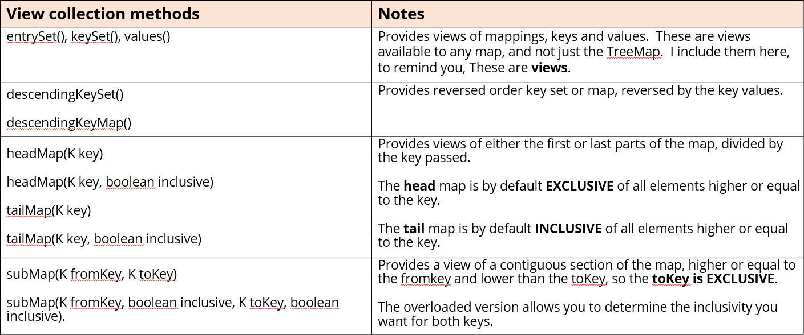

### EnumSet and EnumMap

There are two more classes in the collections framework specifically created to support enum types more efficiently. You can use any List, Set, or Map, with an enum constant.

The EnumSet and EnumMap, each has a special implementation that differs from the HashSet or HashMap. These implementations make these two types extremely compact and efficient. There’s no special list implementation for enum types.

**The Enum Set**

The EnumSet is a specialized Set implementation for use with enum values. All of the elements in an EnumSet must come from a single enum type.

The EnumSet is abstract, meaning we can’t instantiate it directly. It comes with many factory methods to create instances. In general, this set has much better performance than using a HashSet with an enum type.

Bulk operations (such as containsAll and retainAll) should run very quickly, in constant time, O(1), if they’re run on an enumSet, and their argument is an EnumSet.

**The EnumMap**

The Enum Map is a specialized Map implementation for use with enum type keys. The keys must all come from the same enum type, and they’re ordered naturally by the ordinal value of the enum constants.

This map has the same functionality as a HashMap, with O(1) for basic operations. The enum key type is specified during construction of the EnumMap, either explicitly by passing the key type’s class or implicitly by passing another EnumSet.

In general, this map has better performance than using a HashMap, with an enum type.

**Two Types of EnumSet Implementations**

Enum sets are represented internally as bit vectors, which is just a series of ones and zeros. A one indicates that the enum constant (with an ordinal value that is equal to the index of the bit) is in the set. A zero indicates the enum constant is not in the set.

Using a bit vector allows all set operations to use bit math, which makes it very fast. A RegularEnumSet uses a single long as its bit vector, which means it can contain a maximum of 64 bits, representing 64 enum values.

A JumboEnumSet gets returned if you have more than 64 enums.

Below shows a visual representation of the EnumSet for Ann’s workdays. It’s size is 7 for the 7 possible values (based on the number of constants in the WeekDay Enum).

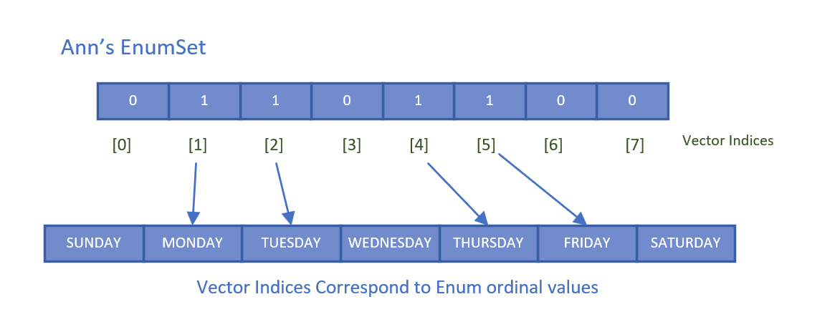

Any weekday that’s part of her set will be set to 1 at the index that corresponds to weekday ordinal value. MONDAY has an ordinal value of 1 in the WeekDays enum, and the value in the underlying bit vector at position 1 is 1.

This means that MONDAY is part of Ann’s EnumSet.

## Section 16 – Final, Immutable Classes, Constructors, Initializers, Sealed Classes

### Mutable vs Immutable

Objects have state, which is the data stored in instance fields. State can change after an object is created either intentionally or unintentionally.

When state remains constant throughout the lifetime of the object and code is prevented from changing the state, this object is called an immutable object.

An immutable object is an object whose internal state remains constant. A *mutable* object is an object whose internal state does not remain constant.

Which is better? Well, like anything else, that depends.

#### Immutable Objects – Advantages

Working with immutable objects has some advantages.

An immutable object isn’t subject to unwanted, unplanned, and unintended modifications known as side-effects.

An immutable class is inherently thread-safe because no threads at all can change it once it has been constructed. This allows us to use more efficient collections and operations which don’t have to manage synchronization of access to this object.

These are two of the most important advantages.

#### Immutable Objects – Disadvantages

Working with immutable objects has some disadvantages.

An immutable object can’t be modified after it’s been created. This means when a new value is needed, we’re probably going to need to make a copy of the object with the new value.

You’ll remember the discussion comparing String vs StringBuilder.

If you’re constantly needing to alter text values, it’s more efficient to use a mutable object like a StringBuilder instance, then generating tons of new String objects.

**Classes Must Be Designed to Produce Immutable Objects**

It’s important to understand that POJOs and Java Beans, which many code generation tools create, are not by design, immutable, and therefore this architecture may not be the preferred design for your class.

This all sounds rather simple, yet there are many topics related to it. One of the most useful tools in our arsenal to build immutable classes is the final access modifier.

### The Final Modifier in Java Revisited

When we use the final modifier, we prevent any further modifications to that component.

* A final method means it can’t be overridden by a subclass.
* A final field means an object’s field can’t be reassigned or given a different value after its initialization.
* A final static field is a class field that can’t be reassigned or given a different value after the class’s initialization process. A field declared on an Interface is always public, static, and final.
* A final class can’t be overridden, meaning no class can use it in the extends clause.
* A final variable in a block of code means that once it’s assigned a value, any remaining code in that block can’t change it.
* A final method parameter means we can’t assign a different value to that parameter in the method code block.

**Using the Final Modifier on Methods**

You can use the final modifier on methods. Using final with methods only makes sense in the context of wanting to restrict what your subclasses can override or hide.

Using final on an **instance** method means subclasses can’t **override** it.

Using final on a **class** (static) method means subclasses can’t **hide** it.

**Hiding vs. Overriding**

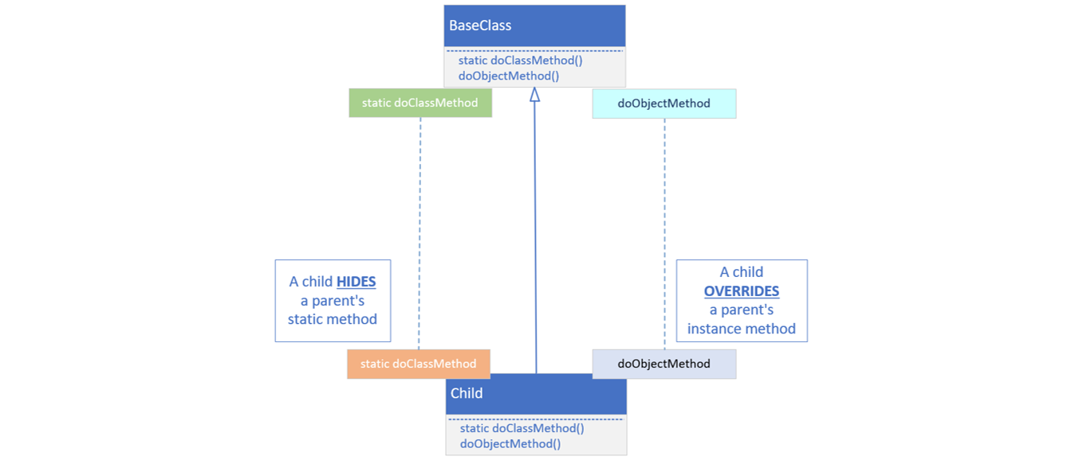

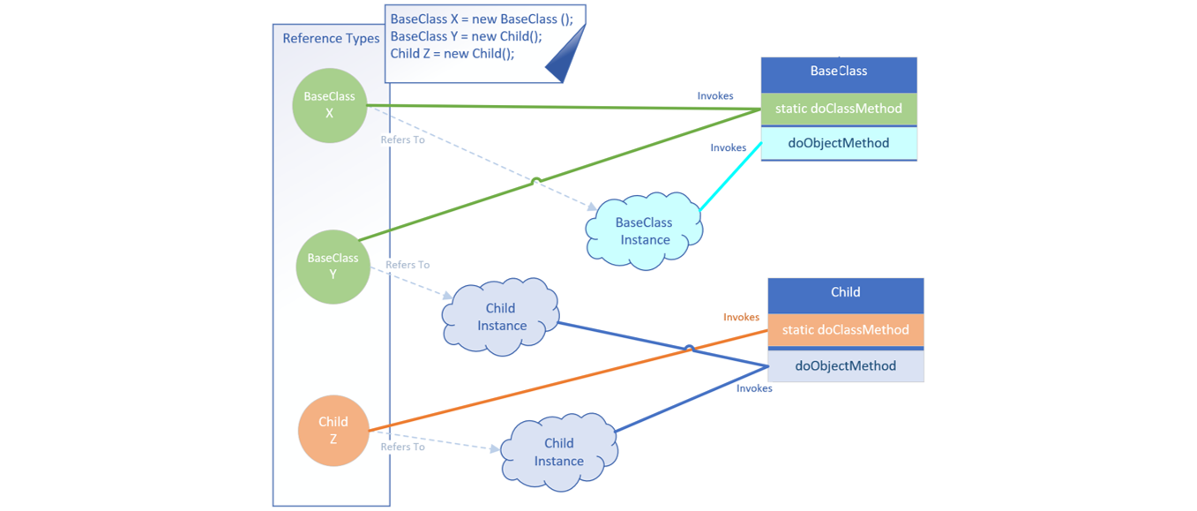

When you execute a static method on an instance, the reference type determines which method is called. So, the reference type that is on the left side of the equal sign determines which method is used.

Instance methods are called based on the run time type of the instance, and not the declared/reference type.

**Recommendation: Always Use the Type to Invoke the Static Method**

Best practice recommends always using the type-reference when executing a static method. If you’re hiding a static method on a parent class, make sure you understand what the implications are for doing so.

If you stick to using a qualifier as the type-reference to execute the specific static method, you’ll avoid the confusion shown above.

### Using final for Variables

It's important to understand when you use final, it doesn't mean the variable is immutable at that point. It means you can't assign or reassign a new instance, variable, or expression to it after the initialization. If you use final for a local variable in a code block, you can only initialize it fully, or assign it a value, once.

Any other additional assignments will result in a compiler error.

If you use final for method parameters, this means you cannot assign any values to the method parameters in the code.

**When Change Isn’t Good**

Formatting Date Time: there are many ways to format date and time. A couple of standardized ones are shown below:

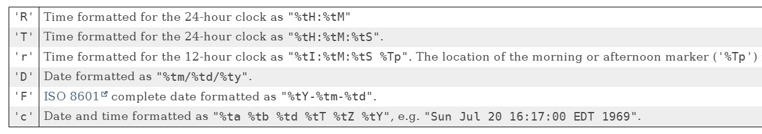

These apply to the formatted method on String, as well as the printf method. This information was retrieved from [here](https://docs.oracle.com/en/java/javase/17/docs/api/java.base/java/util/Formatter.html#dt).

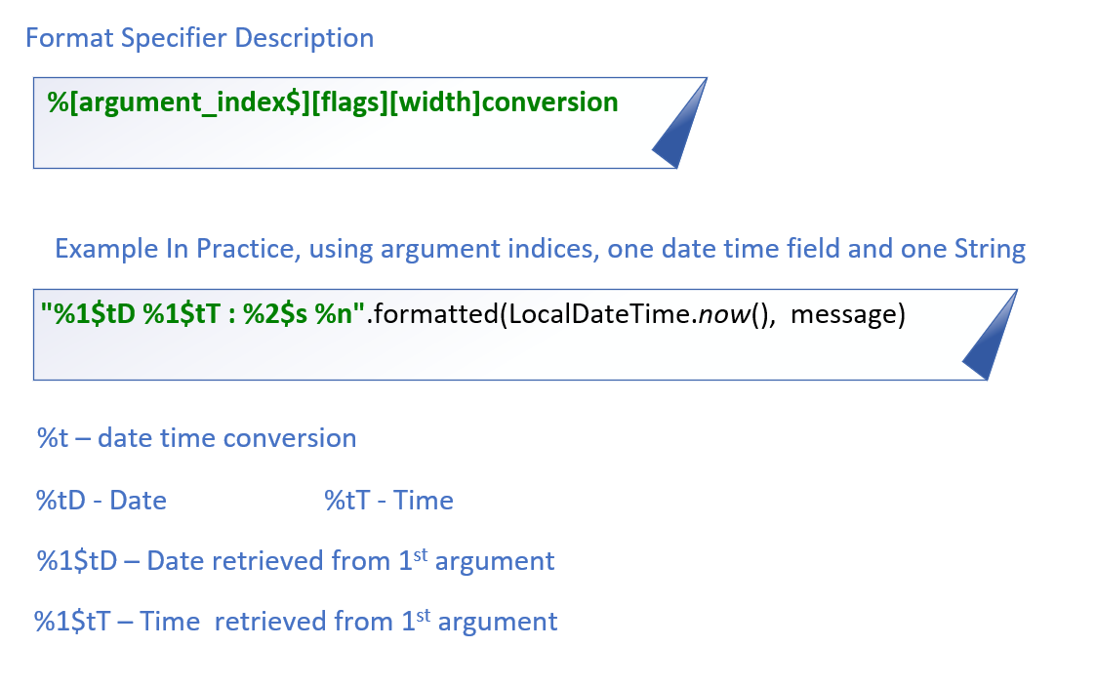

It’s common when using date time conversions to use the argument index feature, which is called *Explicit indexing*.

### Controlling Change

Java provides mechanisms to control changes and extensibility of your code at many different levels.

You can prevent:

* Changes to data in Instance fields, which is called the state of the object, by not allowing clients or subclasses to have access to these fields.
* Changes to methods by not allowing code to override or hide existing functionality.
* Your classes from being extended.
* Instantiation of your classes.

**Immutable Object**

An immutable object doesn’t change state once it’s created. An immutable object is a secure object, meaning calling code can’t maliciously or mistakenly alter it.

An immutable object simplifies concurrency design.

**Strategies for Declaring a Class to Produce Immutable Objects**

This slide describes the strategies of creating a class, that when used, produces immutable objects.

* Make instance fields private and final.
* Do not define any setter methods.
* Create defensive copies in any getters.
* Use a constructor or factory method to set data, making copies of mutable reference data.
* Mark the class final or make all constructors private.

**Defensive Copies as Input**

When you pass mutable types to an immutable object, a defensive copy should be made. The defensive copy should then be assigned to the instance field.

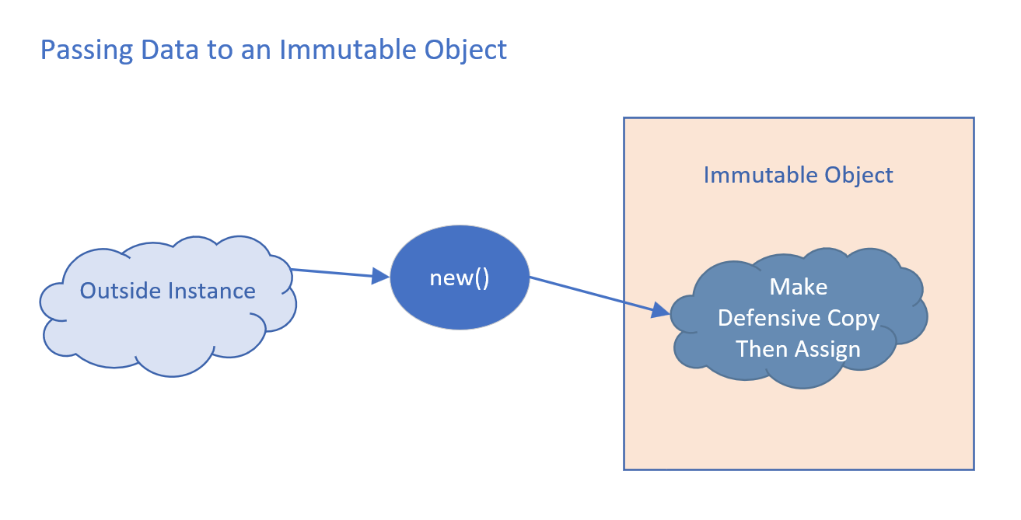

**Defensive Copies as Output**

When you retrieve the data, you should first make a defensive copy, and pass the defensive copy back to the calling code.

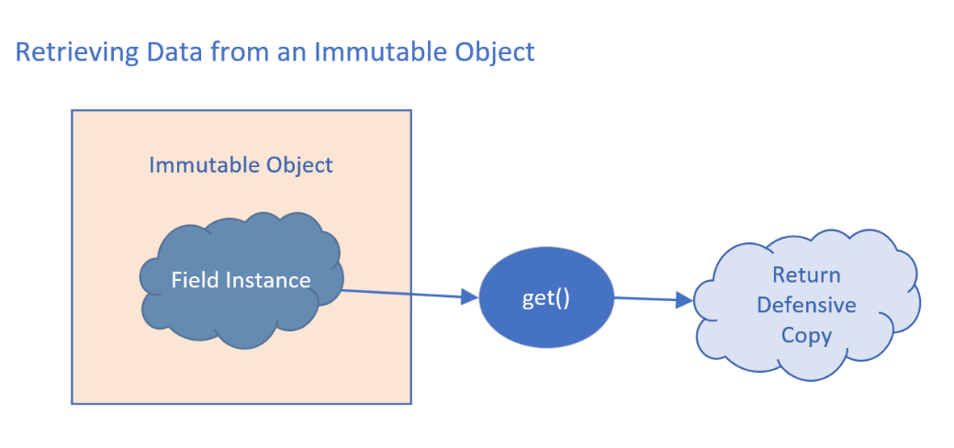

### What’s a Copy? Shallow Copy vs. Deep Copy

The image below shows two very different copies of an array. A *shallow copy* only makes a copy of the structure, and not a copy of the elements in the structure. A *deep copy* makes a copy of both the structure and copies of each element in the structure.

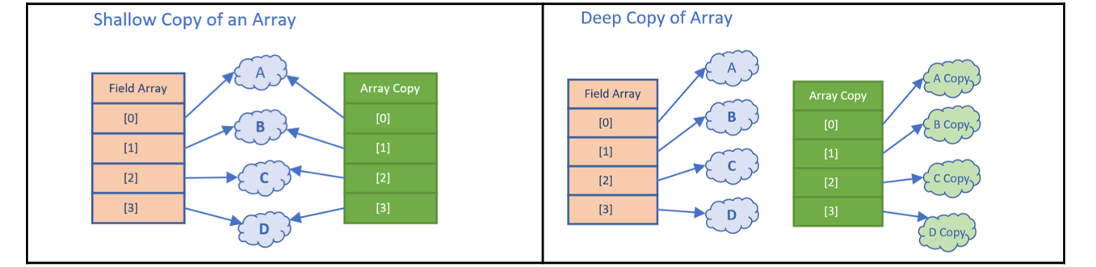

**Shallow Copy**

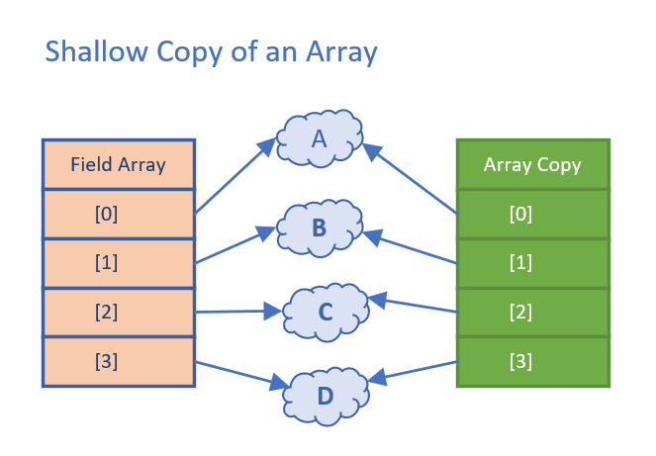When you use copy methods on interfaces and helper classes, the copy that's made will probably be a shallow copy.

A shallow copy of an array means a new array structure is created with the same number of indexed positions. Each indexed position is assigned the same value that was in the previous array, at that same position.

A copy of the referenced element isn't made.

You can see in the diagram to the right that both arrays have indexed references pointing to the same set of instances in memory.

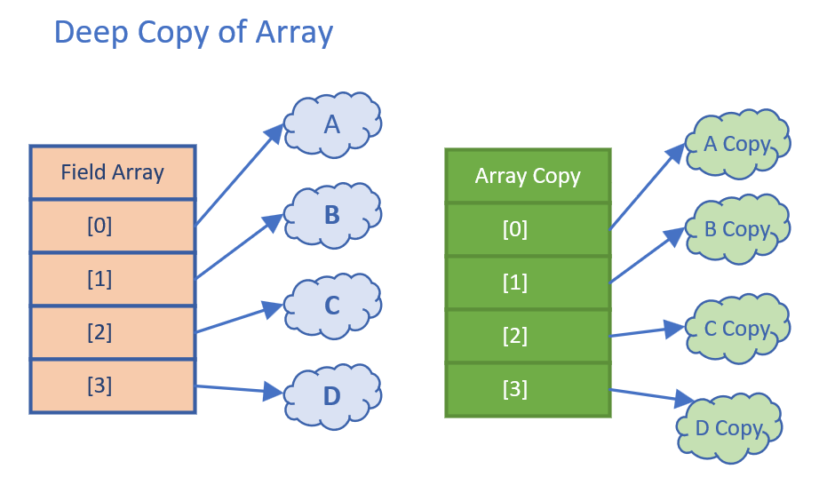

**Deep Copy**

Deep copies usually have to be manually implemented if you need it. The image below demonstrates a deep copy of an array. Each array element has been cloned for the array copy.

Deep copies may need to be applied to arrays and collections, as well as composite classes, to ensure immutability.

**Shallow Copy vs. Deep Copy of a Composite Object**

It’s not just arrays and collections you need to worry about. A class can be composed of other classes, meaning its fields are instances of classes.

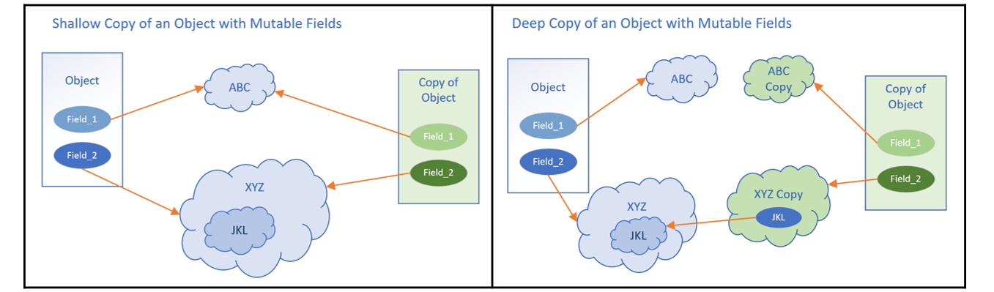

When you clone or copy this type of object, you may also need to copy or clone the class’s more complex fields. The image above shows a shallow copy of an instance of a composite class, comparing it to a deep copy.

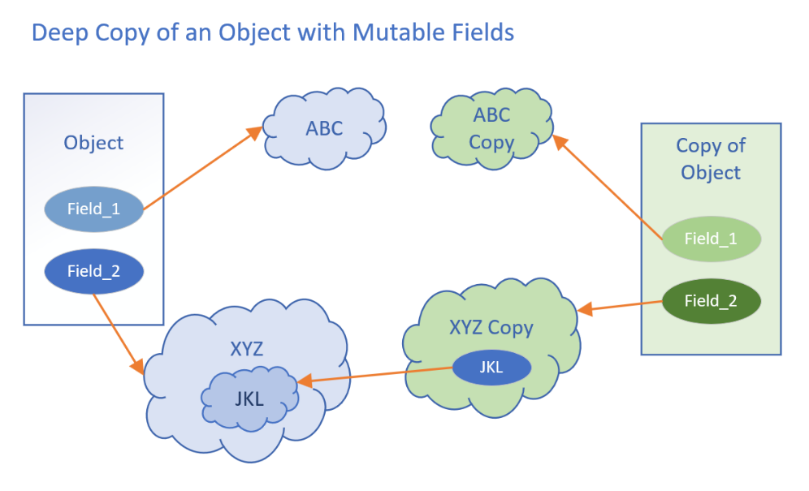

Nesting of a composite class can be multi-leveled, as is shown in the image to the right.

JKL is a field on XYZ, which is a field on the Object.

The deep copy created new instances of ABC and XYZ, the fields on the object, as well as a copy Object.

It didn’t however make a deep copy of XYZ, which is why JKL is still referencing the same instance in the original XYZ

**Unmodifiable Collections are NOT Immutable Collections**

It’s very important to understand that unmodifiable collections are NOT immutable collections. They become immutable collections if the elements in the collections themselves are fully immutable.

They are collections with limited functionality that can help us minimize mutability.

* You can’t remove, add, or clear elements from an immutable collection
* You also can’t replace or sort elements
* Mutator methods will throw an UnsupportedOperationException
* You can’t create this type of collection with nulls

**Unmodifiable Collections vs. Unmodifiable Collection Views**

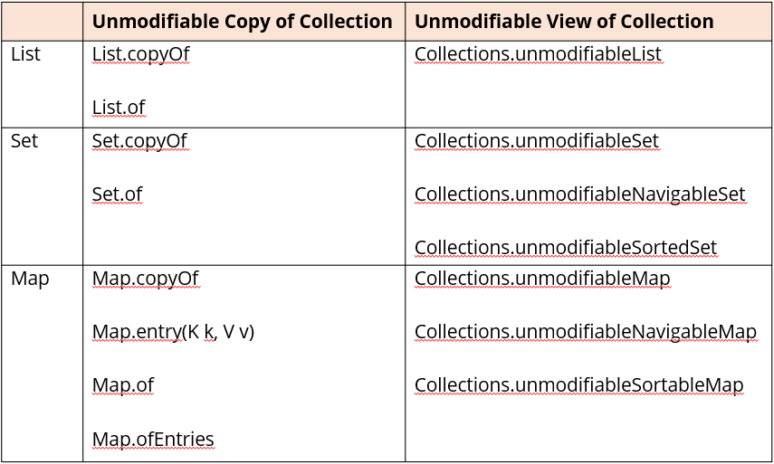

The three primary Collection interfaces, List, Set, or Map, have methods to get an unmodifiable copy on the specific interface related to the collection type, as shown in the table to the right.

In addition, the java.util.Collections class offers methods to get unmodifiable views, as also shown to the right.

These methods allow us to get closer to the ideal of immutability if it’s needed.

**Why Are We Going to Talk About Constructors Again?**

These topics are a bit more advanced, and now that we’ve mastered the basics, it’s time to look at these additional features. We’ll be covering:

* Initializing final fields.
* Initializers, both static and instance.
* Record and enum constructors.

### The Instance Initializers Block

An instance initializer is a block of code declared directly in a class body. This code gets executed when an instance of the class is created.

Instance initializers are executed before any code in class constructors is executed. You can have multiple initializer blocks. They will be executed in the order they are declared.

**Static Initializers**

A static initializer is called the first time a class is referenced or constructed. A class can have any number of static initialization blocks. They can be declared anywhere in the class body.

They’re called in the order they appear in the source code. You might use this to set up some environment data or log information, that’s related to the class before it can be used.

This will get executed only during the class’s construction and not each instance’s construction.

**Record Constructors Come in Three Flavors**

The *canonical* or *long* constructor is the implicitly generated constructor. You can explicitly declare your own, which means the implicit one won’t get generated. If you do declare your own, you must make sure fields all get assigned a value.

The *custom* constructor is just an overloaded constructor. It must explicitly call the canonical constructor as its first statement.

The *compact* or *short* constructor is a special kind of constructor used only on records. It’s a succinct way of explicitly declaring a canonical constructor.

**The Compact Constructor**

You can’t have both a compact constructor and an explicit canonical constructor. This constructor is declared with no parentheses, so no arguments.

It has access to all arguments of the canonical constructor. Don’t confuse arguments with the instance fields! You can’t do assignments to the instance fields in this constructor.

The implicit canonical constructor’s assignments occur after the execution of this code.

### The Java Class File Disassembler

This is javap.

It lists class members by default just public and protected members in the class file.

This helps us ‘see’ implicit code in the compiled class file.

**Final Classes**

Using the *final* keyword on a class means it cannot be extended. We declare a class **final** if its definition is complete, and no subclasses are desired or required.

Enums and Records are final classes.

Subclasses can take advantage of mutable fields on parent classes if the parent classes aren’t implementing defensive code. One of the easiest ways to prevent this is to make your class *final*.

Private constructors will prevent both a new instance and a new subclass from being created. Protected constructors will prevent an instance from being created outside of a subclass or the package.

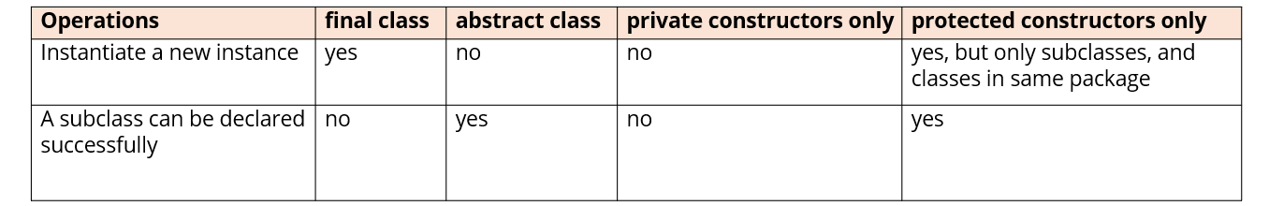

The final and abstract modifiers are incompatible and wouldn’t be used in the same declaration. You can see that if you don’t want your class to be instantiated, you can either make it abstract or use a more restrictive access modifier on the class.

### Sealed Classes

JDK17 introduced a new modifier, ***sealed***, for our new classes and interfaces. This modifier can be used for both outer types and nested types.

When used, a ***permits*** clause is also required in most cases, which lists the allowed subclasses. Subclasses can be nested classes, classes declared in the same file, classes in the same package, or if using Java’s modules in the same module.

What this means, though, for this specific conversation, is that all our code so far, since JDK9, is part of what’s called the unnamed default module. Because of this we can’t use subclasses in the permits clause that are in other packages.

A sealed class and its direct subclasses create a circular reference.

**sealed class**

Using the sealed keyword requires the parent class to declare its subclasses using a ***permits*** clause. This means the parent class has to know about every direct subclass, and these have to exist in the same package in this case.

In addition, the sealed keyword puts a requirement on all the subclasses that were declared in the permits clause. These are **final, sealed, or non-sealed**.

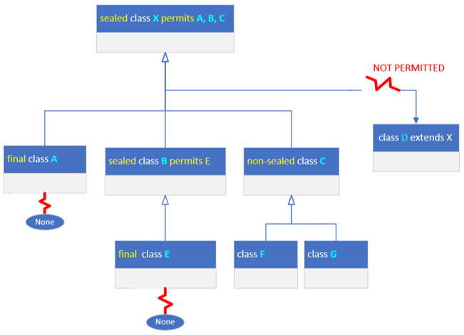In the diagram to the right, we have a parent class X, declared as a sealed class and permitting only classes A, B, and C to subclass it.

For that reason, class D, which may exist and extends X, won’t compile. We’d have to either add D to the permits clause on X or remove D from the hierarchy in some way.

All subclasses declared in the permits clause must be declared as final, sealed, or non-sealed.

Declaring a class final means no other subclasses can extend that class, as is shown with class A. If a subclass is declared with a sealed modifier, shown in the diagram with class B, must in turn use a permits clause. Its subclasses will also have to use one of the three valid modifiers. Lastly, a subclass can use the non-sealed modifier, shown in the diagram with class C. This means it’s basically unsealing itself for all its subclasses.

## Section 17 – Java Streams

### Java Streams – What They Are and What They Aren’t

When you think of a stream, you might be thinking of I/O streams, like a buffered input stream or file output. That isn’t the type of stream we’ll be talking about here.

Oracles Java documentation describes a stream as:

***Stream*** – *a sequence of elements supporting sequential and parallel aggregate operations*

Streams are a mechanism for describing a whole series of processes before actually executing them.

**A Stream is Different From a Collection**

The stream and the collection types were designed for different purposes.

A ***collection*** is used to **store and manage a series of elements** in Java, providing *direct access* to the Collection elements.

You can use collections to manipulate or query a set of data. There’s nothing you can do with a stream that you couldn’t already do with a Collection. However, a ***stream*** was designed to *manage the processing of elements.*

Streams don’t actually store elements, instead these elements are computed on demand from a data providing source.

### The Lazy Stream

Another important difference is that streams are lazy, like lambda expression variables. When you call many of the methods on a stream, execution may not immediately occur.

Instead, you’ll need to invoke a special operation on the stream, like you would by calling a lambda’s functional method. This special operation is called a terminal operation.

### Why Use a Stream?

Streams are an exciting addition to Java because they provide several benefits.

* First, they make the code to process data uniform, concise, and repeatable in ways that feel similar to a database’s structured query language (SQL).
* Second, when working with large collections, parallel streams will provide a performance advantage.

All examples that have been provided up to this point using collections will continue to be valuable for many use cases, but it’s time to move on and discuss using this additional functional programming feature.

### The Stream Pipeline

The entire chain of operations of using a stream in code is what’s called a Stream Pipeline.

The pipeline starts with a source, which is where the data elements are coming from. In our example, it’s coming from a list – bingoPool.

All pipelines start with a stream, so in this example we need to call the stream method on the bingoPool list to get the stream. There are a lot of other kinds of sources and ways to create new streams, including infinite streams.

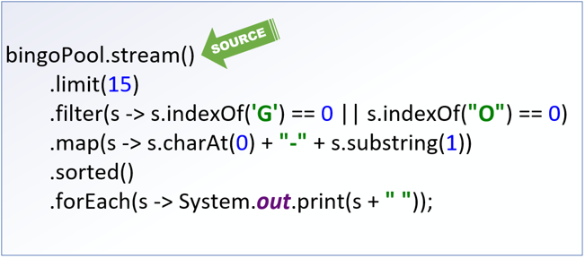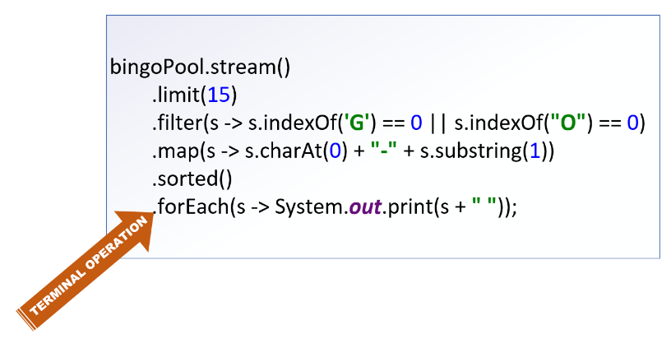

Stream Pipelines end in a terminal operation. A terminal operation is required.

### The Intermediate Operations

Everything else between the source and the terminal operation is an intermediate operation. An intermediate operation is *not required*.

You can have a pipeline that just has a source and terminal operation, and these are quite common. Every intermediate operation processes elements on the stream and returns a stream as a result.

**Streams Are Lazy**

Without worrying about semantics, imagine the stream pipeline as a black box. The source is the input, the result of the terminal operation is the output. Everything in between isn’t going to happen until something tells that terminal operation to start.

What actually happens in that black box may not happen exactly as you’ve described it, or in the order you’ve specified. Execution of the intermediate operations is dependent first on a terminal operation being specified, and second, on an optimization process occurring.

### Stream Computations are Optimized

What this means is that a stream pipeline is kind of a workflow suggestion. Before the process begins, the stream implementation will perform an evaluation to optimize the means to the end.

It will determine the best way to get the elements needed and the most efficient way to process them to give you the result you’ve asked for. The result will be consistent each time, but the process to get there is not guaranteed to be.

Optimizations may change the order of the intermediate operations, it may combine operations, or even skip them altogether. For this reason, **you should avoid side effects in your intermediate operations**.

**You Can’t Reuse a Stream**

Once you invoke a terminal operation on a stream, you can think of the pipeline as being opened and the flow beginning. The flow is allowed to continue until all processes have been performed and a result produced. At that point the valve is shut and the pipeline closed.

You can’t turn it back on or reuse it for a new source. If you want to do the same sort of thing with a different variable for one of the intermediate operations, you’d need to set up a new pipeline.

**Stream Types My Change as the Pipeline Process Progresses**

An intermediate operation can usually be recognized by its signature because it returns a stream. This doesn’t mean the element type of the stream can’t change. In practice, you’ll be regularly transforming your stream element to a different type.

### Stream Sources

The table below shows eight methods covered for streams:

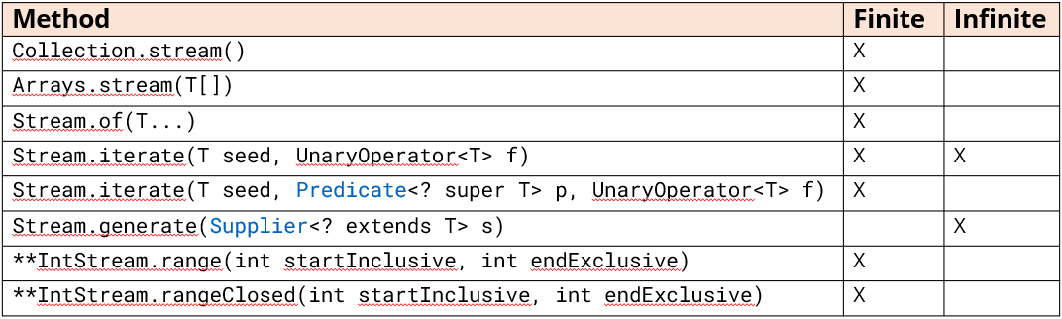

Two can produce infinite streams – the Stream.generate method as well as Stream.iterate, which doesn’t include a Predicate parameter.

** - range and rangeClosed also available on LongStream, with a long type produced for both

**The Most Common Intermediate Operations**

Until now, we’ve kind of glossed over intermediate operations. We’ve used filter, limit, map, and sorted in different examples.

In the table below, the operations we’ve already seen briefly cover half of the basic operations available to stream pipelines:

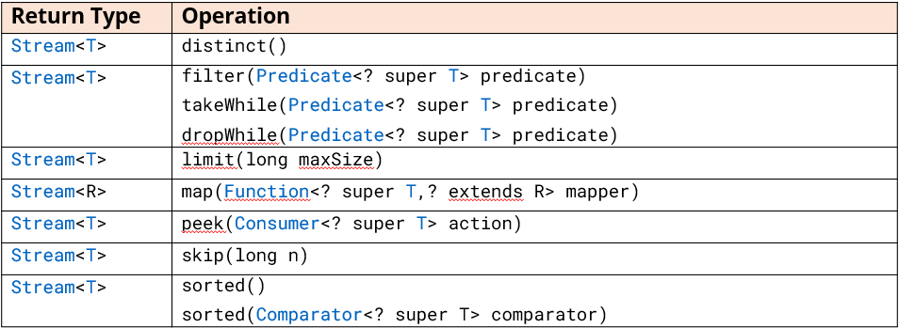

**Intermediat Operations That Effect the Size of the Resulting Stream**

The set of operations below may change the number of elements in the resulting stream:

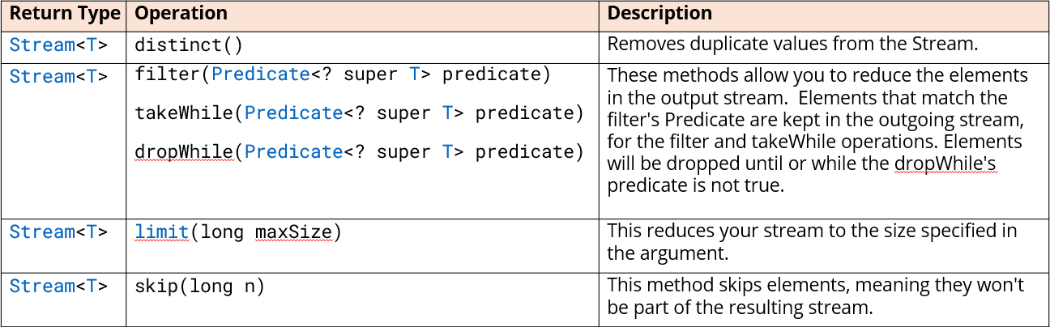

**Declarative Language of Stream Operations Resembles Query Commands**

The Java API designers designed the Stream to let you process data in a declarative way, much like a structured query language or SQL in a database. Again, this lets you say *what should happen*, and not actually *how it will happen*.

If you’ve had experience querying databases, you might be familiar with the limit and distinct keywords available in some database query languages.

The filter operation represents your where clause, and sorted would be your order by clause, and so on. There are aggregate functions commonly used in queries as well, such as max, min, count, and so on.

**Intermediate Streams that Operate on Every Element**

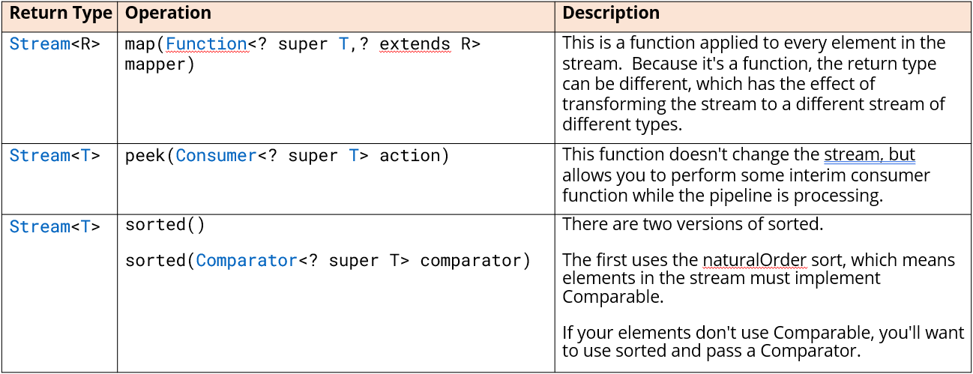

### Primitive Streams

In addition to the generic Stream that lets you stream any reference type, Java has three primitive streams:

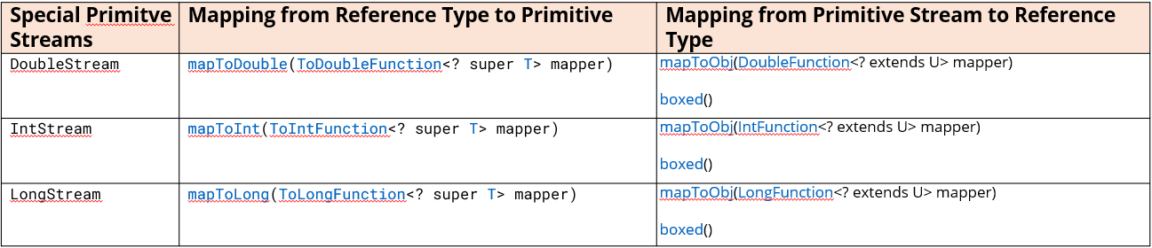

### Terminal Operations

Now it’s time to see why stream processes are such a welcome feature and look at other terminal operations we can use. Some are designed to find matches, most of which are targets for a Predicate Lambda expression.

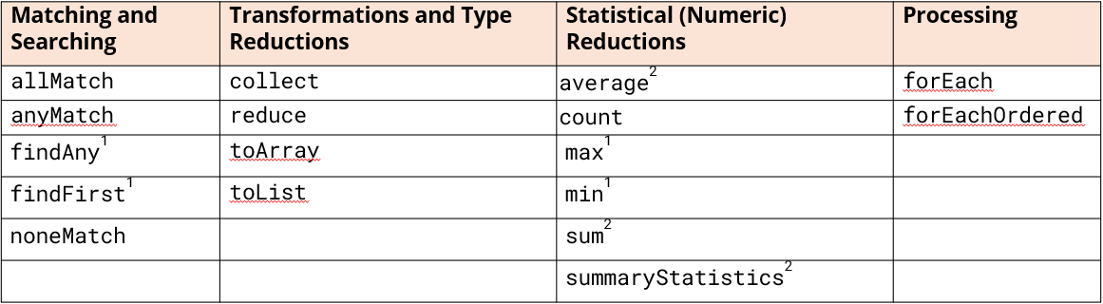

Some are designed to transform stream data into a collection or some other reference type. Others aggregate information to count elements, or find a minimum or maximum value, and don’t take arguments.

The primitive streams have average and sum as well, and a summaryStatistics operation which gives you count, min, max, average, and sum in one result.

#### What is a Reduction Operation?

A reduction operation is a special type of terminal operation.

Stream elements are processed to produce a single output. The result can be a primitive type, like a long, in the case of the count operation. The result can also be a reference type, like Optional or one of the Statistics types we’ll be covering.

It can also be any type of your choice, such as an array, a list, or some other type.

#### Aggregation Terminal Operations

We can use terminal operations to return information about the aggregated data set.

The methods shown below have no arguments. They all return numerical data, either directly or in specialized types to hold that data:

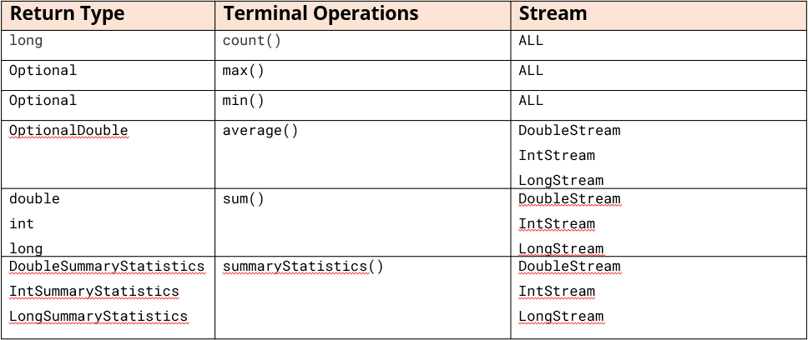

#### Matching Elements in a Stream Based on a Condition

There are three terminal operations that let you get an overall sense of what your stream elements contain based on some specified condition. These all return a boolean and take a Predicate as an argument.

We can think of these as ways to ask true or false questions about the data set, the stream, as a whole.

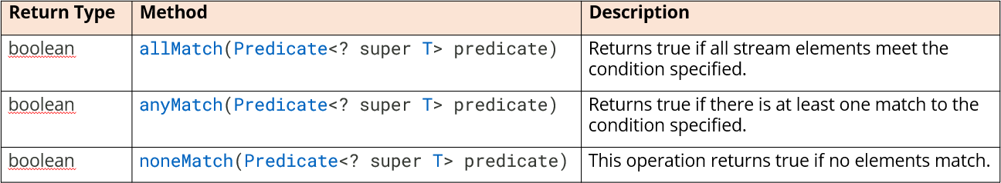

#### Additional Terminal (Reduction) Operations

*Reduction operations* combine the contents of a stream to return a value, or they can return a collection. In the table below are some additional terminal operations we have not covered yet, along with their return types and signatures.

There is also one interface that we have not talked about yet, and that’s the Collector. This is not a functional interface, but there are helper methods on another class, named Collectors, that provide these special types.

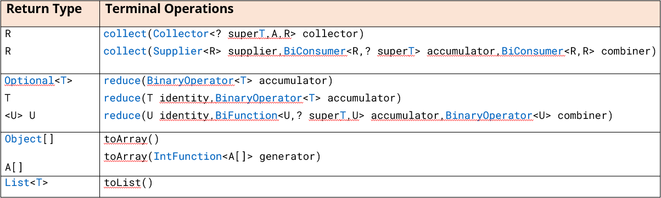

### The Collect Method

The collect method has two overloaded versions. The first can be used by passing it the result of any of the many factory methods on the Collectors class. We saw the asList and asSet as two examples of static methods on that class.

The second is more complex but gives you flexibility, as we saw with the TreeSet example in the source code.

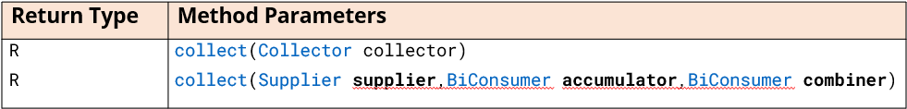

### What’s the Optional Type?

Optional is a generic class whose purpose is to be a container for a value which may or may not be null. It was created by Java’s engineers to address the problem of the NullPointerException, which is one of the most common errors in Java.

This type is primarily intended for use as a method return type under specific conditions.

**No Result is Valid vs. No Result is A Problem**

Optional tries to solve the problem of when no result, or no data, is a perfectly valid situation vs when no result might really be an error.

You can think of many situations where no data makes sense. Not everyone has a middle initial in their name, or even a last name for that matter. No data for a birthdate may or may not be an exception. New inventory may not yet have a sales price.

Optional is a way of telling you that a value may not be present, therefore you can ignore the value in processing.

#### Creating an Instance of Optional

Optional is just another generic class, so you declare it like any other type, with type arguments. But, you don’t construct an Optional. Instead, you use one of the static factory methods shown below:

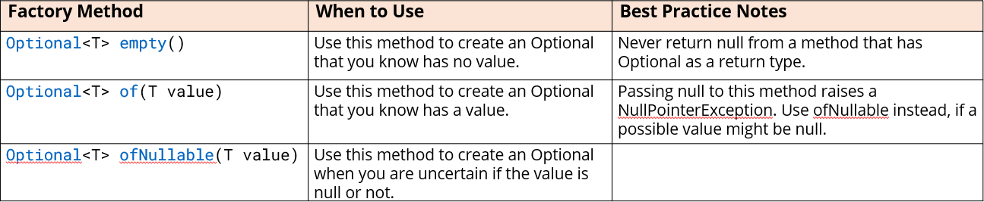

These methods are empty, of, and of Nullable.

#### The Downside of Optional

* Wrapping elements in Optional will consume more memory and has the possibility of slowing down execution.
* Wrapping elements in Optional adds complexity and reduces readability of your code.
* Optional is not serialized.
* Using Optional for fields or method parameters is not recommended.

Reading from the author of Optional on stackoverflow is available [here](https://stackoverflow.com/questions/26327957/should-java-8-getters-return-optional-type/26328555#26328555).

**The Terminal Operations that Return Optional**

Below are the final few terminal operations, all of which return an Optional:

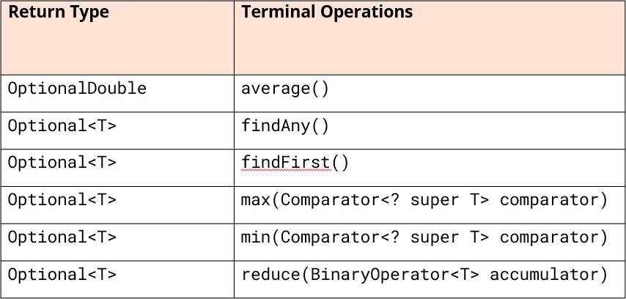

### Static Import

The static import statement is a similar idea. It lets you import one or more static members of a class. We can use the static import statement specifying the Collectors class with a wild card to import all static members.

import static java.util.stream.Collectors.*;

Link to Collectors method summary on Oracle website: [click here](https://docs.oracle.com/en%2Fjava%2Fjavase%2F17%2Fdocs%2Fapi%2F%2F/java.base/java/util/stream/Collectors.html#method-summary)

**The flatMap Operation**

The flatMap intermediate operation performs one-to-many transformations on elements in a stream pipeline. It’s called flatMap because it flattens results from a hierarchical collection into one stream of uniformly typed elements.

The difference is in the return type of the function. For map, you return a different instance of an object. In this case, you’re exchanging one type for another, for each element on the stream.

For flatMap, you return a Stream, which means you’re exchanging one element for a stream of elements back.



## Section 18 – Math and Dates

### java.util.Math

We can think of the Math class as our calculator. It has functions we’d find on a basic calculator, as well as a few scientific methods.

Oracle document for Math class: [click here](https://docs.oracle.com/en/java/javase/17/docs/api/java.base/java/lang/Math.html)

**Use Math.random() or Random’s Methods?**

Below is a sample of code from the internet for how to randomize a character:

int random = (int) (Math.random() * (26)) + 65;

The Math.random method uses an instance of the Random class and invokes the nextDouble method on that class. The first time you call Math.random(), a single new instance of java.util.Random is created and used for all subsequent calls.

**Common Usage of Math.random – Getting a Range of Numbers**

int r = (int) (Math.random() * (upper – lower)) + lower;

This was a pattern used a lot in the past, because until JDK 17, the Random.nextInt() method only supported an upper bound.

When you use Random, you have to use an instance of it.

### What’s a Seed?

In most programming languages, the random functions aren’t truly random. Algorithms exist that create distributions of numbers that achieve what a random distribution might look like over a large range of values.

These are called *pseudorandom number generators*, and they are dependent on an initial value called a *seed*.

**Some Floating Point Number Basics**

Precision defines the number of digits in a decimal number. Precision includes digits to both the left and the right of the decimal point.

Scale is the number of digits to the right of the decimal point in a number.

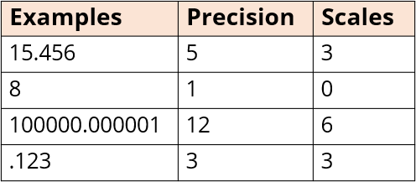

**Fractional Numbers May Not Be Able to be Accurately Represented by Floating Point Numbers**

Many floating-point numbers can only approximate the decimal number they’re supposed to represent. Think about the number 1/3, which has an infinitely repeating decimal. This fraction, by necessity, will get rounded at some point.

Its scale wasn’t big enough as a float when we applied it to our fairly large life insurance benefit. The double worked well enough for this calculation, but it was still off by a penny when reconciling a rounded dollar amount with a calculated double amount.

### BigDecimal

The BigDecimal class stores a floating point number in two integer fields.

The first field holds an *unscaled value* with a type of BigInteger, another class in the java.Math package, that can store numbers bigger than even long values. The second field is the *scale*, which can be positive, 0, or negative.

A positive or 0 scale defines how many digits in the unscaled value are after the decimal point. You can use negative scale as well, which means the unscaled value is multiplied by ten to the power of the negation of the scale.

#### BigDecimal Examples

Using the examples shown above, if we created BigDecimal instances using those values, we would get the unscaled value and scale shown below:

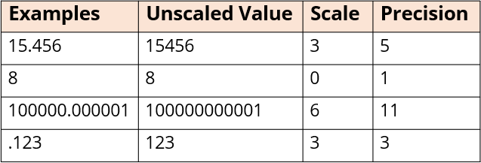

The unscaled value has all the digits and no decimal point.

The decimal point’s placement is determined by the scale, and again, precision identifies the number of digits.

### Java.time

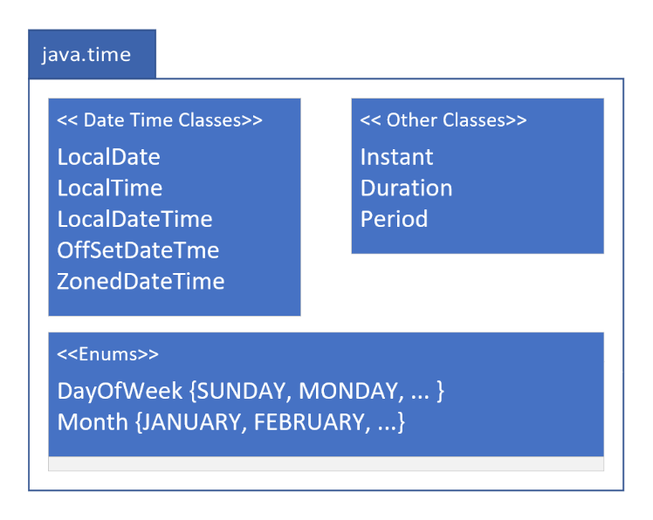

#### Java.time Related Packages

Java has other packages under the java.time umbrella. These are java.time.termporal and java.time.format. In addition, there are the java.time.zone and java.time.chrono packages. These two packages do not contain functionality that is very commonly used.

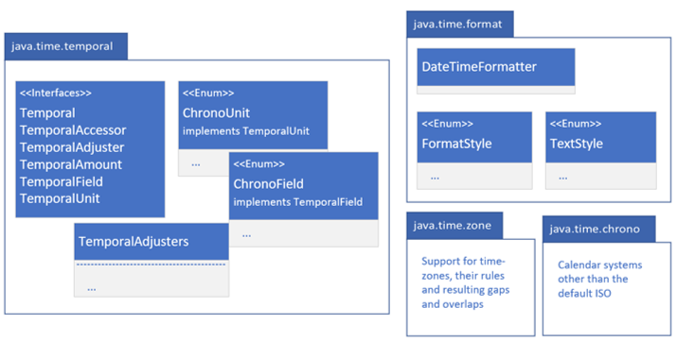

#### A screenshot of a computer Description automatically generatedJava.time.temporal

The java.time.temporal package contains important interfaces that the java.time classes implement. These include Temporal and TemporalAccessor interfaces that describe a uniform way to read from, or write to, a date time object.

The TemporalAdjuster, TemporalAmount, TemporalField, and TemporalUnit interfaces are quite often used as method parameters, to specify what kind of information you want specifically about a date time object.

There are two enums in this package that will be covered in the course, and are shown to the right: ChronoField and ChronoUnit.

The TemporalAdjusters class is a helper class to return specific implementations of TemporalAdjuster, which can give you helpful dates such as first day of month or last day of year, etc.

#### A screenshot of a computer Description automatically generatedJava.time.format

We’ve seen how to format date time using the “%t” specifier in a formatted String. The java.time.format package gives you a great deal more options, as well as support for localization. There are enums to support dates and time in defined styles called Full, Long, Medium, and Short.

#### LocalDate, LocalTime, and LocalDateTime

Below are the most common classes for Date and Time when you don’t need to include time zone data.

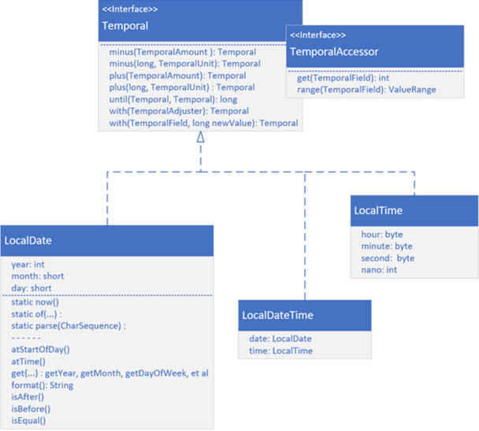

These are LocalDate, LocalTime, and LocalDateTime.

Each implement both the Temporal and the TemporalAccessor interfaces and the methods on those interfaces, as shown in the graphic below. These include the get and range methods from TemporalAccessor.

From Temporal, there are methods to add or subtract units of time from your objects. These are the plus and minus methods.

Field values can be directly set on a returned copy using the *with* methods. There are additional methods on LocalDate that are available with prefixes such as *at, get,* and *is*.

### A blue and white box with text Description automatically generatedCreating Instances of Temporal Implementations

There are several static methods which return a new instance of a temporal class. There is the **now** method that gives you a representation of the current moment for the class you specify.

You can create instances using any of the several overloaded versions of the **of** factory method.

Alternatively, we can use the **parse** method, with a character sequence, usually a String, that’s formatted in a predetermined way, or you can pass in a defined format. You can use similarly named methods on any of the temporal implementations with varying parameters and return types.

#### Temporal Instances are Immutable

All temporal instances of classes in the java.time package are immutable and thread-safe. A new instance is returned from methods that write to a temporal instance such as the plus or minus methods.

You’ll need to assign the result of these methods to a variable. The original instance won’t be modified.

#### A screenshot of a computer Description automatically generatedMethods of Temporal Implementations

In addition to the methods on the Temporal and TemporalAccessor interfaces, most implementations have methods prefixed with at, get, and is, as well as a format method.

The at methods allow you to combine temporal instances. In this example, a time is combined with the LocalDate for both the atStartOfDay and atTime methods and return LocalDateTime instances. The Date and Time instances implement Comparable, so each has a compareTo method.

The get methods are specific to the class, so for LocalDate you’d have date related getters like getYear, getMonth, getDayofWeek, and so on. For LocalTime, these would be getHour, getMinute, etc. Each class supports isAfter, isBefore and isEqual, so you can compare units of date or time. There’s also a format method to output a formatted date.

### A screenshot of a computer Description automatically generatedLocalDate, LocalTime, and LocalDateTime Classes

Java internally stores the date fields and the time fields as separate numeric fields. These fields can be retrieved with or without context of the other fields. For example, you can get day of the month or day of the year.

LocalDate uses int for year and a short for month and day. LocalTime uses bytes for the hour, minute, and second, and an int for nanoseconds. LocalDateTime has two fields, a date with a type of LocalDate, and a time with a type of LocalTime.

#### The LocalDate Class

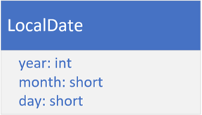

LocalDate is a class for storing and managing a date with a year, month, and day without reference to a specific time zone. This kind of date might be used for an anniversary date, a birth date, or a special holiday like Cinco de May (the 5th of May), or Thanksgiving Day.

This class doesn’t have a clock time component.

#### The LocalTime Class

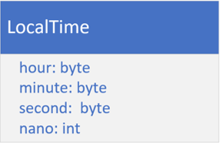The LocalTime class provides a description of the local time as seen on a wall clock. It contains neither a date or a time zone. Time is represented as hour-minute-second with nanosecond precision, if it’s available.

#### TemopralField vs. Temporal Unit

A **temporal field** represents a *field of date-time*, such as month-of-year or minute-of-hour. A **temporal unit** is a *measurement of time*, such as years, months, days, hours, minutes, and seconds.

The diagram below shows both interfaces along with a couple of the methods that would be implemented:

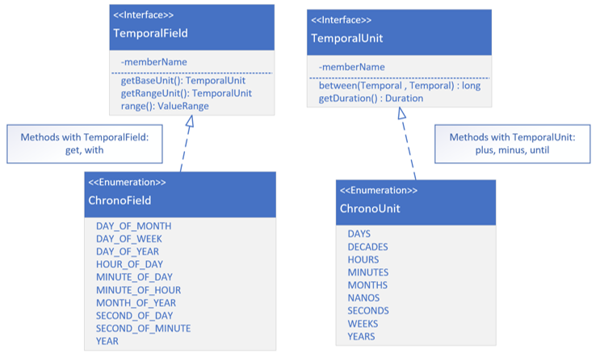

The enum constants on ChronoField and ChronoUnit are also included, as they are ones that are pretty commonly used.

The get and with methods take a TemporalField as a parameter. The plus, minus, and until methods take a TemporalUnit.

#### A Date-Based Timeline

Below is a timeline from January 1st, 2020 through the end of April of the same year. A point on a timeline, shown below as March 20th at 4:55 PM is called an *Instant* in time. An interval (or span of time) on a date timeline is called a *Period*.

It’s often represented by elapsed time in date unites such as years, months, or days.

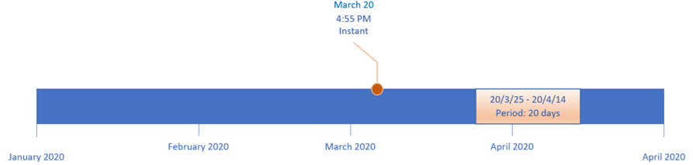

#### An Hourly Timeline

Below is a timeline for a single 24-hour day. This timeline can have an Instant as well, as shown at 16:30 which represents 4:30 PM on this timeline.

The timeline also shows a span of time from 6:40 AM until 1:20 PM. When the interval is time based (in terms of the units being in hours, minutes, or seconds), this is called a *Duration*. On this timeline, the duration lasted 6 hours and 40 minutes.



### Instant

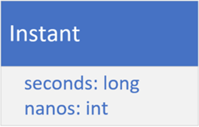

On the previous timelines, events have been shown to be represented as *Instances*. Java provides the **Instant** class for this. It has two fields, one for seconds as a long, and one for nanoseconds as an int.

If you’re new to programming, you might be asking what does seconds mean? How can you store a moment in time as seconds? Doesn’t it need some context, like a starting point in time from which to measure these seconds, or a defined timeline?

These seconds are called *epoch seconds*, and the epoch is the starting point for many such points in time. Instead of having to specify this this point in time, every time you want a time stamp or instant of time, many software languages use a specific date and time, called **Epoch Time**.

**What’s the Significance of the EPOCH Time?**

00:00:00 UTC, Thursday 1st January 1970 is called alternately Unix Time, POSIX Time, Epoch Time, or Unix Epoch Time. Computer systems have different epoch times, but many software languages use this particular date and time, including Java, as the predetermined start of time. It’s used to create time stamps whose meaning, as seconds, can be understood.

If you ever do want to see it or use it, it’s a constant named EPOCH on the LocalDate and Instant classes. UTC is a symbol that stands for Coordinated Universal Time, which coordinates with Greenwich Mean Time (GMT).

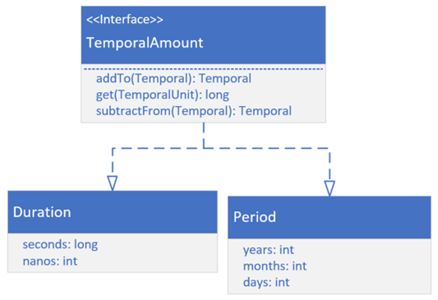

### Duration and Period

If you look at the Duration class diagram, you might think it looks like the Instant class, but there are significant differences. First, Duration and Period do not implement Temporal or TemporalAccessor. The instead implement TemporalAmount.

This means these classes are something quite different from a unit of date or time. They are amounts of time. Both represent elapsed time between units of time (or dates).

### Greenwich Mean Time

If you remember from geography class, the earth is drawn with imaginary lines on it to help uniformly describe locations on the planet. The lines drawn from the north pole to the south pole are called meridians.

These could be drawn anywhere, but a *Prime Meridian* was historically agreed upon as a starting point, or the zero measurement. This is a reference point for all other measurements.

The time in Greenwich was solar time, based on the position of the sun in the sky. When atomic clocks were introduced, they were able to provide more precise time than Greenwich Mean Time (GMT).

In 1972, GMT was superseded by UTC, which stands for Coordinated Universal Time, and is based on atomic time. The differences between GMT and UTC can differ by up to 0.9 seconds in a day. For this reason, GMT and UTC are often used interchangeably, when you don’t need great precision.

### Time Zone

A Time Zone consists of two parts – a UTC offset and, optionally, information about Daylight Savings Time.

Java derives it’s time zone data from three sources:

* The Internet Assigned Numbers Authority (IANA)’s Time Zone Database (TZDB) is the default and takes precedence over the others.
* IATA (the airline industry body).
* Microsoft.

Two helpful links for time zones are given below (both use IANA Time Zone database as their source):

* List of time zone identifiers: <https://twiki.org/cgi-bin/xtra/tzdatepick.html>
* List of day light savings rules: <https://en.wikipedia.org/wiki/Daylight_saving_time_by_country>

**Before JDK8 and the Introduction of the Java.Time Package**

There are classes in java.util that may look attractive to use were used before JDK8, and may be run across these classes at some point in older code. These are:

* Date
* TimeZone
* GregorianCalendar

Additional classes for formatting are in the java.text package:

* DateFormat
* SimpleDateFormat

The use of these classes in new code is discouraged. The immutable thread-safe classes provided by the java.time packages should be used.

**System.currentTimeMillis**

System.currentTimeMillis returns the milliseconds since epoch time, so midnight, January 1st, 1970 UTC. This time is based on the operating system. This can be used to measure elapsed times or provide timestamps.

### System.nanoTime

System.nonTime uses the JVM’s high resolution time source to return nanoseconds from an arbitrary origin time, which is not Epoch time, and may even be a time in the future.

This origin time may differ across different JVM instances. For this reason, it can’t be used to represent real time or wall clock time.

It shouldn’t be used as timestamps for data. Instead, it’s purpose is to measure elapsed time for invocations in a single JVM instance.

**Instant**

The instant class is designed to only represent a point in time or a timestamp. Internally, it stores a value in nanoseconds from the fixed epoch time of 1970-01-01Z.

As such, an Instant can’t be formatted as a date or time without providing time-zone information.

When printed, Z is used as the suffix to indicate this timestamp is in reference to UTC. This allows for comparisons, regardless of time zones or operating systems, which is why it’s an effective timestamp.

### Localization

Where you are matters, because where you are or the region you’re from determines how you’ll expect to see dates, currencies, and numbers formatted. Even ignoring language differences, these formats can be different for different cultures and locations.

For example, Australia displays dates differently than the United States. Many countries use different currency symbols and have different scales for the least significant currency digit.

### Locale

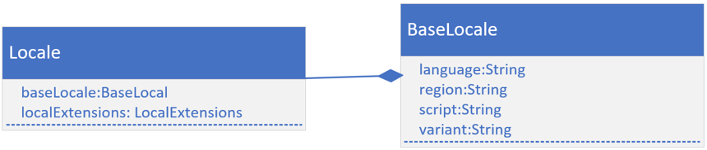Locale is an English word for a place where something happens.

It’s also the name of a class in the java.util package that underpins support for both localization and internationalization.

Java has some built-in support for localization with methods that let you pass a Locale instance to them. A locale has five fields – a language, a country (or region), a variant, and, less apparent, are script and extensions.

Underneath the covers, most of the fields are on a BaseLocale class as shown in the diagram above.

### Java’s Localization Support

Java provides localization support for dates, numbers, currencies with no additional support other than defining a Locale and passing it to certain methods. For languange constructs, other than a month or a weekday specified in a date, you’ll need to do some additional work.

#### Internationalization

Internationalization, or I18n for short, is a method of designing your application to allow language and regional elemtns with the help of locales to be plug and play.

Strings used in messages or user interface elements and images are stored externally to the application. These can be retrieved using a locale and then displayed for a specific user. Java uses the ResourceBundle to support this feature.

Helpful link for supported JDK 17 locales: [click here](https://www.oracle.com/java/technologies/javase/jdk17-suported-locales.html#compatlocales)

#### The ResourceBundle Class

The ResourceBundle class is an abstract class in the java.util package. You can implemente classes that extend this abstract class. You can get an instance of a ResourceBundle by calling one of several static getBundle methods on the ResourceBundle class.

The latter approach is dependent on resource data, either stored in a series of files or provided by a service.

#### ResourceBundle Data In A .properties File

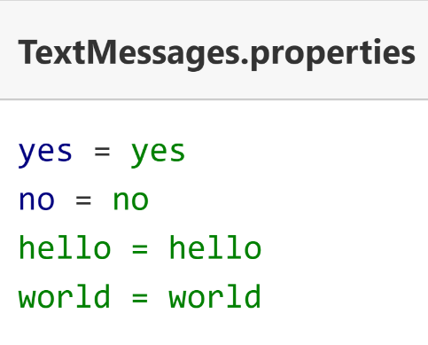Data that’s customized is often textual in the form of user messages, button labels, or menu items, but may contain other elements such as images or audio components.

To date the most common method of supplying data for a ResourceBundle is using the properties file. This is a simple text file containing key value pairs. The key is a string, a name to be used when the data is requested, and the value is also a single text literal.

The properties file name includes a base name, called the bundle name, and some part of the Locale identifier and ends with the extension .properties. The image to the right shows examples.

Additional properties files can be created to support other languages. We can think of a bundle as a series of files that have the same base budle name, but are differentiated by Locale specifics.

If there is a need to support the Spanish language for example, a TextMessages_es.properties file can be created with Spanish language text literals for yes, no, hello, and so on.

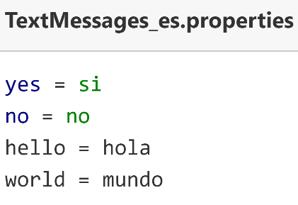An example is shown to the left. Notice that the keys for both these properties files are in English and are the same for both files. Whatever language you choose for your keys is up to you, but they do need to be consistent across files so that the key can be used to look up the value.

Of course, there are many language dialects, so you may need to also provide additional language variations for these, which can be done by including country, script, and/or a variant.

#### Java’s Matching Process To Locate the Best Bundle

Java has specific rules for searching and matching one of these properties files to a Locale. These rules can be found in the ResourceBundle class documentation.

Link to ResourceBundle documentation can be found [here](https://docs.oracle.com/en/java/javase/17/docs/api/java.base/java/util/ResourceBundle.html#default_behavior).

#### ResourceBundle – Alternatives to .properties Files

We’re not limited to using properties files for internationalization support. We can extend the ResourceBundle class or another related abstract class called ListResourceBundle class. Then have the subclasses house the data in code or source it from another place.

Other file formats can also be used, such as xml, with a little extra configuration, by extending both the ResourceBundle and ResourceBundle.Control classes.

Instructions for this can be found in the ResourceBundle.Control API documentation, which is linked [here](https://docs.oracle.com/en/java/javase/17/docs/api/java.base/java/util/ResourceBundle.Control.html).

Alternately, a call to a service provider can be made. Any of these methods can also be mixed and matched.

## Section 19 – Regular Expressions

### What’s a Regular Expression?

A regular expression is simply text. It may contain characters or character combinations that have special meaning. These are called *metacharacters*.

These combinations are interpreted by a regular expression **pattern processor**. Most patterns we’ll need have already been written and can be found with an internet search.

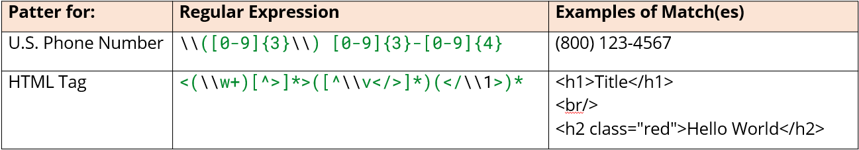

### Regular Expression

Regular Expressions are big time-savers! You don’t have to write a lot of looping and parsing code. You can use a regular expression to do this work with just a couple of lines of code.

There are really good reasons to use regular expressions:

* Verify something is formatted correctly.
* Find occurrences of patterns in text.
* Replace matching occurrences of patterns in text.
* Extract matching occurrences from text.
* Split text by a pattern.

### Ways to Use Regular Expressions in Java

There are classes with methods that take regular expression strings or patterns as parameters. A few of these are:

String, Scanner, Formatter, DateTimeFormatter, Duration

There are also special classes in the java.util.regex package to help you implement your own functionality. This include:

Pattern, Matcher

**String’s Methods Which Use Regular Expressions**

They can all be used with a String literal that doesn’t have any of the special character sequences. They become very powerful, though, when you do pass regular expression patterns.

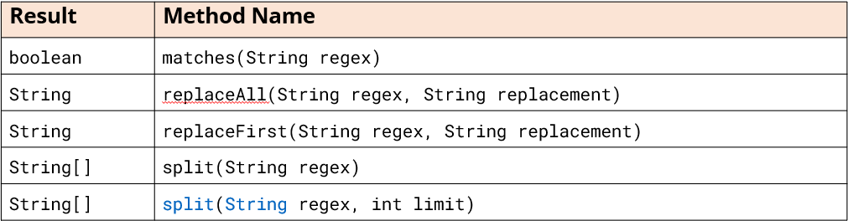

### The Parts of a Regular Expression

A regular expression can be made up of combinations of the following:

* **Literals** – these have no additional meaning and are a one-to-one match. If you specify the literal “abc”, the code will match on the first occurrence of “abc” in your String.
* **Character Classes –** some of these are predefined, others you can define yourself. The period or dot is an example of a predefined character class.
* **Quantifiers** – these metacharacters identify the number of occurrences of a character class or literal required to make a match. We used an asterisk, but there are several others that will be reviewed shortly.
* **Boundary Matchers** **or Anchors** – these specify the position in the text. For example, at the start of the text, in the middle, or the end.
* **Groups** – these identify and allow for the capturing of subexpressions.

The table below displays some common metacharacters that fall into the above categories:

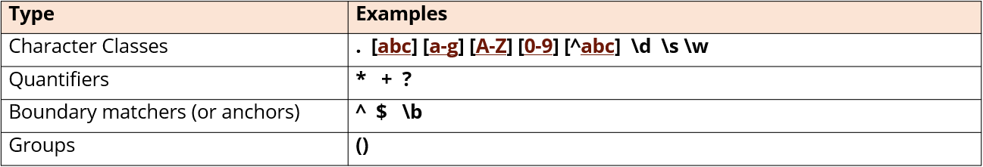

The following link provides additional examples and more looking at Java’s Pattern Class API – [click here](https://docs.oracle.com/en/java/javase/17/docs/api/java.base/java/util/regex/Pattern.html).

**Character Classes Defined with Square Brackets**

Characters in square brackets may have a different meaning. Any character except ^,-,] or \ is a *literal*, when it’s in the **square brackets**.

As an example, a dot in square brackets will represent a literal period, and not a meta character to match any character.



### Quantifiers

There are six different quantifiers you can use in your regular expressions.

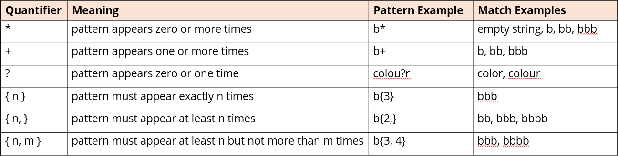

### Boundary Matchers

There are three common boundary matchers or anchors.

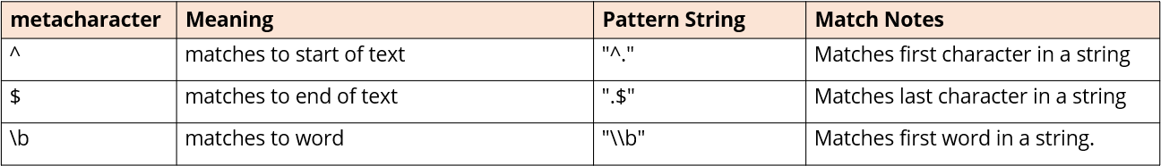

### What Does it Mean to Compile a Regular Expression?

The string containing the expression is passed to the compile method of a Pattern class which returns a Pattern instance. This string, the regular expression, is said to be *compiled into a Pattern* by Java’s regular expression processor.

This compilation process consists of:

* Checking the string for syntactical correctness.
* Building an internal representation – a decision tree made up of nodes and boolean decision points derived from the various parts of the regular expression.
* Optimizing the pattern by simplifying the expression and eliminating redundancies. This process increases the efficiency of matching the expression to character sequences.

### Advantages of the Pattern Instance

Compiling regular expressions into Pattern objects can result in improved performance and code efficiency on subsequent matching. The compiled pattern can be reused across multiple matching operations, saving computational resources and reducing processing time.

### Matcher Class Advantages

In addition to matching on the entire input, Matcher offers two other operations for *partial matching*. These methods are **lookingAt** and overloaded versions of the **find** method.

Matcher supports *capturing groups* and access to the text within the group. Matcher can be reused for multiple match operations on different String inputs, meaning the pattern doesn’t have to be recompiled.

### Matcher Class Disadvantages

An instance of a Matcher class has state, which changes as operations are performed on it. This means the Matcher class is *not thread safe*. It also means state may need to be reset before a new String is evaluated.

### Greedy and Reluctant Regular Expressions

*Greedy* regular expressions match as many characters as possible. The expression .*, which is a greedy expression, matches any number of characters, including the empty string.

*Reluctant* regular expressions on the other hand match as few characters as possible from the input text.

The regular expression .*? matches any number of characters, but stops at the earliest successful point where the overall pattern is matched. The default type of regular expression is greedy. ? can be used to be a quantifier modifier, making the regular expression reluctant.

### Matcher’s Matching Methods

All return a boolean if the regular expression was matched in some way to the string.

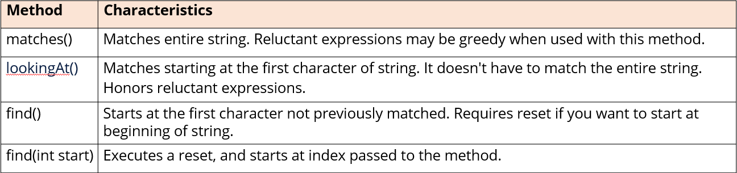

### Grouping and Capturing

*Grouping* is a way to identify targeted parts of a regular expression match, often because you want to do some additional processing on that subexpression. A group is enclosed in parentheses. A match to a group is said to be *captured*, meaning the text is stored for additional usage later.

*Capturing* is a way to access the matched groups, called capturing groups, of a regular expression match. Backreferences in some regular expressions are numeric references to captured groups. There are also named back references.

The Matcher class has methods that let us use both numeric and named references to access the captured groups.

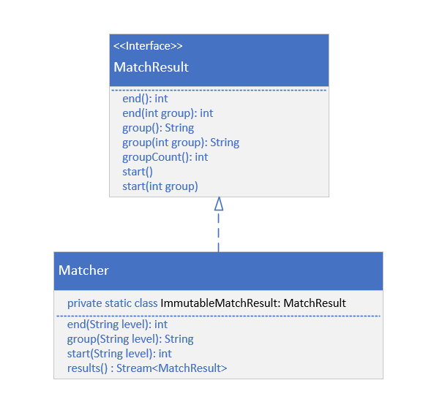

### Matcher and MatchResult

The Matcher class implements MatchResult, which has the end, group, and start methods. Matcher, though, supports the overloaded versions of these methods, which allow you to retrieve a capturing group by its name.

When the results method is called, you’ll get a stream of instances, types that also implement MatchResult.

This class is declared on Matcher as a static nested class.

The actual class is less important. It is more important to know that the methods are available to be used that are declared on MatchResult.

### Back References

You can use back references to refer to the text captured by these groups in regular expressions and also in the methods on Matcher. In a regular expression, a *back reference* is identified by a backslash and a number, which is the capturing group index.

In a replacement string in Java, though, a back reference starts with a $, then a number, and again, the grouping index. You can also use capturing group names in back references.

**Regular Expressions**

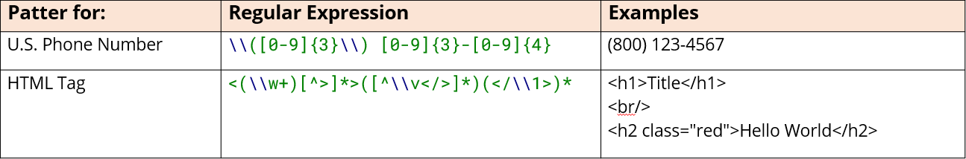

**Understanding the Phone Number Regular Expression**



This pattern starts with two backslashes before an open parentheses. Remember, the parentheses are used in regular expresssions as a meta character, identifying groups in most cases. In this case, though, we want a literal opening parentheses because we want to match a parentheses character in the string, so it needs to escape in this way.

Next is using a character class that defines a range, in this case digits 0-9, and with 3 in curly brackets as a quantifier to only get three of them. This is followed by a closing parentheses and again needs to escape since it is a literal.

After the closing parentheses is a literal space followed by a character class in square brackets for the full range of digits (0-9 again), with the quantifier 3 in curly brackets, a hyphen/dash, then the same thing with 4 as the quantifier after that.

The dash doesn’t need to be escaped in Java.



Another way of writing the phone number regular expression, but this time with the character class including an asterisk quantifier that will match either a closing parentheses or a space, zero or many times.

**Alternate Character Classes**

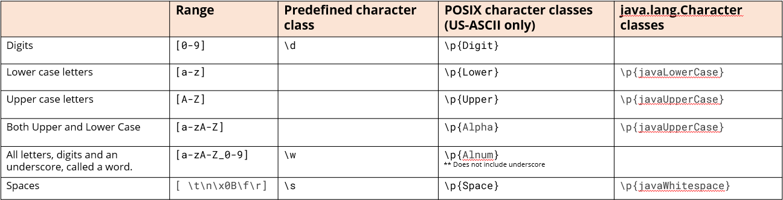

The table above shows some common ranges and some alternatives that mean the same or similar things.

The zero through 9 rance can be replaced with either a backslash d or backslash p and Digit spelled out in curly brackets.

The range with lowercase letters a-z can be substituted with backslash p and Lower spelled out in curly brackets.

If you need to support unicode characters, you can use the java.lang.Characters classes. There are similar predefined classes for upper case letters, and there is a combined class for US-ASCII alphabetical letters.

Words are described by letters, digits, and the underscore, as shown by the range. Whitespace, as defined by backslash s, will match a literal space, a tab, a new line, carriage returns, etc.

### Understanding the HTML Tag Regular Expression



This expression starts with an angle bracket. An angle bracket is a metacharacter when used if you’re naming your group, but the regular expression processor is smart enough to check context, so here it doesn’t need to be escaped. This means this regular expression will start matching when it fines the opening angle bracket of a tag.

Next, there’s a group defined, which is automatically indexed as group 1. Remember, group 0 is the entire matching subsequence. In this case, there’s a double-backslash w+ in the parentheses. The backslash w meta character means it’s a word character. It’s followed by the plus quantifier, which means it will match at least one word character but could match more.

After this there is a character class in brackets that starts with a carat. A carat in square brackets means to ignore the characters that follow, so in this case, a closing angle bracket will stop the matching. This is followed by an asterisk, so any character that’s not a closing angle bracket is going to match.

After the asterisk is the closing bracket for the tag. This code will match tags that have no body as well as tags that have attributes.

Another group follows. This group’s purpose is to capture the text that’s contained between the opening and closing html tags. This once again contains a custom character class with a carat, so that any character that follows the carat will end the matching for this subsequence. These characters are new lines or charage returns, the opening and closing angle brackets, and the back slash character.

Line breaks or carriage returns are called vertical white space.

After this is the opening angle bracket, the backslash, and the closing bracket. This just means the code will match any character that is not one of these, and because it’s using the asterisk quantifier, it can be empty.

The final group is really only a group to use a quantifier for the entire set. This includes the opening angle bracket and a backslash. This is how most html tags end and then they’re followed by the tag label (p, h1, section, div, or whatever). This is using a back reference to the first group, which means the ending label needs to match the opening label.

The last group is also using a quantifier, meaning this could be omitted, for instance for the use of the xhtml formatted br tag that just includes a backslash before the closing bracket.

### Building a regular expression for email addresses:

Start with: “(.+)@(.+)”

“[\\p{Alnum}_.-]+)@(.+)”

“[\\w.-]+)@(\\w+\\.\\w{2,})”

“[\\w.-]+)@((\\w+\\.)+\\w{2,})”

“[\\w.-]+)@(([\\w-]+\\.)+[\\w-]{2,})”

## Section 20 – Input & Output (I/O) – Working with Files in Java

### Communicating Outside of the JVM Using Resources

Resources can be files, network connecitons, database connections, streams, or sockets. We use these resources to interact with file systems, networks, and databases to exchange information.

**Exception Handling**

When you’re dealing with external resources, exception handling becomes much more important.

### What Really Happens When You Open a File From a Java Application?

When one of Java’s file access classes is instantiated, Java will delegate to the operating system to open a file from the OS File System. This then performs some or all of the following steps:

* First, it checks if the file exists.
* If the file exists, it next checks if the user or process has the proper permissions for the type of access being requested.
* If this is true, then file metadata is retrieved and a file descriptor is allocated. This descriptor is a handle to the opened file.
* An entry is made in the file table or file control block table of the operating system to track the opened file.
* The file may be locked
* The file may be buffered by the OS, meaning memory is allocated to cache all or part of the file contents to optimize read and write operations.

### Closing an Open File Resource

Many of the methods in Java make opening a file look just like instantiating another object. You don’t have to call open on a file, so it’s easy to forget that you’ve really opened a resource.

Closing the file handle will free up the memory used to store any file related data and allow other processes to access the file. Fortunately, most of the Java classes you’ll use to interact with files also implement AutoCloseable interface, which makes closing resources seamless.

**IO, NIO, NIO.2**

Java has what seems like a very confusing and large series of classes in many packages to support input/output.

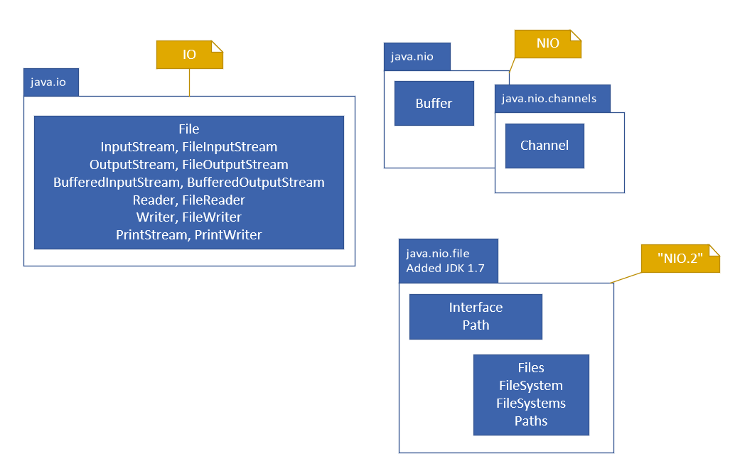IO was a term for input/output and java.io is a package that contains the original set of types which support reading and writing data from external resources.

NIO was introduced as *Non-blocking IO* with the java.nio package in Java 1.4 as well as a few other related packages. The communication with resources is facilitated through specific types of Channels, and the data is stored in containers called *Buffers* when exchanged.

NIO.2 stands for *New IO* and is a term that came into being with Java 1.7 emphasizing significant improvements to the java.nio package, most importantly the java.nio.file package and its types.

### IOException

The IOException is a special kind of exception called a *Checked Exception*. It’s the parent class of many common exceptions you’ll encounter when working with external resources.

**Checked Exception**

A *checked exception* represents an anticipated or common problem that might occur. You can imagine that a typo in the file name might be a common occurrence and the system wouldn’t’ be able to locate the file. It’s so common that Java usually has a named exception just for that situation – the FileNotFoundException, which is a subclass of IOException.

*A Checked Exception must be caught or specified in the containing method’s throws clause.*

How do you handle a checked exception? You have two options:

* You can wrap the statement that throws a checked exception in a try-catch block and then handle the situation in the catch block.
* Of, alternatively, you can change the method signature declaring a throws clause and specifying this exception type.

**LBYL or EAFP?**

*LBYL* stands for “Look Before You Leap”. This style of coding involves checking for errors before you perform an operation.

*EAFP* stands for “Easier to Ask for Forgiveness than Permission”. This assumes an operation will usually succeed and then handles any errors that occur if they do.

**Which is Better, LBYL or EAFP?**

Like all questions about software, the answer is – that depends.

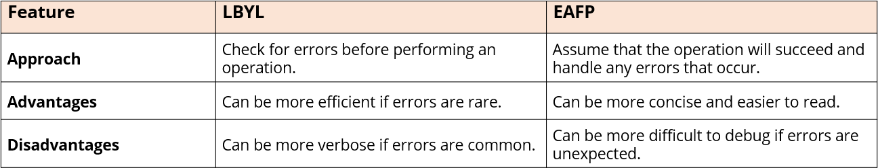

**How Do You Recognize a Checked Exception?**

When you’re coding with an IDE, it’s pretty easy to recognize one because your code won’t compile if one is thrown from code you’re calling.

A checked exception means it is NOT an *unchecked exception.*

An **Unchecked Exception** is an instance of a **RuntimeException** or one of its subclasses. More information on the RuntimeException is available in its API documentation via the link [here](https://docs.oracle.com/en/java/javase/17/docs/api/java.base/java/lang/RuntimeException.html).

### The finally Clause

A finally clause is used in conjunction with a try statement. A traditional try statement requires either a catch or a finally clause, or can included both. The finally clause is always declared after the catch block is declared.

The finally block’s code is always executed, regardless of what happens in the try or catch blocks. The finally block does not have access to either the try or catch block’s local variables.

#### What is the Purpose of the finally Clause?

The original purpose for the finally clause was to have a single block of code to perform cleanup operations. This included closing open connections, releasing locks, or freeing up resources.

This clause ensured that this code was executed, both during normal completion as well as in the event of an exception.

The *try with resources* syntax introduced in JDK7 is a better approach than using the finally clause for closing resources.

The finally clause can be used to execute other important tasks such as logging or updating the user interface.

**Disadvantages of Using the finally Clause**

* It can be difficult to read and understand code that uses this clause.
* It can be used to hide errors, which can make debugging more difficult.
* If you execute code that’s not related to cleanup tasks, this will make it harder to maintain your code.

### Comparing try-with-resources To The Traditional try Clause

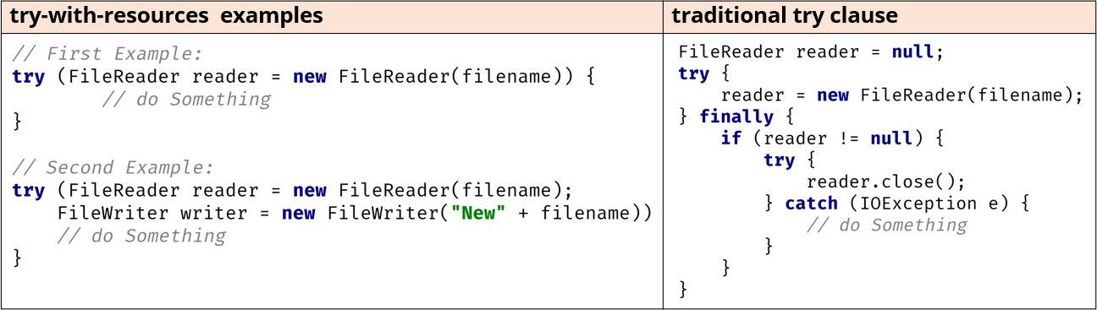

The try-with-resources takes a *colon delimited list* of resource variables. The resources in this list must implement the AutoCloseable or the Closeable interface.

The try-with-resources statement can be used without a finally block because all resources are automatically closed when this type of try block completes or if it gets an exception.

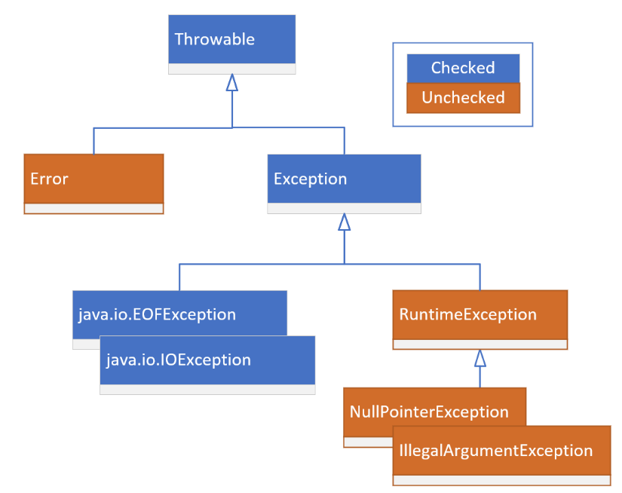

### Throwable

The chart to the right shows which classes are Checked (in blue) and Unchecked (reddish-brown).

The *Error* class indicates serious problems that a reasonable application shouldn’t try to catch or recover from. As mentioned previously, there are two types of Exceptions – those that subclass from RuntimeException and those that don’t.

This hierarchy becomes important for the second variation of a catch clause.

### Legacy (io)

The File class and the FileReader class have been a part of Java since version 1. The FileReader class implements the AutoCloseable interface through its parent class, Reader. This class opens a file resource implicitly.

In contrast, when you create an instance of a File, you aren’t actually opening that file. Instead, you’re working with something called a file handler that lets you perform OS-like operations.

### File Handle vs. File Resource

A file handle is a reference to a file that is used by the operating system to keep track of the file. It is an abstract representation of the file, and it does not contain any of the actual data from the file.

A file resource on the other hand is the actual data from the file. It is stored on the disk and it can be accessed by the operating system and by applications.

### File System Concepts

* A **directory** (or folder) is a file system container for other directories or files.
* A **path** is a directory or a filename and may include information about the parent directories or folders.
* A **root directory** is the top-level directory in a file system.
* The **current working directory** is the directory that the current process is working in or running from.
* An **absolute path** includes the root by either starting with / or optionally C:\ in Windows where C is the root identifier.
* A **relative path** defines a path relative to the current working directory, and therefore would not start with /, but may optionally start with dot (.) then a file separator character.

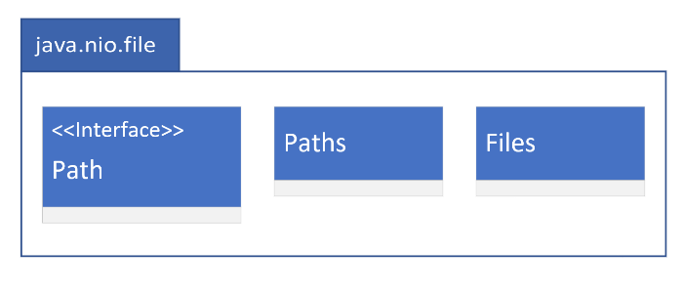

### Updated (jdk7, nio2)

Path is an interface and not a class like the File class was.

The Paths class consists exclusively of static methods that return a Path instance.

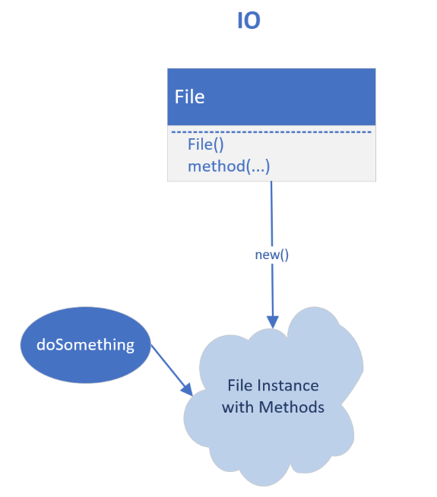The Files class on the other hand, has many static methods that perform operations on files and directories.

### IO – Using File

When you use the File class, you get an instance with a File constructor, and then you execute a method on that instance. Here, behavior is a member of the instance itself.

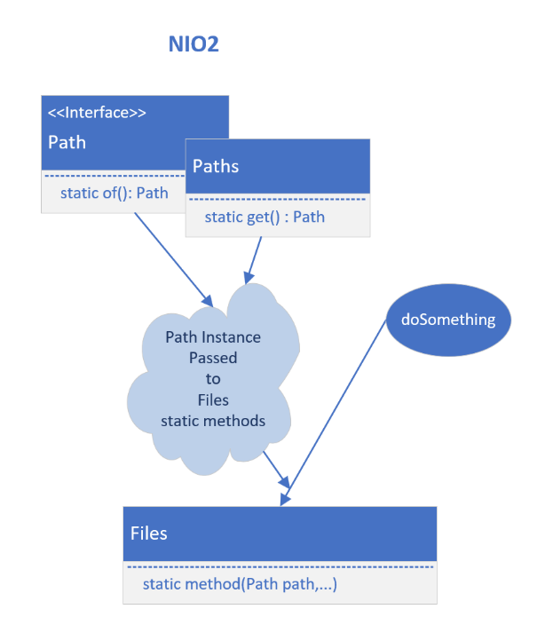

### NIO2 – Using Files and Path (Instead of File)

In order to use the NIO2 types to do something, an instance of Path is needed. Factory methods on the Path class or the Paths class are used to do this. After that, the static method on the Files class is called to do something on the path instance passed as an argument.

### Functionality in Common

The table below shows quite a bit of the functionality one would expect from a File System and the methods that would be used for each of these classes: 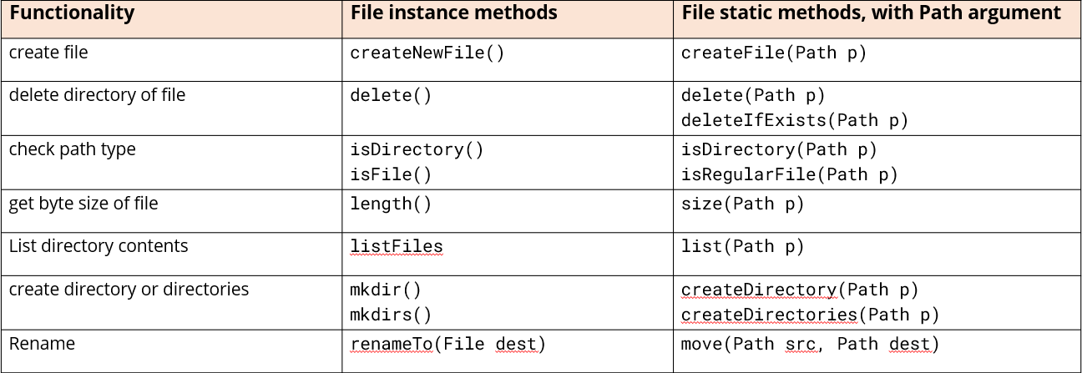

### NIO2 File Operations

**NIO2 File Operations Have Been Improved**

The NIO2 types include support for:

* Asynchronous file I/O operations.
* File locking, including more granular locking. This means instead of locking the entire file, a region of it can be locked.
* File metadata retrieval.
* Symbolic link manipulation.
* File system notifications. This means changes occurring on a path can be made watchable to registered services.

**NIO2 File Operations Are Better Performant**

NIO2 types are non-blocking, meaning asynchronous access to resources by multiple threads is supported. They manage memory more efficiently, reading and writing files directly to and from memory into buffers through something called a FileChannel.

You can also read from or write to multiple buffers from a single operation

**Basic Attributes and the Type Returned (as an Object)**

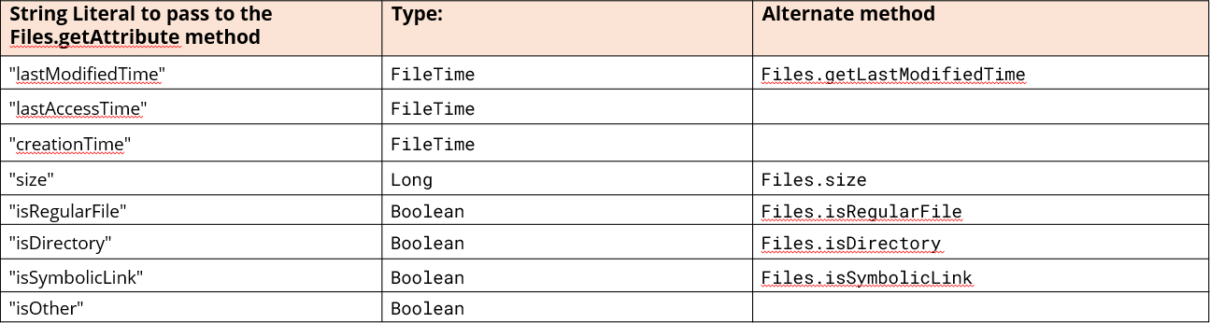

The Files.getAttribute method returns this data as an Object, which means you may have to cast it.

In addition to the getAttributes and getAttribute methods, you can get a couple of these fields by specifically named methods on the Files class, also shown in the third column.

**Globbing Patterns for File Matching**

A glob is limited pattern language that resembles regular expressions but with simpler syntax. More information for these can be seen via the following link: [click here](https://docs.oracle.com/en/java/javase/17/docs/api/java.base/java/nio/file/FileSystem.html#getPathMatcher(java.lang.String)).

### Walking the File Tree

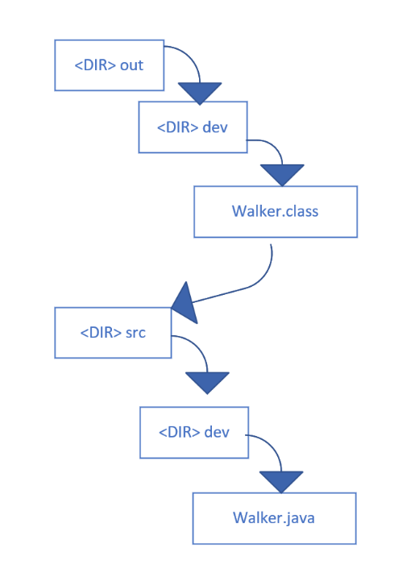

This method walks the file tree, depth first (as does the walk method).

*Depth First* means the code will recursively visit all the child elements before visiting any of a folder’s siblings.

The alternative is *breadth first*, which means any dependent nodes are walked after the sibling nodes.

#### Why is This Important?

Because it is depth first, the Files.walkFileTree() method provides a mechanism to accumulate information about all the children up to the parent.

Java provides entry points in the walk to execute operations through a FileVisitor interface. This stubs out methods that can be implemented at certain events in a file walk.

These events are:

* Before visiting a directory.
* After visiting a directory.
* When visiting a file.
* A failure to visit a file.

#### FileVisitor Interface and the SimpleFileVisitor

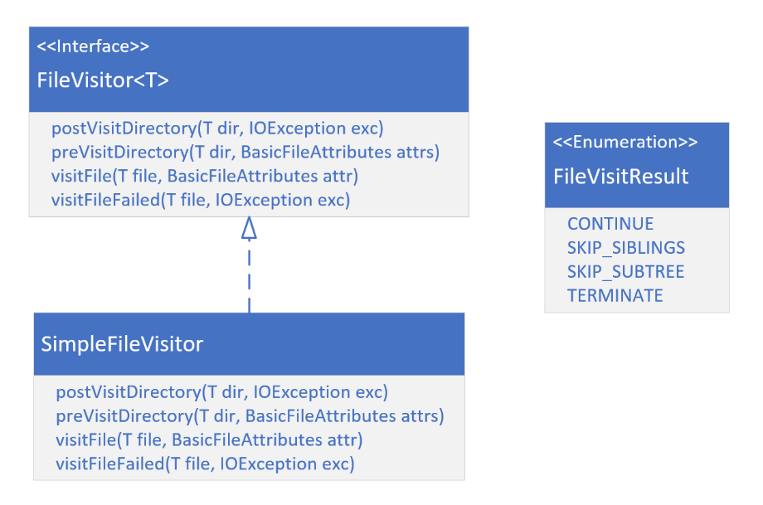A simple class diagram fo the FileVisitor Interface and its simplest default implementation, SimpleFileVisitor is included to the right.

It can be seen from these method signatures that in most cases we would have access to the current path, either a directory or a file.

The return type is not included, which for all of these methods is the same – an enum value, as shown on the FileVisitResult enum.

In addition, there is access to basic attributes on both the visitFile and preVisitDirectory methods.

#### IO – The Old School Way

To understand how that magical little method works, let’s roll back the clock a little bit and look at the methods offered in Java 1.0. These methods mirrored a bit how data is really read from a file vs. a black box method called *readAllLines*.

### Disk Read

A *disk read* means something is physically, or mechanically, occurring on the hard disk to read that character from the file. This is expensive, and Java provides ways to reduce the number of disk reads being done.

#### What’s a File Buffer?

A *file buffer* is just computer memory temporarily used to hold data while it’s being read from a file. Its primary purpose is to improve the efficiency of data transfer and processing.

It reduces the number of direct interactions, or disk reads, against the actual storage device.

#### Input Streams

An *InputStream* is an abstract class, representing an input stream of bytes. It represents a source of adata and a common interface for reading that data.

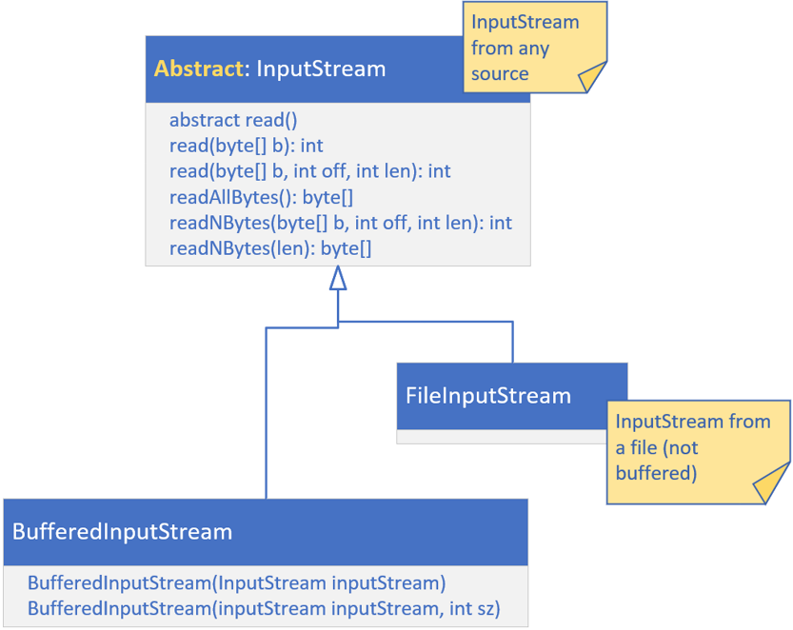Input Streams can return a byte stream or a character stream.

For files, the implementation is the *FileInputStream*. This class is used for files containing binary data. Using the read method on a FileInputStream is very inefficient, so if you’re going to use a FileInputStream, you’ll want to wrap it in a BufferedInputStream.

#### An InputStream Is Not a Source for a Stream Pipeline

We’ve talked a lot about streams before this, but an input stream is not that kind of stream.

It’s a similar concept, in that we get a stream of data in some kind of sequential way. However, an InputStream can’t be used in a Stream pipeline without first transforming it.

#### A diagram of a computer Description automatically generated with medium confidenceReaders

*Readers* read **characters** as can be seen from the methods on the abstract parent shown in the diagram to the left. An InputStreamReader is a bridge from byte streams to character streams.

If you want to read a character stream, it’s recommended you use a FileReader. FileReader is doing buffered Reading.

A BufferedReader will also do buffered reading, using a much larger buffer size than the FileReader. You can modify the size of the buffer on BufferedReader.

The default buffer size is large enough for most purposes. The BufferedReader also provides convenience methods for reading lines of text.

#### Character Set

A character set is a defined collection of symbols, letters, numbers, punctuation marks, and other characters. Each character in the set is assigned a unique numerical code called a code point, which allows computers to store, transmit, and interpret text. Two of the most common character sets are ASCII and Unicode.

ASCII stands for the American Standard Code for Information Interchange. It’s the oldest and most widely used character set. Unicode is a newer character set designed to support all of the world’s writing systems.

#### Character Encodings

Character encoding is the process of assigning numbers to various characters called glyphs. A glyph can be an alphabetical character in any language, punctuation, or emojis, for example.

There are differen ways to represent glyphs with a numeric value.

ASCII Encodings

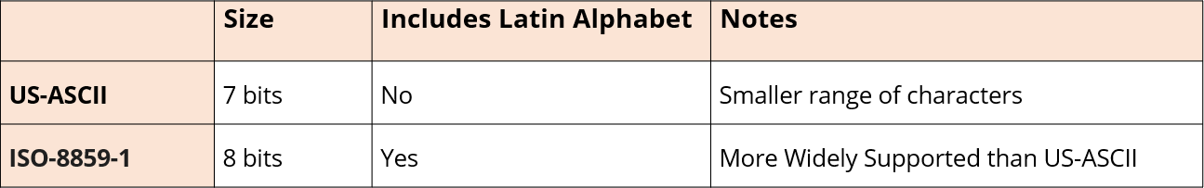

Unicode Encodings

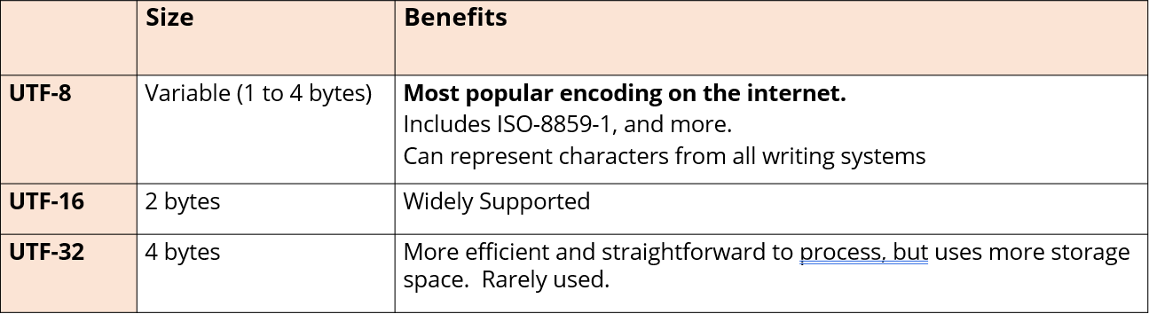

**Which Should You Use?**

In general, UTF-8 is the better choice for most applications. It’s more efficient, more widely supported, and can represent a wider range of characters.

However, if you’re only working with ASCII characters, ISO-8859-1 may be a better choice for efficiency reasons. Java has the most common encodings specified on an enum called StandardCharsets.

Documentation on StandardCharsets can be found at this link: [click here](https://docs.oracle.com/en/java/javase/17/docs/api/java.base/java/nio/charset/StandardCharsets.html)

**Support on Files for Reading Data From a File**

All of these methods read the entire contents of a file into memory. These methods support files up to about 2 gigabytes.

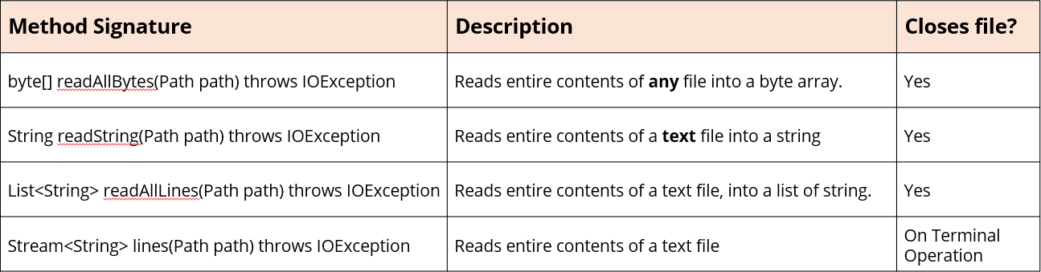

### Writing Data to a File

There are a lot of reasons why you might want to write data to a file.

These include:

* Storing user data.
* Logging application events to a log file.
* Storing configuration data.
* Exporting Data for Exchange of Information.
* Supporting Offline Usage in a File Cache.
* Generating file products.

#### Is Writing to a File so Different than Reading to It?

Some of the concepts of writing to a file are naturally similar to those of reading from a file.

You’ll use similar named classes, but instead of InputStream, you’ll work with an OutputStream, for example. There’s a FileWriter class rather than a FileReader class, and so on.

Understanding buffered data becomes more important, as well as managing multiple writes to a single file from different threads. There are different ways to open a file for writing.

#### Default Open Options

All available options are found on an enum in the java.nio.file package called StandardOpenOption.

The default options for Files.write methods are shown in this table:

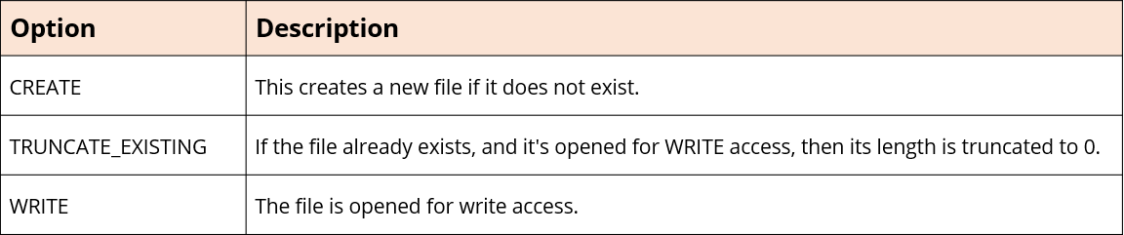

#### JSON

JSON stands for JavaScript Object Notation, and it’s a pretty popular, lightweight data interchange format. Link for more information can be found [here](https://www.w3schools.com/js/js_json_intro.asp).

**Writing to Files Challenge**

Start with the Student Engagement code from the previous videos. First generate 1000 students, then output each student record as a JSON record. To do this, you can:

* Use the Write or WriteString methods on Files.
* Or try FileWriter, PrintWriter, or BufferedWriter, or a combination of these.

The text should be printed as a list of students. The entire set of student records should be contained in square backets. Each student record should be enclosed in curly braces and separated by commas.

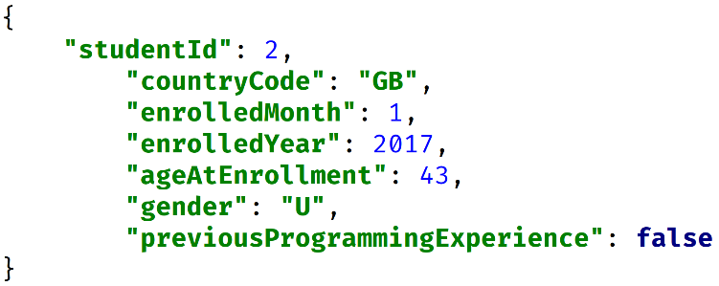

At a minimum, print the student id and some demographics data. The graphic to the right demonstrates a flattened structure with key value pairs that are all children of the student record. Keys are enclosed in quotes, as are values that are text based, with colons separating the keys and the values.

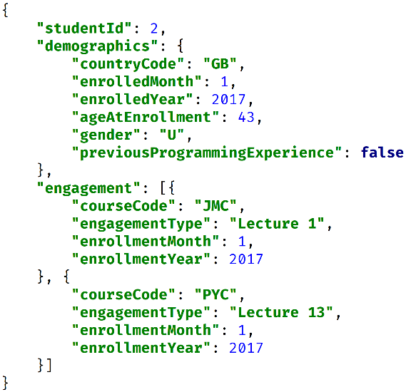The graphic here shows a more hierarchical structure for a single student, showing the demographics followed by the course engagements.

The demographics key has a value that’s an object and not a simple string, and that’s enclosed in curly brackets.

The engagement key’s values is also an array containing separate engagement records.

**Hints From Course**

You might want to explore the use of IntelliJ’s template functionality to create your own JSON string template. Link for information can be found [here](https://www.jetbrains.com/help/idea/2022.3/generating-code.html#customize-templates).

Don’t forget about the StringJoiner class that lets you define a delimiter as well as a prefix and suffix. Start by testing 2 or 3 students.

#### Linter

A *linter* is a software development tool that will analyze source code for potential errors and styling issues.

Popular linter: <https://jsonlint.com/>

**File and Directory Management**

So much of what we might want to do with files and directories is renaming, copying, moving, and deleting them. Occasionally, we might also want to make a global search and replacement on the contents of an existing file.

### The RandomAccessFile

There’s another way to access data from a file, and this is with a **RandomAccessFile**. This class provides the ability to directly access and modify data at any specific location within the file. A random access file behaves like a large array of bytes stored in the file system.

There’s a kind of cursor, or index, into the implied array called the *file pointer*. A RandomAccessFile both reads and writes binary data, using special methods which keep track of how many bytes will be read or written.

This class can be used for both read and write operations.

#### The RandomAccessFile File Pointer

When you open a RandomAccessFile, it’s file pointer is at 0, or the start of the file. To move the file pointer, you execute a method on the file called seek, passing it a long value, the position in the file file you wish to go to.

To get the file pointer, you execute **getFilePointer**.

Depending on the type of read or write method you’re using, the file pointer will move a certain number of bytes when these operations complete. There are a lot of these methods, and they can be found by looking in the Java API documentation for this class’s methods.

#### Why Would You Use This?

Let’s say you have a file with many millions of records, and you really need to access about 50 of those at any one time. Instead of loading a million records into memory, you can load a simple array or small map, which will tell you how to locate records of interest in the big file.

You wouldn’t want to start reading from the beginning of the file and read 10 million records, checking each one to see if it’s a match. The RandomAccessFile lets you fast forward or backward to a position in a file using the seek method.

From this position, you can read in only the data that matters for your application. To do this, though, you need to understand how many records are in your file, what its record length is, and how you want to identify each record to retrieve them.

#### Understanding the Random Access File’s Index

A RandomAccessFile needs an index, which houses a file pointer position, to each record of interest. This index could be implied for a file with fixed width records if you only need to get data by a row number, for example.

This means it’s very easy to do a little math to get the 10 thousandth record when all the records are 250 characters in length. 10,000 * 250 will point you to the 10,000th record in your file.

It’s much more common, though, to retrieve records by a non-sequential id, than a row id. For this, you’ll need an index that will contain this id and the position in the file of the record associated with that id.

For fixed width records, your index wouldn’t need the file pointer position, just an association between the row id and the record id. This index might be an array of record IDs, for example, in row id sequence.

In the table below, you can see that record id 10000 is the first record in the file, so it’s at index 0. The highlighted rows on this table represent the indexed data needed to locate the records by record id.

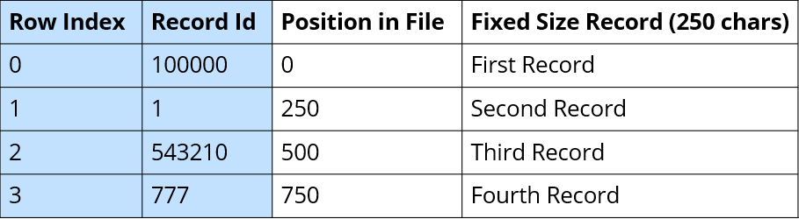

For variable length records, the row id alone isn’t enough information to calculate the file pointer. You could store the length of each record, or you could just store the starting file pointer position. It’s more common to do the latter.

Again, the indexed information is represented by the highlighted data, shown in the table below. The index should store the record id and its associated file pointer.

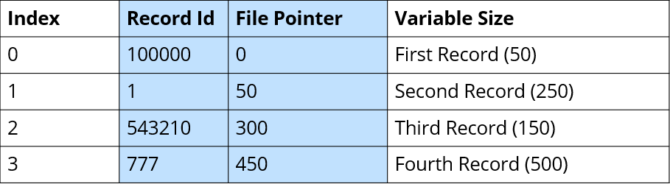

#### Where’s the Index?

In the case of a fixed width file, an index may not exist. If it does, then it will be in the same place as an index for a variable width file.

This may be at the beginning of the data file, before the record data. It may be at the end of the data file, so after all the record data. Or the indexed data may be in a separate file all together.

#### The .dat File, With an Index

The graphic to the right represents what the file will look like once it’s been completely generated. However, we will not be creating the file in top down order.

Step 1 will consist of writing the records to the output file at the file pointer position shown by the arrow. We’ll be keeping track of the file position of each record with a map as we write out each of the records.

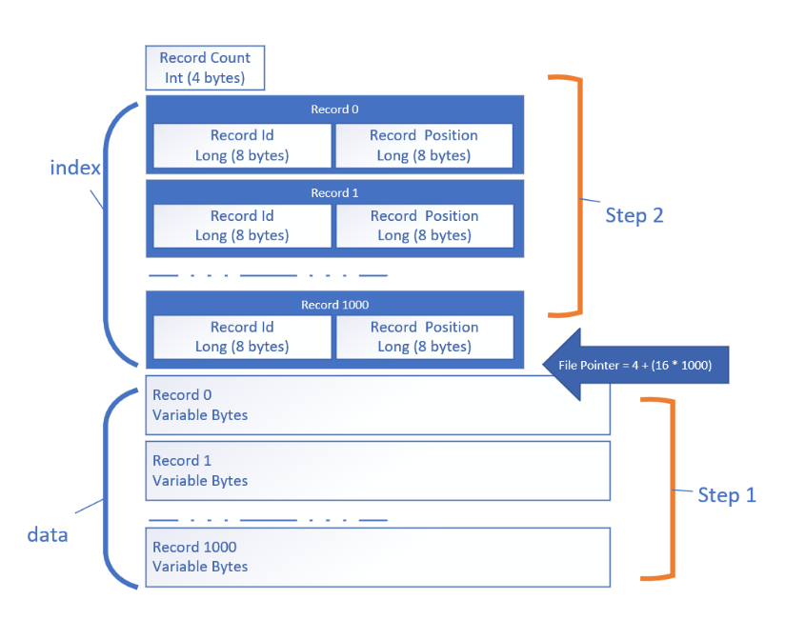

Once all the records are inserted and the index map is complete, we’ll write the total number of records at position 0.

Then, at Step 2, we’ll start outputting each index key value pair.

Using a random access file allows us to start writing records in step 1 before inserting the index, and we can also moe to the position we want to write to. We can derive the position to start by calculating that we’ll use 4 bytes to store the record count which will be output as an integer.

Then we’ll have 16 bytes for each indexed entry because each long takes up 8 bytes. We can multiply that by the number of records, so 1000*16, then plus 4, will be the file pointer position to start writing the records.

### DataOutputStream

A DataOutputStream lets an application write primitive Java data types to an output stream in a portable way. An application can then use a DataInputStream to read the data back in.

#### Serialization

The process of translating a data structure or object into a format that can be stored on a file is called *serialization*. Only instances of Serializable classes can be serialized, meaning the class must implement the Serializable interface. This interface doesn’t have any methods, it’s just used to mark the class as serializable.

All subtypes of a serializable class are themselves also serializable.

We can have our class implement the Serializable interface, and then use readObject and writeObject with Object streams, and it all works. Well, that’s part of the truth.

#### Deserialization or Reconstituting an Object

The default serialization mechanism writes the class of the object, the class signature, and the values of non-static fields. These elements are used to restore the object and its state during the read operation.

This process is called reconstituting the data, or deserialization.

#### serialVersionUID

Ther *serialVersionUID* field is a runtime field that the compiler will implicitly create, if it’s not explicitly declared, for classes that are serialized. It’s based on class details such as the number of fields, their types, and declarations.

When we read an object from a stream, the runtime checks the stored serialVersionUID. If they don’t match, then there’s a compatibility problem and the runtime will throw this invalid class exception.

**Versions May Be Incompatible Between JVMs**

In addition, it’s possible that different compliers will generate this implied field differently. To ensure this doesn’t happen, it is *strongly recommended* that you include this as a private static field, as shown below:



What Constitutes an Incompatible Change?

* Changing the declared type of a primitive field.
* Deleting fields.
* Changing a non-static field to static, or a non-transient field to transient.

There are other more complicated changes, such as moving a class within its hierarchy, changing the writeObject and readObject methods after you’ve used them to serialize previously, and a few others.

For the full documentation on incompatible changes, click on the link [here](https://docs.oracle.com/en/java/javase/17/docs/specs/serialization/version.html#incompatible-changes).

What constitutes a Compatible Change?

The good news is that not all changes made to a class are going to invalidate the serialization process. Some changes are compatible changes:

* Adding fields.
* Adding writeObject and readObject methods.
* Changing the access to a field.
* Changing a field from static to nonstatic, or transient.

The documentation for all compatible changes can be found [here](https://docs.oracle.com/en/java/javase/17/docs/specs/serialization/version.html#compatible-changes).

#### The Transient Modifier

The transient modifier is used to indicate that a field should not be serialized. This can be useful for variables that contain sensitive information, or just variables that don’t need to be persisted for other reasons.

## Section 21 – Concurrency

### Introduction to Concurrency and Threads

**Process** is a unit of execution that has its own memory space. The terms process and application are often used interchangeably.

### Process Memory Space = Heap

Each application has its own memory space, also known as the *heap*. The heap isn’t shared between two applications or two processes. They each have their own.

#### A Thread

A *thread* is a single unit of execution within a process. **Each process can have multiple threads**.

Every application has at least one thread, and that’s the main thread. The course code will run on the main thread. Code can also run in other threads, which can be explicitly created and started.

#### Threads Share Process Memory

Creating a thread doesn’t require as many resources as creating a process does. Every thread created by a process shares that process’s memory space – the heap.

This can cause big problems with your applications.

#### Threads Also Have Stack Memory

Each thread’s got what’s called a thread stack. This is memory that only a single thread has access to. Every Java application runs as a single process, and ecah process can then have multiple threads within it.

Each process has a heap, and every thread has a thread stack.

#### Why Use Multiple Threads?

One of the most common reasons is to offload long running tasks. Instead of tying up the main thread, we can create additional threads to execute tasks that might take a long time. This frees up the main thread so that it can continue working and executing, and being responsive to the user.

You also might use multiple threads to process large amounts of data, which can improve performance of data intensive operations.

A web server is another use case for many threads, allowing multiple connections and requests to be handled simultaneously.

### Concurrency

*Concurrency* refers to an application doing more than one thing at a time.

Concurrency allows different parts of a program to make progress independently, often leading to better resource utilization and improved performance.

One task doesn’t have to complete before another one can start, and multiple threads can make incremental progress.

### Java’s Threads

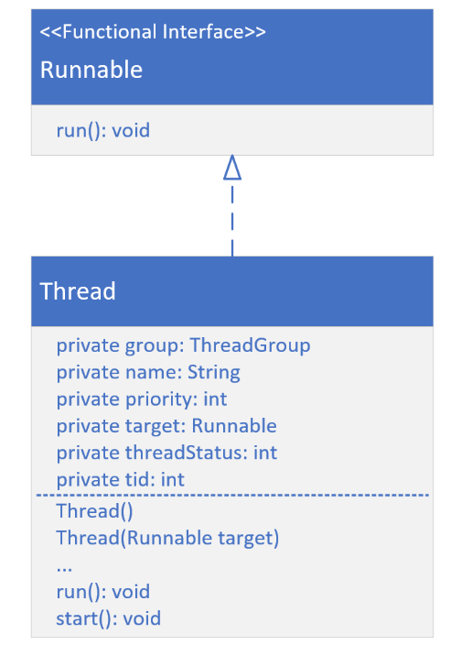Threads are the fundamental building blocks to support concurrency in a Java application.

They’re essential because they allow us to perform multiple tasks simultaneously within a single process.

#### The java.util.Thread Class

You can see that this class implements the Runnable interface, which has a single abstract method, the run method. Each instance of a thread has some state.

The fields displayed to the right are all encapsulated and this includes thread group, a name, a priority, a status, and a thread id.

A thread can be constructed with no arguments. It can also be constructed by passing a Runnable instance to it.

The first method is the run method, which has to be overridden since it’s declared abstract on the Runnable interface.

#### Thread Priority

Thread priority is a value from 1 to 10. The Thread class has three predevined priorities included as constants.

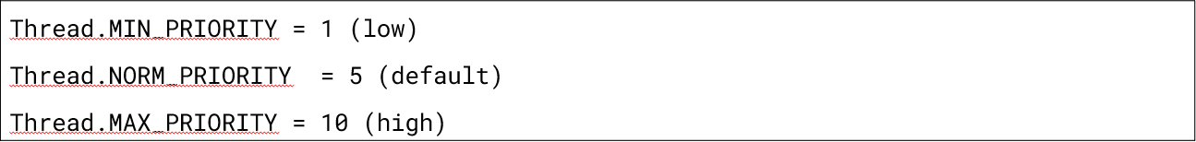

Higher-priority threads have a better chance of being scheduled over the lower-priority threads by a thread scheduler. However, priority behavior can vary across different operating systems and JVM implementations.

You can think of this priority as more of a suggestion to the thread management process.

#### Creating a Thread Instance

* Extend the Thread class and create an instance of this new subclass.
* Create a new instance of Thread and pass it any instance that implements the Runnable interface. This includes passing a lambda expression.
* Use an Executor to create one or more threads for you.

**The Difference Between Executing Run and Start on a Thread**

There’s a big difference between calling run() and start() on a thread.

If you execute the *run* method, it’s executed synchronously by the running thread it’s invoked from. If you want your code to be run asynchronously, you must call the *start* method.

### The Native Modifier On a Method

The *native* modifier indicates that this method’s source code isn’t written in Java. It’s written in another language, such as C or C++.

The code in this example is part of a native library such as a dll file.

**Why Use a Native Library?**

The reasons to do this include:

* To access system-level functionality that’s platform-specific.
* To interface with hardware.
* To optimize performance for tasks that might be computationally-intensive.

**Runnable is a Functional Interface**

It’s important to recognize that Runnable is a functional interface.

Its functional method, or its single access method, is the run method. Anywhere you see a Runnable type, it’s a target for a lambda expression.

You can have any class implement the Runnable interface to run asynchronously.

### Extending the Thread Class

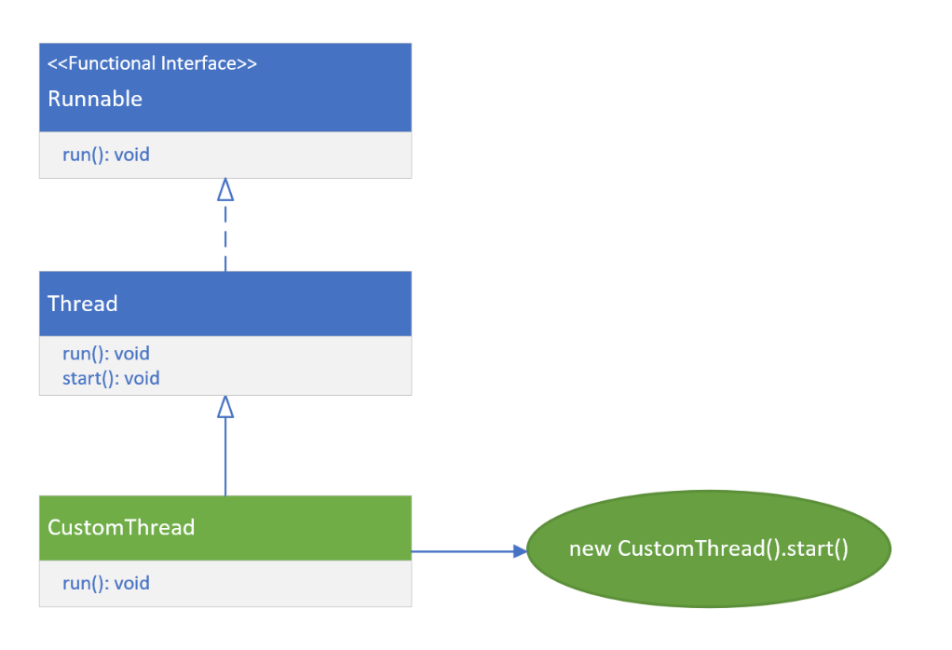The diagram to the right demonstrates extending the Thread class.

The new subclass overrides the Thread’s run method to provide the concurrent thread’s task.

To use this thread, you create a new instance of your subclass with no argument constructor, and execute the start method on that instance.

#### Advantages of Extending Thread

* You have more control over the thread’s behavior and properties.
* You can access the thread’s methods and fields directly from your subclass.
* You can create a new thread for each task.

#### Disadvantages of Extending Thread

* You can only extend one class in Java, so your subclass can’t extend any other classes.
* Your class is tightly coupled to the Thread class, which may make it difficult to maintain.

### Implementing Runnable

Besides extending the Thread class, you can create threads by implementing the Runnable interface.

This method allows any class to implement Runnable, meaning any class at all can be used in a thread.

This class is passed to the Thread constructor that accepts a Runnable.

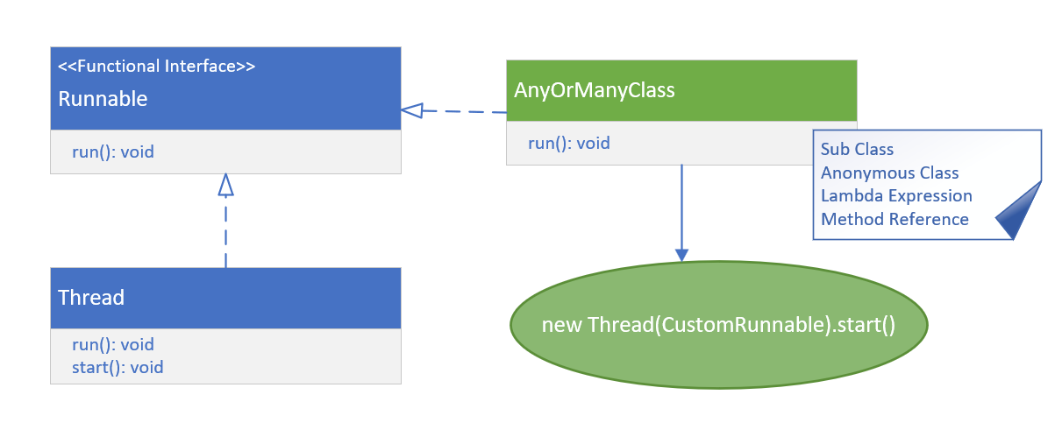

You can also pass an anonymous class, lambda expression, or a method reference to this constructor to create an instance of a Thread.

Again, call start on the new thread instance to execute the code asynchronously.

#### Advantages of Implementing a Runnable and Creating a Thread Instance With It

* You can extend any class and still implement Runnable.
* Your class (if you create a class) is loosely coupled to the Thread class, which makes it easier to maintain.
* You can use anonymous classes, lambda expressions, or method references, to very quickly describe thread behavior.

#### Disadvantages of Implementing a Runnable and Creating a Thread Instance With It

* You have less control over the thread’s behavior and properties – in other words, you can’t access the thread’s methods and fields directly from the run method.

### Thread States on Thread.State

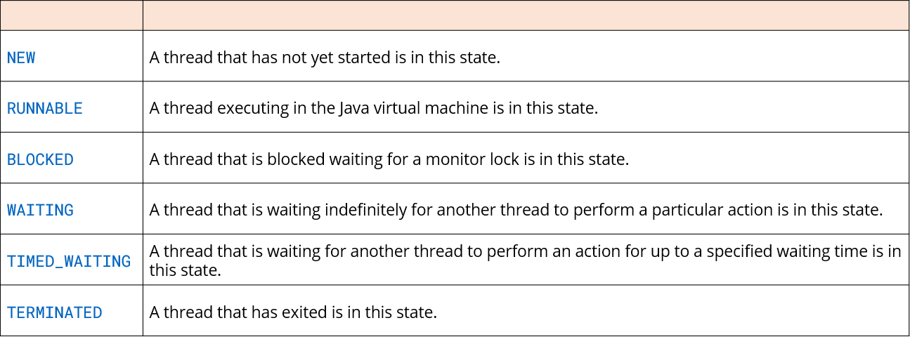

### Threads Accessing Memory

Each thread has its own stack for local variables and method calls. One thread doesn’t have access to another thread’s stack.

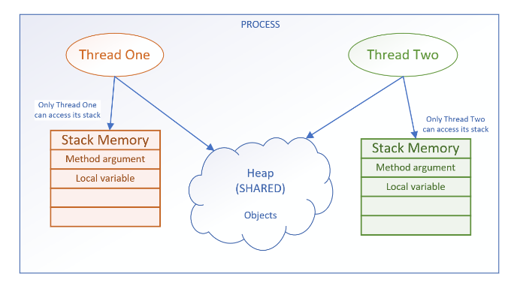

Every concurrent thread additionally has access to the process memory, or the heap. This is where objects and their data reside.

This shared memory space allows all threads to read and modify the same objects. When one thread changes an object on the heap, these changes are visible to other threads.

### Time Slicing

*Time slicing* is also known as time-sharing or time division. It’s a technique used in multitasking operating systems to allow multiple threads or processes to share a single CPU for execution.

Available CPU time is sliced into small time intervals, which are divvied out to the threads. Whether it completes its task or not in that time slice doesn’t matter to the thread management system.

When the time is up, it has to yield to another thread and wait until it’s its turn again. Unfortunately, when your threads are sharing heap memory, things can change during that wait.

### The Java Memory Model (JMM)

The Java Memory Model is a specification that defines some rules and behaviors for threads to help control and manage shared access to data and operations.

* **Atomicity of Operations** – Few operations are truly atomic.
* **Synchronization** – is the process of controlling threads’ access to shared resources.

#### Interference

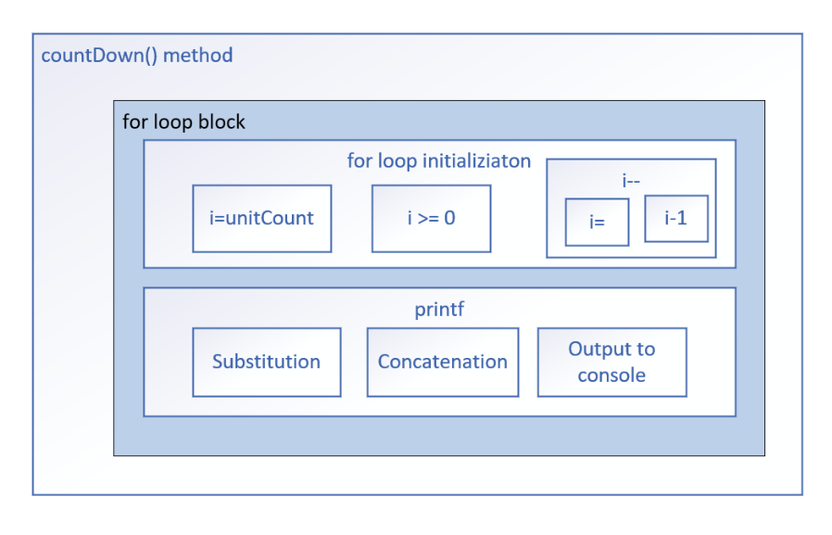The graphic to the right shows a conceptual picture of the countDown method.

Each box shown is in the diagram is a unit of work. Only the smalles blocks might be atomic.

A thread can be halfway through the work in any one of these blocks when its time slice expires, and it then has to pause or suspend execution to allow other threads to wake up and execute.

This means another active thread has an open door to that same unit of work where the paused thread is only partially done.

When threads start and pause in the same blocks as other threads, this is called *interleaving*.

#### Interleaving

When multiple threads run concurrently, their instructions can overlap or interleave in time. The execution of multiple threads happens in an arbitrary order.

The order in which the threads execute can’t be guaranteed.

### Atomic Actions

In programming, an atomic action is one that effectively happens **all at once**. An atomic action either happens completely or it doesn’t happen at all.

Side effects of an atomic action *are never visible until the action completes*.

#### Even The Simplest Operations May Not Be Atomic

Even decrements and Increments aren’t atomic, nor are all primitive assignments. For example, long and double assignments may not be atomic in all JVMs. Below are three examples of operations that may not be atomic.

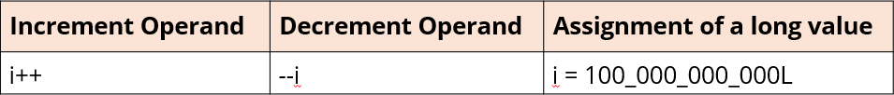

Even simple statements can translate to multiple non-atomic steps by the virtual machines.

#### Thread-Safe

An object or a block of code is thread safe, if it isn’t compromised by the execution of concurrent threads. This means the correctness and consistency of the program’s output or its visible state is unaffected by other threads.

Atomic operations and immutable objects are examples of thread-safe code.

### Memory Constency Errors

The operating system may read from heap variables and make a copy of the value in each thread’s own storage cache. Each thread has its own small and fast memory storage that holds its own copy of a shared resource’s value.

One thread can modify a shared variable, but this change might not be immediately reflected or visible. Instead, it’s first updated in the thread’s local cache.

The operating system may not flush the first thread’s changes to the heap until the thread has finished executing.

### Volatile

The *volatile* keyword is used as a modifier for class variables.

It’s an indicator that this variable’s value may be changed by multiple threads. This modifier ensures that the variable is always read from and written to the main memory, rather than from any thread-specific caches.

This provides memory consistency for this variable’s value across threads.

Volatile has limited usage, though.

#### When to Use Volatile

There are specific scenarios when you’ll want to use volatile.

* When a variable is used to track the state of a shared resource, such as a counter or a flag.
* When a variable is used to communicate between threads.

#### When NOT to Use Volatile

* When a variable is only used by a single thread.
* When a variable is used to store a large amount of data.

### Synchronization

#### Synchronized Methods

Different invocations of synchronized methods on the same object are guaranteed not to interleave.

When one thread is executing a synchronized method for an object, all other threads that invoke synchronized methods for the same object block and suspend their execution until the first thread is done with the object.

When a synchronized method exits, it ensures that the state of the object is visible to all threads.

#### Critical Section

The critical section is the code that’s referencing a shared resource like a variable. Only one thread at ta time should be able to execute a critical section.

When all critical sections are synchronized, the class is thread-safe.

#### The Object Instance Monitor

Every object instance in Java has a built-in intrinsic lock, also known as a monitor lock.

A thread acquires a lock by executing a synchronized method on the instance, or by using the instance as the parameter to a synchronized statement.

A thread releases a lock when it exits from a synchronized block or method, even if it throws an exception.

Only one thread at a time can acquire this lock, which prevents all other threads from accessing the instance’s state until the lock is released. All other threads which want access to the instance’s state through synchronized code will block and wait until they can acquire a lock.

#### The Synchronized Statement Can Be Applied to a More Granular Code Block

The synchronized statement is usually a better option in most circumstances since it limits the scope of synchronization to the critical section of the code. In other words, it give syou much more granular control over when you want other threads to block.

#### The Synchronized Statement Can Be Applied to a More Granular Object in State

The synchronized block can use a different object on which to acquire its lock. This means that code accessing this object instance wouldn’t have to block entirely.

#### Reentrant Synchronization

We said before that once a thread acquires a lock, all other threads will block which also require that lock. Because these method calls are executed from the *same thread*, any nested calls which try to acquire the lock won’t block because the current thread already has it.

This feature is called **Reentrant Synchronization**. Without this, threads could block indefinitely. This concept is built into the Java language, and it’s based on the monitor mechanism.

### Producer Consumer Application

This kind of application has a class that produces data, so the *Producer*. It also has a class that reads the data, or consumes it in some way. This is the *Consumer*.

#### Deadlock

In the graphic below, Thread A is our Consumer. It can usually get in to run the read method because the hasMessage flag is usually true.

If the flag is false, it will execute its while loop. It’s waiting on that hasMessage flag to change value to exit the loop.

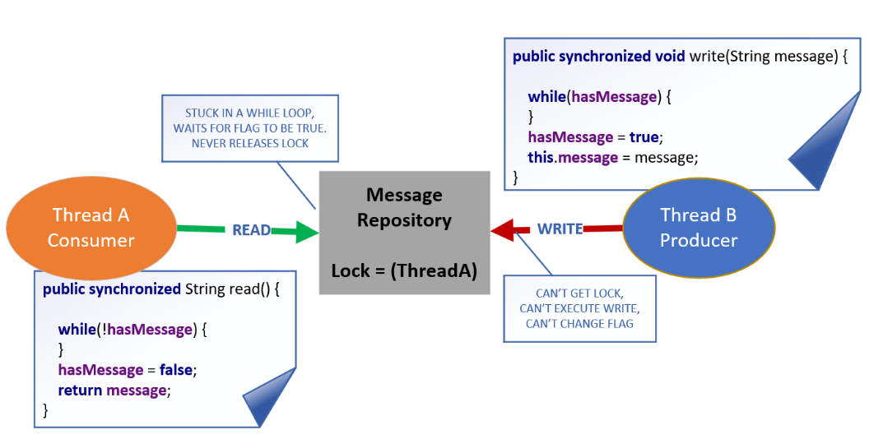

That flag is never going to change its value. Thread A has acquired a lock on the shared resource, in this case the Message Repository, and Thread B can’t get that lock.

Because Thread B is blocked, it can’t change the flag that would set the condition to let Thread A exit its while loop and release the lock.

The threads are stuck, one spinning indefinitely, the other blocked from doing anything.

This is a classic deadlock situation.

#### The Object’s Class’s wait, notify, and notifyAll Methods

The wait, notify, and notifyAll methods are used to manage some monitor lock situations to prevent threads from blocking indefinitely.

Because these methods are on Object, any instance of any class can execute these methods from within a synchronized method or statement.

#### The Purpose of a Lock

The purpose of a lock is to control access to a shared resource by multiple threads.

#### Limitations of the Monitor Lock

The monitor lock is pretty easy to use, but it does have limitations.

1. There’s no way to test if the intrinsic lock has already been acquired.
2. There’s no way to interrupt a blocked thread.
3. There’s not an easy way to debug or examine the intrinsic lock.
4. The intrinsic lock is an exclusive lock.

#### The java.util.concurrent.locks Package

JDK5 gave us the java.util.concurrent package. This provided developers with some additional solutions to prevent problems in a multi-threaded environment.

The Lock Interface and some of the provided implementations can give us a bit more control and flexibility over locking, and when and how to block threads.

#### Lock Hold Count

The hold count of a lock counts the number of times that a single thread, the owner of the lock, has acquired the lock.

* When a thread acquires a lock for the first time, the lock’s hold count is set to one.
* If a lock is re-entrant and a thread reacquires the same lock, the lock’s hold count will get incremented.
* When a thread releases a lock, the lock’s hold count is decremented.
* A lock is only released when its hold count becomes zero.

Because of this, it’s really important to include a call to the unlock method in a finally-clause of any code that will acquire a lock, even if it’s re-entrant.

#### Review of the Advantages of Using Lock Implementations

* **Explicit Control** – over when to acquire and release locks, making it easier to avoid deadlocks and manage other concurrency challenges.
* **Timeouts** – allow you to attemt to acquire a lock without blocking indefinitely.
* **Interrubtible Locking** – along with timeouts, lets you handle interruptions during acquisition more gracefully.
* **Improved Debugging** – methods let you query the number of waiting threads and check if a thread holds a lock.

### Managing Threads

These are the ExecutorService classes, and they exist to manage the creation and execution of threads.

#### Managing Individual Threads

When using a Thread class, you have rudimentary control over that thread. You can interrupt a thread and join it to another thread.

You can name the thread, try to prioritize it, and start each manually, one at a time. You can also pass it an UncaughtExceptionHandler to deal with exceptions that happen in a thread.

Managing threads manually can be complex and error-prone. It can lead to complex issues like resource contention, thread creation overhead, and scalability challenges. For these reasons, you’ll want to use an ExecutorService, even when working with a single thread.

#### Benefits of Managing Threads With an Implementation of ExecutorService

The ExecutorService type in Java is an interface. Java provides several implementations of this type which provide the following benefits:

* Simplify thread management by abstracting execution to the level of tasks which need to be run.
* Use Thread Pools, reducing the cost of creating new threads.
* Efficient Scaling by utilizing multiple processor cores.
* Built-in synchronization, reducing concurrency-related errors.
* Graceful Shutdown, preventing resource leaks.
* Scheduled implementations exist to further help with management workflows.

#### Advantages of Using an ExecutorService

The job of managing threads is simplified. ExecutorService implementations let you stay focused on tasks that need to be run rather than thread creation and management.

#### Creating Threads is Expensive

Creating threads, destroying threads, and then creating them again can be expensive.

A thread pool mitigates the cost by keeping a set of threads around in a pool for current and future work.

Threads, once they complete one task, can then be reassigned to another task without the expense of destroying that thread and creating a new one.

### Thread Pool

#### The Mechanics of a Thread Pool

A thread pool consists of three components.

* **Worker Threads** – are available in a pool to execute tasks. They’re pre-created and kept alive throughout the lifetime of the application.
* **Submitted Tasks** – are placed in a First-In First-Out queue. Threads pop tasks from the queue and execute them, so they’re executed in the order they’re submitted.
* **The Thread Pool Manager** – allocates tasks to threads and ensures proper thread synchronization.

#### Java’s Thread Pool Classes

Java has five variations of the Thread Pool.

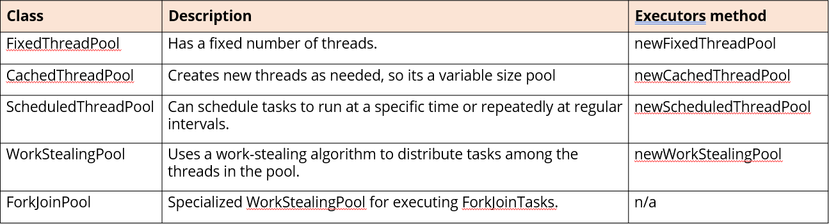

#### Difference Between Runnable and Callable

What’s the difference between Runnable and Callable?



Significantly, Callable returns a value. This means you can get data back from your running threads.

#### execute vs submit

The table below displays the method signatures for both the execute and submit methods:

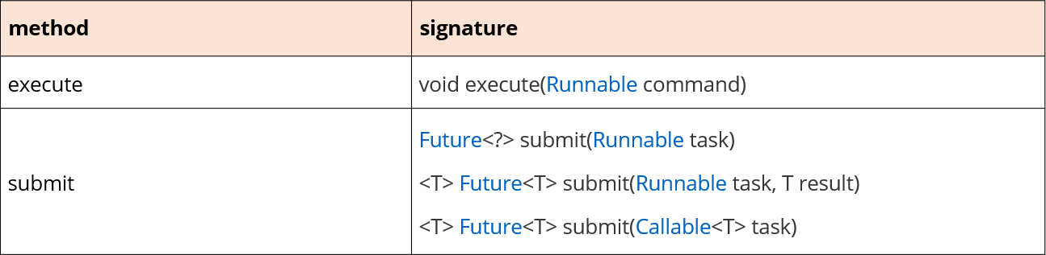

#### The Futrue Interface

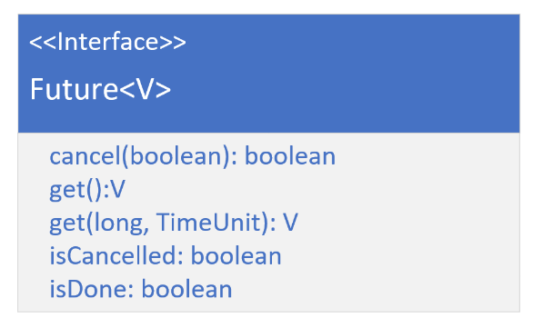A Future represents a result of an asynchronous computation. It’s a generic type – a placeholder for a result instance.

It has methods that cancel the task, retrieve the result, or check if the computation was completed or cancelled.

The get method returns the result, but you can only call this get method when the computation is complete, otherwise the call will block until it does complete. The overloaded version of the get method allows you to specify a wait time, rather than blocking.

#### invokeAll vs. invokeAny

When would you want to use invokeAny vs invokeAll?

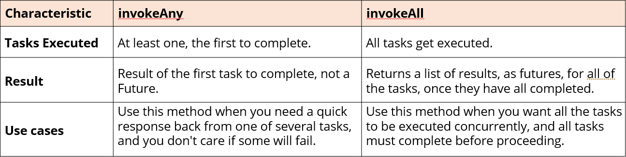

#### Scheduling Tasks

You schedule tasks with a special type of ExecutorService, the ScheduledExecutorService.

#### Work Stealing Thread Pool

The work stealing thread pool is used for parallelism and concurrent execution of tasks. Each worker thread has its own task queue.

When a worker thread finishes its own tasks and its queue is empty, it can “steal” tasks from the back of other worker threads’ queues. This helps to balance the workload among threads, reduces idle time, and optimizes resource usage.

#### The ForkJoinPool

The ForkJoinPool class is Java’s implementation of the Work Stealing Pool. It’s based on the fork-join, or divide and conquer, algorithm of computing.

This algorithm:

* Breaks down a complex task into smaller subtasks.
* Processes them independently and in parallel.
* Then combines the results to solve the original problem.

### Types of Parallelism

There are two main types of parallelism:

* **Task Parallelism** – divides a program into smaller tasks that get executed concurrently. Each task can run on a separate thread or processor core.
* **Data Parallelism** – processes different parts of the same data concurrently.

#### Parallel Streams

Parallel streams allow you to perform operations on collections in parallel, thus potentially speeding up data processing.

The key advantages of parallel processing are:

* Improved performance on multi-core CPUs.
* Simplified code for concurrent processing.
* Automatic workload distribution among available threads.

Why a Parallel Stream May Not Always Be Faster Than a Serial Stream

* Parallel streams introduce some overhead, such as the need to create and manage multiple threads. This overhead can be significant for small arrays.
* Parallel streams need to synchronize their operations to ensure that the results are correct. This synchronization can also add overhead, especially for small arrays.

It’s not always a straightforward decision, whether or not to use parallel operations.

#### Why the HashMap Isn’t Thread-Safe

The HashMap

* Lacks synchronization.
* There are no guarantees of memory consistency while iterating.

#### Map Classes

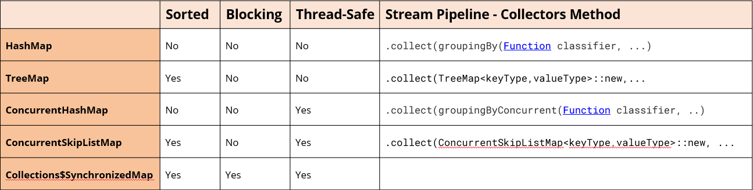

#### Concurrent Classes vs. Synchronized Wrapper Classes

Both concurrent and synchronized collections are thread-safe and can be used in parallel streams, or in a multi-threaded application.

* **Synchronized Collections** – are implemented using locks which protect the collection from concurrent access. This means a single lock is used to synchronize access to the entire map.
* **Concurrent Collections** – are more efficient than synchronized collections because they use techniques like fine-grained locking, or non-blocking, algorithms to enable safe concurrent access without the need for heavy handed locking, meaning synchronized or single access locks.

Concurrent collections are recommended over synchronized collections in most scenarios.

### Concurrent Collections

LinkedList and ArrayList, as well as TreeSet and HashSet, are also NOT thread-safe. Each of these can be used with a synchronized wrapper, which you can get from the Collections helper class.

The synchronized wrappers provide a thread-safe option for us with less impact on the design if we need to make existing code work concurrently. If starting with new code, though, it’s recommended to use concurrent collections.

#### Concurrent Collections for Arrays and Lists

For lists, there are two concurrent collection choices depending on the type of work which needs to be done in parallel.

* Use *ConcurrentLinkedQueue* when frequent insertions and removals, such as producer-consumer scenarios, or task scheduling are required.
* Use *CopyOnWriteArrayList* when a read-heavy workload with infrequent modifications is needed.. This type of list is useful for scenarios like configuration management or read-only views of data.

For an array, one of the concurrent list options above can be used. Otherwise, the following can be used:

* An *ArrayBlockingQueue* – is a fixed-size queue that blocks under two circumstances. The first is if you try to poll or remove an element from an empty queue. The second is if you try to offer or add an element to a full queue. This is designed as a First In-First Out, or FIFO, queue.

#### Adding an Element to the ArrayBlockingQueue

In the table below, the four methods that can be used to add an element to the ArrayBlockingQueue are displayed:

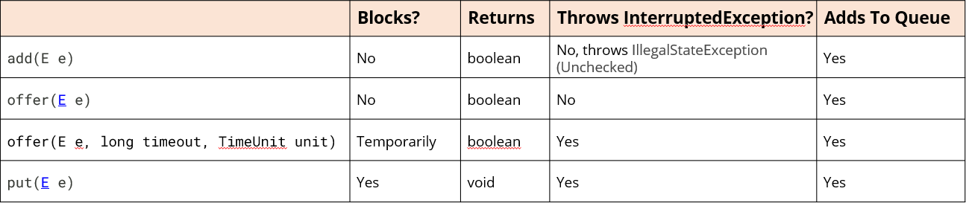

#### CopyOnWriteArrayList

The name “CopyOnWrite” is important. Whenever this list is modified by adding, updating, or removing elements, a new copy of the underlying array is created.

The modification is performed on the new copy, allowing concurrent read operations to use the original, unmodified array. This ensures that reader threads aren’t blocked by writers.

Since changes are made to a separate copy of the array, there aren’t any synchronization issues between the reading and writing threads. This is ordinarily too costly but may be more efficient than alternatives when traversal operations vastly outnumber mutations.

#### Removing Single Element From the ArrayBlockingQueue

The ArrayBlockingQueue has several different methods to get an element from the queue. Most of these will get the element at the head of the queue, or the first in.

If the queue is empty, a method will return null or block as described in the table below:

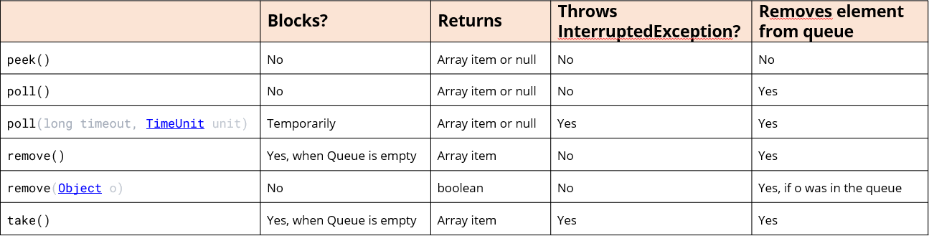

### Common Problems in Multi-Threaded Applications

#### Deadlock in the Consumer Producer Example



In an earlier example, a deadlock was demonstrated with the Consumer Producer sample code.

Both classes were accessing a single boolean field on a shared object in a while-loop with no code in it.

This situation was resolved by using the notifyAll and wait methods on object in both of these methods.

#### The Common Problems in a Multi-Threaded Application

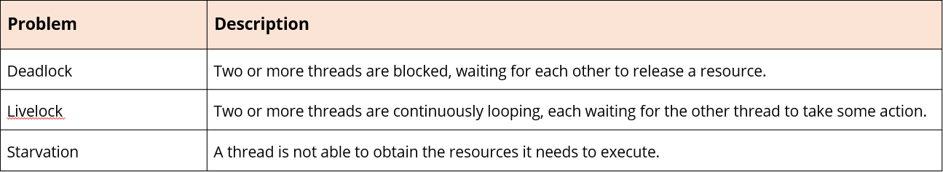

#### A Second Deadlock Scenario

When both threads need access to multiple resources in a certain order, this can cause contention and produce a deadlock.

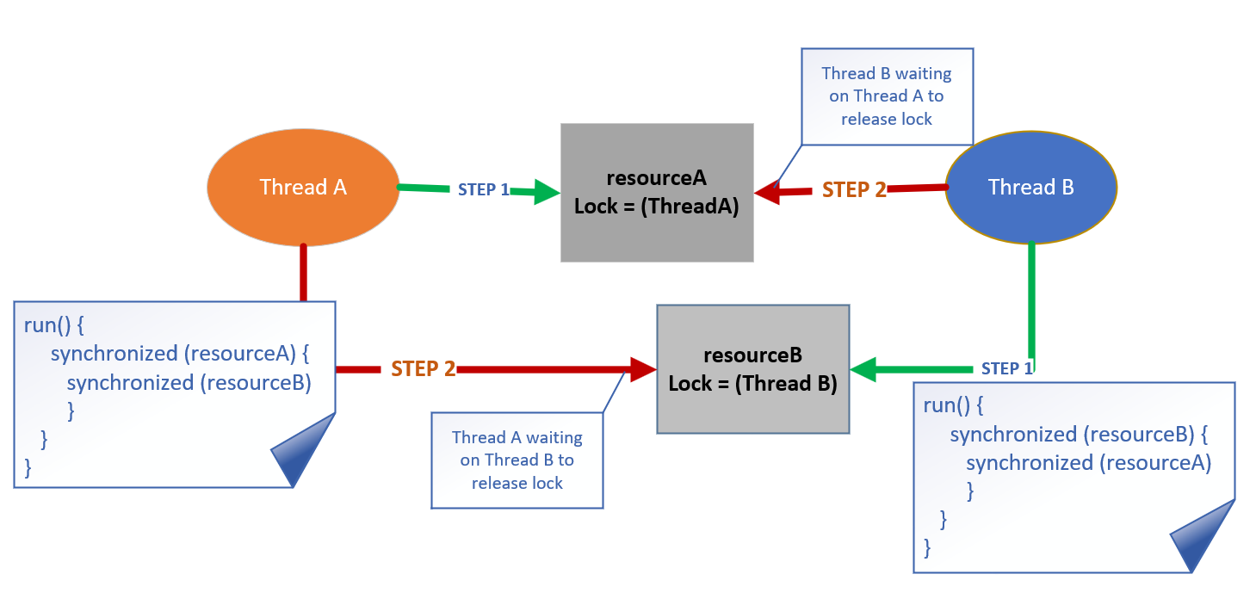

#### Preventing Deadlocks

A couple of common ways to avoid this kind of deadlock situation are listed below:

* Organize your locks into a hierarchy and ensure that all threads acquire locks in the same order to avoid circular waiting, which is a common cause of deadlocks. This approach helps establish a global lock order that all threads must follow.
* Instead of using traditional synchronized blocks or methods, you can use the tryLock method on the Lock interface. This method allows you to attempt to acquire a lock. If it fails, you can handle the situation without causing a deadlock.

#### Livelock

A *livelock* is when two or more threads are continuously reacting, each responding to the other’s actions. And, they can never successfully complete.

You can find different examples of this problem on the internet.

Livelocks can be difficult to debug and fix.

For this reason, there are a few general things you can do to avoid them:

* Avoid having threads that are constantly checking each other’s states.
* Use timeouts to prevent threads from waiting indefinitely for each other.
* Use randomization to break the symmetry between threads.

#### Simple ‘Maze’

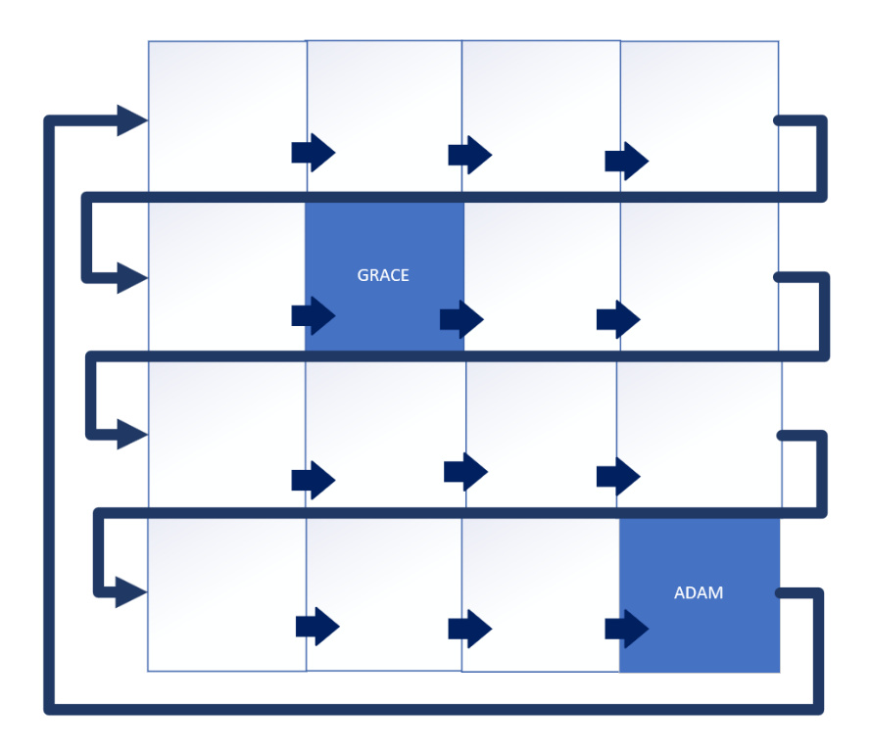As an example, a simple maze can be used to demonstrate how you and your friend in the escape room’s maze might be caught in a live lock scenario. It will be created as a 4 by 4 maze, and the paths are shown by the arrows in the diagram to the right.

There will be two people in the maze searching for each other. In the case of the graphic, Grace is at position (1 1), and Adam is at position (3 3).

If Adam moves to the next position, he will go to position (0 0), or the top left corner.

In the graphics below, the first grid shows the starting positions of both players. In the second grid, Adam has moved 4 places from his original position at (3 3), and each cell he searched so far, he hasn’t found Grace.

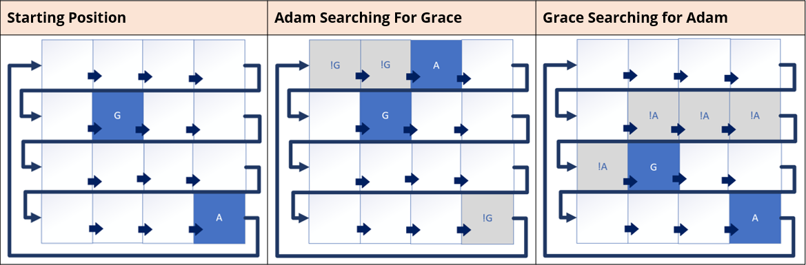

These are shown as gray cells and have not-G in them, meaning Grace wasn’t there. If Grace is searching, and Adam is standing still, then we have the third grid.



Grace started in position (1 1), and has moved to (2 1), and all the cells along her path are marked as not-A, because Adam wasn’t there.

**

This algorithm is only good if one player stays put.

#### Starvation

*Starvation* occurs when one thread is unable to obtain the resource is needs to execute. This is usually caused by other concurrent threads being greedy.

Some threads are able to make progress but others can’t. This mean’s your application may still continue running and some of the work is getting done, but not all of it.

#### Fair Locks

A *fair lock* guarantees that all threads waiting to acquire the lock will be given an equal chance of acquiring it. This is in contrast to an unfair lock, which doesn’t make any guarantees.

Remember, the monitor lock is unfair. A Reentrant lock can be fair or unfair.

#### How Fair Locks Work

When a thread requests access to a fair lock, it gets added to a FIFO queue. The lock is then granted to the thread at the head of the queue, or the first in.

#### Should You Use a Fair Lock?

Benefits:

* Fair locks can help to prevent thread starvation.
* They may improve the overall performance of a system by ensuring that all threads get a chance of accessing resources.
* They can make a system more predictable and easier to debug.

Drawbacks:

* Fair locks might have a negative impact on performance, especially in systems where threads are frequently competing for locks.
* Fair locks can be more difficult to implement.

### More Java Concurrency Features

#### java.util.concurrency.atomic

Another concurrency class package is java.util.concurrency.atomic.

A small toolkit of classes that support lock-free, thread-safe programming on single variables.

Why is lock-free so important?

These classes can significantly improve the performance of concurrent applications, especially high-throughput systems.

#### Atomic Classes

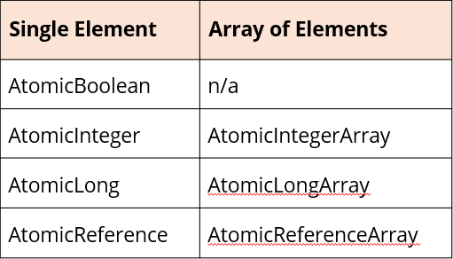The java.util.concurrent.atomic package has several atomic classes as shown in the table, including atomic arrays.

In each of these cases, an instance of one of these classes can be updated automatically.

Let me encourage you to review this toolkit if you’re working on concurrent applications.

#### WatchService Interface

The final type in the concurrency section is the WatchService. This is a special type of service which watches registered objects for changes and events.

For example, a file manager may use a watch service to monitor a directory for changes so that it can update its display of the list of files when files are created or deleted.

#### Use a Watch Service

A Watchable object is registered with a watch service. When events occur on the registered object, they’re queued on the watch service.

A consumer can retrieve and process the event information using the poll or take methods on the queue.

#### WatchKey States and Relationship

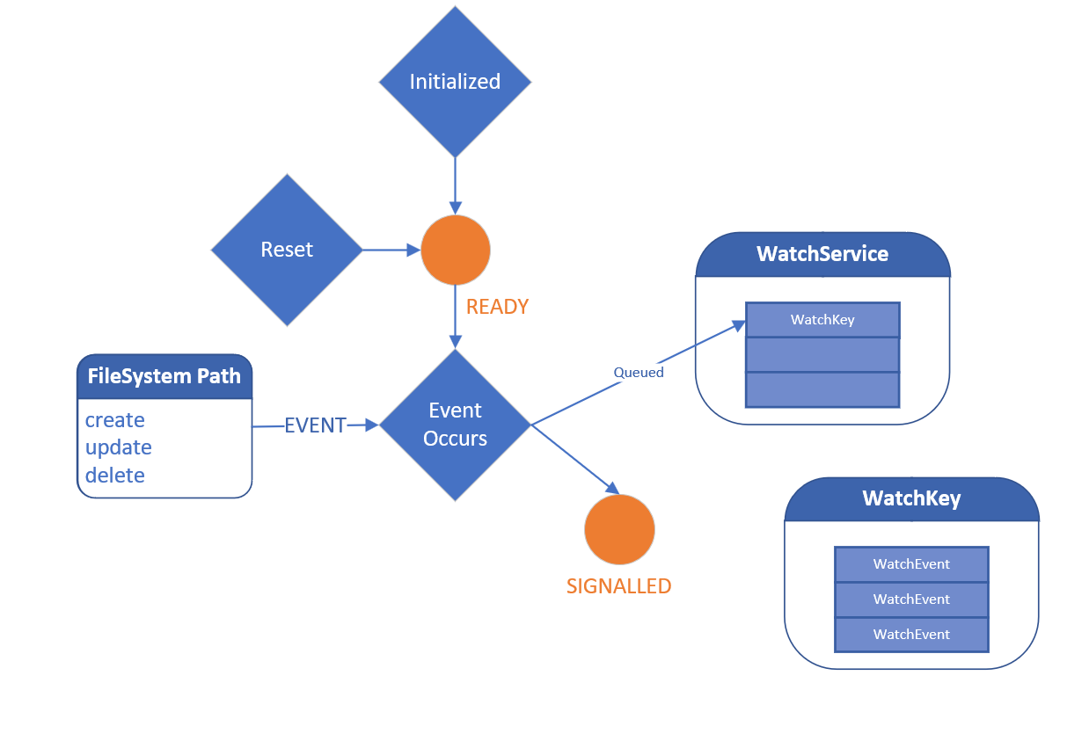When initially created, the WatchKey is said to be *ready*. When an event is detected, then the WatchKey is signalled, a special state which means it can be polled.

A WatchKey gets queued at this point on the WatchService so that it can be retrieved by invoking the watch service’s poll or take methods. Once signalled, a WatchKey remains in this state until its reset method is invoked.

When that happens, the WatchKey returns to the ready state.

Events that occur while the key is in the signalled state are added to the WatchKey. A WatchKey has a list of events that occurred while the WatchKey was in the signalled state.

Each WatchEvent object represents a specific change to the watchable object.

## Section 22 – Working with Databases

### Java and Databases

#### The Basics

This section will show how to connect to a database using a connection string and a special object called a Java Database Driver.

We’ll get information from the database through a database language called *Structured Query Language* or *SQL*.

We’ll learn how to execute SQL statements as strings against tables in the database using Java’s support and how to process the results we get back from these types of queries. In addition, we’ll cover executing parameterized statements using Java’s **PreparedStatement**, which allows SQL statements to be reusable, more flexible, and less prone to some well known security issues.

#### Additional Support

Many Database Management Systems support a built-in procedural language as well. This means there may be functions stored with the database that you can use to get data or perform some action, rather than actually writing SQL code to do it.

We’ll be going over how to make calls to these database stored procedures with Java’s **CallableStatement**.

Finally, we’ll examine different *object relational mapping*, or *ORM*, technologies used by popular Java frameworks to handle basic boiler plate interactions with databases.

#### Reason for Using MySQL

It’s free and downloaded from Oracle, and the installation isn’t too difficult.

It’s important to learn about CallableStatements, and for that we need a database that suports stored procedures.

MySQL is a popular industry standard

#### Database Popularity Surveys

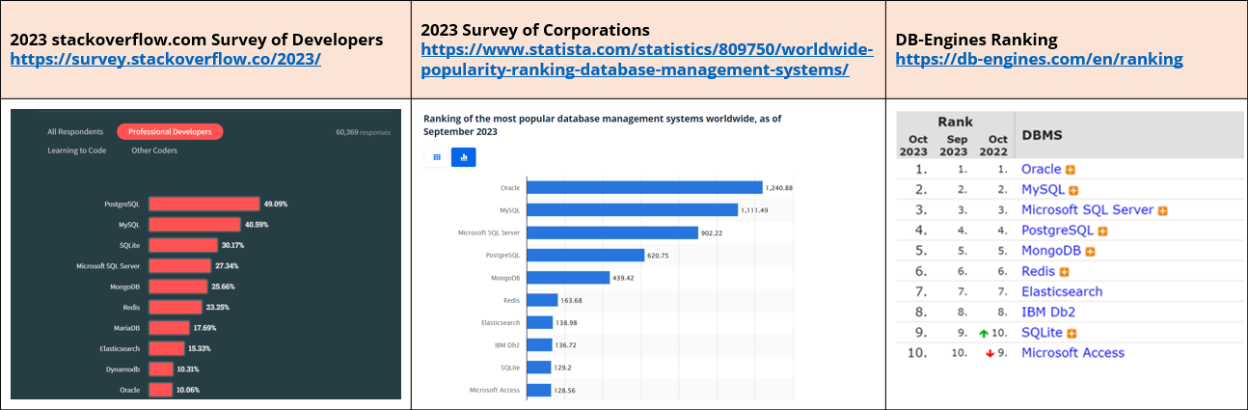

Links to surveys:

* 2023 stackoverflow.com Survey of Developers - <https://survey.stackoverflow.co/2023/>
* 2023 Survey of Corporations - <https://www.statista.com/statistics/809750/worldwide-popularity-ranking-database-management-systems/>
* DB-Engines Ranking - <https://db-engines.com/en/ranking>

### Schema

This section is for those who are new to databases and database terminology.

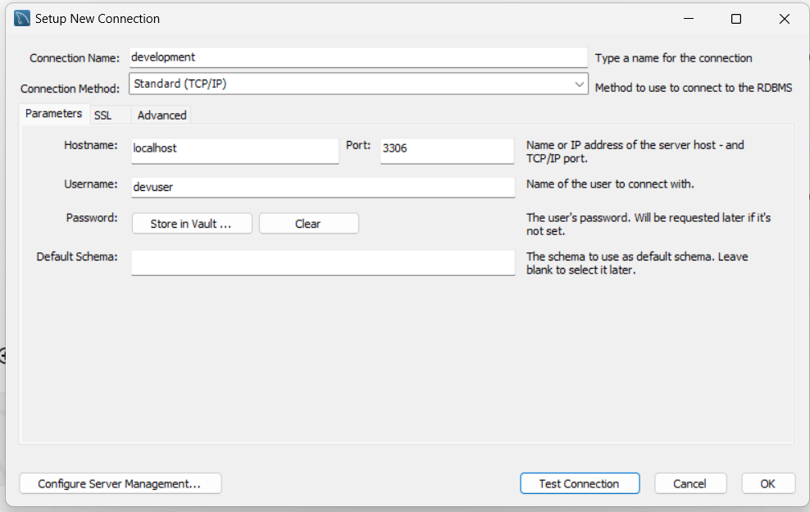

Here is a quick tour of a Relational Database Management System, or RDBMS, and the objects we’ll be working with in case these might be unfamiliar.

At the highest level, data is organized into a *schema*. This is used to group related database objects together.

A schema represents a logical grouping, or namespace, for database objects such as tables, views, and procedures.

#### Is a Database a Schema?

In some database systems like PostgreSQL and Oracle, the term “schema” is used to represent the namespace within a database where objects are organized. These systems can have multiple schemas within a single database.

In other database systems, like MySQL, the term schema is often used interchangeably with database. In MySQL, you typically create databases and refer to them as such, but the SQL Workbench refers to them as schemas.

#### Common Database Objects or Artifacts

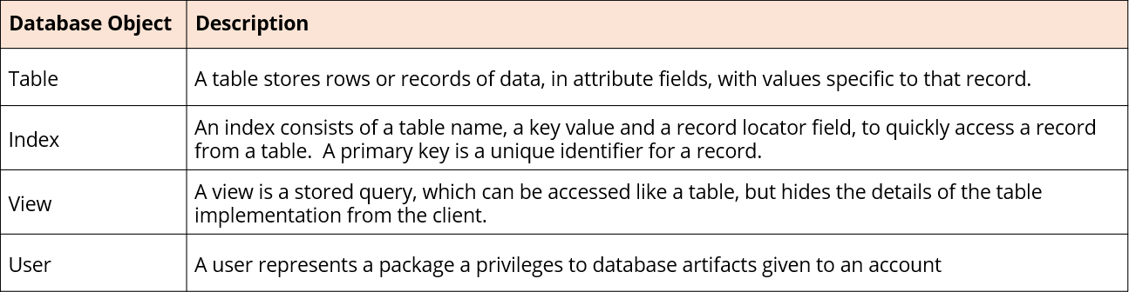

#### Structured Query Language (SQL)

Like any software, databases also have a language you need to learn to use to work with that software. In databases, the language lets us create objects, populate them with information, create relationships, and query data.

This language is called the Structured Query Language, or SQL. For relational Databases, the language has become standardized with ANSI SQL, although each database may still retain some of its own unique clauses or commands.

SQL is divided into two categories – Data Definition Language, or DDL, and Data Manipulation Language, or DML, which serve two very distinct purposes.

#### Data Definition Language (DDL)

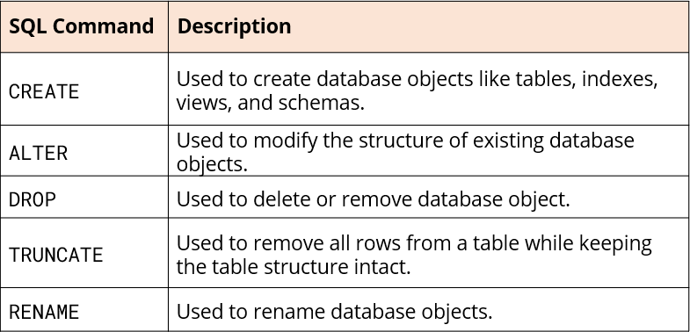The *Data Definition Language* is used to define, create, manage, and modify the **database objects**.

DDL statements don’t manipulate the data in the object. Instead, they manipulate data structures that store and organize the data.

Some of the most common DDL statements are shown on the table to the right.

#### Data Manipulation Language (DML)

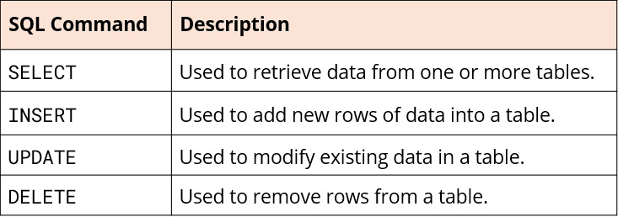The *Data Manipulation Language* is used to interact with and manipulate the **data** stored within the database objects or artifacts.

DML statements perform operations like inserting, updating, retrieving, and deleting data in the database.

Some of the most common DML statements are shown in the table to the right. These commands are often represented with another acronym that may be familiar – CRUD.

#### CRUD

This acronym is CRUD and it stands for:

**C**reate: This operation involves creating new records or entries in a database. This is equal to an INSERT command.

**R**ead: The read operation involves retrieving or querying data from a database. This is equal to a SELECT command.

**U**pdate: Updating refers to modifying existing data in a database. This is equal to an UPDATE command.

**D**elete: The delete operation involves removing records or data from a database. This is equal to a DELETE command.

CRUD represents the fundamental operations for managing data in a database system. Later we’ll cover different Java frameworks that will aim to simplify database interactions, making it easier to perform CRUD operations in Java projects.

#### Relational Database

Unlike a simple spreadsheet, data stored in an RDBMS can be stored in many different tables.

The tables can be associated with one another through different kinds of relationships.

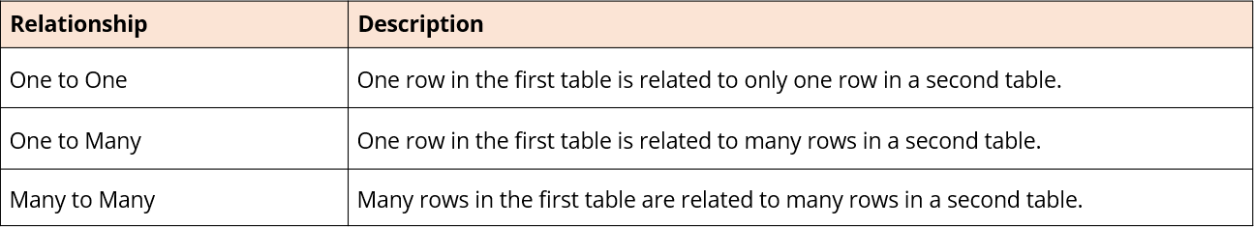

#### Database Design Through Normalization

Database normalization is the process of organizing data in a database mainly to reduce data redundancy and improve data integrity. It’s a design process which involves breaking down a large table into smaller related tables and defining relationships between them.

This process is guided by a set of rules, often called normal forms. The goal of each of these forms is to progressively eliminate redundancy, meaning a data attribute should be represented in only one table, as well as dependency issues.

Once the design process is complete, we’ll have a schema full of tables will implicit or explicit relationships. Having data in these separate silos, where no data is repeated, is great for maintenance and storage, but it complicates data retrieval.

#### Joins

A join is a SQL clause that combines rows from two or more tables based on a common field. Joins are used to create more complex queries and to retrieve data from multiple related tables simultaneously.

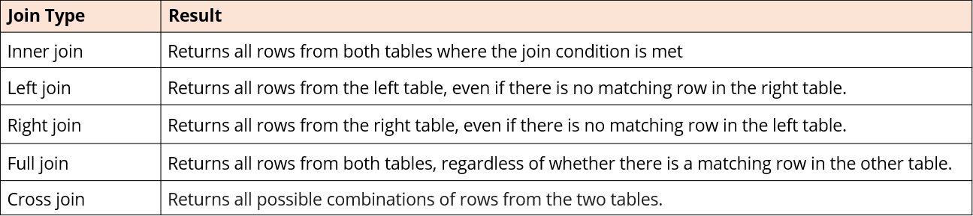

#### Entity Relationship Diagram (ERD)

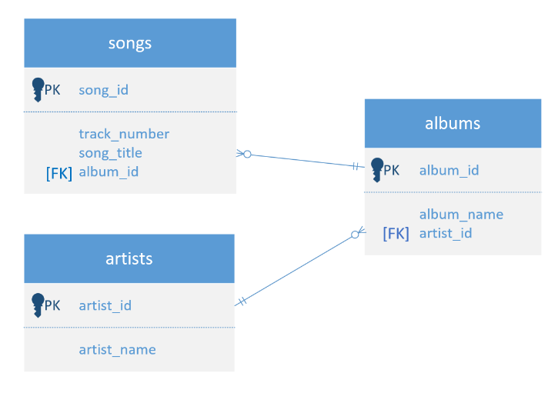

An *Entity Relationship Diagram* is similar to a Class Diagram.

An Entity is a table in this case, so all three tables are shown in the diagram.

Relationships are shown with connector lines which describe how two tables, or entities, relate to one another.

Both of the relationships shown in the diagram are one to many, or many to one, depending on how you look at it.

### JDBC

#### What is JDBC?

JDBC stands for Java database connectivity. It’s Java’s way of providing a consistent way to connect to a wide variety of databases including relational, NoSQL, and object-oriented databases.

It abstracts the complexities of connecting to different databaes through a common interface. This means we can use the same code to interact with different databases, without needing to re-write or have a separate version of the application logic for each one.

Think of JDBC as a middleman that sits between a Java application and a data source. JDBC can also be used with spreadsheets and flat files, meaning the structured query language can be used to interact with these files.

#### What’s a JDBC Driver?

To use a particular data source from an application, you’ll need a JDBC driver for that data source. A driver is simply a Java library, containing classes that implement the JDBC API.

Drivers are usually provided by the database vendor, either as a library .jar or a java module, which we can import into our application.

The current version of the JDBC API is JDBC 4.3. For backwards compatibility, it contains all the methods that were in previous JDBC versions.

You can find this information in the java.sql package API documentation, found [here](https://docs.oracle.com/en/java/javase/21/docs/api/java.sql/java/sql/package-summary.html).

#### What’s the JDBC Driver Used For?

At the most basic level, these drivers allow us to:

* Connect to the database. Each database may have a different mechanism to establish a connection to it.
* Execute SQL statements. These statements can be DML statements, any of the CRUD statements for example, or they can be DDL statements where you create tables or data artifacts from the application.
* Execute Stored Procedures. This sends a request to the database to execute a procedure or function stored in the database.
* Retrieve and process results. This could be a set of data from a select statement or a count of rows updated or inserted.
* Handling Database Exceptions.

#### Differences Between JDBC 4.0 and Previous Versions

Since there have been changes to the way that JDBC works over time, you want to be sure you’re working with a driver that supports at least JDBC 4.0.

Some Features in JDBC 4.0 and later include:

* Auto-loading of JDBC drivers. This was a significant improvement, but there is some legacy code that uses explicit driver registration.
* Build-in Connection Pooling.
* Distributed Transactions.
* Row streaming.
* SQLXML support.
* Try-With-Resources.

#### java.sql and javax.sql

JDBC consists of two packages – java.sql, which is core JDBC, and javax.sql, which provides the API for server-side data source access.

The java.sql package contains most of the types needed to communicate with a data source. However, javax.sql provides two alternative types for several of the most significant types.

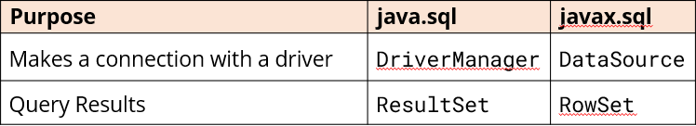

DriverManager should be replaced with DataSource in most cases because it’s newer and supports a lot more functionality. For querying results, there’s the standard ResultSet type but the RowSet interface provides many advantages.

#### JDBC Connection URLs by Some Vendors

Below are a few of the more common databases and what a basic connection string might look like if the database was named music.

Some of the details after the jdbc: vendor part may vary:

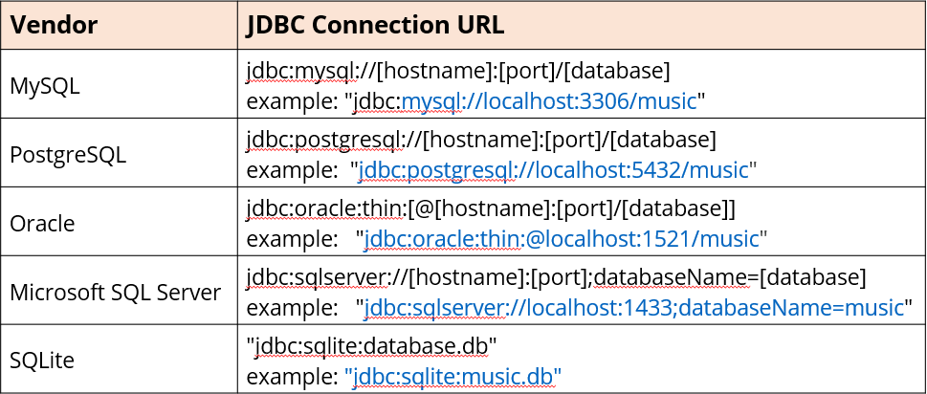

PostgreSQL and MySQL are similar, but Oracle in the example inclues an at-sign (@) before the host, and Microsoft SQL Server has a semi-colon after its port. Be sure to understand the right connection string that is needed to use for the vendor.

### SQL Injection

SQL injection is a serious security vulnerability. It occurs when an attacker attempts to manipulate the input data sent to an application’s database query.

#### SQL Injection Points

SQL injection vulnerabilities usually exist at points where user input is used to construct SQL queries.

Common injection points include:

* User login forms where input is checked against stored credentials
* Search forms where user input is used to filter database records.
* URL parameters, used in dynamic SQL queries.
* Any input field in a web application, that interacts with a database.

#### Preventing SQL Injection

There are methods to minimize and prevent this type of attack.

* Validate and sanitize user input before using it.
* Practice the Least Privilege Principle.
* Implement proper error handling and logging to avoid exposing any database or table name specifics in messages the user will see.
* Use prepared statements or parameterized queries whenever possible.

#### ANSI SQL

ANSI SQL stands for the American National Standards Institute Stuctured Query Language. Each database vendor provides documentation, that covers its own SQL language statements.

This documentation often include information about their compliance with the ANSI SQL standards. ISO SQL is the International Organization for Standardization’s version.

Both are based on the same core SQL syntax and semantics, and both are maintained by the same technical committee.

#### Why Stick to ANSI SQL

There are some good reasons to strive to use ANSI SQL with your JDBC code.

* **Portability and Database Independence.** Because ANSI SQL is supported by all major database vendors to some degree, you can write JDBC statements using it.
* **Readability and Collaboration.** It’s well-defined and easy-to-read. This makes it easier to write uniform code, as well as understand JDBC statements.
* **Maintainability and Future-Proofing.** ANSI SQL is a stable language, which means it’s unlikely to change in the future.
* **Compliance Requirements.** In some industries compliance with standards and regulations is mandatory.

#### Not All Vendors Implement All ANSI SQL Standards

While using ANSI SQL is a good practice, different databases implement ANSI SQL standards to varying degrees.

Some advanced features and optimizations will remain vendor-specific and some vendors may only implement the standards minimally.

It’s recommended to start with ANSI SQL, which can help to maintain flexibility and minimize what’s called vendor lock-in.

#### Database Vendors Getting First Number of Records

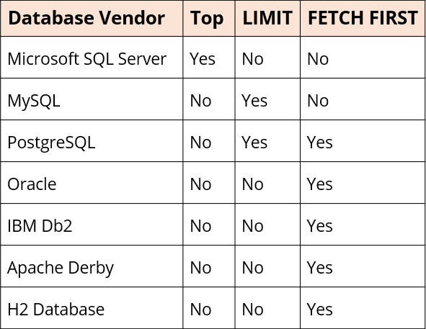

The limit clause is a good example of how each database might implement this functionality.

The ANSI SQL standard specifies a ‘FETCH FIRST’ clause.

But MySQL doesn’t support that, and instead has the LIMIT clause.

The table on this slide demonstrates which vendors support FETCH FIRST and which don’t.

#### How Do You Find the ANSI Standards?

Trying to learn what the standards are and how well each vendor supports each standard is a challenging exercise.

Oracle provides a good guide, not for the MySQL database, but for their Oracle database, that at least lists quite a few of the standards in one document.

It then describes how well that database conforms to the standards.

Link to Oracle Compliance to Core SQL is [here](https://docs.oracle.com/en/database/oracle/oracle-database/19/sqlrf/Oracle-Compliance-To-Core-SQL2011.html).

#### Music Entry Relationship Diagram

Foreign key relationships are commonly set up in databases to prevent users from inadvertently deleting parent records.

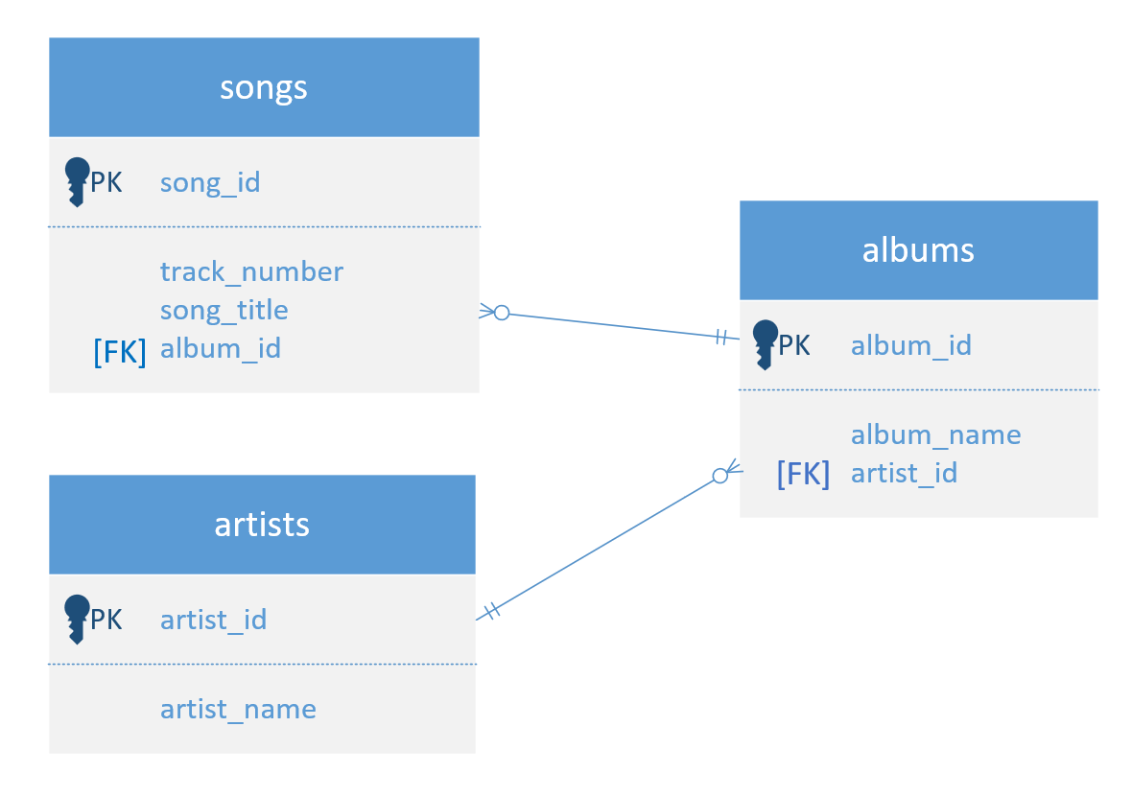

### Working With Transactions

#### Database Commits

The AUTOCOMMIT option tells the database to automatically commit changes after every statement. *By default, a Connection object is in auto-commit mode*.

This can be useful for small changes, but it can also be dangerous if you make a mistake. Changes are first stored in a temporary location called a redo log or journal file.

When you execute a commit, these changes are then persisted permanently to the database. It’s a good idea to turn AUTOCOMMIT off if you want a series of related statements to be treated as a single atomic operation.

This means all the statements in that group have to be run successfully before they actually get persisted permanently.

#### Transactions

In the database world, a *transaction* is a series of one or more database operations that are treated as a single unit of work. Transactions ensure that database operations are atomic, meaning they either all succeed or all fail.

If any part of the transaction fails, the transaction gets rolled back and no changes are applied to the database. In JDBC, a transaction is initialized when we turn AUTOCOMMIT off on the connection object.

#### Key Points About Using executeBatch

* Multiple SQL statements can be bundled together and sent to the database in one trip.
* executeBatch does not necessarily execute all statements sent if a failure occurs in one of the statements. This depends on the type of driver and how it’s configured.
* It’s still important to manage transactions with the use of commit and roll back when using this method.
* Batch processing is often used to improve the performance of inserting, updating, or deleting multiple rows in a database at once.

### PreparedStatement

#### Request Process

*What Happens on the Database Server When it Receives a Request from a JDBC Driver?*

* Query is parsed.
* An Execution Plan is created.

The result is a compiled statement.

Once the statement is compiled, it’s stored in a cache on the database server. This means it can be reused without having to be recompiled each time it is executed.

#### The PreparedStatement

A PreparedStatement in JDBC is a precompiled SQL statement.

It was discussed in a previous section that it is possible to get a compiled regular expression by using Pattern.compile. In some ways, this is similar to precompiling a SQL statement.

In both cases, a String is passed which needs to get interpreted as some operation that will occur. The string first needs to get parsed, its syntax tested, and some optimizations may optionally be applied.

There is some overhead with this process, so if you’re using the statement multiple times, it makes sense to precompile it.

#### The PreparedStatement Syntax

A PreparedStatement is used to execute the same statement multiple times with parameter value placeholders.

A parameter in a SQL string passed to a PreparedStatement is defined with a question mark as a placeholder, shown below in the example:

SELECT * FROM music.artists WHERE artist_name = ?

Notice here that we are not including single quotes around the question mark.

Importantly, PreparedStatements help prevent SQL injection attacks.

It is possible to have multiple parameters in the SQL string and they can be different types. For example, album_id in the songs table is a number.

Specifying placeholders is the same regardless of the type of parameter, as shown below in this example:

SELECT * FROM music.songs WHERE album_id = ? AND song_title like ?

#### Advantages of PreparedStatement

The PreparedStatement has many advantages over the Statement

* Precompilation – parsing, optimizing, and storing SQL statements to be efficiently executed. Happens only once.
* Parameterized Queries – supported with placeholders. Identified as question marks (?) in SQL string. Help prevent SQL injection attacks.
* Efficient Reuse – PreparedStatements can be used multiple times, executing the same or similar SQL statements.
* Automatic Type Conversion – PreparedStatements handle conversions between Java and SQL data types.
* Readability and Maintainability – Code with PreparedStatements is easier to read and understand.
* Type Safety – helps provide data type mismatches that lead to runtime errors or data corruption.

### CallableStatements

#### Challenges Working with Databases via JDBC

There are many challenges and concerns, when you’re working with databases via JDBC.

* SQL Injection
* Monitoring and Loggin
* Concurrency Control
* Scalability
* Testing and Integration
* Vendor Lock-In
* Performance Tuning
* Transaction Management
* Resource Leaks
* Data Type Mapping

Consider addressing at least some of the problems listed above with server solutions. This is often done with functions and routines, written in SQL or transactional or procedural languages that integrate easily with SQL.

These items are often called stored procedures as a category, though there are two separate database artifacts, the procedure and the function.

#### The Stored Procedure

Stored procedures are a way to encapsulate complex SQL logic and data manipulation into reusable modules. They can help to improve application performance, modularity, and security.

They’re precompiled queries or segments of code that are stored as just another database object.

Stored procedures are designed to execute a sequence of SQL statements and can perform multiple operations within a single call.

They can modify the state of the database, meaning they can create, update or delete data.

Procedures can also control transaction management, ensuring data consistency and integrity.

#### The CallableStatement

Java supports the execution and retrieval of results from these code segments with a special kind of statement named the *CallableStatement*.

Like a PreparedStatement, this first takes a parameterized string when you get an instance. The object referenced will already be compiled in the database server.

Simlar to a method in Java, data with parameters is passed in, and data may or may not be returned.

#### Callable Statements Input and Output

MySQL has three different types of parameter types for its procedures:

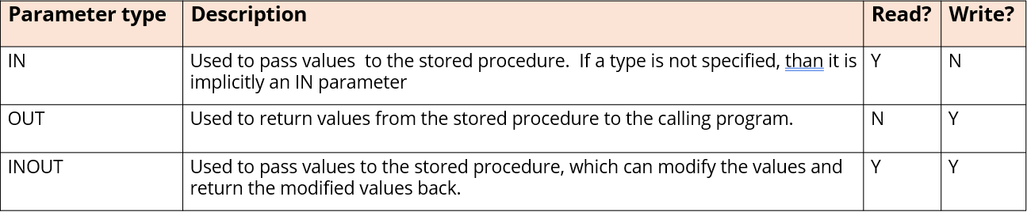

#### Stored Functions

In relational database management systems, like MySQL, precompiled collections of SQL statements can be either a stored procedure or a stored function. Both are stored in the database, and both can be executed as a single unit.

While each may encapsulate common database operations, they are different. Specifically, stored functions are designed to perform a specific calculation, or data manipulation, and return a value.

Use Cases:

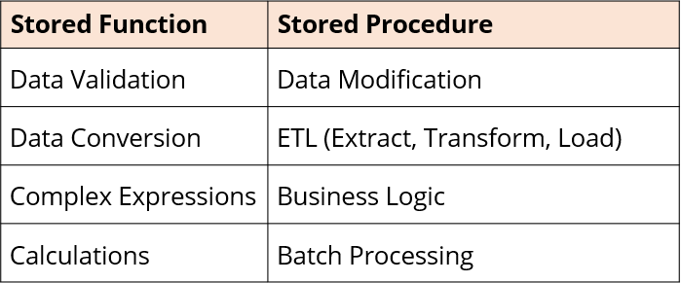

#### Characteristics of Stored Functions

The key characteristics of a stored function are:

* **Returns a value.** Stored functions are expected to return a single value.
* **Is immutable.** Stored functions should not have side effects and should not modify data in the database.
* **Can be used in SQL expressions.** You use it directly in SELECT statements, WHERE clauses, or JOIN conditions.

#### Using CallableStatements to Execute Stored Functions

Stored Functions are not called from CallableStatements as often as Stored Procedures, but it is still good to know how to do it, as there are a couple of key differences.

The first is that the SQL string will always start with a placeholder, so a question mark, for the returned result.

The second is that MySQL stored functions only support IN parameters.

#### JDBC Escape Sequences

JDBC Escape sequences provide a way to execute database-specific operations in a more consistent and portable manner across different database systems.

They’re enclosed in curly braces {} and are used within SQL statements.

There are certain things that aren’ts database agnostic:

* Date, time, timestamp literals.
* Scalar functions such as numeric, string, and data type conversion.
* Escape characters for wildcards used in LIKE clauses.
* Stored procedures and functions.

#### Summary

Stored procedures are designed for executing multiple operations, modifying data, and enforcing business logic. In contrast, stored functions are primarily used for calculations and data transformations.

Both enhance code reusability, improve performance, and promote encapsulation of complex database operations. And, even better, they simplify the JDBC code you have to write.

### Other Techniques for Database Interactions

The alternative is something called the Java Persistence API, or JPA for short.

#### What is JPA?

JPA is a specification.

There’s no default implementation of the specification provided in Java’s Standard Edition. There’s a very good chance of working on an application that usses some form of it.

These are called JPA Providers.

In 2019, the Java Persistence API officially changed its name to Jakarta Persistence API. Documentation can be found via the following link: [click here](https://jakarta.ee/specifications/persistence/3.1/apidocs/jakarta.persistence/module-summary.html).

#### Key Concepts of JPA

A few key concepts of the JPA specification include:

* Object-Relational Mapping, or ORM.
* The Entity (which is the mapped object), and the Entity Manager which manages lifecycles of these entities.
* The Persistence Context is a special cached area where the entities exist.

Think of the JPA as an extra layer of functionality between the application code and the JDBC code seen in the last lectures.

#### Object-Relational Mapping (ORM)

Object-Relational Mapping is a method of mapping database tables defined by columns to a class with correlated fields and getters and setters.

A record in a table then becomes an instance of one of these classes.

ORM frameworks often automate the process of object relational mapping:

* Simplify code, reducing the need to write boilerplate classes.
* Simplify database operations, hiding the complexities of SQL queries, and handling database interactions.
* Provide code portability across different database systems.
* Encourage a more structured and organized approach to data access.

#### The Entity

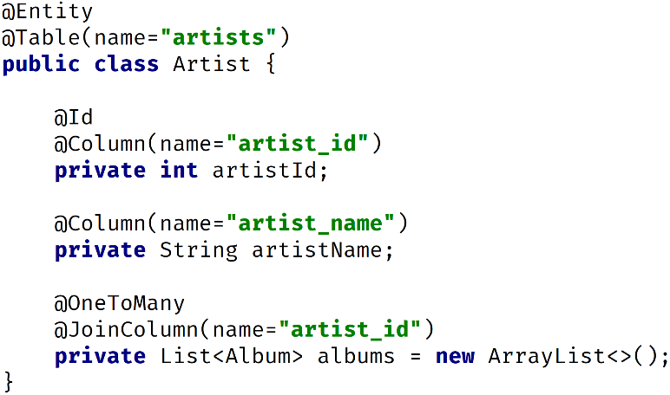Typically, an Entity is a class that represents a table in a relational database.

Each entity is annotated with metadata.

The example shown here to the right is a relatively simple one of an annotated class called “Artist”.

#### The Entity Manager

The entity manager is implemented by the JPA Provider.

An entity can exist in a managed state, managed by the Entity Manager, or it can exist in a detached state outside of an Entity Manager.

A detached entity can then be merged into an Entity Manager if a commit is needed to a persistence layer.

There are some key methods on the Entity Manager interface to know that line up with the CRUD operations

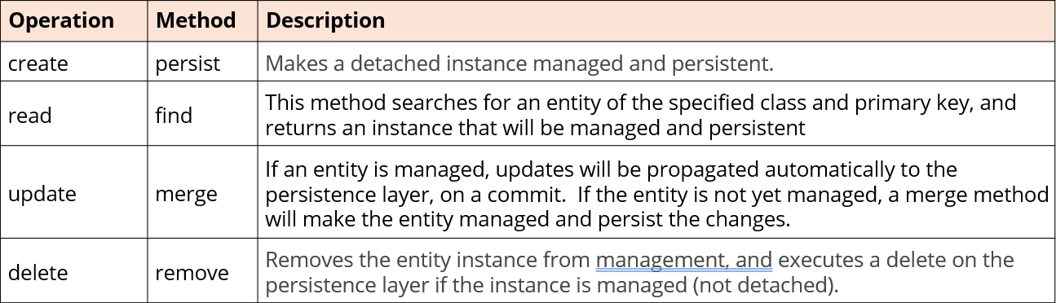

#### The Persistence Context

The persistence context has multiple purposes:

* It tracks the lifecycle state of managed entities. These states include new, managed, detached, and removed, reflecting any changes that are made to their properties.
* It synchronizes changes made to managed entities with the database. This happens automatically when a transaction is commited or flushed, ensuring the database state reflects the state of your in-memory objects.
* It performs identity management, ensuring unique entity identity within a transaction. Even if duplicate objects are created with the same identifier, the persistence context recognizes and manages them as a single entity.
* It acts as a cache, reducing database roundtrips by keeping frequently accessed entities in memory for faster retrieval.

#### JPA Queries

As previously mentioned, a query in the database is often a select statement of some kind.

In JPA, there are three options to execute a query, all of which still rely on the existence of an entity class:

* JPA Query using a special query language called JPQL.
* Criteria Builder, which is a more programmatic way to put together the selection request.
* Native Query which relies on SQL.

#### JPA Query (JPQL)

The Java Persistence Query Language, or JPQL, is an object-oriented query language.

It’s specifically designed to work with entities in Java applications that use JPA.

It provides a way to query data stored in relational databases without needing to understand the details of how the data is actually structured there.

#### JPA Tuple

A JPA Tuple is an ordered collection of values retrieved from a database query.

It’s like a lightweight data container offering more flexibility than simply returning entire entities or raw object arrays. Think of it as a mini-record holding just the specific data you need from the database.

A few useful links for JPA Tuple are listed below:

Wikibooks Java Persistence/JPQL: [click here](https://en.wikibooks.org/wiki/Java_Persistence/JPQL)

Jakarta Persistence, Query Languagen: [click here](https://jakarta.ee/specifications/persistence/3.0/jakarta-persistence-spec-3.0.html#a4665)

2013 Oracle’s The Java EE 6 Tutorial, Creating Queries Using the Java Persistence Query Language: [click here](https://docs.oracle.com/javaee/6/tutorial/doc/bnbrg.html)

### The CriteriaBuilder Interface

The CriteriaBuilder interface describes a factory class for creating various type-safe query components. It provides methods for creating the different parts of a JPA query, each described as an object.

#### The CriteriaBuilder’s Factory Method Output Types

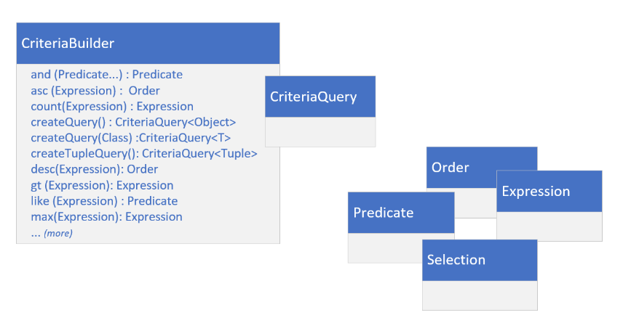A query in it’s simplest form consists of a command as well as a source of some sort.

A query may also have many other clases and specifics which define what needs to be done.

The Criteria Builder provides all the building blocks as Java objects to fashion a specific query.

The Criteria Builder is just responsible for creating customizable components you’ll need.

#### The CriteriaQuery

The CriteriaQuery is a bit like scaffolding. Things get added and the instance mutates and grows. The methods represent specific clauses or expressions in a select query.

A Predicate represents a condition in a WHERE clause. An Expression represents a computed value. An Order is used to represent sorting criteria for the ORDER BY clause.

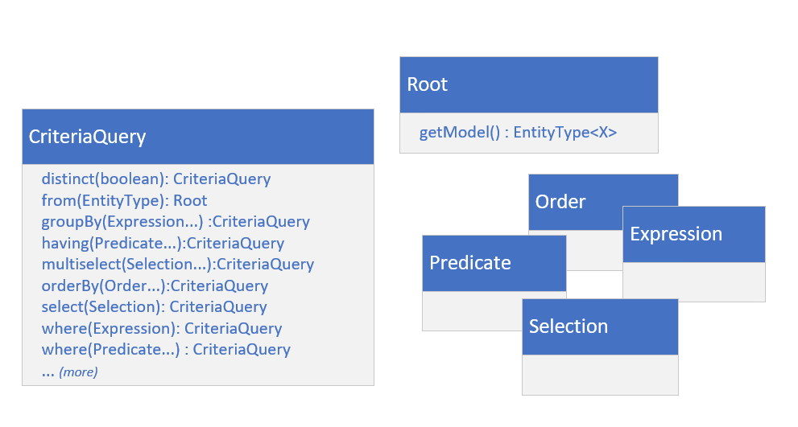

A Selection represents an attribute, expression, or result used to define the selectable output of the query.

The Root is a special type, and it’s the bridge between the criteria query and your entity. It’s the source of the query’s data.

All of these methods return an instance of CriteriaQuery. This means you can optionally chain these together.

#### Creating an Executable Query Using CriteriaBuilder

The Process to create an executable query using CriteriaBuilder is summarized in the below. The table below summarizes the steps to use the CriteriaBuilder and CriteriaQuery types to execute queries using JPA entities:

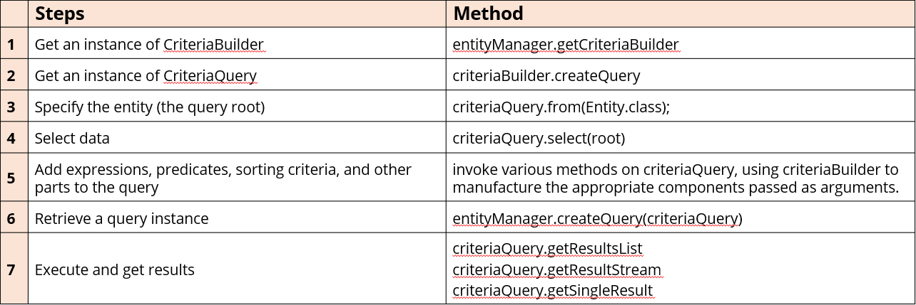

#### Summary of JPA Queries

The table below summaries the three types of queries that can be executed using JPA:

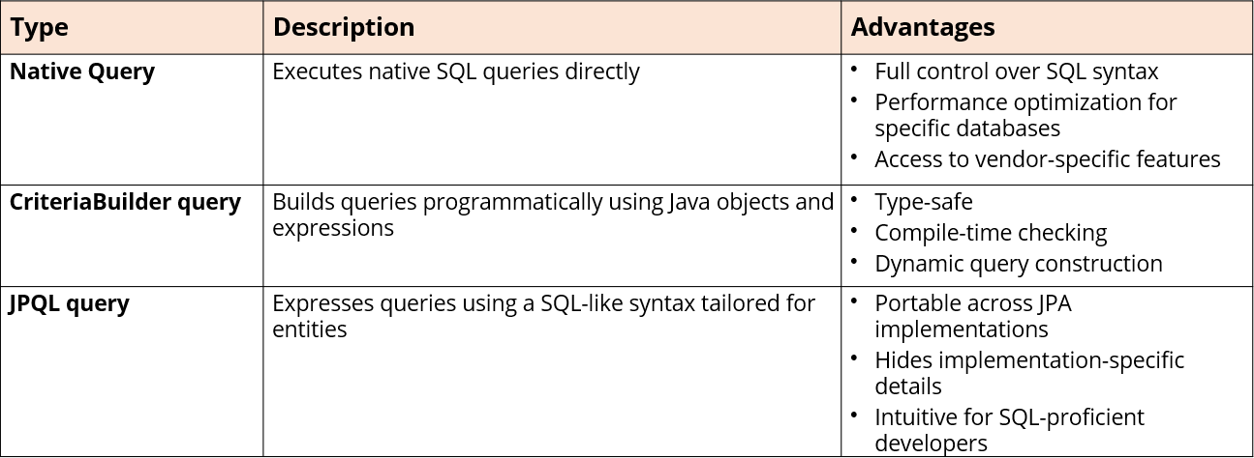

## Section 23 – Java Networking

### Introduction

#### What is Networking and Why Is It Important?

Wikipedia describes the internet as a global system of interconnected computer networks.

It’s a network of networks, consisting of private, public, academic, business, and government networks, some of which are local and some that are global.

The internet provaides a vast range of information resources and services as we all know.

#### Java’s Support for Writing Networking Code

Java has had support for networking since its first version. Like many of the other topics covered in this course, the Java language continues to change.

In this section, we’ll start out with the original java.net package and the types it provides. This includes types for low level programming which work with sockets and addresses. It also includes higher level types that hide or manage connection level details.

#### Java’s Alternatives to java.net

This section will also be used to introduce some exciting new changes.

Channels offer a much more robust way of communicating between interconnected devices, and there are several channels we can use for network communications.

In addition, JDK11 also saw the includion of the java.net.http package. This includes support for HTML 2.0 as well as builder patterns to create instances of types specifically used for internet communication.

Additionally, this package also gives us the WebSocket type. Unlike HTTP clients, WebSockets establish persistent connections between the browser and the server, enabling bi-directional communication.

### Networking Terminology

#### What Is Networking?

Networking is the foundation of modern communications.

A **network** is a system of computers and other devices connected together so that they can communicate with each other to exchange data and shared resources.

**Networking** refers to how the connected computers communicate. This can be done over the internet or over a local area network, which is just a collection of devices connected together in one physical location.

#### Importance of Networking

*Why is networking important in software development?*

Important reasons for networking:

* Data Communication – allowing applications to exchange data in real-time between users and systems.
* Distributed Systems – allowing applications to be deployed across many servers.
* Foundational for Internet and Cloud Computing.
* Enables Remote Access and Control to distributed systems.
* Enables communication between applications through the use of APIs and Web Services

#### Private Network (Intranet)

Computers may also communicate across a private network, also known as an *intranet*.

In fact, that’s where networking actually began, and intranets are still common today in many businesses.

#### The Host

A host refers to any hardware device capable of participating in network communication.

A common network configuration that many have probably heard of is client server.

This means that one or more hosts on the network are acting as servers, and the other hosts are clients that connect to the server.

#### What’s A Client?

Clients are end-user devices or applications that request services or resources from servers.

They initiate communication with the servers and rely on them to fulfill specific requests.

#### What’s A Server?

Servers are usually powerful computers or software applications that provide services or resources to clients.

They listen for incoming requests from clients, process those requests, and respond with the appropriate data or action.

#### What’s A Client-Server Model?

Communication between the user’s devices and servers responding to their requests is called the client-server model.

This is a very common networking model used in many different applications, including web applications, email, file sharing, and gaming.

Web browsing is a classic example, where the web browser (the client) sends requests to web servers, and the servers respond by sending back web pages, images, or other resources.

You can have a client-server interaction on the same host.

For example, the MySQL database comes with software we’ve been using called MySQL Workbench. The workbench is the client, and it connects to the MySQL database server on that local host. It could also connect remotely to another server if needed as well.

#### Client-Server Communication

*How do the Client and Server Communicate?*

Clients and Servers communicate through several layers of protocols.

The lowest level is the network layer, which uses addresses to facilitate network communication.

On top of this is the data transport layer.

#### The Port

When data arrives at one physical connection to the network, it gets routed to the target application through a port.

Each application that needs data from the network is assigned a port.

This includes clients connecting to a server that’s on the same machine.

When data arrives, the port number is used to route the data for the specific application that’s waiting for it.

A port number is a positive integer between 0 and 65535.

#### The IP Address

Every host connected to the internet also has a unique IP address.

*IP* stands for *Internet Protocol*.

This describes the destination, or where the data is supposed to go in the network, and it does it with and IP Address.

#### IPv4 vs. IPv6

IPv4 stands for Internet Protocol versioin 4 and IPv6 stands for Internet Protocol version 6.

Once upon a time there were only IPv4 addresses.

IPv4 uses a 32-bit address scheme that allows for over 4 billion unique addresses.

Now that we’ve got computers, tablets, game consoles, smart TVs, smartphones, smart appliances, four billion IP addresses wasn’t enough, so IPv6 was born.

#### IPv6

IPv6 uses a 128-bit address scheme, which allows for many more IP-addresses than IPv4 does.

Many Internet Service Providers provide both IPv4 and IPv6 addresses to their customers. This ensures compatibility with older and newer technologies.

For example, new routers support IPv6, but if you’re hanging onto an older router, it may not. Or your ISP may only provide IPv4 addresses, or you just have it configured that way.

#### How Do the Client and Server Communicate?

The data transfer layer provides different protocols for transferring data.

In this section, we’ll cover the TCP and UDP protocols.

These two protocols are still widely used by client server applications.

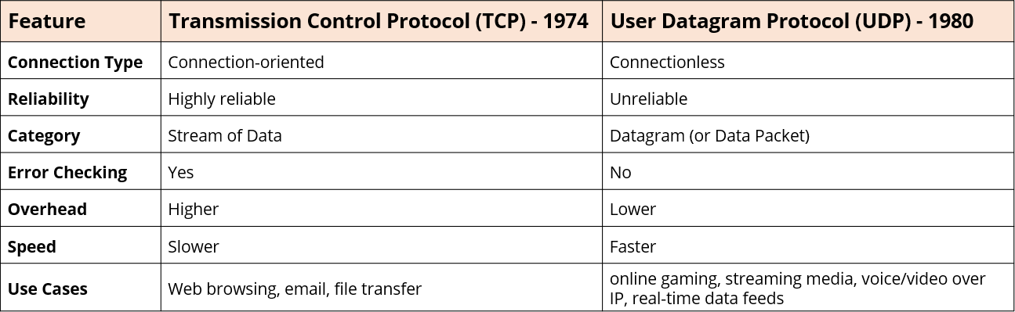

#### TCP/IP

TCP/IP describes both the networking and data transport layers used. It refers to using the TCP protocol for transferring data over a network of IP addresses.

Two applications running on the same host can still use TCP/IP to communicate with each other. When the client and server are on the same host, usually the IP address, 127.0.0.1, which is also referred to as the local host, is used to identify the host.

#### Networking Packages

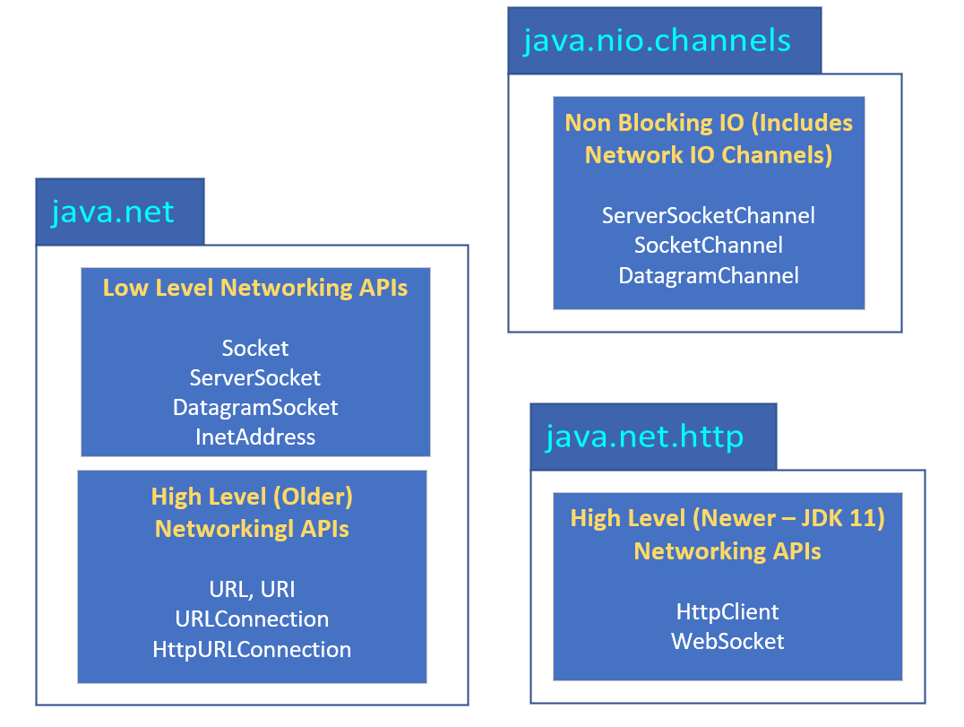

Java Networking types can be split roughly into two groups – low-level APIs, which work with sockets and network addresses, and high-level API types that abstract connectivity with the use of such types as URLs, HTTP connections, and HTTP clients.

In addition, the java.nio package offers an alternative communication mechanism in the form of channels.

When using the low level API, you have to be more aware of networking concepts.

#### Sockets

When using the low-level networking API, sockets are used to establish connections, send requests, and receive responses.

A *socket* is one end point of the two-way connection.

The client will have a socket, and the server will also have a socket.

When you have multiple clients connecting to the same server, they’ll use the same port, but each client will have its own socket.

The code should use the Socket class for the client socket, and the ServerSocket class for the server socket.

### Section Preview Overview

Since we’re talking about networking, we’re going to have to write two applications to demonstrate how to do networking coding.

One application will be the server, and the other will be the client.

### TCP/IP

#### Communicating with TCP/IP

Because it’s so common, we’ll start by using TCP/IP client server examples. This means using a reliable two-way communication link between the client and the server.

Typical TCP/IP Client-Server Interaction:

* The Server needs to first create a ServerSocket and bind it to a port.
* The Server calls accept() on the ServerSocket, which returns a Socket when a client connects.
* The Client creates a Socket using a constructor that takes a host and a port.
* The Server and the Client use their respective sockets to exchange data.

### ServerSocket vs. ServerSocketChannel

#### Advantages and Disadvantages

The tables below compare the two approaches across many levels.

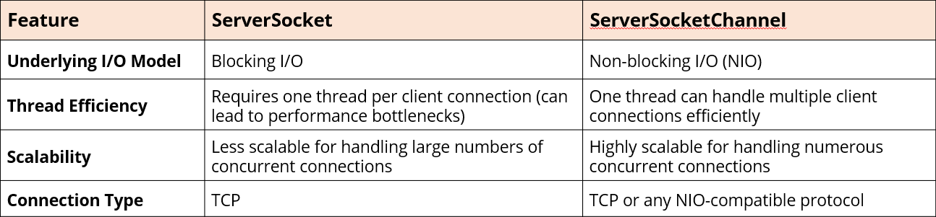

The ServerSocketChannel has other advantages as shown in the table below:

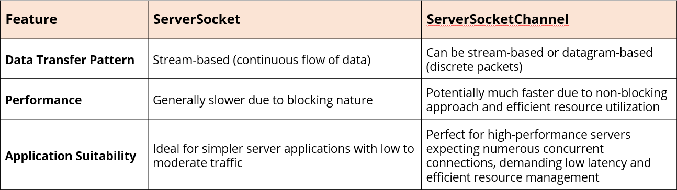

#### ServerSocketChannel Drawback

The ServerSocketChannel has one major drawback.

It’s a much more complex API.

In the next sections, we’ll cover a server application that uses a ServerSocketChannel. In addition, we’ll launch into some of the details of buffers, channels, and selectors, which make the code somewhat more difficult to implement.

### NIO Channels and Buffers

#### What’s a Channel?

A Channel is an interface that’s part of the java.nio.channels package. It represents an open connection to some entity that’s capable of input and output operations.

This can be a file, a hardware device, a network socket, or another program component.

Some implementations of Channel are the SocketChannel and ServerSocketChannel. But there are others such as DatagramChannel, FileChannel, and others.

Think of this type as a data pathway.

#### How Does a Channel Work?

A channel is constructed when you call the static method, open, on a specific Channel implementation. Under the covers for SocketChannels, an internally managed socket is also opened.

This socket can also be accessed using the accessor method socket().

Data is transferred through channels using buffers, which offer control over data segmentation and optimization of I/O operations.

#### What’s a Buffer?

The Buffer type is an abstract class that’s part of the java.nio package.

It’s a data container for temporary storage that can be pushed onto the data pathway.

The Buffer’s characteristics are:

* Designed to provide a more general way to handle data, whether it’s bytes, characters, or other primitive types.
* It provides methods for accessing, manipulating, and tracking the buffer state.
* A Buffer’s states are Ready to Read and Ready to Write, as well as Empty and Full.
* More memory-efficient and offers more flexibility than a simple array.
* There is a buffer subtype for each primitive type, except boolean.

#### Channel/Buffer Interactions

Channels interact with buffers for data transfer.

The Channel’s read method takes a buffer as input and *fills the buffer* with data from the connected entity.

Data can be consumed from the buffer using its get() methods. Data is added to the buffer using it’s put() methods.

The Channel’s write() method takes a buffer as input and transfers the buffer data to the connected entity.

#### The java.nio.Buffer

A java.nio.Buffer can be both readable and writeable.

The state can be changed by using the flip() method.

The table below shows other significant differences:

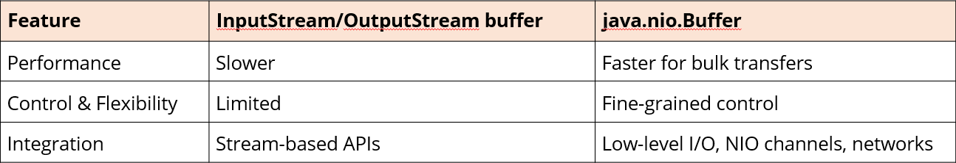

#### Buffer Properties

Aside from its content, the essential properties of a buffer are its capacity, limit, and position:

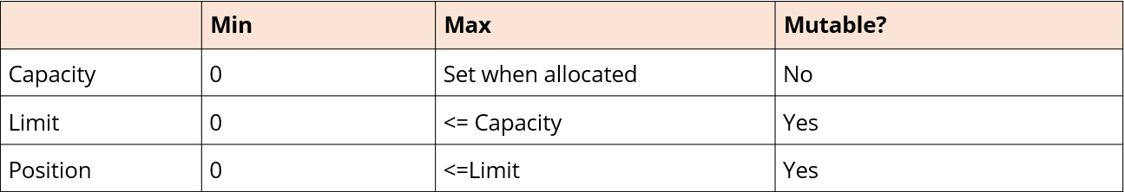

#### ByteBuffer vs. CharBuffer

Typically, a ByteBuffer is the best choice for Socket Channels.

* Socket Channels operate at the byte level, transmitting raw data without inherent character encoding.
* ByteBuffer directly aligns with this model, making it a natural fit for efficient data transfer.
* CharBuffer, while useful for character-based operations, introduces an extra layer of encoding and decoding, potentially impacting performance.

### Polling vs. Event-Driven

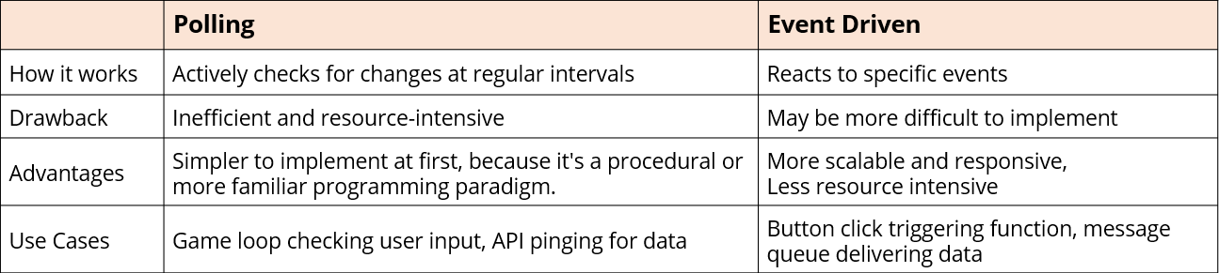

#### Core Features of Event Driven Concepts

When using Even Driven architectures, events that are expected to occur are identified, and components can register an interest in that event.

When one of these events is triggered, the system reacts, sharing the event’s notification with interested parties.

In an Event Driven architecture, components are loosely coupled and operate independently from one another. Communication occurs through the firing of, and listening for, events.

Events usually trigger an asynchronous action to components with an interest in that event.

The asynchronous action can in turn be registered. The system can then listen for the completed response event and also react when it occurs.

Events drive the action rather than code looping indefinitely, trying to identify changes to respond to.

#### Selectable Channels

Selectable channels are like any other channel and represent various I/O endpoints like sockets, pipes, and file channels.

Importantly, selectable channels are associated with a *Selector*, which is the key to event-driven NIO programming in Java.

The SelectableChannel class is in the java.nio.channels package.

ServerSocketChannel and SocketChannel are two examples of selectable channels.

#### What Does a Selector Do?

The primary functions of a Selector are as follows:

* The Selector monitors a set of channels for readiness for special events.
* Events are sometimes called interests, and the application can register that a channel has an interest in a specific event. This registration is done via the Selector.
* When an event occurs on a registered channel, the Selector wakes up the program, providing information about the event and the interested channel.
* The program then reacts to the event in some way, typically by performing the I/O operation or taking other appropriate actions.

### UDP Client Server

#### UDP Benefits

When using UDP, there’s no handshaking at all, and the destination host, which may or may not be a server, doesn’t send a response to the message sender.

It is used when there is no need for a reliable connection or a two-way connection, or when speed is essential.

#### Datagrams

UDP uses datagrams.

A *datagram* is a self-contained message.

Which protocol to use will depend on the application that needs to be written.

#### UDP Interactions Are Connectionless

The communication between client and server is connection-less.

There’s no explicit connection extablishment phase, like there is with a TCP handshake.

In other words, UDP sockets don’t have to establish a persistent connection before sending data.

#### Comparing TCP vs. UDP Low Level Interactions

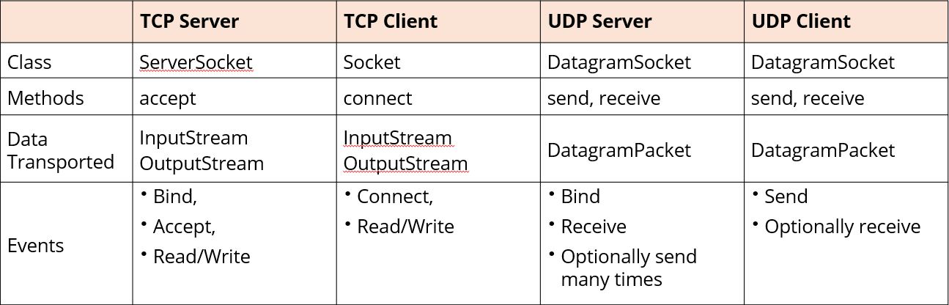

#### Datagram Channel Connections

A newly-created datagram channel is open but not connected. A datagram channel need not be connected in order for the send and receive methods to be used. This is what we’ve seen in the example.

A datagram channel *may be connected* by invoking its connect() method in order to avoid the overhead of the security checks, which would otherwise be performed as part of every send and receive operation.

A datagram channel must be connected in order to use the read and write methods since those methods don’t accept or return socket addresses.

### High Level Networking

#### Java’s High Level Networking APIs

Most modern applications are mainly interested in accessing the internet.

This is more easily done using the high-level APIs Java provides.

These types abstract networking concepts even further, starting with the URI.

#### URI, URL, URN

*URI* stands for Uniform Resource **Identifier**.

This is the brodest category of identifier and it encompasses any resource identifier.

*URL* stands for Uniform Resorce **Locator**, and *URN* stands for Uniform Resource **Name** and is often used to describe physical items like a book’s ISBN number.

The URL and URN are both subsets of a URI.

#### Location, Location, Location

A URL specifically identifies and locates resources on a network.

A URL includes both the name of the resource and the protocol and address (like domain and path) needed to access it.

For this reason, URI strings may contain relative paths, but URLs won’t.

#### URL Class

The URL class represents a URL, which Java describes as a pointer to a resource in the World Wide Web.

A resource can be something simple like a file or a directory, or it can be a reference to a more complicated object such as a query to a database or search engine.

#### URI Class

A URI is made up of hierarchical parts.

At the top level, the format is as follows, consisting of a scheme, scheme-specific part, and a fragment:



The scheme-specific-part consists of an authority, a path, and query as shown:



In turn, the authority component may consist of user-info and a host and port in the following format:



In total, there are 9 components in the hierarchy, some of which are optional, as are listed in the table below:

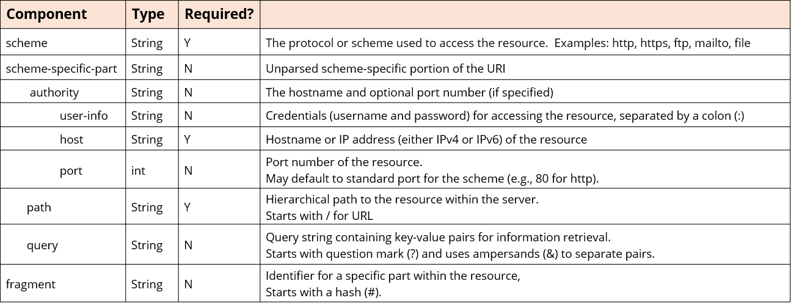

#### URL to URI

Although a URI is a super set of URL, this isn’t true in Java’s class hierarchy.

URL is not a subclass of URI.

To use a URI as a URL in Java, you can use the method toURL on a URI instance.

Similarly, if you want to use a URL as a URI, you can use the method toURI on a URL instance.

However, not all URIs are URLs, and this transformation may result in an exception.

#### What’s a Relative URI

A relative URI is a reference to a resource such as a web page, file, or image that’s relative to the current context.

Relative URIs are commonly used in web development to specify the location of resources in relation to the location of the current document or web page.

### HTTP

#### HTTP (Hypertext Transfer Protocol)

HTTP stands for hypertext transfer protocol.

* It’s the foundation of data communication for the World Wide Web on the internet.
* It follows a client-server model but, importantly, HTTP is stateless.
* HTTP messages consist of a request or a response, each containing a header and an optional body.
* HTTPS is a secure version of HTTP.

#### HTTP Request Methods

The HTTP protocol supports various request methods. You might hear these called HTTP verbs in some circles.

The most common methods are:

* GET
* POST
* PUT
* DELETE.

Additional methods which are usually less commonly used are: PATCH, HEAD, OPTIONS, CONNECT, and TRACE.

#### HTTP Response Codes

When your browser asks for a webpage, it will most often do what’s called a GET request. The server that hosts the page will then respons and the response will include a code.

For example, the code 200 means OK, the server found the webpage and was able to return it. Code 404 means the server can’t find the webpage being requested.

A code of 500 means something went critically wrong on the server side.

For additional HTTP URL connection information, see the Oracle documentation [here](https://docs.oracle.com/en/java/javase/17/docs/api/java.base/java/net/HttpURLConnection.html).

#### HttpURLConnection vs HttpClient

HttpURLConnection or HttpClient?

Historically, many Java developers felt the http client classes in the java.net package weren’t robust enough. They preferred other alternatives like Apache’s HttpClient, OKHttp, or even Jetty’s client API.

An incubator version of an enhanced Java Http client was released in JDK9. This incubator version wasn’t exactly well received.

In JDK11, Java released the java.net.http package with its own HttpClient class.

#### HTTP/1.1 and HTTP/2

The newer HTTP/2 protocol was introduced in 2015 and has many advantages over the previous HTTP/1.1 version. HTTP/2 is faster.

It uses several techniques to transfer data more efficiently, resulting in faster webpage loading times.

HTTP/2 is also more efficient. The most important content can be loaded first, leading to a smoother user experience.

HttpURLConnection only works with HTTP1.1, while Java’s HttpClient supports both.

Creating a new HttpClient using HttpClient.newHttpClient() creates a new instance with builder methods with default settings with HTTP2 protocol.

More information can be found on the HttpResponse method handlers page from Oracle [here](https://docs.oracle.com/en/java/javase/17/docs/api/java.net.http/java/net/http/HttpResponse.BodyHandlers.html#method-summary).

#### Feature Level Support

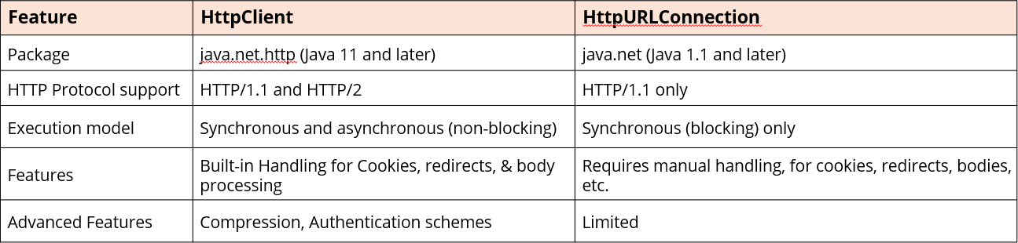

#### Application Design and Ease of Use

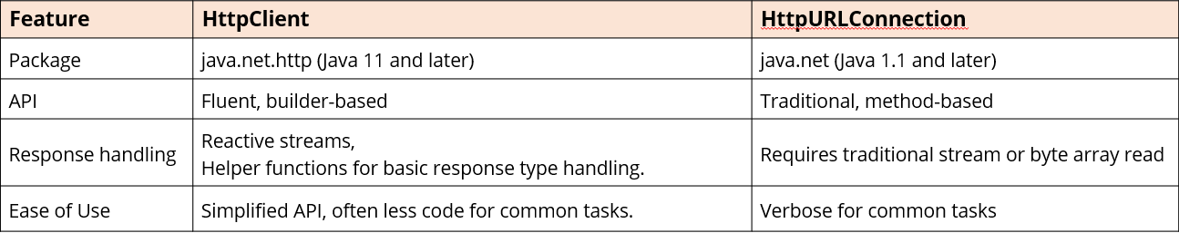

#### Key Takeaways & Summary

HttpClient provides a more modern alternative to HttpURLConnection. It’s an efficient and feature-rich API for HTTP interactions.

Oracle has been prioritizing development efforts on HttpClient indicating a clear preference for its usage in new projects.

Leading frameworks and libraries in the Java ecosystem, such as Spring, are increasingly adopting the JDK’s HttpClient.

HttpURLConnection is still usable, but its future is uncertain, so try to use HttpClient for new projects. It’s the preferred choice due to its modern design, performance, and ease of use.

Consider migrating existing code to HttpClient for better maintainability and alignment with future Java development trends.

### Asynchronous Requests and Commands

#### Comparing send to sendAsync

In the table below is an example of calling the send method on the left and the sendAsync method on the right for comparison:



#### Return Types for send vs. sendAsync

As shown in the table above, the return type is different for both methods. In the concurrent programming section, we covered the *Future* type and said it represents a result of an asynchronous computation:

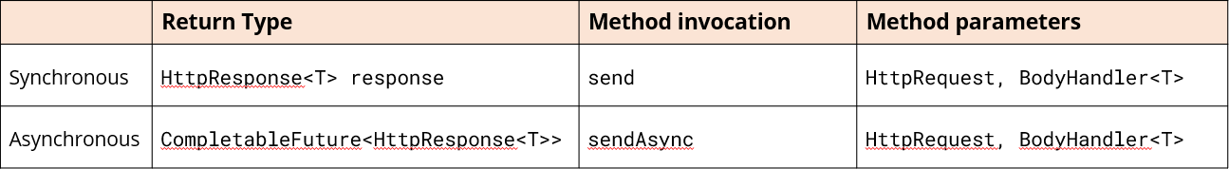

#### Future vs. CompletableFuture

A Future is an interface which the concrete CompletableFuture class implements.

The CompletableFuture specifically extends Future’s capabilities to support asynchronous processing.

Officially, the Java API states:

* A CompletableFuture is a Future that may be explicitly completed by setting its value and status,
* And may be used as a *CompletionStage*, supporting dependent functions and actions that trigger upon its completion.

It’s a promise of a future result.

#### What’s a Callback?

A callback is a general programming concept which describes passing a function as an argument to another function.

This gets called later, in the future, when a specific event occurs.

Lambda expressions don’t get executedm if they’re used as method arguments until the method is invoked.

Similarly, callbacks don’t get executed until a certain stage or triggering event occurs.

#### Selector Compared to CompletableFuture

The Selector is more low-level and is specifically designed for non-blocking I/O operations.

The CompletableFuture, with its support for callback functions, is higher-level and not really specific to a single use case.

It’s a general-purpose class designed for managing asynchronous computations.

#### Different Approaches to the Asynchronous Send

The table below shows two different approaches to the Asynchronous send: one using callback, and one that polls for completion:

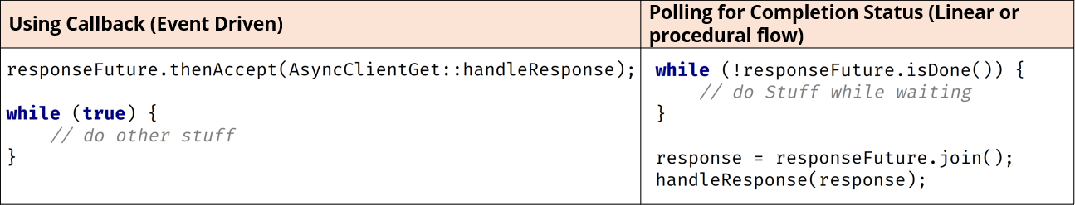

More details on the CompletableFuture methods can be found on the Oracle site [here](https://docs.oracle.com/en/java/javase/17/docs/api/java.base/java/util/concurrent/CompletableFuture.html#method-summary).

### WebSocket

HTTP Communication is one-directional. The client makes a request to a server and the server optionally responds.

This puts the onus of staying up to date on the client to poll the server regularly, checking for status updates.

#### Introduction to WebSocket

*WebSocket Communication is Bi-Directional*.

A WebSocket creates a persistent connection between the server and client which can be used to send messages back and forth.

This makes it ideal for real-time applications like chat, stock tickers, and collaborative tools where data needs to be constantly updated and distributed.

The WebSocket also allows data to be pushed from the server to the client and vice versa, without the overhead of repeatedly establishing new connections.

#### WebSocket Upgrade

WebSockets leverage the reliability of TCP connections, and communicate using an “upgrade”.

WebSockets establish a connection using something called an HTTP handshake, which starts with an Upgrade header on the request.

This handshake paves the way for the upgrade to the WebSocket protocol itself, with real-time data exchange and low overhead and latency.

This upgrade process ensures compatibility with existing web infrastructure. At the same time, it enables more efficient and responsive communication for interactive web applications.

#### WebSocket Communication Complexity

WebSocket Communication can get complicated. Communicating with WebSockets involves more than a standard HTTP connection:

* WebSockets require a special handshake mechanism when a connection is established.
* They use a specific message format.
* They typically use something called a binary framing format.
* Text needs to be encoded before sending and decoded on the receiving end.

For more information, see the following link: [click here](https://developer.mozilla.org/en-US/docs/Web/API/WebSockets_API/Writing_a_WebSocket_server_in_Java).

#### Java’s WebSocket Implementation

The java.net.http package provides a class called WebSocket.

It’s very important to understand that this is a WebSocket ***client***.

Oracle Java 17 WebSocket documentation: [click here](https://docs.oracle.com/en/java/javase/17/docs/api/java.net.http/java/net/http/WebSocket.html).

#### WebSocket.Listener

Listener is an interface declared on the java.net.http.WebSocket type.

It’s described as the receiving interface of a WebSocket. Even if you don’t override any of its methods, its processes are still occurring.

This type handles all the specifics of opening a connection, receiving data from a connection, as well as responding to pings from the server. If you want to add additional handling, you override the individual method and make a call to the listener’s super class’s method.

#### WebSocket Frames

The term *frames* is sometimes used to describe communication messages or payloads between WebSocket clients and the server. The term “frame” refers to the basic unit of data that is sent over the WebSocket connection.

It’s a structured unit of information which can consist of data or control signals. Control frames are passed when opening or closing connections, or when pinging connections.

Data frames are used to pass message data. When a message is too large to fit into a single frame, it can be split into multiple smaller frames, each of which is transmitted separately.

These smaller frames are then reassembled by the receiving WebSocket endpoint to reconstruct the original complete message.

#### WebSocket Control Methods

In all cases, the first parameter is the WebSocket instance itself.

In this case for the examples in the table below, the WebSocket parameter is a java.net.http.WebSocket:

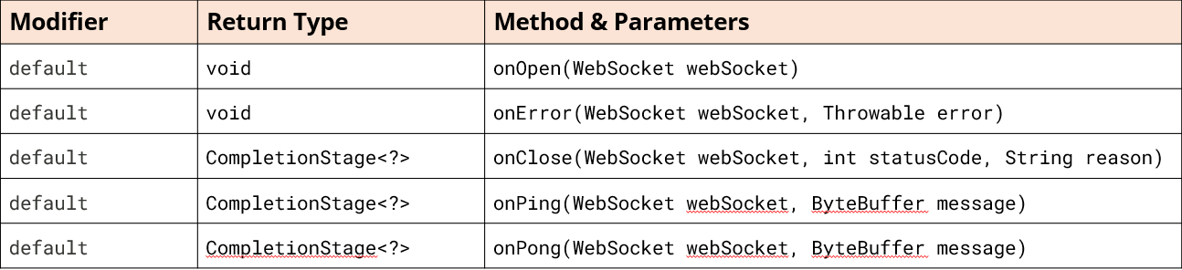

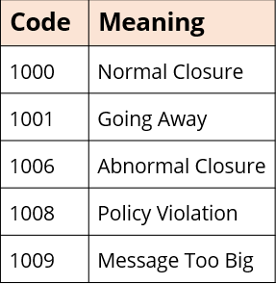

The onClose() method is invoked with a status code and a reason why the connection closes.

Some common status codes are shown to the right:

#### Ping and Pong Control Methods

The ping and pong control frames are used to maintain the connection between the client and the server and ensure liveliness. When one party (either the client or the server) wants to check if the other party is still responsive, it sends a “ping” frame.

Upon receiving a “ping” fram, the recipient must respond with a “pong” frame to acknowledge that it is still active.

This exchange helps in detecting unresponsive connections and allows for timely reconnection or error handling if necessary. These frames ensure the reliability and stability of the connection.

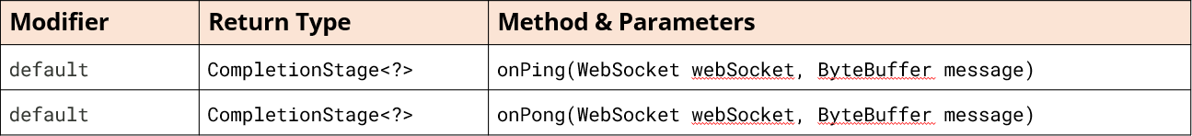

#### Data Methods

There are two data frame methods. The onText method makes it easy to send and receive text messages. You may also have messages with binary components, like images and audio for example, so you’d use onBinary.

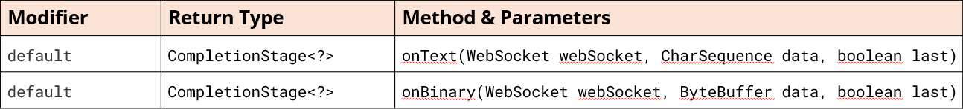

## Section 24 – Debugging and Unit Testing

***NOTE*** There are no slides from the course for Section 24, so these are from the JetBrains website

### Introduction to Debugging

#### What Is Debugging?﻿

Broadly, debugging is the process of detecting and correcting errors in a program.

There are different kinds of errors, which you are going to deal with. Some of them are easy to catch, like syntax errors, because they are taken care of by the compiler.

Another easy case is when the error can be quickly identified by looking at the stack trace, which helps you figure out where the error occurred.

However, there are errors that can be very tricky and take really long to find and fix. For example, a subtle logic error, which happened early in the program may not manifest itself until very late, and sometimes it is a real challenge to sort things out.

This is where the debugger is useful. The debugger is a powerful tool, which lets you find bugs a lot faster by providing an insight into the internal operations of a program. This is possible by pausing the execution and analyzing the state of the program by thorough examination of variables and how they are changed line by line.

While debugging, you are in full control of the things. In this manual we are covering a basic debugging scenario to get you started.

#### Examine the Code﻿

Let's try a simple debugging case. Imagine we have the following application:

public class AverageFinder {

public static void main(String[] args) {

System.out.println("Average finder v0.1");

double avg = findAverage(args);

System.out.println("The average is " + avg);

}

private static double findAverage(String[] input) {

double result = 0;

for (String s : input) {

result += Integer.parseInt(s);

}

return result;

}

}

The program is supposed to calculate the average of all values passed as command-line arguments.

It compiles and runs without issues; however, the result is not what one would expect. For instance, when we pass 1 2 3 as the input, the result is 6.0.

First of all, you need to think about where the suspected error might be coming from. We can assume the problem is not in the print statements. Most likely, unexpected results are coming from our findAverage method. In order to find the cause, let's examine its behavior in the runtime.

#### Set Breakpoints﻿

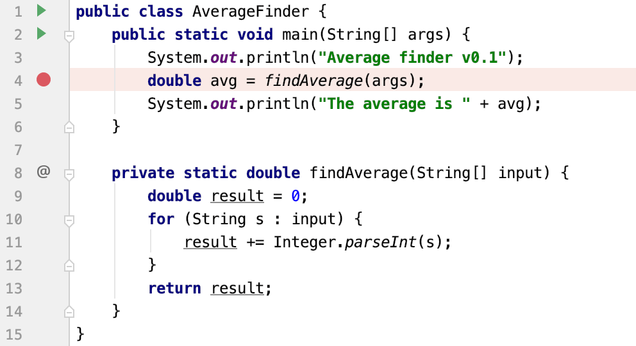

To examine how the program operates at runtime, we need to suspend its execution before the suspected piece of code. This is done by setting breakpoints. Breakpoints indicate the lines of code where the program will be suspended for you to examine its state.

* Click the gutter at the line where the findAverage method is called.

#### Run the Program in Debug Mode

**﻿**

Now let's start the program in debug mode.

Since we are going to pass arguments for running and debugging the program, make sure the run/debug configuration has these arguments in place.

1. Click the Run icon in the gutter, then select Modify Run Configuration.\

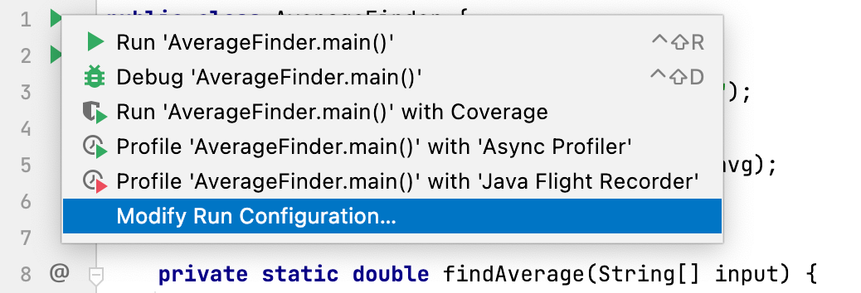

1. Enter arguments in the Program arguments field.

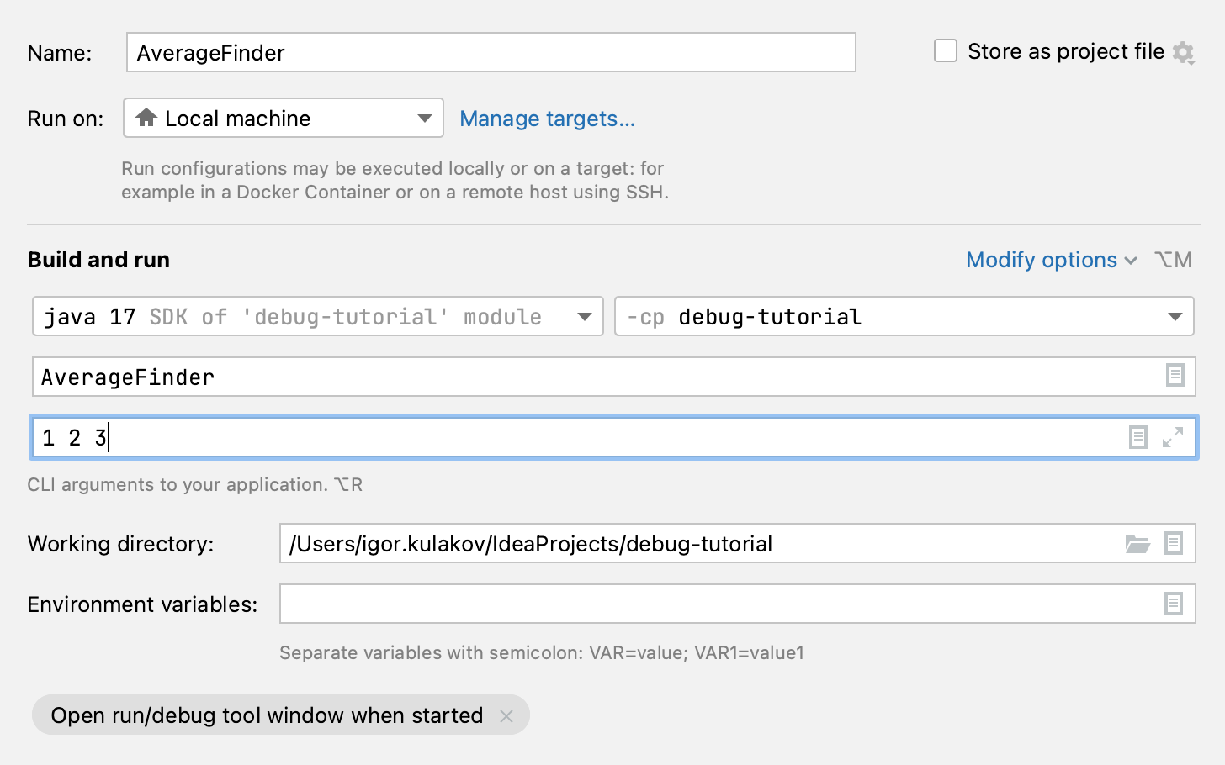

1. Click the Run button near the main method. From the menu, select Debug.

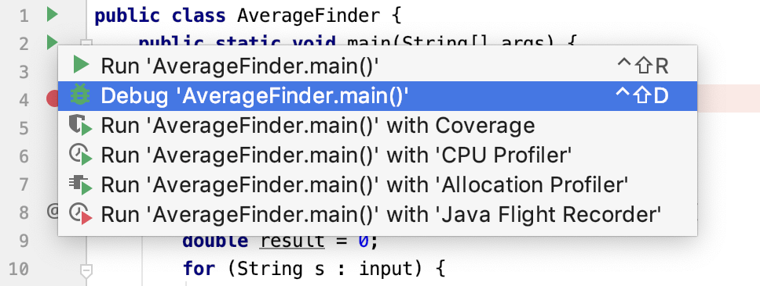

#### Analyze the program state﻿

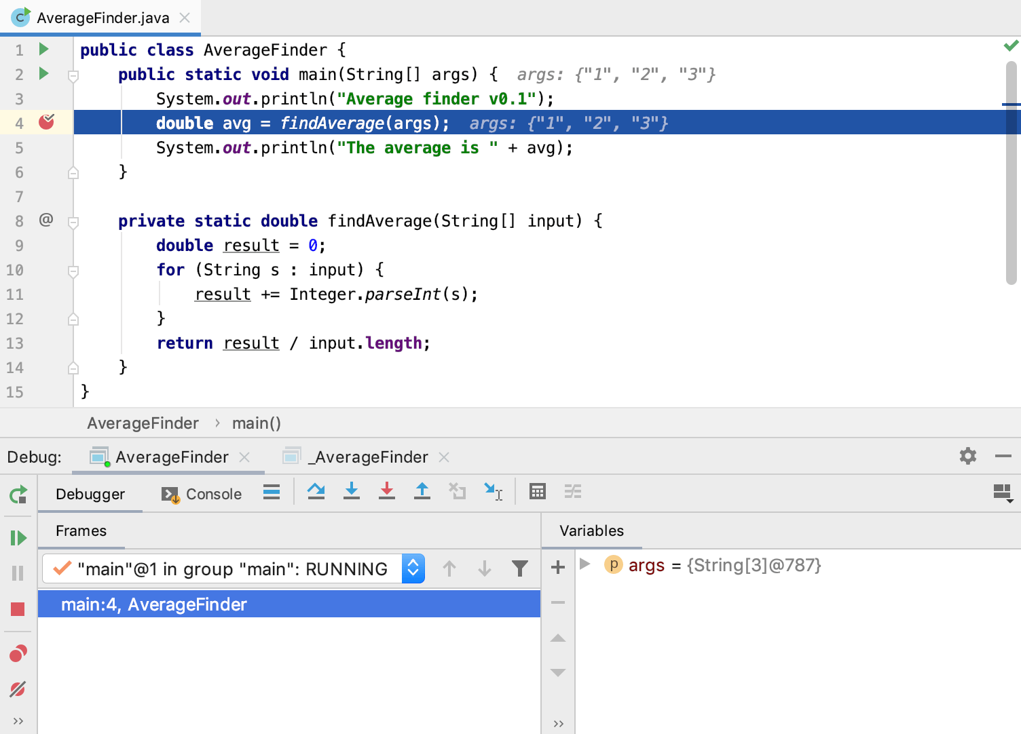

After the debugger session has started, the program runs normally until a breakpoint is hit. When this happens, the line where the program paused gets highlighted and the Debug tool window appears.

The highlighted line has not been executed yet. The program now waits for further instructions from you. The suspended state lets you examine variables, which hold the state of the program.

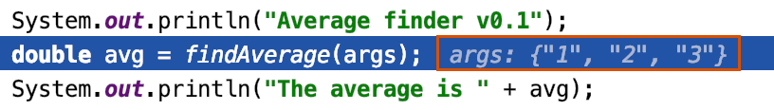As the findAverage method has not been called yet, all its local variables like result are not yet in scope, however, we can examine the contents of the args array (args is in scope for the main method). The contents of args are displayed inline where args is used – see the image to the right:

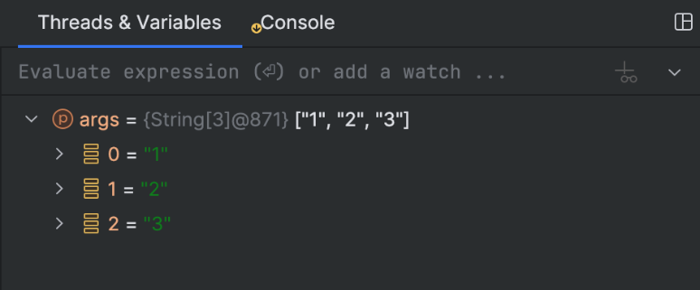You can also get information about all variables that are currently in scope on the Threads & Variables tab on the Debug tool window.

#### Step Through the Program﻿

Now that we are comfortable with the Debug tool window, it's time to step into the findAverage method and find out what is happening inside it.

1. To step into a method, click the Step Into button or press F7.

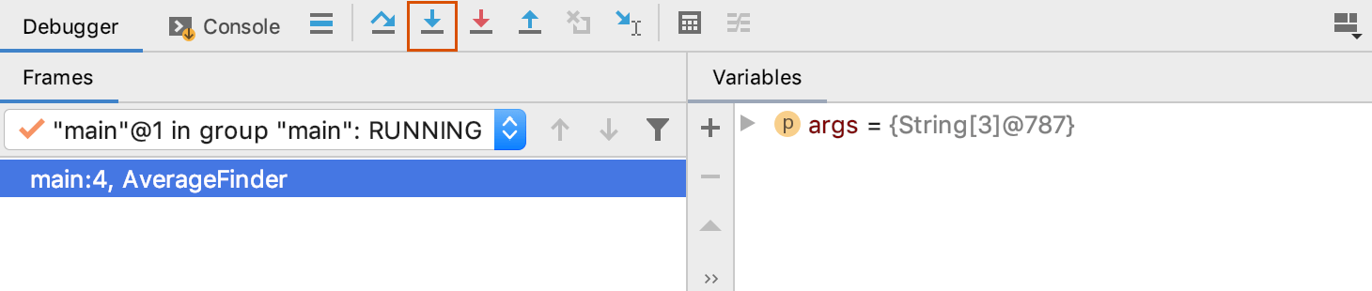

Another line gets highlighted in the editor because we advanced the execution point one step forward.

1. Continue stepping with Step Over F8. Notice how it is different from Step Into. While it also advances the execution one step forward, it doesn't visit other methods like Integer.parseInt() along the way.

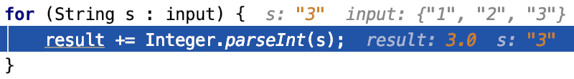

Let's keep stepping and see how the local variable result is declared and how it is changed with each iteration of the loop.

Right now the variable s contains the value "3". It is going to be converted to int and be added to result, which currently has the value of 3.0. No errors so far. The sum is calculated correctly.

1. 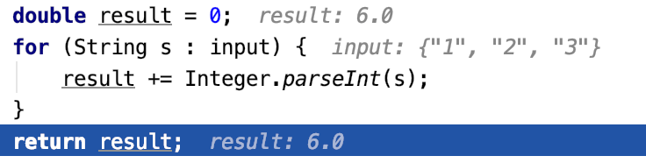Two more steps take us to the return statement, and we see where the omission was. We are returning result, which has the value of 6.0, without dividing it by the number of inputs. This was the cause of incorrect program output.

To continue the program execution after it has been suspended, press F9 or select Run | Debugging Actions | Resume from the main menu.

1. Let's correct the error: return result / input.length;

#### Stop the Debugger Session and Rerun the Program﻿

To check that the program works fine, let's stop the debugger session and rerun the program.

1. 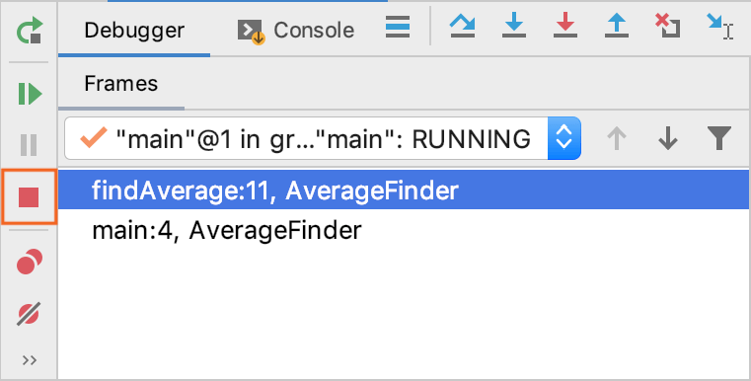Click the Stop button or press Ctrl+F2.
2. 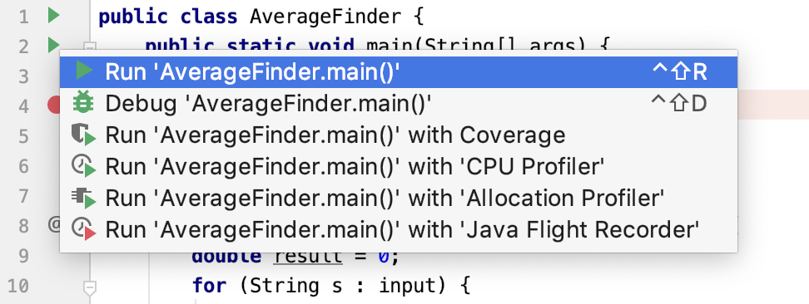Click the Run button near the main method. From the menu, select Run.
3. 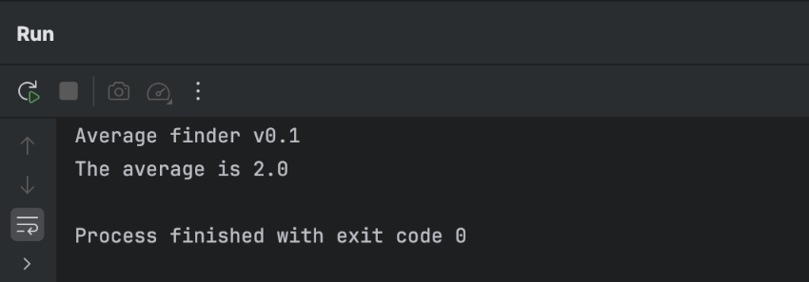Verify that the program works correctly now.

### Create Tests﻿

The simplest way of creating a new test class in IntelliJ IDEA is by using a dedicated intention action that you can invoke from your source code. In this case, the IDE creates a new test class and generates test code for this class, package, or function.

#### Add a New Test﻿

1. In your production code in the editor, place the caret at the class for which you want to create a test, press Alt+Enter, and select Create Test.
2. In the Create Test dialog, select the library that you want to use.

* If you don't have the necessary library yet, you will be prompted to download it. To do that, click Fix.
* If you're using Maven, the IDE will add the missing dependencies to your **pom.xml**. For Gradle projects, [add the necessary dependencies](https://www.jetbrains.com/help/idea/testing.html#add-testing-libraries) manually.

1. Configure the test class name and its location and select the methods that you want to test. Click OK.

As a result, IntelliJ IDEA creates a new test class with the specified name and generated test methods in the Test Sources Root.

#### Create Test Dialog Controls﻿

##### Create a New Test Class Manually﻿

1. Right-click the [test root folder](https://www.jetbrains.com/help/idea/testing.html#add-test-root) or package in the test root folder in which you want to create a new test and select New | Java Class.

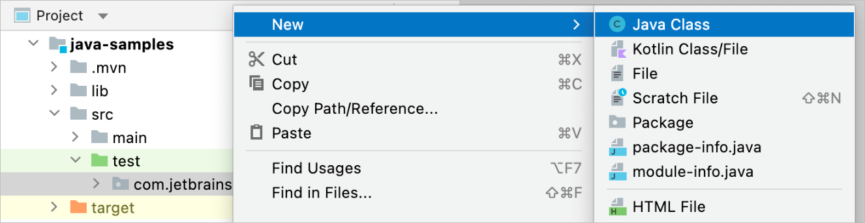

1. Name the new class and press Enter.
2. Press AltInsert and select Test Method to generate a new test method for this class. Name the new method and press Enter.

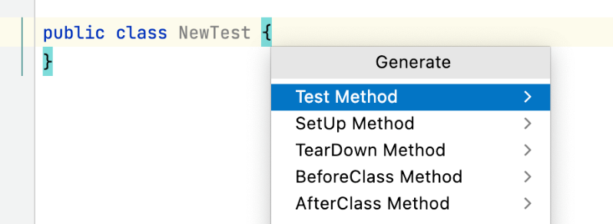

#### Configure Naming Pattern for Test Classes﻿

By default, IntelliJ IDEA adds the Test suffix to class names when generating test classes. For example, if you create a test class for HelloWorld, its name by default is HelloWorldTest. You can change the naming pattern in the settings.

1. In Settings Ctrl+Alt+S, go to Editor | Code Style | Java, and open the Code Generation tab.
2. In the Naming section of the tab, locate the Test fields and type a suffix or a prefix (or both) that you want to use for generated test classes into the corresponding fields.

#### Navigate Between Tests and Production Code﻿

In IntelliJ IDEA, you can jump between test classes and production code.

* In the editor, place the caret at the test class or at the test subject in the source code and press Ctrl+Shift+T (Navigate | Test Subject or Navigate | Test).

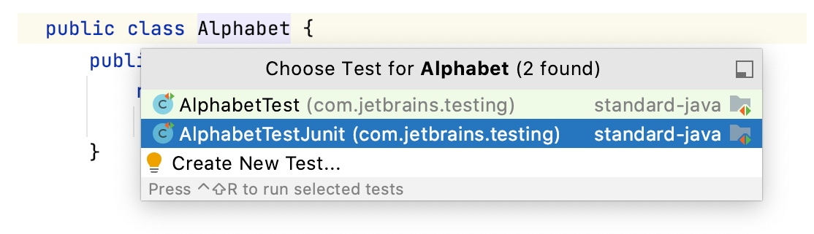

If there's only one test for this class, the IDE will navigate you to it right away. Otherwise, you will be prompted to select the necessary test from a popup or [create a new test](https://www.jetbrains.com/help/idea/create-tests.html#create-test).

### Run Tests﻿

Run the selected test or test folder: Ctrl+Shift+F10

Stop the current test session: Ctrl+F2

There are several ways to run tests including, [from a file or folder](https://www.jetbrains.com/help/idea/performing-tests.html#run-tests), using the [Run widget](https://www.jetbrains.com/help/idea/performing-tests.html#run-with-options), and from the [Structure tool window](https://www.jetbrains.com/help/idea/performing-tests.html#run_tests_from_structure). This article covers running tests in general. If you're looking for information for a specific build tool, see:

* [Testing in Maven projects](https://www.jetbrains.com/help/idea/work-with-tests-in-maven.html)
* [Testing in Gradle projects](https://www.jetbrains.com/help/idea/work-with-tests-in-gradle.html)

#### Run Tests Drectly In a File or Folder﻿

If your tests don't require any specific actions before start, and you don't want to configure additional options, such as [code coverage](https://www.jetbrains.com/help/idea/code-coverage.html), you can run them by using the following options:

* Place the caret at the test class to run all tests in that class, or at the test method, and press Ctrl+Shift+F10. Alternatively, click the  gutter icon next to the test class or test method and select Run '<test name>' from the list.

The gutter icon changes depending on the state of your test:

* + The  gutter icon marks a set of tests.
  + The  gutter icon marks new tests.
  + The  gutter icon marks successful tests.
  + The  gutter icon marks failed tests.

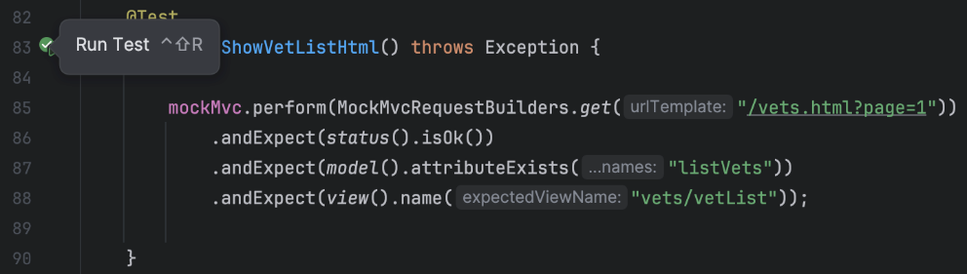

* To run all tests in a folder, select this folder in the Project tool window and press Ctrl+Shift+F10 or select Run Tests in 'folder' from the context menu.

#### Run Tests Using the Run Widget﻿

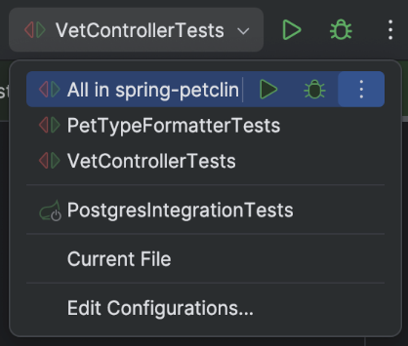

When you run a test, IntelliJ IDEA creates a temporary run configuration. You can save temporary run configurations, change their settings, share them with other members of your team. For more information, refer to [Run/debug configurations](https://www.jetbrains.com/help/idea/run-debug-configuration.html).

1. Create a new [run configuration](https://www.jetbrains.com/help/idea/run-debug-configuration.html) or save a temporary one.
2. Use the Run widget on the main toolbar to select the configuration you want to run.
3. Click  or press Shift+F10.

#### Run Tests From Structure﻿

In the [Structure tool window](https://www.jetbrains.com/help/idea/viewing-structure-of-a-source-file.html#structure-tool-window), you can select one or several test methods in a class to run. In this case, the IDE also creates a temporary run configuration with these methods that you can [save](https://www.jetbrains.com/help/idea/run-debug-configuration.html#save-as-permanent) and edit.

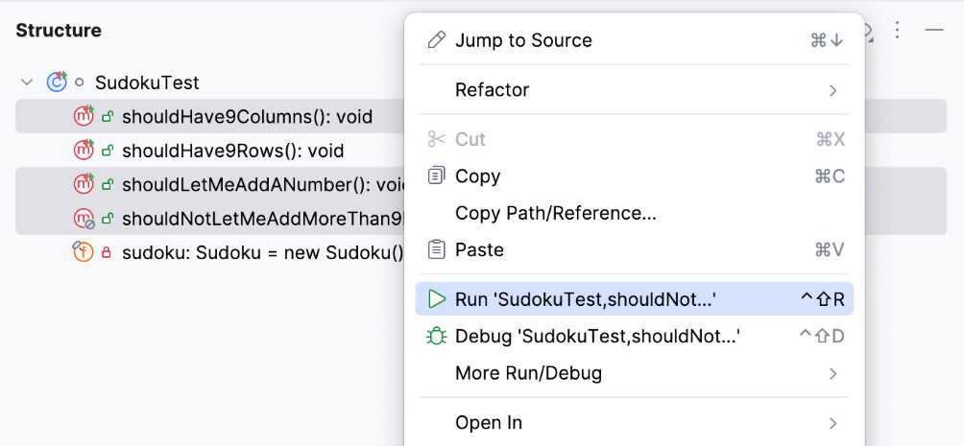

1. In the Structure tool window, right-click one or several test methods and select  Run 'method name' (Ctrl+Shift+F10).

The tool window allows you to add test methods to an existing run configuration (for JUnit and TestNG tests) in which the test scope is specified by means of a [pattern](https://www.jetbrains.com/help/idea/run-debug-configuration-junit.html#testKind). You can add methods from several different classes creating a test suite.

1. Right-click a method in the Structure tool window and select:

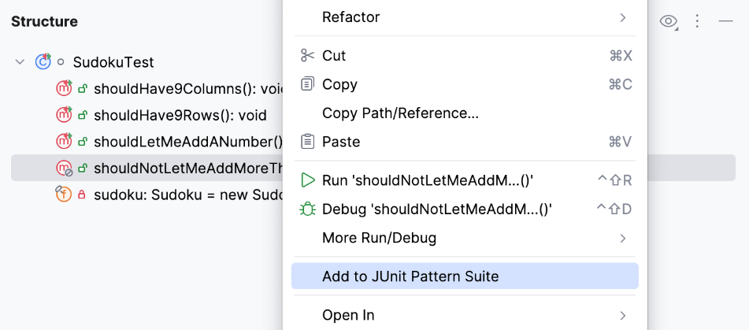

* + Add to temp suite: <Configuration_name> if there is only one configuration with the Pattern test scope.
  + Add to JUnit Pattern Suite (JUnit) / Add to Temp Suite (TestNG) if there are several configurations with the Pattern test scope. In this case, a popup appears in which you can select the target configuration.

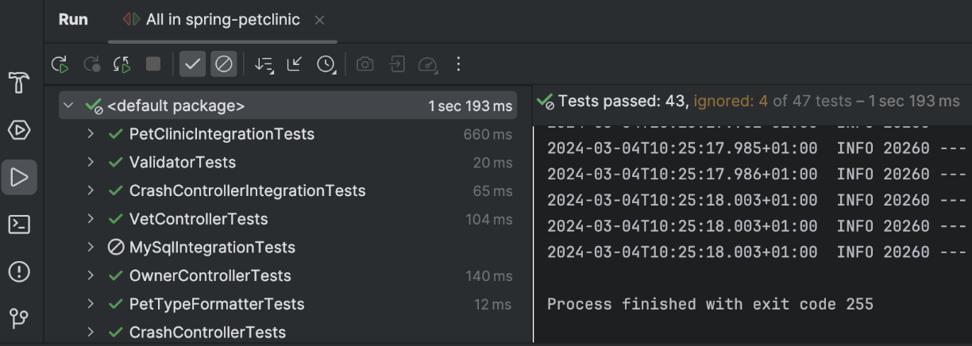To preserve the tab of a run configuration even if you execute another run configuration, [you may pin it](https://www.jetbrains.com/help/idea/run-tool-window.html#pin_tabs).

After IntelliJ IDEA finishes running your tests, it shows the results in the Run tool window on the tab for that run configuration. For more information about analyzing test results, refer to [Explore test results](https://www.jetbrains.com/help/idea/viewing-and-exploring-test-results.html).

The console on the right shows the output of the current test session. The test results toolbar located above the list of test results provides you with several helpful options.



#### Run Tests After Commit﻿

When you want to check that your changes wouldn't break the code before pushing them, you can do that by running tests as commit checks.

This feature is only available for [Git](https://www.jetbrains.com/help/idea/using-git-integration.html) and [Mercurial](https://www.jetbrains.com/help/idea/using-mercurial-integration.html).

##### Set Up Test Configuration﻿

1. Press Alt+0 to open the Commit tool window and click Show Commit Options .
2. Under the Commit Checks menu, next to the Run Tests option, click Choose configuration and select which configuration you want to run. This can be a test configuration provided by your build tool, for example, gradle test or a single test class from the project. The graphic below shows the commit checks dialog:

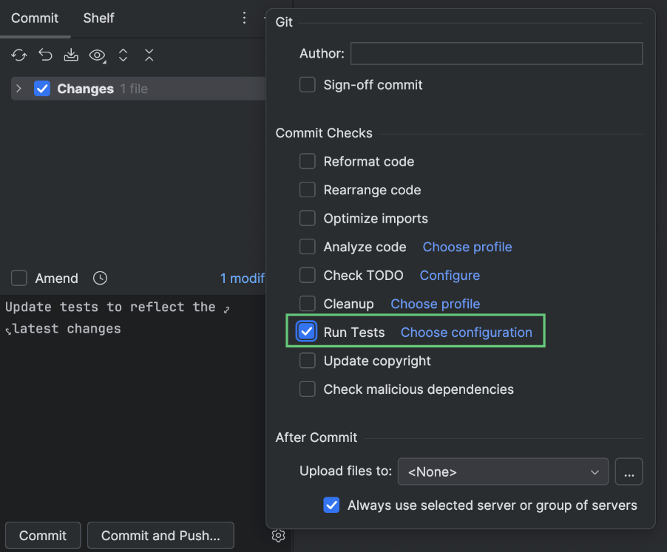

After you have set up the test configuration, the specified tests will run every time you make a commit.

#### Stop Tests﻿

Use the following options on the test results toolbar of the tab for the run configuration:

* 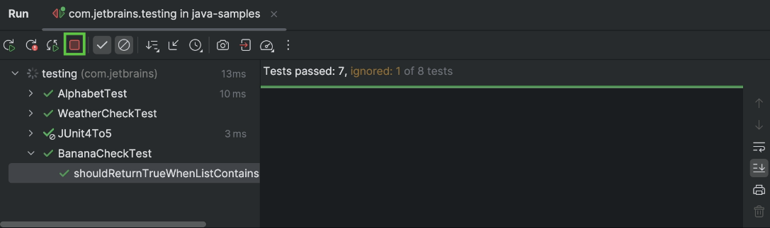Click  or press Ctrl+F2 to terminate the process immediately.
* 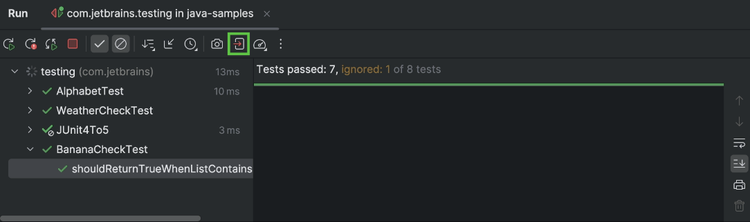Click  to terminate the process gracefully, allowing shutdown hooks to run.

### Rerun Tests﻿

#### Rerun a Single Test﻿

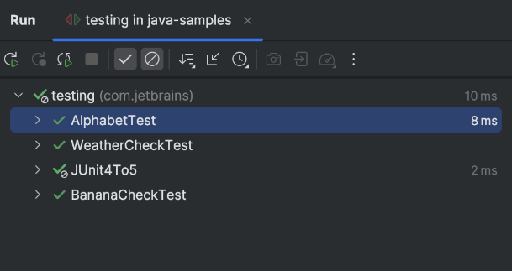

* Right-click a test on the tab for the run configuration in the Run tool window and select Run 'test name'.

#### Rerun All Tests in a Session﻿

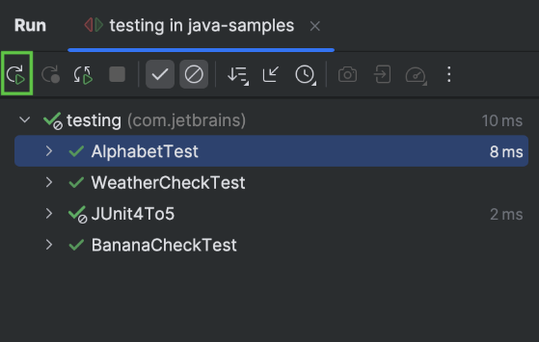

* Click  on the test results toolbar or press Ctrl+F5 to rerun all tests in a session.

#### Rerun Failed Tests﻿

* 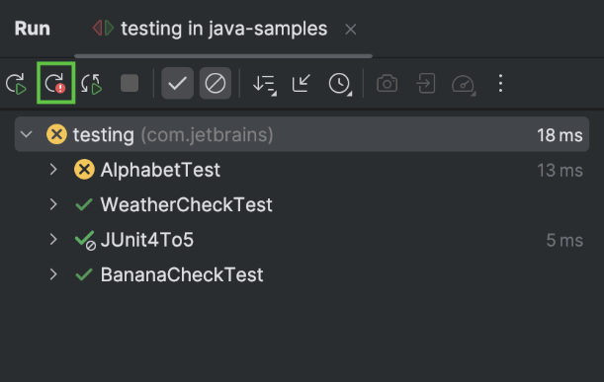Click  on the test results toolbar to rerun only failed tests.

Hold Shift and click  to choose whether you want to Run the failed tests again or Debug them.

You can configure the IDE to trigger tests that were ignored or not started during the previous test run together with failed tests. Click  on the test results toolbar and enable the Include Non-Started Tests into Rerun Failed option.

#### Rerun Tests Automatically﻿

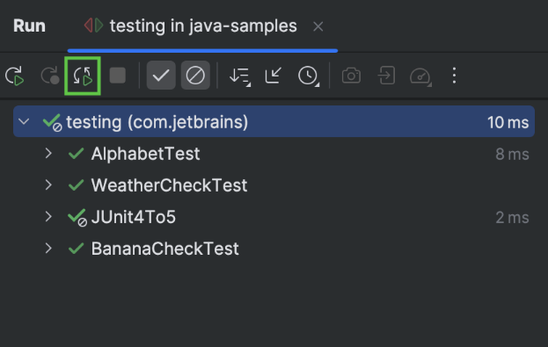In IntelliJ IDEA, you can enable the autotest-like runner: any test in the current run configuration restarts automatically after you change the related source code.

* Click  Rerun Automatically on the test results toolbar to enable the autotest-like runner.

### Debug Failed Tests﻿

If you don't know why a test fails, you can debug it.

1. In the editor, click the gutter on the line where you want to set a breakpoint.

There are different types of breakpoints that you can use depending on where you want to suspend the program. For more information, refer to [Breakpoints](https://www.jetbrains.com/help/idea/using-breakpoints.html).

1. Right-click the  gutter icon next to the failed test and select Debug 'test name'.

The test will rerun in debug mode. After that, the test will be suspended, allowing you to [examine its current state](https://www.jetbrains.com/help/idea/examining-suspended-program.html).

You can [step through the test](https://www.jetbrains.com/help/idea/stepping-through-the-program.html) to analyze its execution in detail.

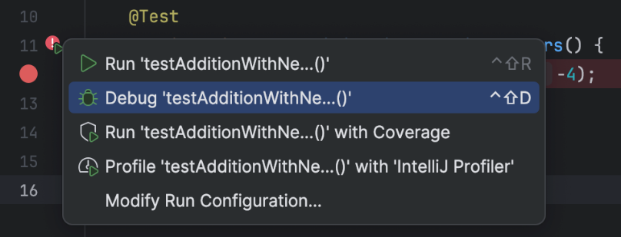

#### Explore Test Results﻿

Open the Run tool window: View | Tool Windows | Run (Alt+4)

While the tests are running in IntelliJ IDEA, the test execution is shown in the Run tool window on a tab for that run configuration. When the test execution is finished, you can look at the test results in that tab.

The console on the right shows the output of the current test session. It allows you to see the detailed information on the test execution and why your tests failed or were ignored. You may also [save the console output to a file](https://www.jetbrains.com/help/idea/setting-log-options.html#save-console-output-to-a-file).

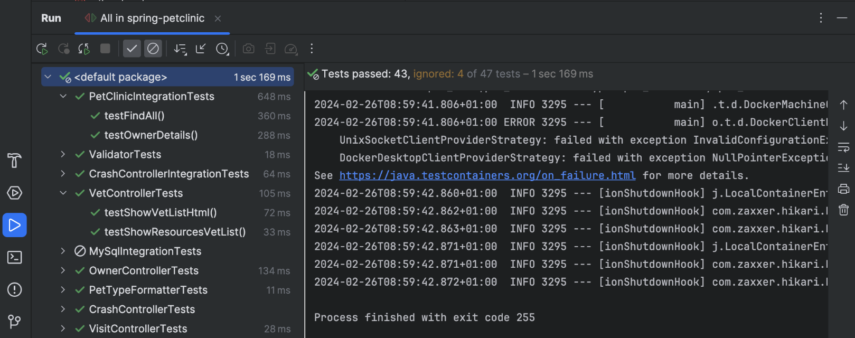

The test results toolbar located above the list of test results allows you to [show and hide](https://www.jetbrains.com/help/idea/viewing-and-exploring-test-results.html#sort-test-results) successful and ignored tests, [display how much time](https://www.jetbrains.com/help/idea/viewing-and-exploring-test-results.html#stats) it took to run each test, [export](https://www.jetbrains.com/help/idea/viewing-and-exploring-test-results.html#export), [import](https://www.jetbrains.com/help/idea/viewing-and-exploring-test-results.html#import-test-results), and [sort](https://www.jetbrains.com/help/idea/viewing-and-exploring-test-results.html#sort-test-results) test results.



Next to each test on the run configuration tab, the IDE shows the test status icon:

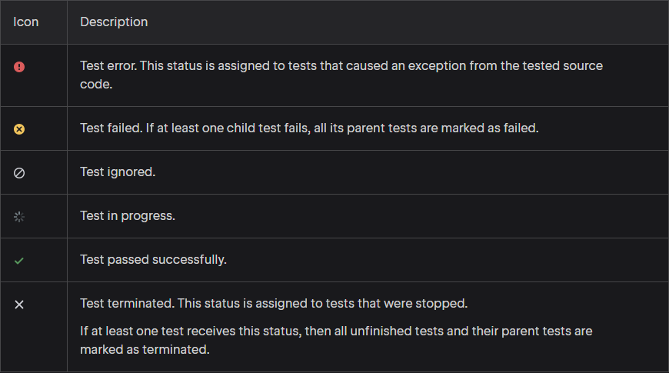

#### Sort and Filter Test Results﻿

Use the following options on the test results toolbar if you want to focus only on the failed tests or if you want to reorganize test results.

* 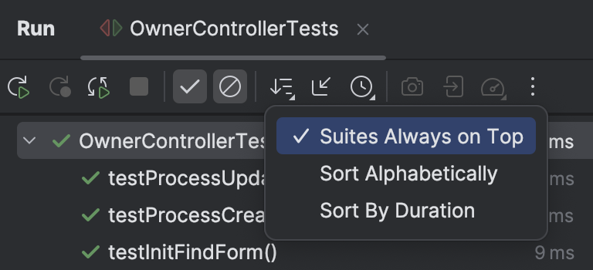Disable the  Show Passed option to hide successful tests.
* Disable the  Show Ignored option to hide ignored tests.
* Click  and select how you want to sort the test results:
  + Suites Always on Top – click to display suites on top.
  + Sort Alphabetically – click to sort test results alphabetically.
  + Sort by Duration – click to place test nodes on top of the list.

#### Track Test Execution﻿

In IntelliJ IDEA, you can monitor execution of the current test. If a test suite contains multiple tests, the list of tests expands to show test methods as they run one by one.

* To monitor test execution, click  More on the toolbar and navigate to Test Runner Settings | Track Running Test. Ensure that Track Running Test is selected.

Track Running Test enabled:

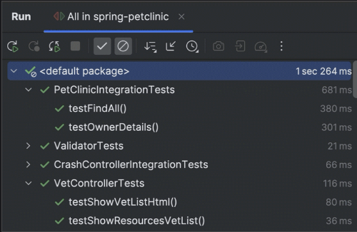

Track Running Test disabled:

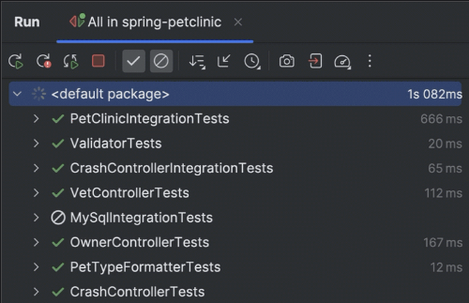

#### Manage Test Results﻿

* Click  on the test results toolbar then select Test Runner Settings and enable the following options:

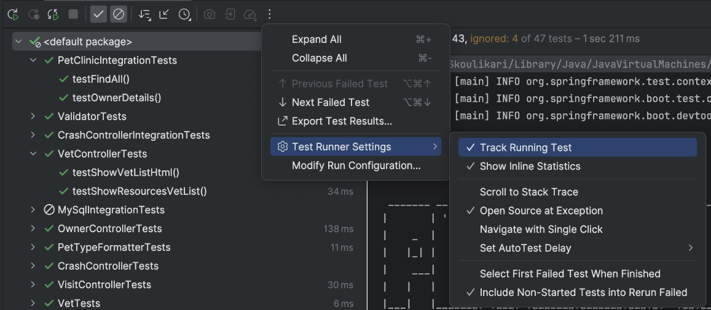

* + [Track Running Test](https://www.jetbrains.com/help/idea/viewing-and-exploring-test-results.html#track-test-execution): monitor execution of the current test.
  + [Show Inline Statistics](https://www.jetbrains.com/help/idea/viewing-and-exploring-test-results.html#stats): view the execution time for tests.
  + Scroll to Stack Trace: if a test produced a lot of output (for example, logging) before failing, this option automatically scrolls the output console to the assertion failure once you select the test on the run configuration tab.
  + Open Source at Exception: if you double-click a failed test method on the run configuration tab with this option on, the editor will scroll to the line on which the exception was thrown (instead of scrolling to the test method declaration).
  + Navigate with Single Click: open the code for the selected test automatically in the editor.
  + Set Auto Test Delay: point to this node to reveal the list of available delays between file saving and rerunning tests. The selected value gets the check mark.
  + Select First Failed Test When Finished: automatically select the first failed test in the list upon completing the test session.
  + Include Non-Started Tests into Rerun Failed: if some tests were ignored or not started during the previous test run, this option executes them together with the failed tests when you click  ([Rerun Failed Tests](https://www.jetbrains.com/help/idea/performing-tests.html#rerun-failed-tests)).

#### View Statistics﻿

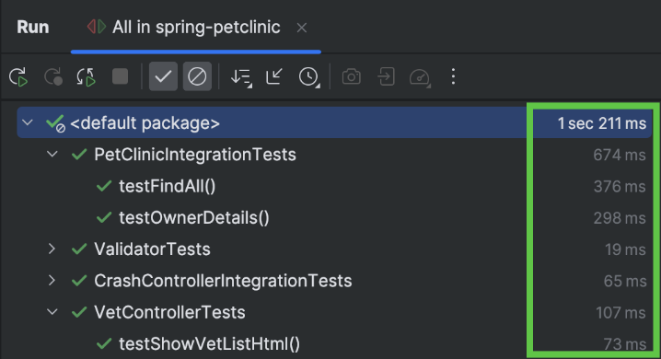

* To view the execution time for tests, click  on the test results toolbar, then select Test Runner Settings and enable the Show Inline Statistics option.

#### Jump to Test Declaration﻿

* Select the necessary test from the list on the Test Runner tab and press F4.

To make navigation even faster, use the [Navigate with Single Click](https://www.jetbrains.com/help/idea/viewing-and-exploring-test-results.html#manage-test-results) option.

#### View assertEquals difference﻿

If a unit test contains string assertEquals failures, the IDE allows you to compare the strings and view the differences.

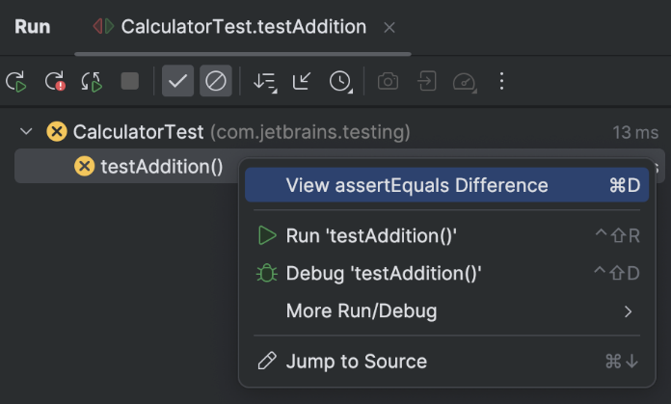

1. Right-click the necessary test and select View assertEquals Difference from the context menu.
2. 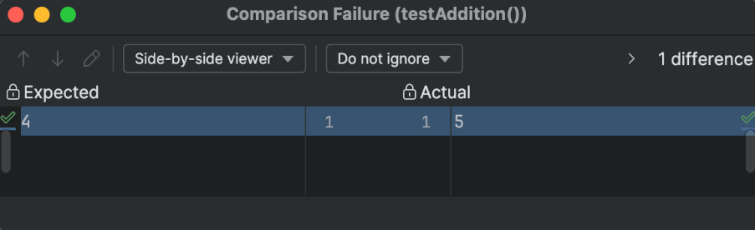Compare strings in the dedicated [Diff Viewer](https://www.jetbrains.com/help/idea/differences-viewer.html).

#### View Results of Previous Tests﻿

IntelliJ IDEA automatically saves results of the last 10 test sessions. To open the list of recent test sessions:

* Click the  icon on the test results toolbar and select the necessary test session from the list.

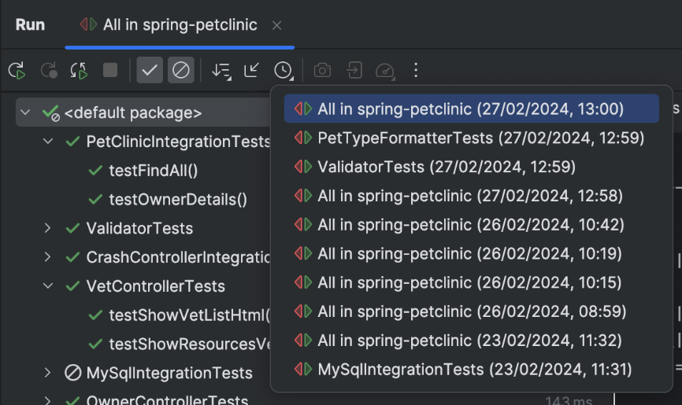For each test session, the list displays the [run configuration](https://www.jetbrains.com/help/idea/run-debug-configuration.html) name and a timestamp:

You can also [export](https://www.jetbrains.com/help/idea/viewing-and-exploring-test-results.html#export) test results to a file if you want to keep them or share with your team.

### Export and import test results﻿

#### Export test results to a file﻿

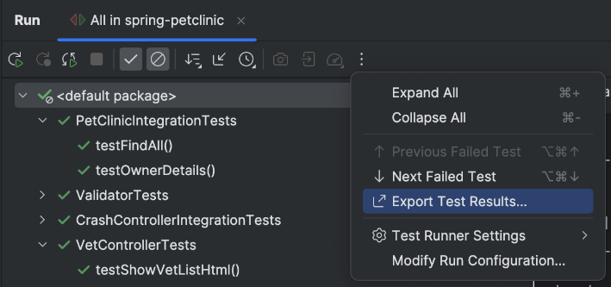

1. Click  on the test results toolbar, then click  Export Test Results.
2. 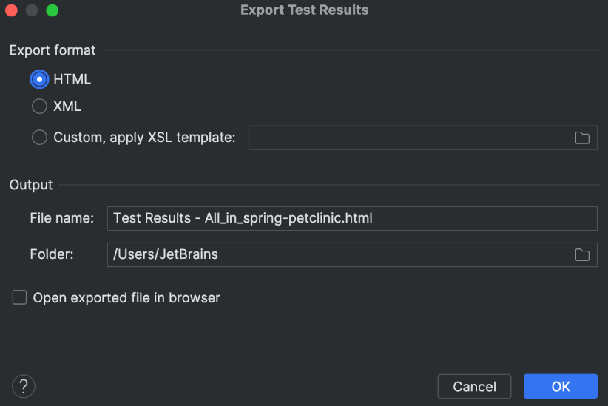Select the format in which you want to save the file:
   * HTML: generate an HTML file from a pre-defined template.
   * XML: use this format if you want to import this file later to IntelliJ IDEA.
   * Custom, apply XSL template: use your custom [XSL](https://www.w3schools.com/xml/xsl_intro.asp) template to generate an HTML file from the raw XML output. Click  next to this option and select the **\*.xsl** code style definition file.
3. Specify the name of the output file and its location.
4. If you want to open the file in your browser after you export it, select the Open exported file in browser checkbox. Click OK.

#### Import test results﻿

1. 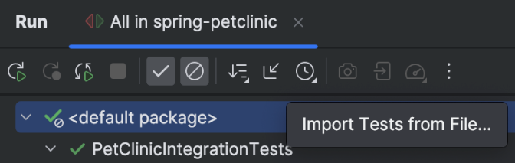To load a previously exported file, click  on the test results toolbar.

If you haven't run any tests yet, and the tool window with the test results toolbar is not available, press Ctrl+Shift+A and type Import Tests from File.

1. In the file system dialog that opens, select the **.xml** file with test results and click Open.

Import only works for the test results in **.xml** format.

### Get started with JUnit﻿

For more about JUnit, refer to [the official documentation](https://junit.org/junit5/). To learn more about testing features of IntelliJ IDEA, refer to other topics in this section.

You can choose to follow the tutorial using either Maven, Gradle, or the IntelliJ builder.

#### Maven:

##### Create a Project﻿

1. In the main menu, go to File | New | Project.
2. In the New Project wizard, select Java from the list on the left.
3. Specify the name for the project, for example, junit-tutorial, and select Maven as a build tool.
4. From the JDK list, select the [JDK](https://www.jetbrains.com/help/idea/sdk.html#jdk) that you want to use in your project.

If the JDK is installed on your computer, but not defined in the IDE, select Add JDK and specify the path to the JDK home directory.

If you don't have the necessary JDK on your computer, select Download JDK.

1. Click Create.

For more information about working with Maven projects, refer to [Maven](https://www.jetbrains.com/help/idea/maven-support.html).

##### Add Dependencies﻿

For our project to use JUnit features, we need to add JUnit as a dependency.

1. Open **pom.xml** in the root directory of your project.

To quickly navigate to a file, press Ctrl+Shift+N and enter its name.

1. In **pom.xml**, press AltInsert and select Dependency.
2. In the dialog that opens, type org.junit.jupiter:junit-jupiter in the search field.

Locate the necessary dependency in the search results and click Add.

1. When the dependency is added to **pom.xml**, press Ctrl+Shift+O or click  in the Maven tool window to import the changes.

The procedure above shows the 'manual' way so that you know what happens behind the scenes and where you set up the testing framework. However, if you just start writing tests, IntelliJ IDEA [will automatically detect if the dependency is missing and prompt you to add it](https://www.jetbrains.com/help/idea/testing.html#add-testing-libraries).

##### Write Application Code﻿

Let's add some code that we'll be testing.

In the Project tool window Alt+1, go to **src/main/java** and create a Java file called Calculator.java.

Paste the following code in the file:

import java.util.stream.DoubleStream;

public class Calculator {

static double add(double... operands) {

return DoubleStream.of(operands)

.sum();

}

static double multiply(double... operands) {

return DoubleStream.of(operands)

.reduce(1, (a, b) -> a * b);

}

}

##### Create Tests﻿

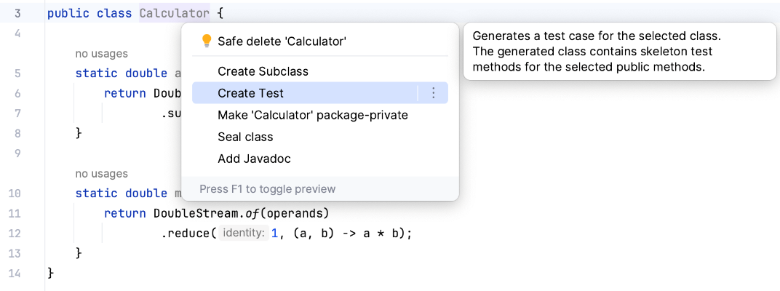Now let's create a test. A test is a piece of code whose function is to check if another piece of code is operating correctly. In order to do the check, it calls the tested method and compares the result with the predefined expected result. An expected result can be, for example, a specific return value or an exception.

1. 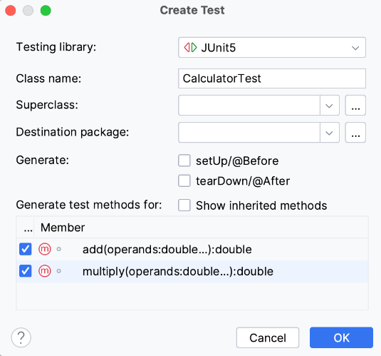Place the caret at the Calculator class declaration and press Alt+Enter. Alternatively, right-click it and select Show Context Actions. From the menu, select Create test.
2. Select the two class methods that we are going to test.
3. The editor takes you to the newly created test class. Modify the add() test as follows:

@Test

@DisplayName("Add two numbers")

void add() {

assertEquals(4, Calculator.add(2, 2));

}

This simple test will check if our method correctly adds 2 and 2. The @DisplayName annotation specifies a more convenient and informative name for the test.

1. Now what if you want to add multiple assertions in a single test and execute all of them regardless of whether some of them fail? Let's do it for the multiply() method:

@Test

@DisplayName("Multiply two numbers")

void multiply() {

assertAll(() -> assertEquals(4, Calculator.multiply(2, 2)),

() -> assertEquals(-4, Calculator.multiply(2, -2)),

() -> assertEquals(4, Calculator.multiply(-2, -2)),

() -> assertEquals(0, Calculator.multiply(1, 0)));

}

The assertAll() method takes a series of assertions in form of lambda expressions and ensures all of them are checked. This is more convenient than having multiple single assertions because you will always see a granular result rather than the result of the entire test.

To navigate between the test and the code being tested, use the Ctrl+Shift+T shortcut.

##### Run Tests and View Their Results﻿

After we have set up the code for the testing, we can run the tests and find out if the tested methods are working correctly.

* To run an individual test, click  in the gutter and select Run.

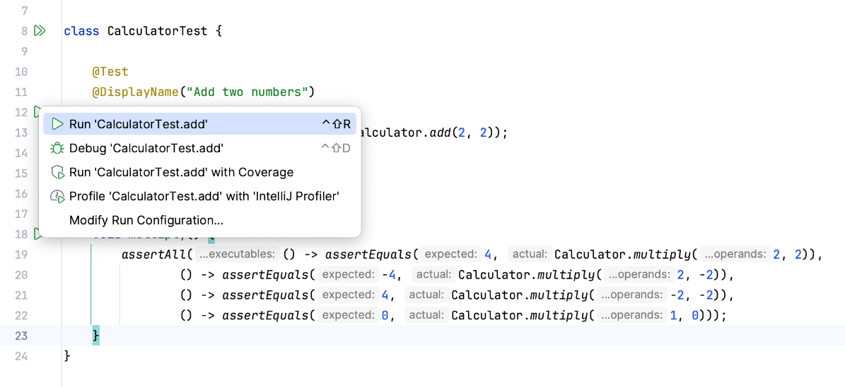

* To run all tests in a test class, click  against the test class declaration and select Run.

You can view test results in the Run tool window.

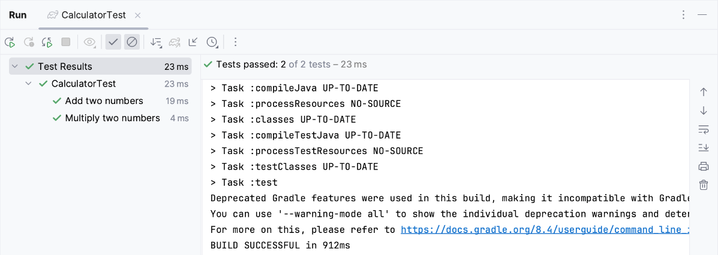

#### IntelliJ Build Tool

##### Create a Project﻿

1. In the main menu, go to File | New | Project.
2. In the New Project wizard, select Java from the list on the left.
3. Specify the name for the project, for example, junit-tutorial, and select IntelliJ as a build tool.
4. From the JDK list, select the [JDK](https://www.jetbrains.com/help/idea/sdk.html#jdk) that you want to use in your project.

If the JDK is installed on your computer, but not defined in the IDE, select Add JDK and specify the path to the JDK home directory.

If you don't have the necessary JDK on your computer, select Download JDK.

1. Click Create.

##### Add Dependencies﻿

For our project to use JUnit features, we need to add JUnit as a dependency.

1. In the main menu, go to File | Project Structure (Ctrl+Alt+Shift+S).
2. Under Project Settings, select Libraries and click  | From Maven.
3. 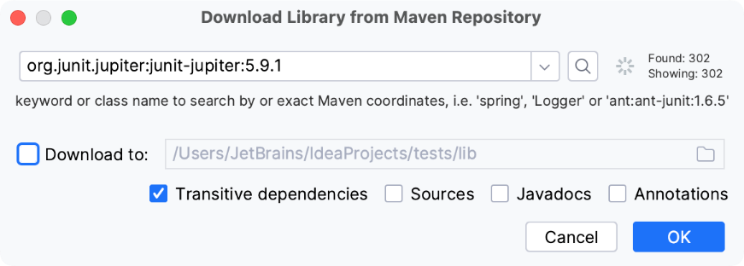In the dialog that opens, specify the necessary library artifact, for example: org.junit.jupiter:junit-jupiter:5.9.1.
4. Apply the changes and close the dialog.

The procedure above shows the 'manual' way so that you know what happens behind the scenes and where you set up the testing framework. However, if you just start writing tests, IntelliJ IDEA [will automatically detect if the dependency is missing and prompt you to add it](https://www.jetbrains.com/help/idea/testing.html#add-testing-libraries).

##### Write Application Code﻿

Let's add some code that we'll be testing.

1. In the Project tool window Alt+1, go to **src/main/java** and create a Java file called Calculator.java.
2. Paste the following code in the file:

import java.util.stream.DoubleStream;

public class Calculator {

static double add(double... operands) {

return DoubleStream.of(operands)

.sum();

}

static double multiply(double... operands) {

return DoubleStream.of(operands)

.reduce(1, (a, b) -> a * b);

}

}

##### Create Tests﻿

Now let's create a test. A test is a piece of code whose function is to check if another piece of code is operating correctly. In order to do the check, it calls the tested method and compares the result with the predefined expected result. An expected result can be, for example, a specific return value or an exception.

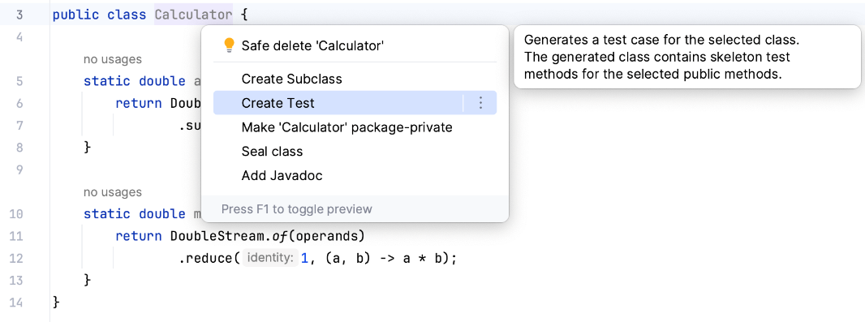

1. Place the caret at the Calculator class declaration and press Alt+Enter. Alternatively, right-click it and select Show Context Actions. From the menu, select Create test.
2. 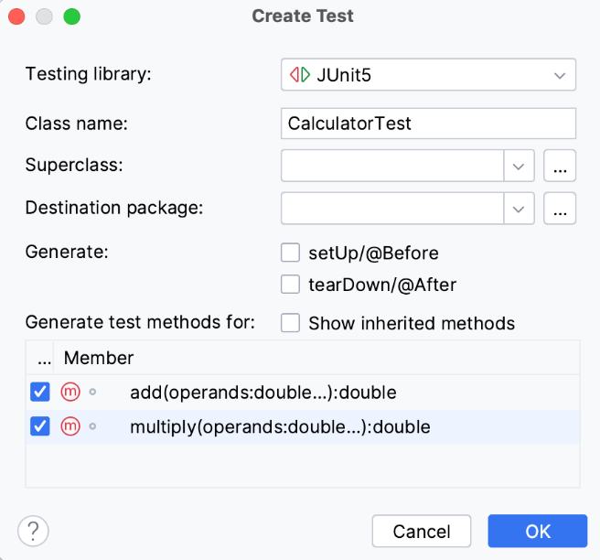Select the two class methods that we are going to test.
3. The editor takes you to the newly created test class. Modify the add() test as follows:

@Test

@DisplayName("Add two numbers")

void add() {

assertEquals(4, Calculator.add(2, 2));

}

This simple test will check if our method correctly adds 2 and 2. The @DisplayName annotation specifies a more convenient and informative name for the test.

1. Now what if you want to add multiple assertions in a single test and execute all of them regardless of whether some of them fail? Let's do it for the multiply() method:

@Test

@DisplayName("Multiply two numbers")

void multiply() {

assertAll(() -> assertEquals(4, Calculator.multiply(2, 2)),

() -> assertEquals(-4, Calculator.multiply(2, -2)),

() -> assertEquals(4, Calculator.multiply(-2, -2)),

() -> assertEquals(0, Calculator.multiply(1, 0)));

}

The assertAll() method takes a series of assertions in form of lambda expressions and ensures all of them are checked.

This is more convenient than having multiple single assertions because you will always see a granular result rather than the result of the entire test.

To navigate between the test and the code being tested, use the Ctrl+Shift+T shortcut.

##### Run Tests and View Their Results﻿

After we have set up the code for the testing, we can run the tests and find out if the tested methods are working correctly.

* 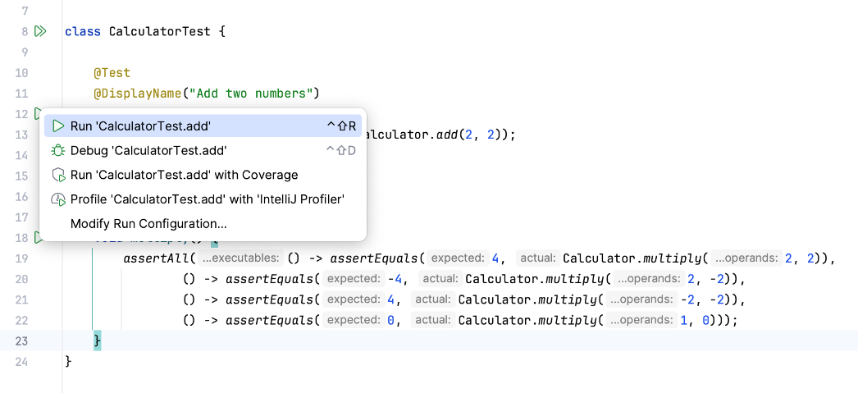To run an individual test, click  in the gutter and select Run.
* 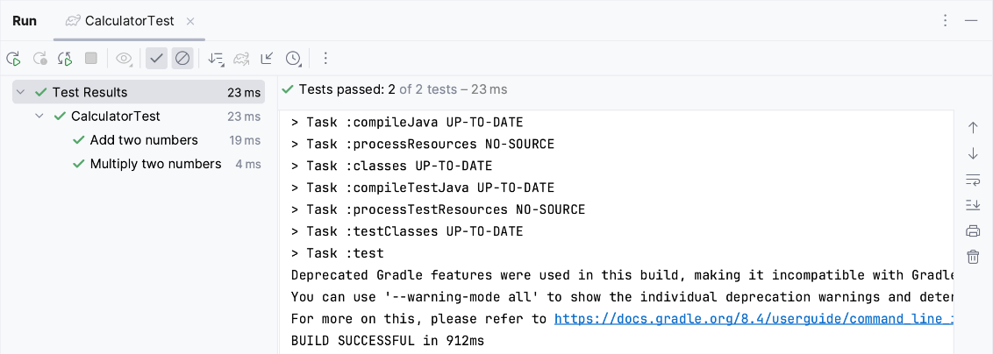To run all tests in a test class, click  against the test class declaration and select Run.

You can view test results in the Run tool window.

#### Run/Debug configuration: JUnit﻿

JUnit run/debug configurations define how unit tests that are based on the JUnit testing framework should be run.

##### Create a New JUnit Run Configuration﻿

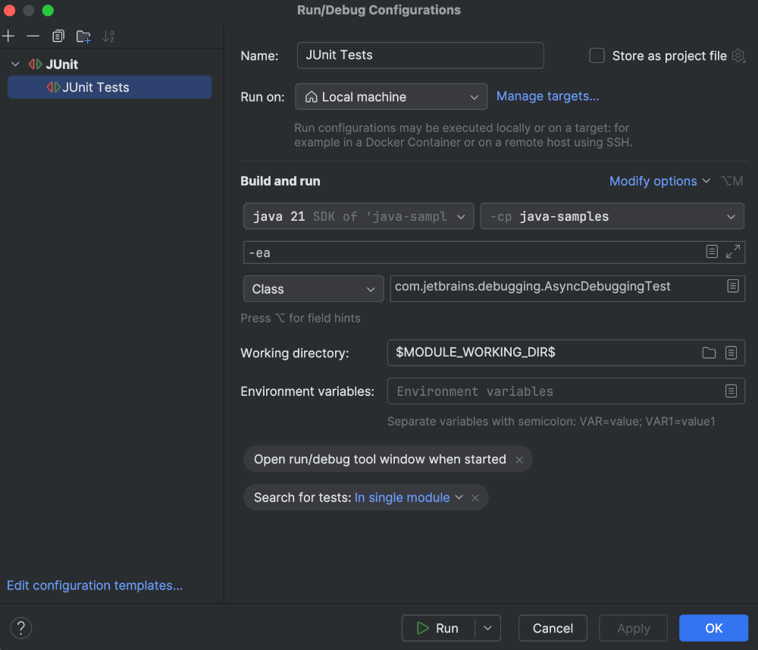

1. In the main menu, go to Run | Edit Configurations.
2. In the Run/Debug Configuration dialog, click  on the toolbar or press Alt+Insert.

The list shows the run/debug configuration templates. Select JUnit.

On the right, you will see configuration options.

You can use Ctrl+Space to let IntelliJ IDEA [help you fill in the fields](https://www.jetbrains.com/help/idea/auto-completing-code.html) in this dialog.

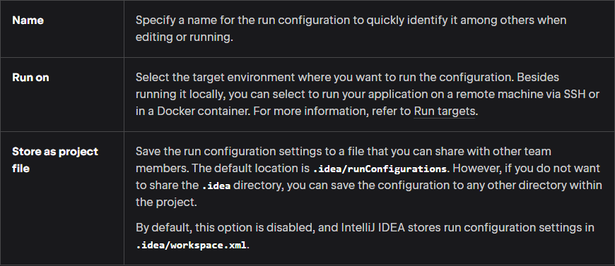

##### Required Options﻿

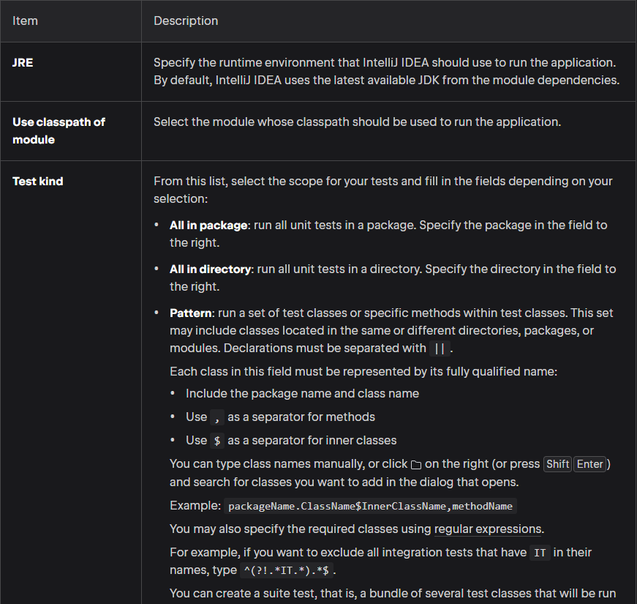

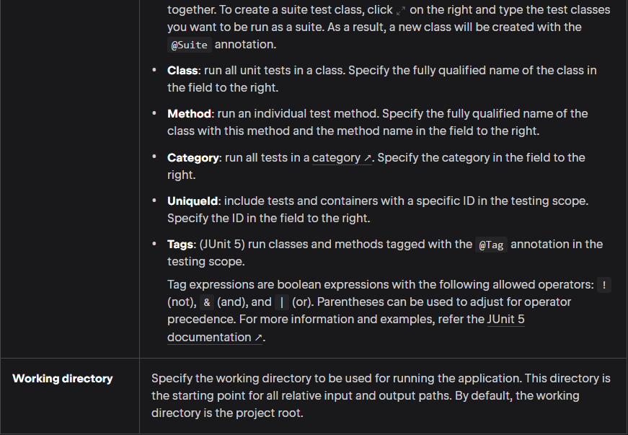

##### More Options﻿

To view more options for how to run unit tests that are based on the JUnit testing framework, select Modify options in the Run/Debug Configurations dialog. This will open the Add Run Options dialog.

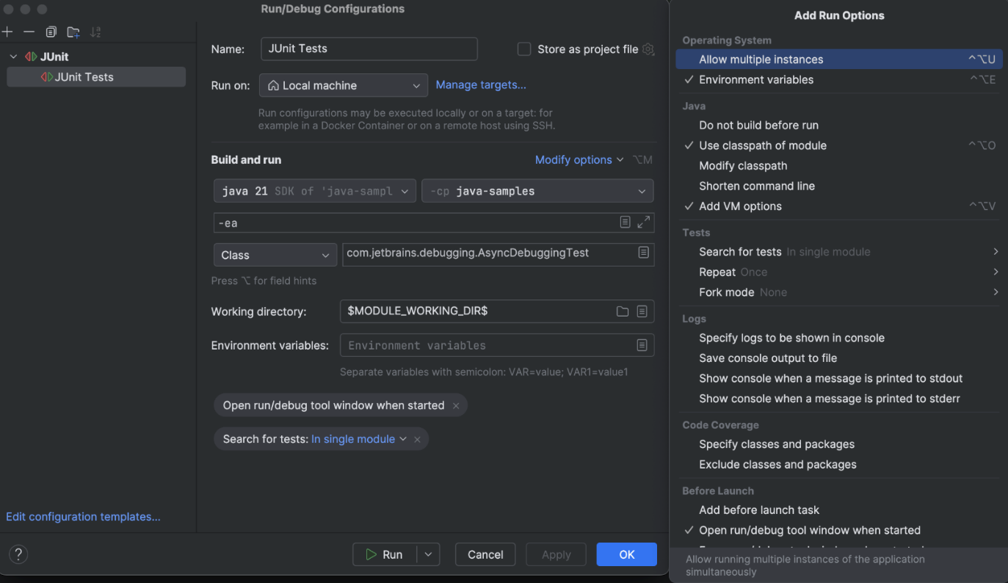

##### Operating System﻿

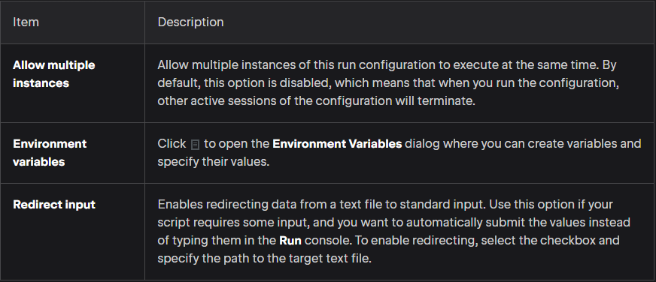

##### Java﻿

The following options are specific to the Java compiler and runtime:

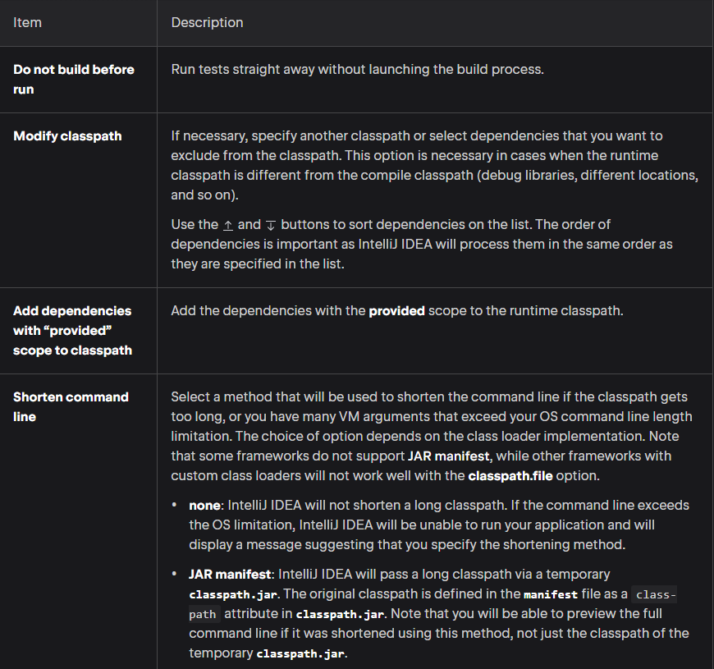

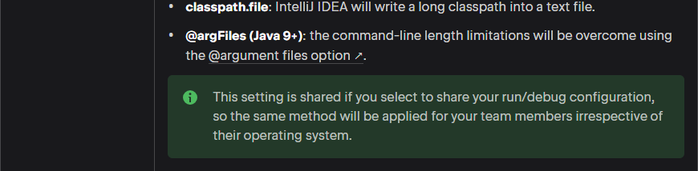

##### Tests﻿

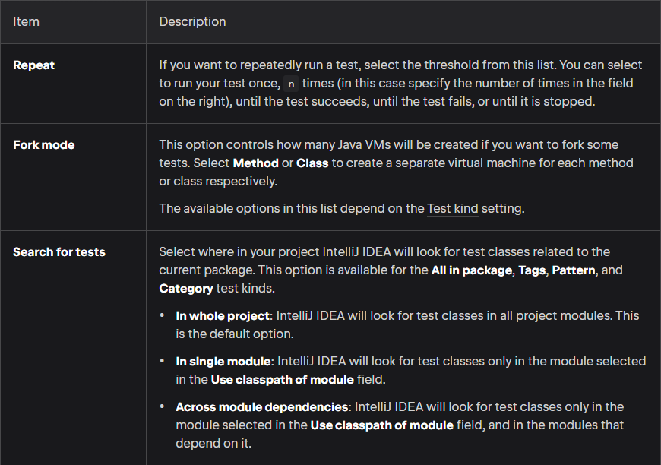

##### Logs﻿

The following options are related to logging the execution of this configuration. For more information, refer to [View logs](https://www.jetbrains.com/help/idea/setting-log-options.html).

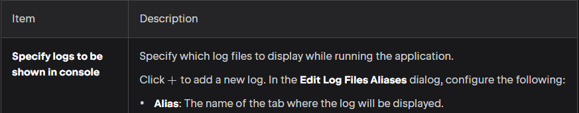

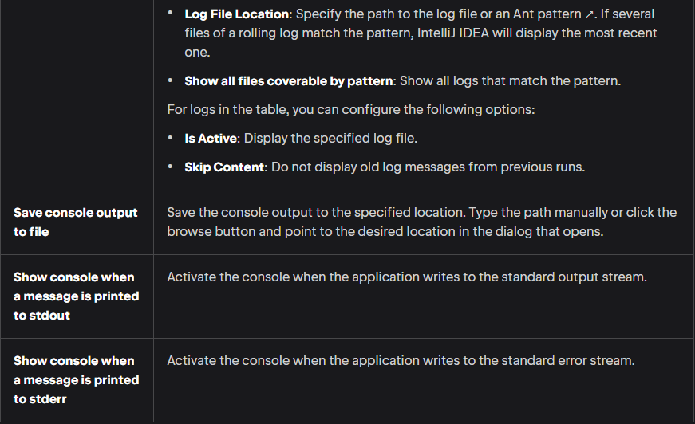

##### Code Coverage﻿

The following options are related to code coverage. For more information, refer to [Code coverage](https://www.jetbrains.com/help/idea/code-coverage.html).

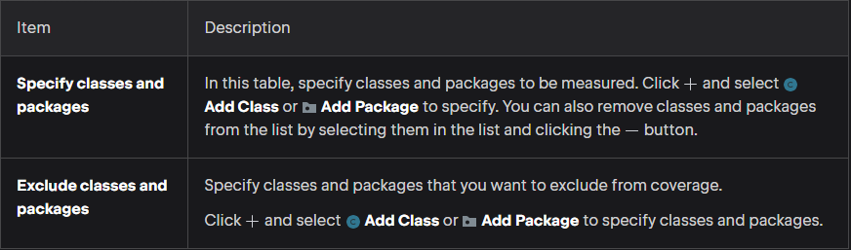

##### Before Launch﻿

In this area, you can specify tasks to be performed before starting the selected run/debug configuration. The tasks are performed in the order they appear in the list.

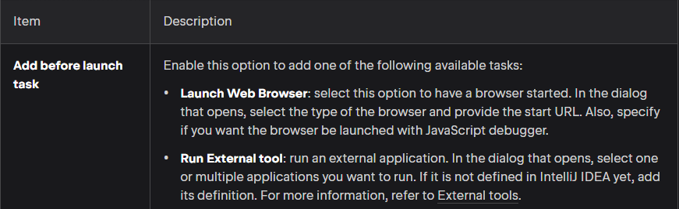

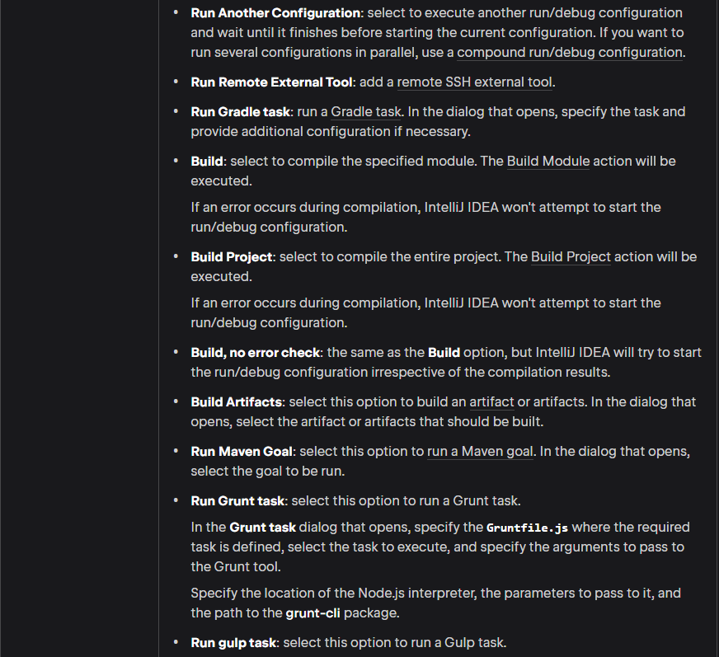

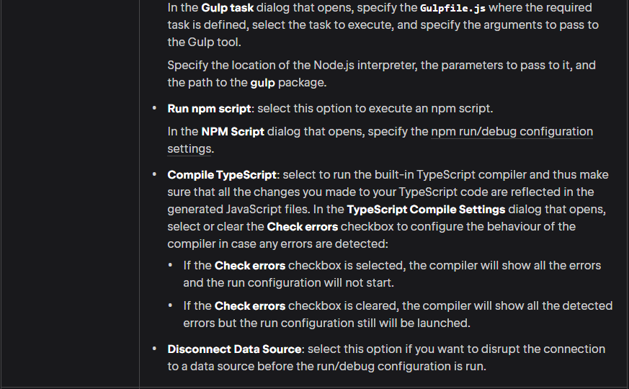

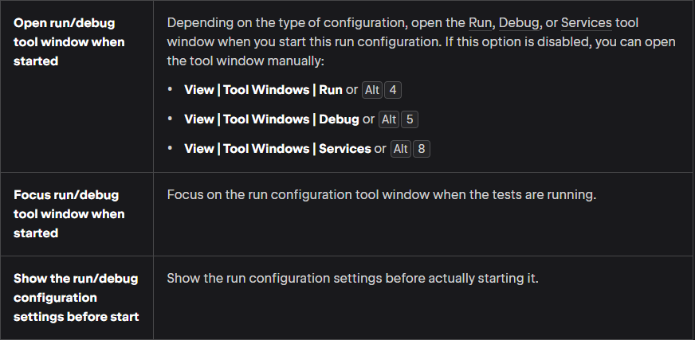

##### JUnit Assertion Methods

There are many assertion methods available in JUnit:

1. assertEquals() – Checks that two primitives/objects are equal.
2. assertTrue() – Checks that a condition is true.
3. assertFalse() – Checks that a condition is false.
4. assertNotEquals() – we can use this instaed of assertEquals() when we don’t want the actual value to be equal to a specified value.
5. assertArrayEquals() – when we want to verify the value of an array, we have to use the assertArrayEquals() method. The assertEquals() method won’t work because it will only consider two arrays equal if they are the same instance. The assertArrayEquals() method considers two arrays equal when their lengths are the same and every element in both arrays is the same (and in the same order).
6. assertNull() and assertNontNull() – we can use these methods to check for null and non-null values. We can use assertEquals() to check for null, but as with the assertTrue() and assertFalse() methods, using assertNull() and assertNotNull() makes the intention clearer, and we only have to pass the actual value to the method.
7. assertSame() and assertNotSame() – we use this when we want to check whether two instances are the exact same instance. Remember that the assertEquals() method uses the equals() method to test for equality. The assertSame() method compares the object references.
8. assertThat() – this method compares the actual value against a matcher (not the Matcher in the JDK, but a JUnit matcher class). This is more powerful than the other assert methods since we can compare the actual value against a range of values. Note that this method only became available in JUnit 4.4.

## Section 25 – JavaFX

### Introduction

#### Overview

JavaFX was designed with the MVC, or model-view-controller, pattern in mind. In a nutshell, this pattern keeps the code that handles an application’s data separate from the UI code.

Because of this, when you’re using the MVC pattern, we wouldn’t mix the code that deals with the UI and the code that manipulates the application data in the same class. The controller is sort of the middleman between the UI and the data.

When working with JavaFX, the model corresponds to the application’s data model, the view is the FXML, and the controller is the code that determines what happens when a user interacts with the UI. Essentially, the controller handles events.

#### Layouts

Layouts allow us to add controls, which are UI components, to a container without having to write the code required to manage the positioning as well as the resizing behavior of those controls. The layout will manage all of that for us.

JavaFX has 8 layouts:

* GridPane ● AnchorPane ● StackPane ● HBox ● VBox
* FlowPane ● FlowPane ● TilePane ● BorderPane

##### BorderPane

If we use the BorderPane, the nodes are arranged in the Top, Left, Right, Bottom and Center positions. The class named **BorderPane** of the package **javafx.scene.layout** represents the BorderPane.

This class contains five properties, which include −

* 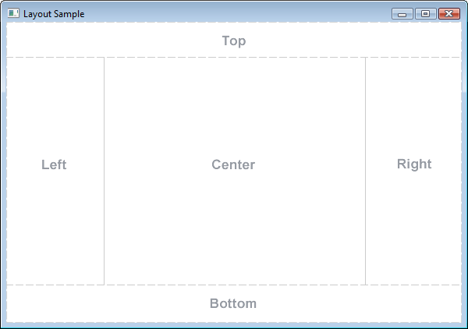**bottom** − This property is of **Node** type and it represents the node placed at the bottom of the BorderPane. You can set value to this property using the setter method **setBottom()**.
* **center** − This property is of **Node** type and it represents the node placed at the center of the BorderPane. You can set value to this property using the setter method **setCenter()**.
* **left** − This property is of **Node** type and it represents the node placed at the left of the BorderPane. You can set value to this property using the setter method **setLeft()**.
* **right** − This property is of **Node** type and it represents the node placed at the right of the BorderPane. You can set value to this property using the setter method **setRight()**.
* **top** − This property is of **Node** type and it represents the node placed at the top of the BorderPane. You can set value to this property using the setter method **setTop()**.

In addition to these, this class also provides the following method −

* **setAlignment()** − This method is used to set the alignment of the nodes belonging to this pane. This method accepts a node and a priority value.

#### Preferred Size

Every control computes its preferred size based on its contents. So, whenever talking about preferred size, it’s referring to preferred width and height when a control is being displayed.

As an example, JavaFX has a button control where the button will automatically resize itself to be able to display whatever it has inside it – whatever the button’s contents are. So, if working with an ‘OK’ button, the button would work itself so that its border would fit itself around the text “OK”. It wouldn’t stretch itself all the way across the application, it would just make itself wide enough to fit around the text “OK”, and tall enough as well.

Layouts often use the preferred size of the controls they are laying out to determine how much space the control will ultimately get. So, when a control is placed into a layout, it becomes a child of that layout. Thus, some layouts will ensure that their children will display at their preferred widths and heights.

### Create a new JavaFX project﻿

JavaFX is a software platform used for developing desktop applications that can run across a wide variety of devices.

JavaFX support in IntelliJ IDEA includes code completion, search, navigation and refactoring in JavaFX-specific source files (including **.fxml** and JavaFX **.css** files), integration with JavaFX Scene Builder, JavaFX application packaging capabilities, and more.

#### Make Sure the JavaFX Plugin is Enabled﻿

To be able to work with JavaFX in IntelliJ IDEA, the JavaFX bundled plugin must be enabled:

1. Press Ctrl+Alt+S to open settings and then select Plugins.
2. Switch to the Installed tab and make sure that the JavaFX plugin is enabled.

If the plugin is disabled, select the checkbox next to it.

1. Apply the changes and close the dialog. Restart the IDE if prompted.

#### Create a new project﻿

Java 11 or later is required to create JavaFX applications.

When you create a new JavaFX project, IntelliJ IDEA generates a fully configured sample application.

1. Launch IntelliJ IDEA.

If the Welcome screen opens, click New Project. Otherwise, go to File | New | Project in the main menu.

1. From the Generators list on the left, select JavaFX.
2. Name the new project, change its location if necessary, and select a language, and a build system.
3. In the Group field, specify the name of the package that will be created together with the project.
4. From the JDK list, select the [JDK](https://www.jetbrains.com/help/idea/sdk.html#jdk) that you want to use in your project.

If the JDK is installed on your computer, but not defined in the IDE, select Add JDK and specify the path to the JDK home directory. If you don't have the necessary JDK on your computer, select Download JDK.

Click Next.

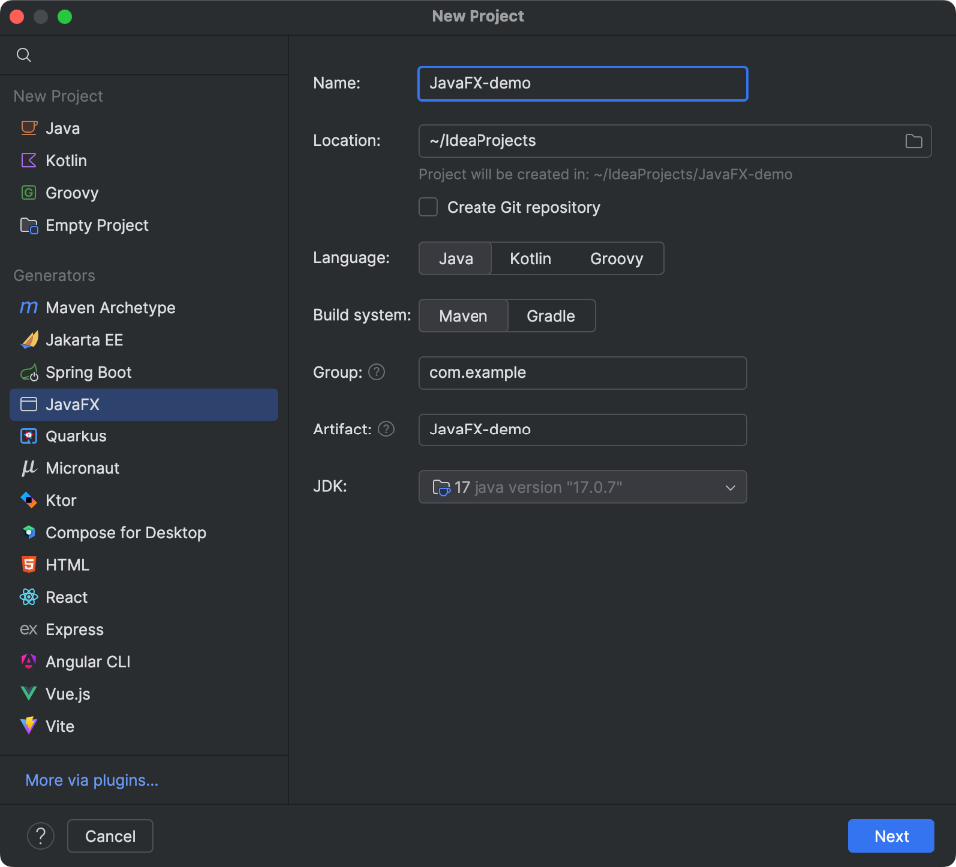

1. On the next step of the wizard, select the libraries that you want to use in your application and click Create.

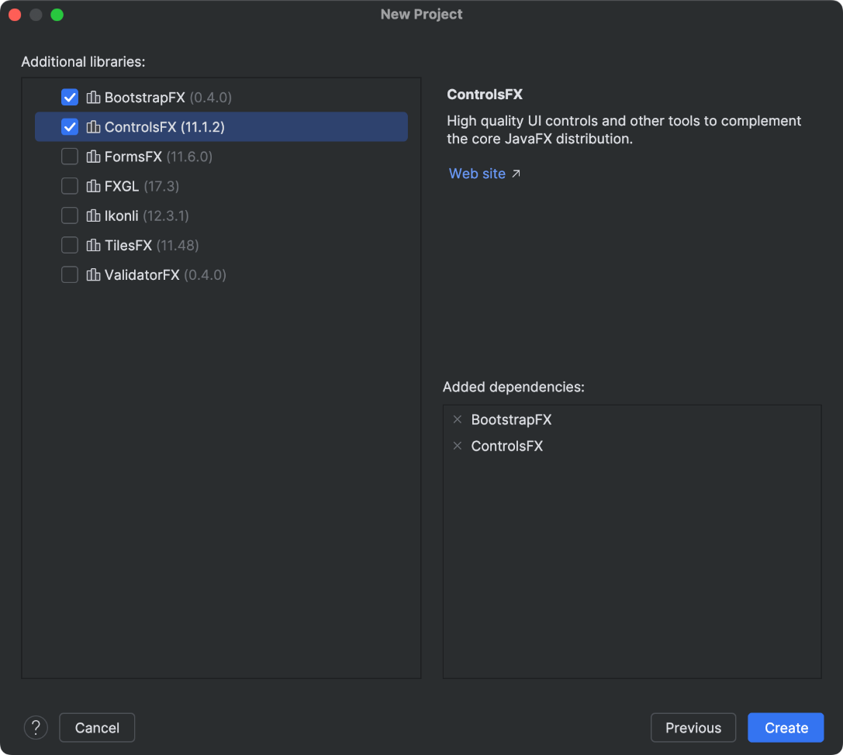

#### Run the Application﻿

1. Open the **HelloApplication.java** class, click the  icon in the gutter, and select Run 'HelloApplication.main()'.

The IDE starts compiling your code.

1. When the compilation is complete, the application window appears.

This means that the project is configured correctly and everything works as it should. When you clicked Run, IntelliJ IDEA created a temporary [run configuration](https://www.jetbrains.com/help/idea/run-debug-configuration.html) named after the HelloApplication class. You can view and edit this configuration: in the main menu, go to Run | Edit Configurations.

For more information about creating modular and non-modular projects with Maven or Gradle, refer to [Getting Started with JavaFX](https://openjfx.io/openjfx-docs/#IDE-Intellij).

#### Package the Application with JLink﻿

JavaFX was removed from the JDK starting with Java 11. As a result, JavaFX libraries are no longer bundled with the JDK and are not automatically included when packaging your application into a **JAR** file.

To package your code with Java 11 and later, you can use the jlink tool that is bundled with the JDK. Maven and Gradle projects that you create in IntelliJ IDEA come with the corresponding tasks to call jlink.

This will build a folder with JRE and application executables. The resulting program will only work on the same operating system and architecture as the host. For example, Linux will produce Linux binaries, macOS will produce macOS binaries, and x64 will produce x64 binaries.

Press Ctrl twice to open Run Anything and run mvn javafx:jlink.

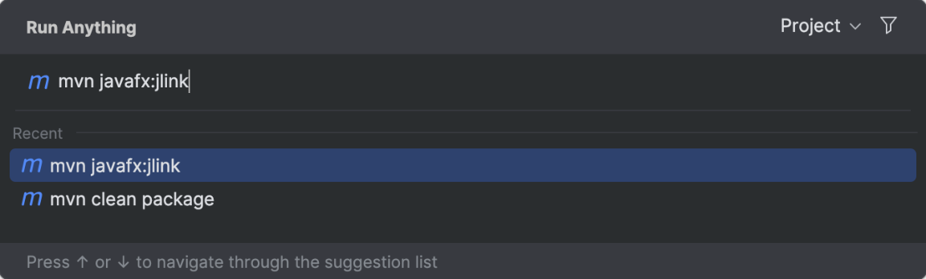

The IDE places the application to the **target | app** folder.

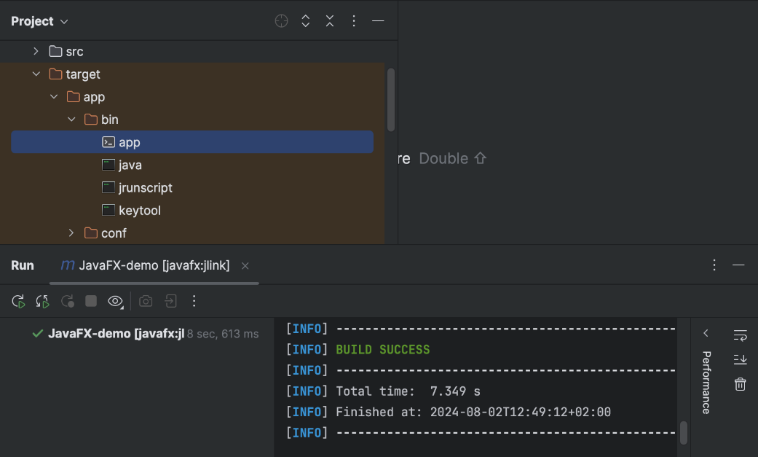

#### Troubleshoot﻿

* Process finished with exit code -1073740791 (0xC0000409)

The problem is caused by an error in the NVIDIA driver. Update your driver to the latest version. For more information, refer to the [community forum](https://intellij-support.jetbrains.com/hc/en-us/community/posts/115000060510-Process-finished-with-exit-code-1073740791-0xC0000409-JavaFX-Application).

* "..." cannot be opened because the developer cannot be verified.

The problem is caused by [notarization](https://developer.apple.com/documentation/security/notarizing_macos_software_before_distribution) in macOS software. Follow the steps in the [discussion](https://github.com/hashicorp/terraform/issues/23033) to resolve the problem.

### Configure JavaFX Scene Builder﻿

IntelliJ IDEA allows you to open **.fxml** files in JavaFX Scene Builder right from the IDE so that you can visually design JavaFX interfaces directly.

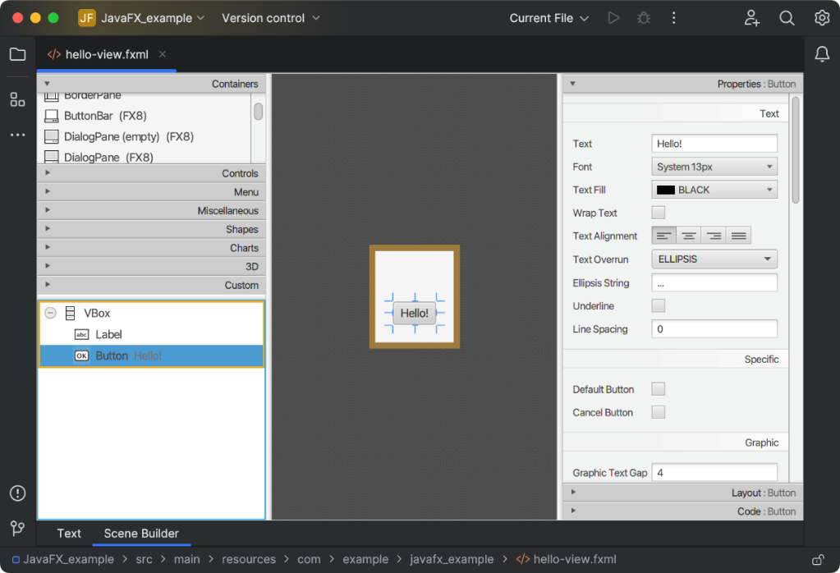

#### Open Files in Scene Builder in the IDE﻿

When you open an **.fxml** file in the editor, there are two tabs underneath the editing area: the Text tab is for developing the markup, and the Scene Builder tab is for editing the file in Scene Builder.

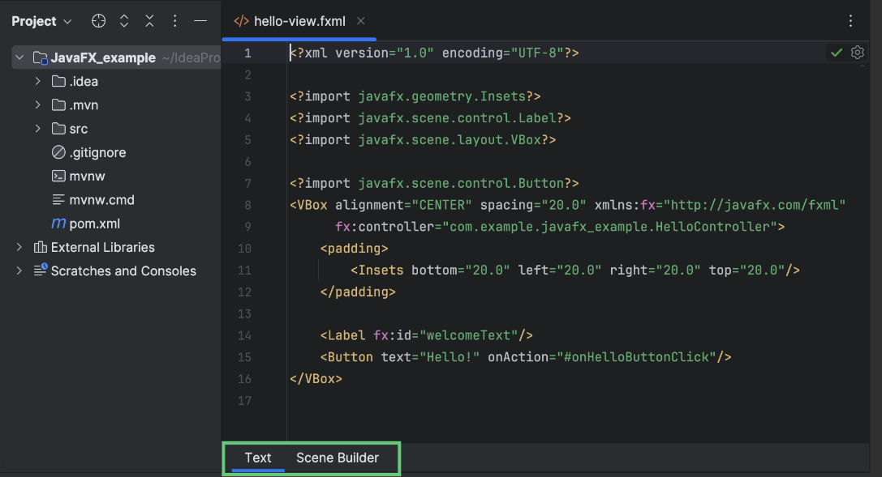

1. Open an **.fxml** file in the editor.
2. Switch to the Scene Builder tab.
3. If your project doesn't have JavaFX Scene Builder, you will see a notification panel prompting you to install Scene Builder Kit.

Click Download Scene Builder Kit on the panel.

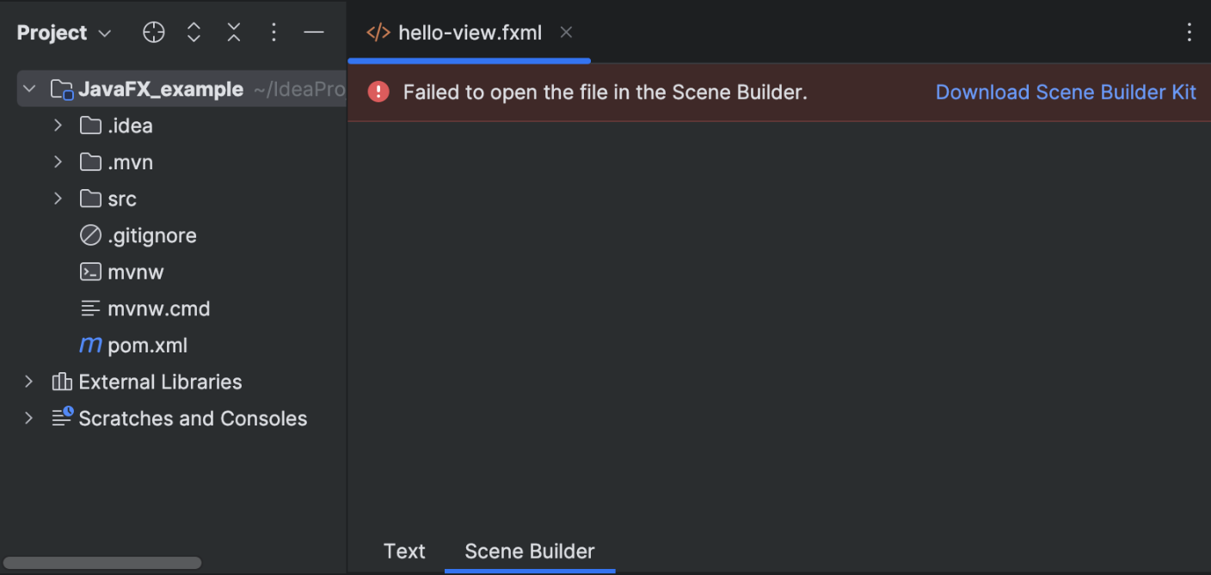

After that you can view **.fxml** files in Scene Builder right in the IDE by switching to the dedicated tab.

Learn how to use JavaFX Scene Builder from [JavaFX Scene Builder: User Guide](https://docs.oracle.com/javase/8/scene-builder-2/user-guide/index.html) on the Oracle website.

#### Open Files in the Scene Builder Application﻿

You can configure the path to Scene Builder in IDE settings. In this case, you will be able to open **.fxml** files outside the IDE in the Scene Builder application.

##### Configure the Path to Scene Builder﻿

1. Download and install the latest version of [Scene Builder](https://gluonhq.com/products/scene-builder/).
2. Press Ctrl+Alt+S to open settings and then select Languages & Frameworks | JavaFX.
3. Click  in the Path to SceneBuilder field.
4. In the dialog that opens, specify the path to the Scene Builder executable file on your computer.

The standard paths are:

Windows:

**С:\Users\Username\AppData\Local\SceneBuilder\SceneBuilder.exe**

The path on Linux depends on your distribution.

1. Apply the changes and close the dialog.

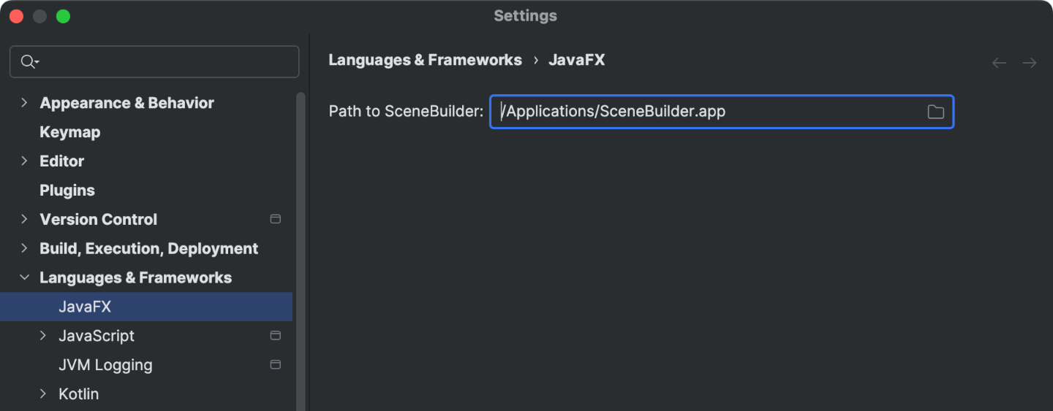

#### Launch Scene Builder from the IDE﻿

1. Press Alt+1 or go to View | Tool Windows | Project in the main menu to open the Project tool window.
2. Right-click an **.fxml** file you want to open and select Open In SceneBuilder.

The Scene Builder application starts, showing you the contents of the selected file.

### Package JavaFX Applications﻿

You can package your JavaFX application by building the corresponding artifact (a Java archive). For JavaFX applications, IntelliJ IDEA provides a dedicated artifact type: JavaFx Application.

Packaging a JavaFX application in **.jar** is possible only with Java 8. For Java 11 and later, use the [jlink tool to package your application](https://www.jetbrains.com/help/idea/javafx.html#package-app-with-jlink).

#### Build JavaFX Artifacts﻿

##### Create a New Artifact Configuration﻿

IntelliJ IDEA creates the artifact for packaging the application together with the project. However, you can create a new artifact configuration with your custom settings.

1. In the main menu, go to File | Project Structure Ctrl+Alt+Shift+S and click Artifacts.
2. Click , point to JavaFx Application, and select From module '...'.

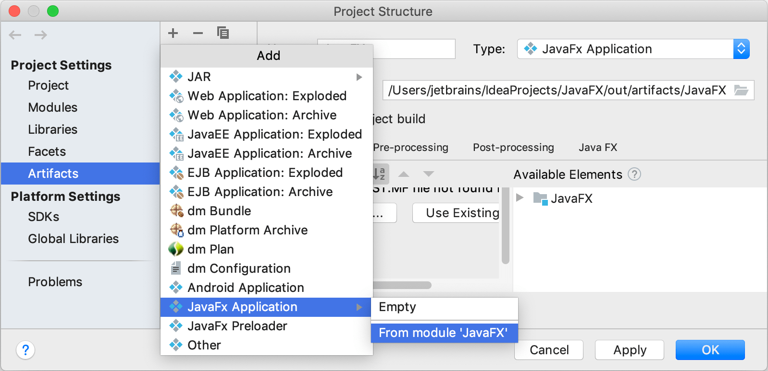

IntelliJ IDEA creates the artifact configuration and shows its settings in the right-hand part of the Project Structure dialog.

1. Name the new configuration.
2. Switch to the JavaFX tab and in the Application class field, specify the main() method.
3. Apply the changes and close the dialog.

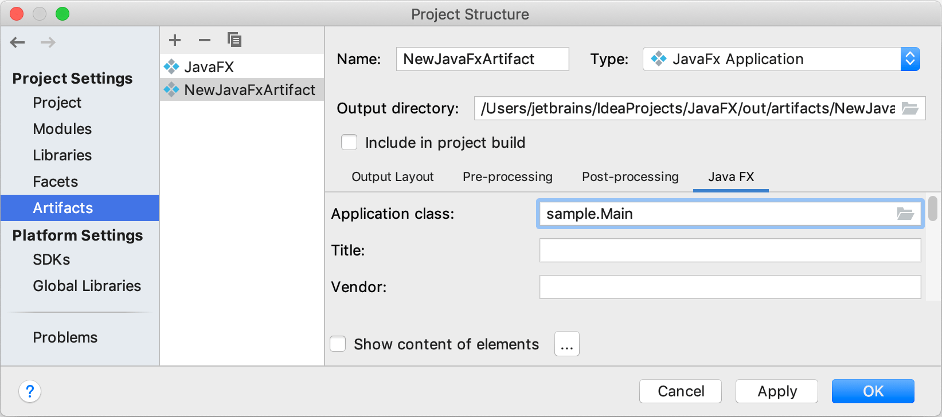

This is a basic configuration that is sufficient to package an application. You can specify additional options on the JavaFX tab. For the detailed description of each option, refer to [Java FX tab](https://www.jetbrains.com/help/idea/project-structure-artifacts-java-fx-tab.html).

##### Build the Artifact﻿

1. In the main menu, go to Build | Build Artifacts.
2. In the popup that opens, select the necessary artifact and select Build.

By default, the artifact is generated to **<project_folder>\out\artifacts\<artifact_name>**.

If you want to make sure that your artifact is built correctly, create a new run configuration and run it as described in the section [Run the packaged application](https://www.jetbrains.com/help/idea/creating-and-running-your-first-java-application.html#run_jar_artifact).

##### Troubleshoot﻿

* Error:Java FX Packager: Can't build artifact – fx:deploy is not available in this JDK

The **fx:deploy** task was a part of the Ant plugin that was formerly distributed in **ant-javafx.jar** as a part of Java Packager. The Ant plugin is not included in jpackage in the current JDK versions.

If you're using a JDK build of version 9 and later, use third-party solutions for packaging. For example, refer to section [Runtime images](https://openjfx.io/openjfx-docs/#modular) in the JavaFX official documentation. You can find more options for packaging on [Stack Overflow](https://stackoverflow.com/a/30162808).

You can package your application using [jlink](https://www.jetbrains.com/help/idea/javafx.html#package-app-with-jlink) or use a JDK with JavaFX included, for example, the [Bellsoft Liberica](https://bell-sw.com/) JDK 11.

### Scene Builder

#### Introduction

We've learned how to create our UI using fxml, and we've been doing so by editing the fxml file.

Now instead of writing the fxml ourselves, we could have used the javafx scene builder tool. Scene builder is a GUI builder, graphical user interface builder.

We can actually use it to build our user interface by dragging and dropping javafx controls and containers onto a content area.

Scene builder then generates the fxml code for us, and it's written using javafx, so it's an example of a complex javafx application.

#### Scene Builder vs fxml

Why have we spent so much time learning how to code fxml when we could have really just used a tool like scene builder instead? Well, GUI builders can be wonderful tools that do make our life easier, but when using any tool that generates code, it's really important to learn how to write the code yourself first.

The reason for that is the tool might get discontinued, we might want to tweak the generated code, or perhaps you need to debug the code when it doesn't work as you would expect.

#### GUI Builder

GUI builders should always be seen as a way to help us create the user interface. They shouldn't ever be used because we don't actually know how to write the code ourselves, so we don't understand what's happening behind the scenes.

That's why we've spent so many lessons in this section, learning the manual way of creating fxml, so the scene builder tool is going to really make things complement our skills now that we've sort of started off on the manual way and we can now save a bit of time using scene builder.

When it does come to scene builder, the javafx community is wondering, and I'm in the same boat here whether Oracle will actually keep the tool under active development.

#### Oracle Continuous Support

To give you an example of that, Oracle used to offer installers for a scene builder, but they no longer do. Oracle instructs developers who want to use the tool to download the source code and to build the tool themselves.

Also, Oracle have made the scene builder code open source and potentially that could mean that Oracle doesn't have any real sort of long-term plans to work on it anymore (pure speculation). But, in any event fortunately, the javafx community has stepped up to the plate and they've actually kept the scene builder code in sync with javafx update, something that oracle haven't been doing, but of course that could change at any time.

For now though, the scene builder is still a tool we can use and it is still very useful. If you search for scene builder, you might find some old binaries from oracle that you can use, but they don't actually include the latest updates to javafx.

There is an alternative way to get scene builder installed on a windows machine and also on a mac machine.

## Section 27 – Migrating Projects to Java 9 Topics

### Transitive Dependency

#### What is Transitive Dependency?

* Let’s say we have modules A, B, and C
  + When module A requires module B, module A can read public and protected types exported in module B.
  + If module B also requires module C, module B can have methods that return types exported in module C.

In our project, we have modules common, db, and ui. Module db requires/reads common while module ui reads both db and common. Module db or actually DataSource class has some methods that return types from module common. So, every module that uses the DataSource class will require the common module as well.

This is where transitive dependencies can help us. Instead of adding a requires statement to ui, we can use the keyword *transitive* with requires statement. That way every module that reads the db module will automatically be able to read the common module.

## Additional Old Topics (Java 9/Java 11)

### Naming Conventions

#### Java Naming Convention

* Adopting the accepted conventions for naming variables, methods, and objects in Java makes your code easier for others to read.
* “Others” above also includes yourself when you come back to look at your code weeks, months, or years after you wrote it.

#### The things that will be named in Java are:

* Packages
* Classes
* Interfaces
* Methods
* Constants
* Variables
* Type Parameters

#### Packages

* Always lower case.
* Package names should be unique.
* Use your internet domain name, reversed, as a prefix for the package name.
* Oracle specifies a convention for package names located [here](https://docs.oracle.com/javase/specs/jls/se6/html/packages.html#7).

#### Invalid Domain Name Components

* Replace invalid characters (i.e. dashes/hyphens ‘-‘) in the domain name with an underscore (‘_’).
* Domain name components starting with a number should instead start with an underscore _ .
* Domain name components that are Java keywords should have that component start with an underscore.

Examples with replacements

* switch.supplier.com 🡪 com.supplier._switch
* 1world.com 🡪 com._1world
* experts-exchange.com 🡪 com.experts_exchange

Example Package Names

* java.lang
* java.io
* org.xml.sax.helpers
* com.timbuchalka.autoboxing

#### Class Names

* CamelCase
* Class names should be nouns because they represent things.
* Should start with a capital letter.
* Each word in the name should start with a capital letter (e.g LinkedList)

Example Class Names

* ArrayList
* LinkedList
* String
* TopSong
* GearBox
* Main

#### Interface Names

Similar to class names:

* Capitalized like class names (CamelCase).
* Consider what objects implementing the interface will become or what they will be able to do when you are coming up with the name

Examples:

* + List
  + Comparable
  + Serializeable

#### Method Names

* mixedCase (lower camelCase)
* Often verbs.
* Reflect the function performed or the result returned.

Examples:

* + size()
  + getName()
  + addPlayer()

#### Constants

* ALL UPPER CASE.
* Separate words with an underscore ‘_’.
* Declared using the ‘final’ keyword.

Examples:

* Static final int MAX_INT
* Static final short SEVERITY_ERROR
* Static final double PI = 3.141592653

#### Variable/Field Names

* mixedCase (lower camelCase).
* Meaningful and indicative.
* Start with a lower case letter.
* Do NOT use underscores ‘_’.

Examples

* i
* league
* sydneySwans
* boxLength

#### Type Parameters

* Single Character, capital letters.
* Guidelines given [here](https://docs.oracle.com/javase/tutorial/java/generics/index.html).

Type Parameter Examples

* + E – Element (used extensively by the Java Collections Framework)
  + K – Key
  + T – Type
  + V – Value
  + S, U, V, etc. – 2nd, 3rd, 4th types